

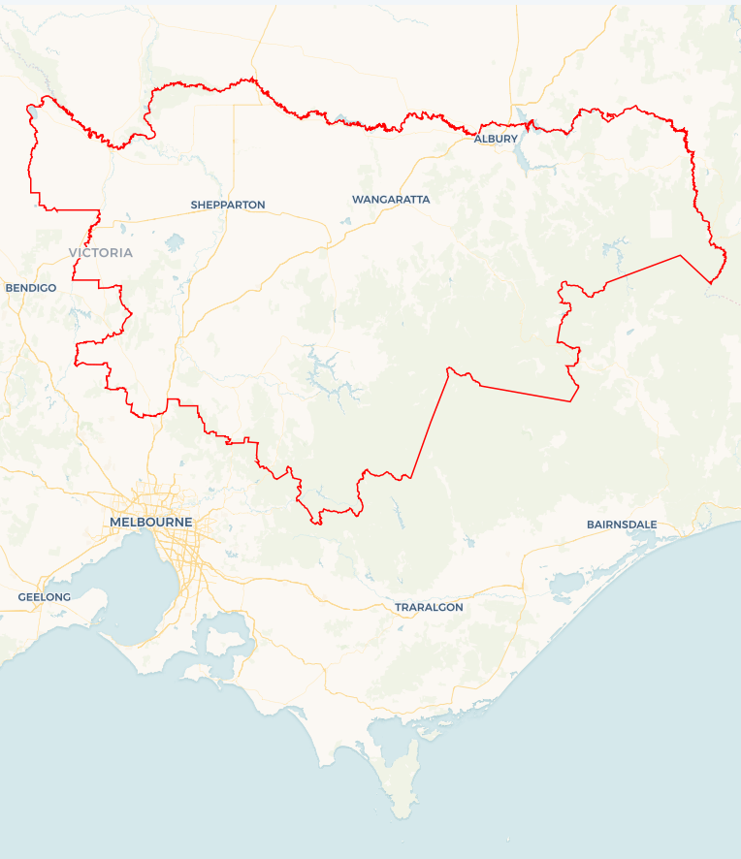Local Jobs Plan

Goulburn Murray ****Employment Region**** | VIC | ****June 2024****

Workforce Australia Local Jobs (Local Jobs) is a program that supports tailored approaches to accelerate   
reskilling, upskilling and employment pathways in response to current and emerging local workforce needs.

## Local Jobs elements

### Local Jobs Plan

The Local Jobs Plan sets out the skills and employment challenges and priorities of the region, and associated strategies that will drive the design and implementation of activities to be implemented to address these challenges.

### Employment Facilitators

Employment Facilitators and Support Officers support the delivery of the program by bringing together key stakeholders including businesses, employment services providers, and higher education and training organisations.

### Local Jobs and Skills Taskforce

Each Employment Region has its own Taskforce. Representatives include local stakeholders who have demonstrated experience in upskilling, and reskilling, and an ability to represent, connect and collaborate with others in the region to meet labour market needs.

### Local Recovery and National Priority Funds

The Local Recovery Fund supports projects that meet the priorities identified in the Local Jobs Plan. The National Priority Fund provides funding for innovative local solutions to address structural barriers to employment.

Explore labour market insights for the   
[Goulburn Murray](https://www.jobsandskills.gov.au/work/employment-region-dashboards-and-profiles/monthly-labour-market-dashboards) Employment Region

## Local labour market challenges in the region

* Health care and social assistance, construction, manufacturing, agriculture, and education and training are Goulburn Murray’s primary employing industries. These high-skilled industries minimise employment opportunities available in entry-level roles.
* A high proportion of participants in employment services have been receiving assistance for more than 12 months and face complex challenges to employment.
* For smaller regional areas, transport is a significant barrier to workforce participation due to the limited availability of:
  + driver training and support to obtain a licence; and
  + public transport within and between regional centres across Victoria and New South Wales.
* The housing market is facing significant challenges, especially for   
  low-income earners. Housing shortages and affordability have exacerbated the situation.
* Access to quality, affordable childcare is a challenge in parts of the region with limited spaces available and long wait lists. This creates challenges for parents and carers looking to enter or re-enter the workforce.
* Goulburn Murray’s ageing workforce in industries such as agriculture, health care and social assistance, and education and training will require workforce planning now to attract and train future workers into farming, nursing, aged care or disability support and teaching roles.
* The timber industry is undergoing significant changes and as a result, workers are facing the need to reskill to adapt to new technologies and practices.
* The flooding events in Echuca, Rochester, and Seymour during late 2022 had a significant impact on these communities, with many individuals still in temporary accommodation which impacts their ability to work.
* Goulburn Murray has a significant requirement for seasonal workers across industries such as agriculture, hospitality, tourism, and viticulture sectors.

## Local jobs and skills priorities and strategies in the region

### Priority 1 – Growth and emerging industries

#### What are our challenges and opportunities?

#### Many regional growth industries including hospitality, tourism, transport, manufacturing, construction, early childhood education, health care and social assistance, agriculture, and viticulture are currently operating at a reduced capacity due to the inability to attract, recruit and retain skilled or unskilled workers. Emerging industries such as the Net Zero transformation will require reskilling and upskilling the current and future workforce.

#### How are we responding?

* We are engaging with businesses and industry stakeholders on workforce planning strategies, recruitment practices and inclusive approaches to attract and retain workers and foster workplace diversity.
* We are collaborating with Workforce Australia Employment Services Providers, Registered Training Organisations (RTOs) and industry stakeholders in the development of industry-specific ‘taster programs’ that expose individuals to workplaces, educational institutions, and local employers.
* We are raising awareness of the benefits of apprenticeships and traineeships through community engagement to bridge the skills gap and enhance industry growth.
* We are connecting businesses to Workforce Australia Employment Services Providers, supports, activities and programs to optimise outcomes for businesses and individuals.
* We are promoting clean energy employment pathways and Net Zero events with community organisations and businesses across the Goulburn Murray Employment Region.

### Priority 2 – Mature age individuals

#### What are our challenges and opportunities?

#### As industries evolve, new skills and technologies are essential in today’s changing Labor market. Mature age individuals have the opportunity to identify their transferrable skills, update their qualifications and increase their digital skills to align with current industry demands to thrive in today’s job market.

#### How are we responding?

* We are working with the industry to review their recruitment practices and encourage job flexibility while promoting the benefits of employing mature age candidates.
* We are engaging with businesses and industry representatives to identify job placements and the development of pre-employment opportunities for mature age individuals.
* We are assisting in the development of activities that support individuals in identifying their transferrable skills and building digital competency and self-esteem to create pathways into sustainable employment.

### Priority 3 – First Nations people

#### What are our challenges and opportunities?

#### There is opportunity to generate innovative and collaborative solutions to improve employment outcomes and economic participation for First Nations people by partnering with the First Nations community in the Goulburn Murray Employment Region.

#### How are we responding?

* We are collaborating with First Nations organisations to understand their cultural needs and strengthen community relationships.
* We are consulting with the First Nations community to develop culturally appropriate recruitment models, activities, and pre-employment programs in collaboration with industry and RTOs.
* We are supporting local businesses to access Cultural Awareness Training, increasing their workforce knowledge and creating a culturally safe workplace.
* We continue to promote existing programs that empower, train, and upskill First Nations people to meet current and future workforce demands.

### Priority 4 – Address complex challenges of long-term unemployed

#### What are our challenges and opportunities?

#### Long-term unemployed individuals face complex challenges to employment including lack of housing security, transport challenges, mental health conditions, low self-esteem, and low educational outcomes. Building resilience and self-belief is essential for re-entering the workforce.

#### How are we responding?

* We are consulting with Workforce Australia Employment Services Providers and community groups to understand the common challenges experienced by specific cohorts.
* We are developing localised workshops addressing the common challenges and connecting individuals to wrap-around support services.
* We are collaborating with Workforce Australia Employment Services Providers and RTOs to develop activities that offer training in industry-relevant skills, including digital literacy, communication, and employer expectations.

### Priority 5 – Culturally and linguistically diverse individuals

#### What are our challenges and opportunities?

#### The Goulburn Murray Employment Region has a high proportion of culturally and linguistically diverse individuals who often face challenges to employment including language barriers, cultural differences and gaps in skills or qualifications. Creating inclusive workplaces for culturally and linguistically diverse employees is essential for fostering diversity, equity, and productivity.

#### How are we responding?

* We are collaborating with culturally and linguistically diverse organisations to understand individual cultural needs and strengthen community relationships.
* We are engaging with local industry, RTOs and culturally and linguistically diverse community groups to co-design solutions and activities that create upskilling, training, and employment opportunities.
* We are promoting new and existing programs and initiatives that support employment and training pathways for culturally and linguistically diverse communities.
* We are engaging with businesses and industry stakeholders to adopt inclusive approaches to culturally and linguistically diverse individuals and a commitment to workplace diversity.

## Want to know more?

* Contact: Faye D’Helin, Goulburn Murray Employment Facilitator: faye.dhelin@goulburnmurraylocaljobs.com.au
* Visit: [Local Jobs](https://www.dewr.gov.au/local-jobs) or [Workforce Australia](https://www.workforceaustralia.gov.au/)