

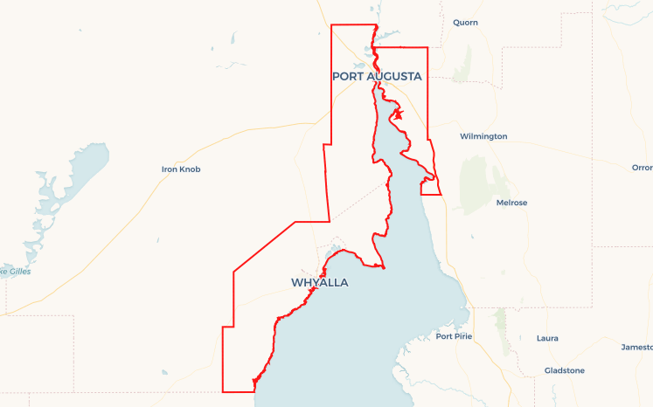Local Jobs Plan

North West Country ****Employment Region**** | SA | ****June 2024****

Workforce Australia Local Jobs (Local Jobs) is a program that supports tailored approaches to accelerate   
reskilling, upskilling and employment pathways in response to current and emerging local workforce needs.

## Local Jobs elements

### Local Jobs Plan

The Local Jobs Plan sets out the skills and employment challenges and priorities of the region, and associated strategies that will drive the design and implementation of activities to be implemented to address these challenges.

### Employment Facilitators

Employment Facilitators and Support Officers support the delivery of the program by bringing together key stakeholders including businesses, employment services providers, higher education and training organisations.

### Local Jobs and Skills Taskforce

Each Employment Region has its own Taskforce. Representatives include local stakeholders who have demonstrated experience in upskilling, reskilling, and an ability to represent, connect and collaborate with others in the region to meet labour market needs.

### Local Recovery and National Priority Funds

The Local Recovery Fund supports projects that meet the priorities identified in the Local Jobs Plan. The National Priority Fund provides funding for innovative local solutions to address structural barriers to employment.

Explore labour market insights for the  
[North West Country SA](https://www.jobsandskills.gov.au/data/employment-region-dashboards-and-profiles/monthly-labour-market-dashboards) Employment Region

## Local labour market challenges in the region

* Expected large pipeline of projects and strong jobs growth.
* Attracting skilled and professional labour.
* Suitable workers for entry-level jobs.
* High unemployment, long-term unemployment, including high numbers of Aboriginal people and disengaged youth.
* Growing workforce shortages in the care and support sector.
* Housing and childcare shortages.
* High demand for trainers to fill skills gaps.
* Access to transport and drivers’ licences, hours on plant to build competency and win jobs.

## Local jobs and skills priorities and strategies in the region

### Priority 1 – Meet the workforce needs of employers and industry

#### What are our challenges and opportunities?

The region has existing workforce shortages across multiple industries and upcoming projects with large workforce needs across the Net Zero Transition. Early engagement and proactive partnerships with employers and industry in designing placed-based initiatives is fundamental to the success of regional employment projects and activities that engage local people into available jobs.

#### How are we responding?

* We work collaboratively across Federal, State and regional organisations to develop comprehensive workforce strategies to address shortages. Examples include work with the care and support sector, renewable energy, construction and mining, retail, tourism and hospitality industries and Net Zero projects.
* We listen to industry and employers to understand their workforce needs and develop industry-driven training and employment initiatives to maximise opportunities and outcomes for local job seekers.
* Our taskforce includes representation from employers, local, State and Federal governments working together on solutions to address regional shortages in housing childcare and building capacity of employers to take on entry level workers.
* We assist other regional stakeholders to develop strategies to mobilise and increase workforce participation, including underemployed people and retirees. Examples include an Upper Spencer Gulf Workforce Strategy, and regional housing and childcare strategies.
* We share local intelligence relating to the region’s employment and skill needs through an industry engagement strategy, to secure funding to address the needs of major projects, industry and enterprise and deliver through a co-design approach to support individuals into work.
* We target skill development in sectors with future growth potential such as aquaculture, agriculture, manufacturing, construction, health care, social assistance and the range of projects in the Net Zero Transition, including critical minerals, green manufacturing, hydrogen and enabling infrastructure.
* We build and maintain strong connections between education, post school training and employment opportunities to improve results for young people.
* We work closely with TAFE South Australia and Registered Training Organisations to develop Vocational Education and Training (VET) capacity in regions including a focus on career transition assistance and employability skills.
* We schedule regular events and activities that showcase local jobs and career pathways.

### Priority 2 – Jobs for Aboriginal and Torres Strait Islander people

#### What are our challenges and opportunities?

The region is home to a diverse range of Aboriginal people from many nations and is covered by the Native Title determination for the Barngarla people. There is a higher than average proportion of Aboriginal people on the caseload in the region (30%), and almost 50% of the caseload in Port Augusta.

#### How are we responding?

* We engage with Aboriginal and Torres Strait Islander people and communities to develop employment and training initiatives and enable self-employment.
* We partner with Aboriginal people, community, business, and organisations, to co-design projects that achieve positive results for people.
* We connect people and work together on solutions to engagement, participation and outcomes in training and employment, in partnership with industry.
* We identify and access leveraged funding to deliver tailored training leading directly to sustainable employment for Aboriginal people.
* We address systemic challenges including access to drivers’ licences and fine regimes that inhibit licence attainment for individuals.
* We advocate for increased cultural competency and understanding across business, government and community.

### Priority 3 – Young people are learning and earning

#### What are our challenges and opportunities?

Young people experience high levels of unemployment in the region and are competing for jobs in an uncertain economy. The youth cohort are having to navigate new approaches to learning and education required to adapt for jobs that don’t yet exist as the economy evolves rapidly. Tailored approaches that engage and employ young people are required to maximise the number of young people in education, training, and available jobs.

#### How are we responding?

* We work together to improve opportunities for young people to engage or remain engaged in learning or earning.
* We engage with young people directly to understand their challenges and involve them in designing and implementing solutions.
* We work closely with the South Australian Department for Education and the VET policy initiative to explore collaborative strategies that link young people directly into the labour market.
* We share information about the support for young people to navigate the labour market, employers, and job opportunities.
* We collaborate with regional stakeholders to co-design programs to build work, wellbeing and resilience awareness and skills.
* We promote apprenticeship and traineeship opportunities, and support for business.
* We support the Australian Red Cross and the rollout of the Youth Development Hub in the Employment Region.

### Priority 4 – Address other challenges to employment

#### What are our challenges and opportunities?

Local people need support to get the job they want. Complex issues like homelessness, mental illness, drug or alcohol addiction, sexual abuse or violence, health or psychological factors, incarceration, and access to driver’s licences and transport require sustained tailored programs and place-based projects to make a difference. Structural issues include housing shortages for existing and new workers and a shortage of childcare places which prevent parents from working.

#### How are we responding?

* We co-design initiatives to support people to get the job they want in partnership with Employment Service Providers, business, and communities.
* We advocate for practical and innovative solutions to address identified needs.
* We develop community-based projects to build entry level skills such as co-design of skills for education and employment projects, and prison to work programs.

### Priority 5 – Ensure government investment in programs and services is maximised in regions

#### What are our challenges and opportunities?

Employers need support to understand the vast suite of government programs, services, and funding opportunities available, and the people representing them. It is important to communicate the guidelines and eligibility to increase uptake of funded initiatives through partnerships, leveraged funding and support.

#### How are we responding?

* We act as a concierge for government funding and programs and build partnerships to maximise regional investment in training and employment.
* We collaborate with Employment Service Providers to better connect individuals and the community with employment, skills, and major project workforce opportunities in the region.
* We promote government programs, services, and funding opportunities in the region through social media, newsletters and presentations.
* We establish networks and working parties to collaborate, communicate, and fund projects, programs, services, and opportunities.

### Priority 6 – Strengthen regional capacity to respond to employment and skill needs

#### What are our challenges and opportunities?

The region has existing and emerging workforce shortages and exponential growth planned in new industries, including hydrogen and renewable energy projects. Our region operates in a thin market, with a lack of services and high demand for workforce. A current shortage of trainers, child care places and housing requires innovative, collaborative responses to enable local people into local jobs.

#### How are we responding?

* We develop collaborative approaches to build region, organisation and stakeholder capacity and capability. Examples include partnerships, network meetings and consultation.
* We explore and action opportunities to upskill people into available roles.
* We advocate for increased cultural competency of organisations and industry to maximise opportunities for Aboriginal and Torres Strait Islander people.
* We connect employers with education and resources that achieve success in employment of staff.
* We support the establishment of the educational infrastructure including the proposed Technical College in Port Augusta and regional Uni Hubs so people can achieve higher level education while they live, work, and play in the region.

## Want to know more?

* Contact: Andrea Broadfoot, North West Country SA Employment Facilitator: [andrea@localjobsprogram.com](mailto:andrea@localjobsprogram.com)
* Visit: [Local Jobs](https://www.dewr.gov.au/local-jobs) or [Workforce Australia](https://www.workforceaustralia.gov.au/)