

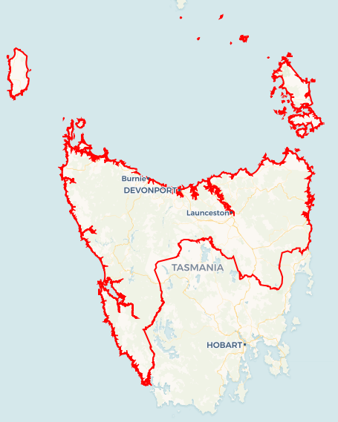Local Jobs Plan

North and North Western Tasmania Employment Region| TAS | ****June 2023****

Workforce Australia Local Jobs (Local Jobs) is a program that supports tailored approaches to accelerate   
reskilling, upskilling and employment pathways in response to current and emerging local workforce needs.

## Local Jobs elements

### Local Jobs Plan

The Local Jobs Plan sets out the skills and employment challenges and priorities of the region, and associated strategies that will drive the design and implementation of activities to be implemented to address these challenges.

### Employment Facilitators

Employment Facilitators and Support Officers support the delivery of the program by bringing together key stakeholders including businesses, employment services providers, higher education and training organisations.

### Local Jobs and Skills Taskforce

Each Employment Region has its own Taskforce. Representatives include local stakeholders who have demonstrated experience in upskilling, reskilling, and an ability to represent, connect and collaborate with others in the region to meet labour market needs.

### Local Recovery and National Priority Funds

The Local Recovery Fund supports projects that meet the priorities identified in the Local Jobs Plan. The National Priority Fund provides funding for innovative local solutions to address structural barriers to employment.

Explore labour market insights for the  
[North and North Western Tasmania](https://www.jobsandskills.gov.au/work/employment-region-dashboards-and-profiles/monthly-labour-market-dashboards) Employment Region

## Local labour market challenges in the region

* Continued and consistent employer demand for entry level workers in key growth sectors, such as community care services and hospitality, and agriculture.
* Workforce and skills gap in manufacturing, mining, and construction industries.
* The Employment Region’s workforce participation rate is significantly lower than the national average.
* High degree of labour market disadvantage for key cohorts (such as mature age, Indigenous, and youth participants).

## Local jobs and skills priorities and strategies in the region

### Priority 1 – Collaboration across all levels of our employment service framework

#### What are our challenges and opportunities?

In Tasmania, we are fortunate to have an employment service framework that includes programs from both the Australian Government Department of Employment and Workplace Relations and the Tasmanian Government’s Department of State Growth. We work collaboratively with state government programs to maximise the effectiveness of various initiatives and to ensure the best outcomes for Tasmanians living in our region. We also apply this principle of collaboration with local government, training and education organisations, and industry peak bodies to support the best possible uptake of employment in our region.

#### How are we responding?

* Our Local Jobs and Skills Taskforce includes representation from Jobs Tasmania (steward of the Tasmanian Community Led Employment Model) are supporting the connection between projects and activities in recognition of both federal and state service delivery arrangements.
* Our Local Jobs team is collaborating with the Regional Jobs Hubs, the key community-led, client-facing component of the Jobs Tasmania suite of programs.
* We are collaborating with local government, regional authorities, industry peak bodies and other services in training, education and employment assistance that operate around North and North Western Tasmania.

### Priority 2 – Bridging the distance between individuals looking for work and businesses looking for employees

#### What are our challenges and opportunities?

Consistently we are hearing that employers are struggling to locate and communicate with those who are looking for work. These individuals are in turn struggling to understand what employers are asking for when they advertise roles. We are aiming to support the Tasmanian employment service framework to bridge the gap and create opportunities for businesses and individuals to meet and build connections. We know how critical this approach is because of the prevalence of informal (word of mouth) recruitment within our region.

#### How are we responding?

* The Local Jobs team are looking for opportunities to bring employers and individuals together to build common ground and to foster warm connections. An ongoing example of this are our ‘Jobs in the Pub’ events – informal networking opportunities happening regularly across the region in local pubs and other venues.
* We are regularly working with and supporting community-led jobs forums or fairs around the region which focus on brokering links between employers and those looking for work or providing a better understanding of employer needs and opportunities.
* We are identifying and developing projects, via the Local Recovery Fund, that promote better linkages between employers and those looking for work.

### Priority 3 – Reducing structural barriers for individuals looking for work

#### What are our challenges and opportunities?

We know that Tasmanians looking for work often face significant personal barriers during their job search, work preparation and then early stages of their new employment. One key driver of this is lack of digital inclusion, with Tasmania frequently ranking as one of the least digitally advanced of all states. Lack of access to safe, reliable and consistent transport is also a prohibitive barrier for many. In addition to this, significant labour market disadvantage is still experienced by Aboriginal and Torres Strait Islander peoples, the long term unemployed, women, mature age workers and young people.

#### How are we responding?

* We are working with businesses and other support organisations to form place-based initiatives to source workforce from a local area.
* We are connecting with supporting services that address barriers to literacy and numeracy to integrate opportunities for participants to expand their digital and alphanumeric literacy, while also developing skills relevant to local employment opportunities.
* We are identifying and developing projects, including Local Recovery Fund projects, which address structural barriers for individuals seeking work and opportunities for training or qualifications/licences which will promote their employability. An example of this approach was an activity run by National Job Link (NJL) and Bitlink called GamesFest. This activity was aimed at young people (aged 18 – 25) who had an interest in gaming and were keen to learn how this interest could be adapted to employment. Together, NJL and Bitlink taught participants games development skills, building confidence and their range of skillsets, while discussing how these transferrable skills could be used in the workplace.

### Priority 4 – Encouraging seasonal workforce recruitment in horticulture, agriculture, hospitality and tourism

#### What are our challenges and opportunities?

Effective closure of Australia’s international borders from late March 2020 meant that several industry sectors which would normally rely on temporary overseas workers, such as horticulture, agriculture, hospitality and tourism, experienced subsequent labour shortages. These are still being felt in 2023, with industries struggling to entice local workers into roles also due to industry working conditions that are perceived as not ideal or as industries that aren’t suitable for ongoing full-time careers.

#### How are we responding?

* We are ensuring we have ongoing engagement with human resource teams from various businesses. This is customised to employer needs and can include facilitating introductions to Workforce Australia Employment Services Providers and staging or supporting insight tours for participants.
* We are supporting and facilitating local employment events timed around recruitment cycles in these sectors and promoting/participating in their upcoming recruitment activities.
* We are providing Workforce Australia Employment Services Providers with opportunities to refer people looking for these opportunities, and actively encourage these outcomes.
* We provide timely information to the employment service framework regarding upcoming seasonal demand and frequently broker recruitment approaches to best support the needs of business.
* We are providing access and information regarding workforce development opportunities and services available.

### Priority 5 – Finding sustainable solutions to critical workforce shortages in the community care sector and other relevant sectors as needs emerge

#### What are our challenges and opportunities?

Our region has identified that a number of roles in the diverse community care sector are in high demand with significant skill shortages evident across the industry. For example, we know that Tasmania has an ageing population, which has increased our need for skilled aged-care workers. We are also aware that a number of factors are applying pressure to Tasmania’s workforce demands, requiring the Local Jobs team to continue monitoring emerging critical workforce shortages.

#### How are we responding?

* We are engaging regularly with relevant employers and businesses to understand changing needs within the sector. This includes having representation from a disability services business on the Local Jobs and Skills Taskforce.
* We are working alongside the industry peak body for community care services, the Tasmanian Council of Social Service, with initiatives to promote interest in care careers around North and North Western Tasmania.
* We are identifying and developing projects, including Local Recovery Fund projects, which address workforce shortages in the community care sector. An example of this is a current activity called the Care Industries Training to Employment Pathway, run by Community Care Tasmania and TasTAFE in partnership with CVGT. This activity will provide accredited and non-accredited training to participants to facilitate employment as a personal care attendant or domestic service worker within the home care sector.

## Want to know more?

* Contact: James McCormack, North and North Western Tasmania Employment Facilitator: [james@tasmaniafacilitator.com.au](mailto:james@tasmaniafacilitator.com.au)
* Visit: [Local Jobs](https://www.dewr.gov.au/local-jobs) or [Workforce Australia](https://www.workforceaustralia.gov.au/)