

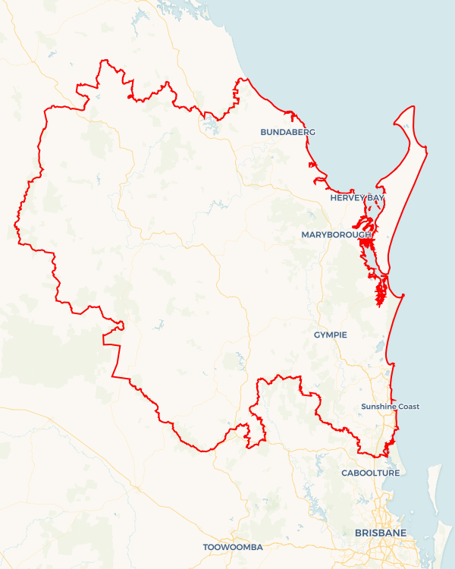Local Jobs Plan

Wide Bay and Sunshine Coast | Queensland |****August 2023****

Workforce Australia Local Jobs (Local Jobs) is a program that supports tailored approaches to accelerate   
reskilling, upskilling and employment pathways in response to current and emerging local workforce needs.

## Local Jobs elements

### Local Jobs Plan

The Local Jobs Plan sets out the skills and employment challenges and priorities of the region, and associated strategies that will drive the design and implementation of activities to be implemented to address these challenges.

### Employment Facilitators

Employment Facilitators and Support Officers support the delivery of the program by bringing together key stakeholders including businesses, employment services providers, higher education, and training organisations.

### Local Jobs and Skills Taskforce

Each Employment Region has its own Taskforce. Representatives include local stakeholders who have demonstrated experience in upskilling, reskilling, and an ability to represent, connect and collaborate with others in the region to meet labour market needs.

### Local Recovery and National Priority Funds

The Local Recovery Fund supports projects that meet the priorities identified in the Local Jobs Plan. The National Priority Fund provides funding for innovative local solutions to address structural barriers to employment.

Explore labour market insights for the

[Wide Bay and Sunshine](https://www.jobsandskills.gov.au/work/employment-region-dashboards-and-profiles/monthly-labour-market-dashboards) Employment Region

## Local labour market challenges in the region

* Elevated levels of demand for entry-level workers in the hospitality, aged care, and disability sectors.
* Significant gaps between current business needs and available skills in the region.
* A large geographical area with diverse labour markets. Employer’s ability to attract and retain people is impacted by their limited access to transport.
* The region has a considerable number of people such as disadvantaged Indigenous peoples and disengaged youth who require on-going support and training.
* A low level of awareness regarding the spectrum of career and employment opportunities in current and emerging industries.
* Large infrastructure projects commencing over the next 24 months, such as Forest Wind and the Torbanlea Train facility will be impacted by predicted skills gaps in the construction and manufacturing sectors and will require a level of labour supply that is currently difficult to access.
* Long term unemployed and middle-aged residents are an identified cohort of people needing on-going targeted support towards training and employment opportunities.
* The Aboriginal community of Cherbourg continues to face challenges in identifying and sustaining employment opportunities for its residents.

## Local jobs and skills priorities and strategies in the region

### Priority 1 - Health and social services sector

### What are our challenges and opportunities?

The health and social services sector is one of the largest employers in the Wide Bay Sunshine Coast Employment Region. The industry has a growing demand for suitably skilled workforce. The industry is predicted to grow exponentially and demand is currently exceeding labour supply in the region.

#### How are we responding?

* Connecting, coordinating, and leveraging existing programs and aligning efforts to upskill and reskill participants to meet employer needs and maximise employment pathways.
* Targeting promotional activities to relevant cohorts such as the mature aged who currently constitute a large component of the industry workforce. Another relevant cohort is young people who are interested in a career in the sector.
* Consulting with industry representatives, employers, and associations to develop and refine strategies to assist in recruitment for the sector.
* Working with migrant organisations to identify cohorts of people that are seeking employment opportunities in the sector.
* Using social media to promote employment opportunities to unemployed people across the region who are currently not being assisted by employment services.

### Priority 2 - Promotion of Australian apprenticeships to align with projected skills shortages

#### What are our challenges and opportunities?

Several large, long-term infrastructure projects are commencing in the region that will require skilled labour. Demand for labour and apprentices in the construction industry is predicted. Projects include Forest Wind, Torbanlea Train Manufacturing Facility, and expansive upgrades of the roads in the region including two major by-passes.

#### How are we responding?

* Engaging with local businesses and industry to identify their requirements and specifications for employment opportunities.
* Promoting to Australian Apprenticeships Support Network providers the employment opportunities within current and emerging infrastructure projects across the region.
* Developing a targeted promotional strategy to inform potential apprentices and employers of current wage subsidy programs available through State and Federal Government Funded initiatives.
* Hosting local forums to promote current and emerging projects in the region that offer employment and career opportunities with an emphasis on career pathways via apprenticeships.

### Priority 3 - Tourism and hospitality Industry

#### What are our challenges and opportunities?

The tourism and hospitality industry across the region is currently facing a significant demand for labour. Waiters, commercial cooks, chefs, and room attendants are required to meet current and future workforce requirements for the sector. In addition, the current housing and affordable accommodation crisis in the region is further suppressing labour supply for the sector. Currently, this is particularly impacting employers in areas such as Noosaville and Hervey Bay.

#### How are we responding?

* Engaging with employers, Registered Training Organisations (RTOs) and providers of other pre-employment programs to promote vacancies in the sector.
* Coordinating with local stakeholders to develop and deliver a range of training options including full qualifications, short courses, and micro-credentials to link the available workforce with industry demand in the region.
* Supporting and encouraging employers to consider a variety of recruitment strategies to identify and attract suitable candidates for the industry.
* Conducting career forums to empower and educate local people and other relevant stakeholders regarding the employment opportunities across the sector.

**Priority 4 - Agriculture, manufacturing, and the renewable energy sectors**

#### What are our challenges and opportunities?

The region will see emerging energy-based projects being implemented over the immediate and long-term future. These projects will require a skilled workforce to meet project implementation timelines. In addition, several large manufacturing firms across the region are seeking to expand and increase their employment composition. The agriculture sector continues to face significant barriers in procuring and retaining staff for entry level positions in harvesting, seeding and other labour-based roles. The forestry and timber sectors are also currently facing significant challenges with an unprecedented demand for product whilst negotiating supply chain delays and on-going labour shortages.

#### How are we responding?

* Identifying new employment opportunities, including those in the renewable energy sectors such as wind, solar, pumped hydro and hydrogen and other major infrastructure projects including supply chains.
* Running forums and coordinating presentations from employers regarding skills and roles/career options and pathways. Working with Workforce Australia Services Providers, training organisations and other stakeholders to promote the emerging energy-based industries in the region.
* Coordinating with manufacturing employers across the region to support them in developing targeted strategies to identify, attract and retain employees.
* Collaborating with key stakeholders in the agricultural sector to develop advocacy initiatives to incentivise suitable candidates to consider employment and career opportunities.
* Developing and delivering career forums that highlight the sectors and the expansive employment pathways they offer.
* Assisting local SMEs (Small to Medium Enterprises) and large businesses that are strategically aspiring towards a NetZero policy. Consult and engage in the advocacy of skills and strategies required to meet a NetZero policy framework.
* Consulting with local RTOs to understand and promote the new skill sets that may be required under a NetZero industry framework.

### Priority 5 - Youth

#### What are our challenges and opportunities?

The Wide Bay and Sunshine Coast region has historically experienced high youth unemployment which is still ongoing due to social, cultural, and long-term generational factors.

#### How are we responding?

* Engaging with local youth.
* Collaborating with the Regional Jobs committees (Jobs Bundaberg) and (Jobs Fraser Coast) in developing strategies to promote pre-employment programs and entry level job opportunities to incentivise the youth demographic towards employment.
* Collaborating with Workforce Australia providers, schools and other stakeholders to develop and raise awareness of employment pathways that align with local labour market opportunities.
* Consulting with employers in retail, hospitality and other sectors that have a high youth employee composition to identify and promote entry level roles to encourage youth participation in the labour market.
* Engaging with community not for profit organisations that deliver Skilling Queenslanders for Work pre-employment programs for youth in the region and connecting program coordinators with employers who are offering entry level vacancies.

### Priority 6 - Indigenous

#### What are our challenges and opportunities?

The Wide Bay and Sunshine Coast region embodies a cohort of Indigenous individuals that require ongoing and customised support towards training, skills development and sustainable employment opportunities.

#### How are we responding?

* Engaging with Indigenous Elders and members of our communities.
* Developing relationships with key stakeholders at the Aboriginal community of Cherbourg to gain an enhanced understanding of their unmet needs.
* Consulting with DATSIP (Department of Aboriginal Torres Strait Islanders and Partnerships) and local Workforce Australia Providers, including Indigenous specialists to identify and customise culturally appropriate strategies.
* Engaging a dedicated Indigenous Taskforce representative to provide guidance, advice and support in developing and delivering suitable strategies for the Indigenous cohort within the Wide Bay and Sunshine Coast Employment Region.

## Want to know more?

* Contact: Austin Ryann - Wide Bay and Sunshine Coast Employment Facilitator: austin@ljpemploymentfacilitator.com.au
* Visit: Local Jobs or Workforce Australia