

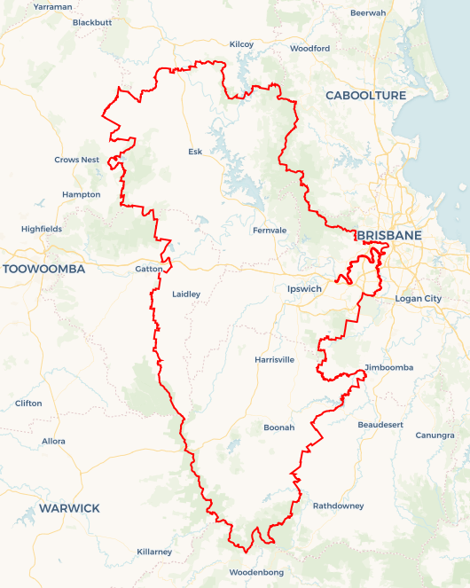Local Jobs Plan

Wivenhoe Employment Region | QLD |July 2023

Workforce Australia Local Jobs (Local Jobs) is a program that supports tailored approaches to accelerate   
reskilling, upskilling and employment pathways in response to current and emerging local workforce needs.

## Local Jobs elements

### Local Jobs Plan

The Local Jobs Plan sets out the skills and employment challenges and priorities of the region, and associated strategies that will drive the design and implementation of activities to be implemented to address these challenges.

### Employment Facilitators

Employment Facilitators and Support Officers support the delivery of the program by bringing together key stakeholders including businesses, employment services providers, higher education and training organisations.

### Local Jobs and Skills Taskforce

Each Employment Region has its own Taskforce. Representatives include local stakeholders who have demonstrated experience in upskilling, reskilling, and an ability to represent, connect and collaborate with others in the region to meet labour market needs.

### Local Recovery and National Priority Funds

The Local Recovery Fund supports projects that meet the priorities identified in the Local Jobs Plan. The National Priority Fund provides funding for innovative local solutions to address structural barriers to employment.

Explore labour market insights for the  
[Wivenhoe](https://www.jobsandskills.gov.au/work/employment-region-dashboards-and-profiles/monthly-labour-market-dashboards) Employment Region

## Local labour market challenges in the region

* The Wivenhoe Employment Region has many entry level job vacancies across all industries. The major challenge in filling these roles is the extent of long-term unemployed people on Workforce Australia Provider caseloads who require support to develop the confidence, motivation, resilience and physical fitness required to return to employment.
* The mismatch between the skills and experience required by employers and industry and the available workforce is also a significant challenge. This mismatch applies in most industries within the Employment Region.
* There is a significant shortage of labour in the health and community care sectors which needs to be addressed by pre-employment programs negotiated with industry, funded by existing programs and which include vocational and soft skills training. There is also a need for the industry to promote the full range and variety of job and career opportunities that exist.
* There are several current and upcoming major construction projects including Gatton Jail, Ipswich Mental Health facility and Inland Rail that have social impact employment commitment requirements. Further development of facilities and infrastructure in preparation for the   
  2032 Olympics will also provide significant opportunities across the Employment Region.
* Transport within and across the Employment Region is a challenge. The local unemployed workforce in the agricultural areas such as the Scenic Rim and the Lockyer Valley is insufficient to meet demand and there are transport barriers to enabling the potential workforce to travel from the major population centre of Ipswich to these jobs.
* The agriculture sector is also becoming more digitised and looking toward ‘smart’ supply chains to minimise future disruptions due to major events. This will likely see future changes in the skills needed for this sector.
* There is a shortage of skilled labour and tradespeople for the manufacturing and construction industries in the Employment Region. Some employers are now prepared to look at trades assistants and labourers but there is still a need for job specific pre-employment preparation.

## Local jobs and skills priorities and strategies in the region

### Priority 1 – Build confidence, motivation, resilience and physical fitness in the Wivenhoe Employment Region’s long term unemployed caseload to meet the entry level job requirements of industries

#### What are our challenges and opportunities?

Long term unemployed people in Wivenhoe represent 70 per cent of the caseload and within this group. 80 per cent have been unemployed for 2+ years, presenting a challenge with their confidence, motivation, resilience and physical fitness to obtain and retain work. Evidence shows that once these soft skills and physical fitness improve, long term unemployed people can meet industry entry level job requirements and obtain work.

#### How are we responding?

* Negotiating and co-designing with stakeholders pre-pre-employment programs to improve the required soft skills and physical fitness in long term unemployed people.
* Designing and delivering soft skills programs for long term unemployed people to directly enter suitable jobs or fully participate in accredited skills-based qualifications or programs required by industry.

### Priority 2 – Address the mismatch between the skills of the available workforce and employer/industry requirements

#### What are our challenges and opportunities?

The mismatch between the skills and experience required by employers and industry and the available workforce is a significant challenge. This mismatch applies in most industries within the Employment Region.

#### How are we responding?

* Negotiating and co-designing with stakeholders pre-employment preparation programs to address the current mismatch between the job requirements of employers/industries with vacancies and the skillsets, experience and work behaviours of participants on the Workforce Australia Provider caseloads.
* Approaches to address this mismatch may also include changes to job design, the use of micro-credential training to fast track the pathway to productivity and exploring the use of various Australian and Queensland government supports and incentives to expand working hours, particularly in small business, and make jobs more viable to job seekers.

### Priority 3 – Collaboration to meet social impact commitments on major projects in the Wivenhoe Employment Region

#### What are our challenges and opportunities?

There are several current and upcoming major construction projects in the Employment Region including the Gatton Jail, Ipswich Mental Health facility, Inland Rail and the 2032 Olympic Games that have social impact employment commitments to be met.

#### How are we responding?

* Collaborating with all relevant levels of government and private sector contractors to identify future major projects and ensure that associated social impact commitments are met through skills development in the current and future workforce.
* Mobilising the Workforce Australia Employment Services Provider network and other stakeholders, including schools, to develop effective employment pathways that align with these major projects and emerging jobs in sectors such as advanced manufacturing.
* Sourcing funding for pre-employment programs through the Employment and Participation Fund as well as other funding sources through Queensland and Australian government programs including the Local Recovery Fund.

### Priority 4 – Address transport barriers

#### What are our challenges and opportunities?

Transport within the Employment Region to assist in mobilising the potential workforce is a challenge, particularly in the areas of farm-based and food processing jobs. The local unemployed workforce in the agricultural areas is insufficient to meet demand and it is difficult for the potential workforce which lives in the major population centre of Ipswich to travel to these jobs.

#### How are we responding?

* Collaborating with key regional stakeholders, including the three levels of government, to address barriers to employment resulting from lack of viable “transport to work” options within the Employment Region.
* Engaging with the transport and driver training industry to develop solutions to transport issues.
* Sourcing program and funding supports available to address any transport issues.

### Priority 5 – Promote the engagement and retention of apprenticeships and traineeships

#### What are our challenges and opportunities?

There is a shortage of skilled labour and tradespeople for the manufacturing and construction industries in the Employment Region. Some employers are now prepared to look at trades assistants and labourers but there will still be a need for job specific pre-employment preparation.

#### How are we responding?

* Promoting the engagement and retention of Australian apprenticeships (including traineeships) to align with projected skills shortages including areas of future demand in the region.
* Connecting appropriate sources of candidates including Workforce Australia Employment Services Providers and pathways from local high schools to engage with the Australian Apprenticeship Support Network to leverage existing approaches and programs to increase apprenticeship and traineeship opportunities.

## Want to know more?

* Contact: John Perry, Wivenhoe Employment Facilitator: [john.perry@localjobsprogram.org.au](mailto:john.perry@localjobsprogram.org.au) or 0418 719 795
* Visit: [Local Jobs](https://www.dewr.gov.au/local-jobs) or [Workforce Australia](https://www.workforceaustralia.gov.au/)