

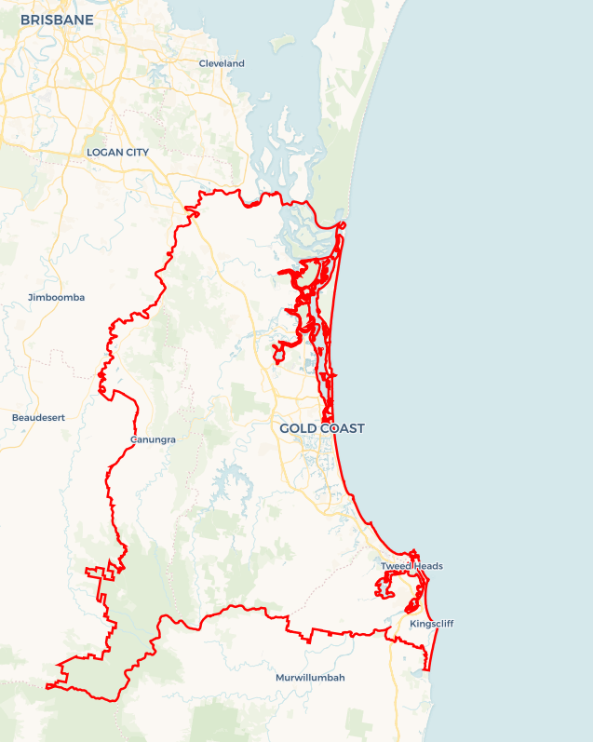Local Jobs Plan

Gold Coast Employment Region | QLD | ****June 2024****

Workforce Australia Local Jobs (Local Jobs) is a program that supports tailored approaches to accelerate   
reskilling, upskilling and employment pathways in response to current and emerging local workforce needs.

## Local Jobs elements

### Local Jobs Plan

The Local Jobs Plan sets out the skills and employment challenges and priorities of the region, and associated strategies that will drive the design and implementation of activities to be implemented to address these challenges.

### Employment Facilitators

Employment Facilitators and Support Officers support the delivery of the program by bringing together key stakeholders including businesses, employment services providers, higher education and training organisations.

### Local Jobs and Skills Taskforce

Each Employment Region has its own Taskforce. Representatives include local stakeholders who have demonstrated experience in upskilling, reskilling, and an ability to represent, connect and collaborate with others in the region to meet labour market needs.

### Local Recovery and National Priority Funds

The Local Recovery Fund supports projects that meet the priorities identified in the Local Jobs Plan. The National Priority Fund provides funding for innovative local solutions to address structural barriers to employment.

Explore labour market insights for the   
[Gold Coast](https://www.jobsandskills.gov.au/work/employment-region-dashboards-and-profiles/monthly-labour-market-dashboards) Employment Region

## Local labour market challenges in the region

* High levels of unmet demand for entry-level workers in essential services areas such as aged and disability care and early education.
* Shortage of workers to fill entry level vacancies in multiple industries, including, but not limited to health, retail, hospitality, customer contact/call centres, manufacturing and construction.
* Public transport to the northern Gold Coast industrial precinct remains a significant challenge for individuals without a reliable car or licence.
* Current and projected gaps for skilled labour in existing and emerging sectors, including health, manufacturing and marine.
* Heightened risk of further entrenchment in the labour market for cohorts experiencing challenges, including First Nations people, youth, mature age, women, and long term unemployed.
* Businesses finding it difficult to attract people to opportunities.

## Local jobs and skills priorities and strategies in the region

### Priority 1 – Health care and social assistance (aged, disability and early education)

#### What are our challenges and opportunities?

The care and support sector are Australia’s largest and fastest growing sectors, with vacancies across aged, disability and child care. Australia’s population is ageing, and employment demands are expected to grow. Gold Coast is no exception to these trends, with health care and social assistance being the largest employment sector in the region.

#### How are we responding?

* We host events online and face to face for businesses to meet employment services providers to educate career influencers about careers in the sector.
* We offer businesses support in hosting events for participants to meet employers and attend industry open day events.
* We continue to support recruitment drives through a range of local networking campaigns.
* We continue to develop and promote tailored preparatory programs and training opportunities to provide participants with the skills they need to commence employment in the sector.
* We collaborate with stakeholders to deliver job events, for example: Jobs Roadshows and Youth Festivals.
* We continue to work with local business to develop workforce attraction, recruitment and retention strategies.

### Priority 2 – Manufacturing and construction

#### What are our challenges and opportunities?

The Gold Coast has seen recent increases in the emergence of blue-collar roles, particularly in manufacturing and construction. The manufacturing sector experienced growth in demand of local product sourcing and manufacturing. This led to a staff shortage of entry level and skilled workers. This includes all manufacturing sectors, for example, marine, textile, food and other products. Construction continues to be in the top 5 largest employing industries in the   
Gold Coast, with labourers being in the top 5 occupations. This trend is expected to continue with projects such as the M1 upgrade, Coomera Connector and   
Light Rail Extension.

#### How are we responding?

* We host events online and face to face for business to meet employment providers to educate career influencers about the variety of careers in the sector and the different types of work sites.
* We offer businesses support in hosting events for participants to meet employers and attend industry open day events.
* We continue to support recruitment drives through a range of local networking campaigns.
* We continue to develop and promote tailored preparatory programs and training opportunities to provide participants with the skills they need to commence employment in the sector.
* We are working with businesses to inform, support and build knowledge and capability in relation to funding opportunities in the region that support workforce development.
* We establish relationships with business that are actively working towards net zero and identify skills and labour needs for current and future employment.
* We continue to work with business to develop workforce attraction, recruitment and retention strategies.

### Priority 3 – Customer service (retail, hospitality, tourism and contact centres)

#### What are our challenges and opportunities?

The Gold Coast hospitality, tourism and retail sectors were largely impacted by the COVID-19 pandemic. The region experienced significant business decline, resulting in job losses. As the region emerges from COVID-19, business is booming, however a critical staff shortage exists. This impacts business operations and limits capacity for growth. Contact/call centres have continued to emerge, creating hundreds of unfilled job vacancies.

#### How are we responding?

* We host events online and face to face for business to meet employment providers to educate career influencers about the variety of careers in the sector and the different types of work sites.
* We offer businesses support in hosting events for participants to meet employers and attend industry open day events.
* We continue to support recruitment drives through a range of local networking campaigns.
* We continue to develop and promote tailored preparatory programs and training opportunities to provide participants with the skills they need to commence employment in the sector.
* We are working with business to inform, support and build knowledge and capability in relation to new and emerging economic opportunities in the region.
* We will continue to work with other programs that address workforce matters, for example the Industry Workforce Advisor – hospitality, tourism and events.
* We continue to work with business to develop workforce attraction, recruitment and retention strategies.

### Priority 4 – Preparatory programs for unemployed people

#### What are our challenges and opportunities?

The unemployment rate in Gold Coast has fallen well below pre-pandemic employment rates in March 2020. More than 50% of the unemployed caseload continues to be made up of women. Whilst the unemployment rate continues to decline post COVID-19, cohorts experiencing challenges, including First National people, youth, mature age, women, multicultural communities and long term unemployed, continue to be impacted. There is a need to address long term unemployment and provide support that is inclusive of programs that build confidence, resilience, and mental and physical fitness.

#### How are we responding?

* We are working with local Workforce Australia Employment Services Providers to discuss caseload demographics and understand the challenges faced by participants, to enable a collaborative approach to solutions.
* We are seeking and promoting solutions and opportunities for tailored preparatory activities to engage and prepare participants.
* We are facilitating connections between business, providers and other organisations, to educate the businesses on the existing labour market and support recruitment activities to engage participants.
* We recognise the lack of public transport in some regions has an impact on the number of suitable referrals and will continue to work with business and local activity hosts to consider solutions to address this.
* We have established a First Nation’s Steering Committee to strategically identify opportunities and support networks for First Nations people.
* We identify opportunities for the broader community to engage in skill development activities and events.

## Want to know more?

* Contact: Jodi Brackenbury, Gold Coast Employment Region: [Jodi.Brackenbury@localjobsprogram.org.au](mailto:Jodi.Brackenbury@localjobsprogram.org.au)
* Visit: [Local Jobs](https://www.dewr.gov.au/local-jobs) or [Workforce Australia](https://www.workforceaustralia.gov.au/)