

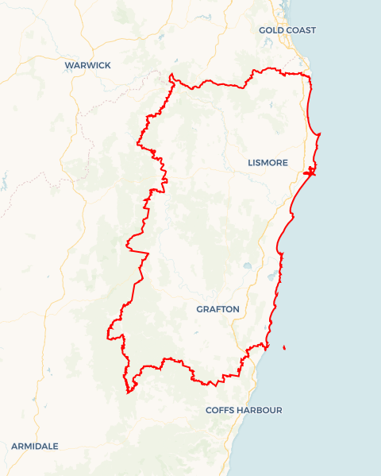Local Jobs Plan

North Coast ****Employment Region**** | NSW | ****April 2024****

Workforce Australia Local Jobs (Local Jobs) is a program that supports tailored approaches to accelerate   
reskilling, upskilling and employment pathways in response to current and emerging local workforce needs.

## Local Jobs elements

### Local Jobs Plan

The Local Jobs Plan sets out the skills and employment challenges and priorities of the region, and associated strategies that will drive the design and implementation of activities to be implemented to address these challenges.

### Employment Facilitators

Employment Facilitators and Support Officers support the delivery of the program by bringing together key stakeholders including businesses, employment services providers, higher education, and training organisations.

### Local Jobs and Skills Taskforce

Each Employment Region has its own Taskforce. Representatives include local stakeholders who have demonstrated experience in upskilling, reskilling, and an ability to represent, connect and collaborate with others in the region to meet labour market needs.

### Local Recovery and National Priority Funds

The Local Recovery Fund supports projects that meet the priorities identified in the Local Jobs Plan. The National Priority Fund provides funding for innovative local solutions to address structural barriers to employment.

Explore labour market insights for

[North Coast](https://www.jobsandskills.gov.au/data/employment-region-dashboards-and-profiles/monthly-labour-market-dashboards) Employment Region

## Local labour market challenges in the region

* The available labour market pool is tight with a low unemployment rate.
* Mature aged individuals and Indigenous Australians experience additional challenges to employment and make up a considerable proportion of participants in Workforce Australia.
* There are limited local employment opportunities in the more remote areas of the region. Transport challenges and other personal barriers prevent accessing jobs in neighbouring towns. The restrictive nature and availability of public transport together with route frequency and timing of these services create further issues.
* There are intergenerational unemployment challenges and pockets of disengagement for some young people on the North Coast. There are also some sectors of the local business community that have apprehensions regarding the level of youth employability skills and preparedness for work.
* There are a variety of complexities involved in securing adequately skilled workers in growth and demand sectors. Entry level work is available, but the roles, responsibilities and reward are not considered attractive by many potential new entrants. For example, this is the case for roles in construction, aged care, disability support, transport and logistics, hospitality, retail, seasonal agricultural work, and meat processing.
* The national labour shortage for the aged care industry also remains a significant challenge for the North Coast. Wage and salary competition from other industries creates further difficulty in attracting new recruits. Aged care has been a key focus over the past three years. While it is not listed among priorities below, the Local Jobs and Skills Taskforce will continue to provide proactive support to the industry with recruitment events, training programs and connections to Traineeship and Apprenticeship providers.
* The North Coast has an ageing workforce with a median age of employees across all industries of 44, versus 40 for the rest of NSW¹. Key industries like health care and social assistance have a median age of 48 versus the rest of NSW at 42, and transport, postal and warehousing median age of 52 versus rest of NSW at 45¹. These industries will have an increased outflow of retiring workers in coming years and enticing a pipeline of new generation workers is proving difficult.
* Affordable accommodation continues to be the primary barrier for many of the low to middle income workers in the service industries with extremely low vacancy rates. Property rentals and sales prices remain at record highs. The North Coast floods of 2022 destroyed or severely damaged an estimated 8,000 buildings, placing extra pressure on affordability and availability. Some workers may consider leaving the area and seek employment in their chosen fields in less expensive towns and cities.
* A recent Federal Court decision affirmed the future of the NSW North Coast Forest Agreement, providing greater certainty for the sector.

## Local jobs and skills priorities and strategies in the region

**Priority 1** **–** **Indigenous Australians and youth**

**What are our challenges and opportunities?**

* Increase the inclusion of Indigenous participants within the local labour market and support access to employment and training opportunities. Support needs to be culturally appropriate and enticing, including using creative arts and cultural experiences.
* The North Coast Employment Region is characterised by significant youth unemployment and comparatively higher levels of youth disengagement.

**How are we responding?**

* Targeted learning and employment pathways are being developed for groups that are under-represented in North Coast regional economic participation, including First Nations people.
* The Local Jobs and Skills Taskforce is identifying opportunities to create skills development pathways aligned with growth sectors to support employability skills for service-related industries like hospitality and retail.
* Flexible models are being developed with on-the-job skills and qualifications via traineeships and apprenticeships, with a shift from training and work as separate activities to a more integrated simultaneous progression.
* Engagement with Workforce Australia Indigenous Specialist Services Provider and the Self Employment Assistance Program to leverage youth self-employment opportunities in emerging local growth industries including wellbeing, fitness, digital solutions, and creative arts.
* Develop and deliver tailored ongoing Indigenous Employment Connection events across the region with participation from major employers and industries as requested and identified by individuals as their jobs and careers of choice.

### Priority 2 – Transport, warehousing and logistics

**What are our challenges and opportunities?**

Encouraging local industry to consider re-positioning and marketing itself to attract a wider non-traditional audience including women and younger people to contemplate the more physically demanding driver and warehousing roles. The North Coast has an ageing workforce in this sector and there could be an opportunity for insurance companies to consider supporting industry with premium reductions for new initiatives that promote safer onboarding and training of inexperienced drivers.

**How are we responding?**

* Building relationships with industry peak bodies, transport insurance peak bodies, NSW State Members of Parliament and local employers to develop new and sustainable ways of bringing new employees on board.
* Continue to develop coordinated training programs packaged up with local employer connections, industry walkthroughs, Heavy Rigid/Heavy Combined driver licence upgrades, forklift licence, manual handling, and soft employability skills training to support people into the industry.
* Leverage existing coordinated programs for upgrading from Car Licence to Heavy Rigid, Heavy Rigid to Heavy Combination and consider Heavy Combination to Multi Combination where costs and time have previously been prohibitive to individuals. A collaborative approach to be taken with Local Jobs, the Department of Industry, Science and Resources, Service NSW, and Registered Training Organisations (RTOs).

### Priority 3 – Construction, civil and trade

**What are our challenges and opportunities?**

The rebuild of the Northern Rivers continues into its third year post the flood event of February 2022. More than $8 billion has been allocated to major infrastructure and resilient homes projects, together with business-as-usual construction and development pipelines for the ever expanding population growth in many townships. The impending Richmond Valley Regional Jobs Creation Precinct will catalyse for new opportunities in the region.

**How are we responding?**

* Collaborating with employers to build stronger pathways to employment in the region’s manufacturing sector and construction projects. This includes developing tools that provide streamlined access to local employment and training opportunities and the development of pre-employment programs that lead to genuine employment opportunities for suitable participants.
* Assisting businesses to be linked to suitable traineeship and apprenticeship providers to allow them to identify and establish career pathway opportunities within the industry.
* We will develop and deliver recruitment solutions informed through engagement with stakeholders across the region. These may include direct recruitment; short course upskilling to support skills transferability into the construction industry; and pre-employment programs comprising employability and   
  industry-specific skills training as preparation for entry-level opportunities, including apprenticeships and traineeships.

### Priority 4 – Hospitality and retail

**What are our challenges and opportunities?**

In the past, the hospitality sector has been highly reliant on transient workers from outside the region to fill vacancies. Both sectors have been heavily focussed on recruiting younger people, with more than 50% of their combined workforce below the age of 25. These two sectors make up more than 16% of the total  
employment in the region. There are significant opportunities for youth to take advantage of the labour shortage and for the mature aged to consider some excellent entry level career pathways.

**How are we responding?**

* Collaborative development of industry-specific solutions including co-design with business groups and industry for targeted pre-employment and pre-vocational training.
* Adopting real-time experiences for participants through face-to-face retail training and customer interaction within a pop-up retail store environment across the region, working together with a flexible RTOs and local major shopping centres.
* The Local Jobs and Skills Taskforce is determining the usefulness and feasibility of facilitating a hospitality and retail jobs expo.
* Reviewing the profile of mature age individuals in Workforce Australia to devise upskilling and reskilling initiatives that engages with this cohort.

## Want to know more?

* Contact: Peter Skorupanovic, North Coast Employment Facilitator: [facilitator@northcoastljp.work](mailto:facilitator@northcoastljp.work)
* Visit: [Local Jobs](https://www.dewr.gov.au/local-jobs) or [Workforce Australia](https://www.workforceaustralia.gov.au/)