

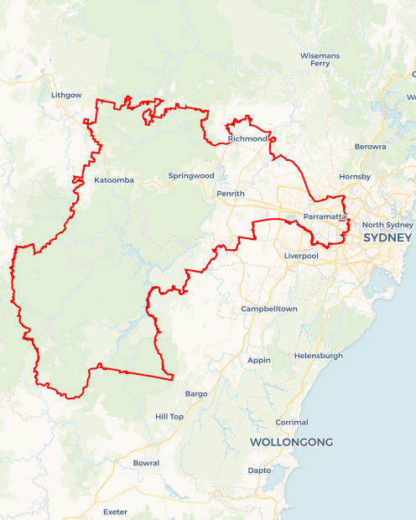Local Jobs Plan

Sydney Greater West Employment Region | NSW | ****April 2024****

Workforce Australia Local Jobs (Local Jobs) is a program that supports tailored approaches to accelerate   
reskilling, upskilling and employment pathways in response to current and emerging local workforce needs.

## Local Jobs elements

### Local Jobs Plan

The Local Jobs Plan sets out the skills and employment challenges and priorities of the region, and associated strategies that will drive the design and implementation of activities to be implemented to address these challenges.

### Employment Facilitators

Employment Facilitators and Support Officers support the delivery of the program by bringing together key stakeholders including businesses, employment services providers, higher education and training organisations.

### Local Jobs and Skills Taskforce

Each Employment Region has its own Taskforce. Representatives include local stakeholders who have demonstrated experience in upskilling, reskilling, and an ability to represent, connect and collaborate with others in the region to meet labour market needs.

### Local Recovery and National Priority Funds

The Local Recovery Fund supports projects that meet the priorities identified in the Local Jobs Plan. The National Priority Fund provides funding for innovative local solutions to address structural barriers to employment.

Explore labour market insights for the  
[Sydney Greater West](https://www.jobsandskills.gov.au/work/employment-region-dashboards-and-profiles/monthly-labour-market-dashboards) Employment Region

## Local labour market challenges in the region

* Supporting the changing nature of employment opportunities across a region that incorporates an ‘established city’ versus an ‘establishing city’ (namely Bradfield City/Western Sydney Aerotropolis: $1.15 billion,   
  100-hectare advanced manufacturing capital of Australia).
* Known and predicted skills gaps in high-value sectors characterised by projected growth, including construction, advanced manufacturing, professional, scientific and technical services, health care, and tertiary education.
* While 52% of vacancies recorded in January 2024 required an individual to have a bachelor's degree or higher qualification, significant demand still exists for entry-level and skilled workers in growth employment areas such as transport and logistics, construction, health care, professional services, and manufacturing.
* Increasing demand for individuals to possess digital skills, written English language competency and numeracy skills, often hinder eligibility for job opportunities.
* Exceptional communication, social, and collaborative skills are crucial for today's workforce. Employers prioritise candidates who possess these qualities to meet their ever evolving needs.
* The region has a diverse caseload of vulnerable individuals comprising youth, migrants, Culturally and Linguistically Diverse (CaLD) individuals, Indigenous Australians, parents returning to work, mature aged workers, and long-term unemployed people.
* Individuals who are long-term unemployed often face additional challenges that contribute to difficulties in finding and securing sustainable employment. Commonly reported challenges for these cohorts include: mental health, digital literacy and equity, limited work experience or Australian-based experience, ex-offender history, requiring part-time or non-standard work hours, recognition of prior learning of overseas qualifications, lack of transportation, limited understanding of available career opportunities.

## Local jobs and skills priorities and strategies in the region

### Priority 1 – Targeted cohort-specific strategies that upskill and prepare CaLD and migrant individuals, Indigenous Australians and/or the long term unemployed

#### What are our challenges and opportunities?

With a plethora of employment opportunities in in-demand industries across the region, there is an opportunity to connect individuals in areas with high rates of unemployment to both entry-level opportunities and positions that require prior qualifications or training obtainable through Vocational Education and Training (VET) pathways. Specifically, the following SA2 areas (as defined by the Australian Bureau of Statistics); Bidwill – Hebersham – Emerton, Lethbridge Park – Tregear, Fairfield – East, Guilford – South Granville, Mount Druitt – Whalan, and St Marys – North St Marys. In addition, today’s employment market recruitment practices tend to be employer-centric, leading to lengthy and complicated application processes, inflexible work arrangements, and insufficient support for diverse individuals.  
**How are we responding?**

The Sydney Greater West Local Jobs team works closely with local key stakeholders to influence, support and deliver strategies that support the region’s CaLD migrant and refugee individuals, Indigenous Australians, and those who are long-term unemployed, through:

* Working with businesses to understand this cohort’s potential and how to proactively support the employment of CaLD and/or migrant, First Nations Australians and or long term unemployed individuals in their business.
* Promoting employment opportunities that build on-the-job skills such as apprenticeships and traineeships (including school-based), and entry-level jobs that build employability skills to the services that support individuals in the focus areas.
* Working with businesses to remove exclusive recruitment practices by streamlining and simplifying application processes, reassessing application requirements for entry-level positions, delivering on-site recruitment open days and place-based interviews, and utilising employment services providers to connect with locally available candidates.
* Working with businesses to co-design pre-employment and employment pathways for entry-level roles for currently available positions that:
* Support ongoing and meaningful work and avoid roles that can be seen as tokenistic or have limited career advancement opportunities.
* Support those who have overseas qualifications and/or work experience by mapping individual career advancement that considers these within the region's context and includes re-credentialing or recognition or prior learning pathways where possible.
* Deliver industry-specific place-based training and upskilling opportunities, that are culturally sensitive and consider delivery for non-English speaking individuals.
* Include appropriate support/mentoring for these cohorts throughout their employment.
* Support individuals to build their digital proficiency, communication skills, language, literacy and numeracy capacity, and understanding of Workplace Health and Safety practices.

### Priority 2 – Addressing transport barriers to employment

#### What are our challenges and opportunities?

There are pockets in the region with limited public transport, which hinders the ability of individuals to access adjacent regions where there are employment opportunities. Limited connections appear to be more prevalent in lower socio-economic areas where lack of access to vehicles and limited driver's licence ownership exacerbates this challenge.

#### How are we responding?

The Sydney Greater West Local Jobs team works closely with local key stakeholders to develop and deliver strategies such as:

* Initiating community or private transport solutions that connect marginalised communities to local employment hubs or training opportunities, implementing models that transport individuals from one location to a place of employment or training.
* Engaging with Transport for NSW to understand future supportive infrastructure plans and advocating for improved transport connections.
* Identifying existing or implementing new programs that enable individuals to work towards obtaining their license and enhancing their driving skills.
* Supporting the establishment of new routes of transport connectivity to the Aerotropolis and surrounding infrastructure and development projects that align with construction hours of operation.
* Implementing place-based and accessible activities such as training and upskilling opportunities, careers support, aspiration events and employment drives in the areas of focus listed in Priority 1.

### Priority 3 – Creating collaboration opportunities that leverage existing resources and increase industries involvement in promoting current and future workforce needs

#### What are our challenges and opportunities?

The area boasts the third-largest economy in Australia and is set to grow with numerous infrastructure projects currently underway or planned for the future. As the region's infrastructure expands, there is a growing demand for skilled and unskilled workers to support continued economic development. However, with low unemployment rates and few job-ready workers, it is proving challenging to meet this demand. A significant portion of those considered not yet job-ready face obstacles to finding employment. To enhance job opportunities and career growth for individuals in the area, it's crucial for key stakeholders to back existing initiatives and work together to create solutions that cater to the region's high-value sectors.

#### How are we responding?

The Sydney Greater West Local Jobs team works closely with local key stakeholders to develop and deliver strategies such as:

* Building collaboration through round tables and working groups consisting of government, industry, employment services, training organisations and community to address challenges, specific cohort needs, and challenges in the labour market.
* Collaborative information sessions that highlight existing opportunities for individuals to reach their employment goals and overcome obstacles targeted for employment services, community services and training providers.
* Delivering forums that focus on businesses and industry stakeholders to highlight the advantages of hiring individuals from the Sydney Greater West Workforce Australia caseload and provide an opportunity to connect with employment services, resources and other supports available to create inclusive and diverse work environments.
* Leveraging existing hands-on ‘Try a Trade’ days, career expos, or place-based training that builds awareness and encourages individuals to consider alternative career paths with a focus on VET pathways.
* Connecting employment services providers, community groups, and schools with promotional collateral or hosting information sessions that demystify industries in demand or non-traditional career pathways.
* Exploring opportunities to tap into the transition to Net Zero and the implications this has on emerging industries and current employers in the area.

## Want to know more?

* Contact: Jamie Petschy, Sydney Greater West Employment Facilitator: [Jamie.PetschySGW@localjobsfacilitator.com.au](mailto:Jamie.PetschySGW@localjobsfacilitator.com.au)
* Visit: [Local Jobs](https://www.dewr.gov.au/local-jobs) or [Workforce Australia](https://www.workforceaustralia.gov.au/)