

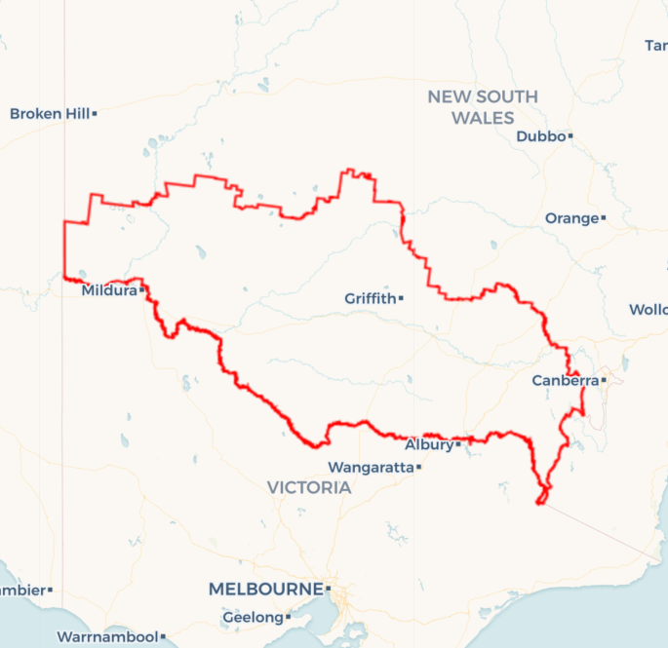Local Jobs Plan

Murray Riverina ****Employment Region**** | NSW | ****April 2023****

Workforce Australia Local Jobs (Local Jobs) is a program that supports tailored approaches to accelerate   
reskilling, upskilling and employment pathways in response to current and emerging local workforce needs.

## Local Jobs elements

### Local Jobs Plan

The Local Jobs Plan sets out the skills and employment challenges and priorities of the region, and associated strategies that will drive the design and implementation of activities to be implemented to address these challenges.

### Employment Facilitators

Employment Facilitators and Support Officers support the delivery of the program by bringing together key stakeholders including businesses, employment services providers, higher education and training organisations.

### Local Jobs and Skills Taskforce

Each Employment Region has its own Taskforce. Representatives include local stakeholders who have demonstrated experience in upskilling, reskilling, and an ability to represent, connect and collaborate with others in the region to meet labour market needs.

### Local Recovery and National Priority Funds

The Local Recovery Fund supports projects that meet the priorities identified in the Local Jobs Plan. The National Priority Fund provides funding for innovative local solutions to address structural barriers to employment.

Explore labour market insights for   
[Murray Riverina](https://www.jobsandskills.gov.au/work/employment-region-dashboards-and-profiles/monthly-labour-market-dashboards) Employment Region

## Local labour market challenges in the region

* The lack of existing skills development and pre-employment pathways into growing sectors such as manufacturing, freight and logistics, construction and health.
* Ongoing difficulty of community service organisations, in particular aged and disability care providers and the early childhood sector, to meet increasing demand for skilled workers.
* Poor communication around strategic workforce planning within major infrastructure projects, limiting the ability to effectively prepare job seekers to meet skills demand.
* Significant impacts to industries such as agriculture and hospitality due to a shortage of foreign workers, adding to difficulties for regional employers to maintain a skilled workforce.
* Job seeker disengagement remains a challenge, with 73 per cent of those commenced with an employment service provider being unemployed for more than 12 months.
* Housing affordability has become an issue, particularly for low-income earners, a result of the increase in people moving to regional areas, in addition to the convergence of a number of infrastructure projects.
* For smaller regional areas, transport is a significant barrier to workforce participation, due to limited availability of:
  + driver training and support to obtain a licence; and
  + public transport within and between regional centres across NSW.

## Local jobs and skills priorities and strategies in the region

### Priority 1 – Boost local workforce and apprenticeships

#### What are our challenges and opportunities?

Remove the skills, mental health, transport and housing related barriers preventing job seekers from accessing local employment and training opportunities and pursue initiatives in line with employment and training needs.

#### How are we responding?

* We are promoting apprenticeships programs and incentives to local industry through local business chamber, government newsletters, peak bodies and business support groups.
* In partnership with industry organisations, NSW Government, local council and education and training organisations, we are developing pathways and pipelines for engaging trainees, apprentices and local job seekers leveraging existing programs and initiatives. For example, we are promoting apprenticeship opportunities at “career days” including encouraging industry organisations to participate and present to attendees.
* We are leveraging existing programs and supports to address mental health, transport and housing barriers preventing job seekers from accessing local employment and training opportunities.

### Priority 2 – Create employment pathways into growth industries

#### What are our challenges and opportunities?

Building a job-ready and skilled workforce that meets the current and future labour demands for the health, construction, transport and logistics sectors.

Support the growth of jobs in the region’s manufacturing sector and in current and future construction projects, through stronger employment and training pathways, and the building of a job-ready and skilled workforce.

#### How are we responding?

* We are collaborating with employers to build stronger pathways to employment in the region’s manufacturing sector and construction projects, including the development of tools that provide more visibility of, and streamlined access to, local employment and training opportunities, and the development of pre-employment programs that lead to guaranteed employment for suitable participants.
* We are working closely with employers and training providers to ensure current and future workforce needs are aligned with the courses and training available to local job seekers, including considering opportunities to deliver flexible training (for example: block release and night courses).

### Priority 3 – Support migrant and refugee job seekers into training and employment

#### What are our challenges and opportunities?

Build clearer pathways to employment and training opportunities for migrant and refugee job seekers in the Employment Region and provide integrated supports to individuals over the longer term.

#### How are we responding?

* Building clearer pathways to employment and training opportunities for migrant and refugee job seekers, including understanding barriers and opportunities to increase outcomes.
* Creating stronger links between employers, migrant/refugee community leaders, employment service providers and training organisations, and ensure specific and region-wide employment and training opportunities and trends are communicated swiftly and effectively.
* Developing mentorship programs that direct a range of supports to migrant and refugee job seekers in an ongoing and integrated way.

### Priority 4 – Create opportunities for First Nations Australians

#### What are our challenges and opportunities?

Build pathways to employment and training opportunities for First Nations Australians and provide culturally appropriate (localised to Traditional Owner land) integrated supports to individuals over the longer term.

#### How are we responding?

* We are building clearer pathways to employment and training for First Nations Australians, including linking significant employment opportunities to ensure streamlined access to local employment and training opportunities.
* Working closely with employers and training providers to ensure current and future workforce needs are aligned with the courses and training available to job seekers.
* We are leveraging existing programs and develop mentorship programs that direct a range of supports to First Nations Australians in an ongoing and integrated way.
* We are supporting projects that promote First Nations Australians business capacity building.
* We are leveraging Australian and state government procurement social inclusion targets on high value projects.

## Want to know more?

* Contact: Angela Rey, Murray Riverina Employment Facilitator: angela.rey@murrayrivjobs.com.au
* Visit: [Local Jobs](https://www.dewr.gov.au/local-jobs) or [Workforce Australia](https://www.workforceaustralia.gov.au/)