

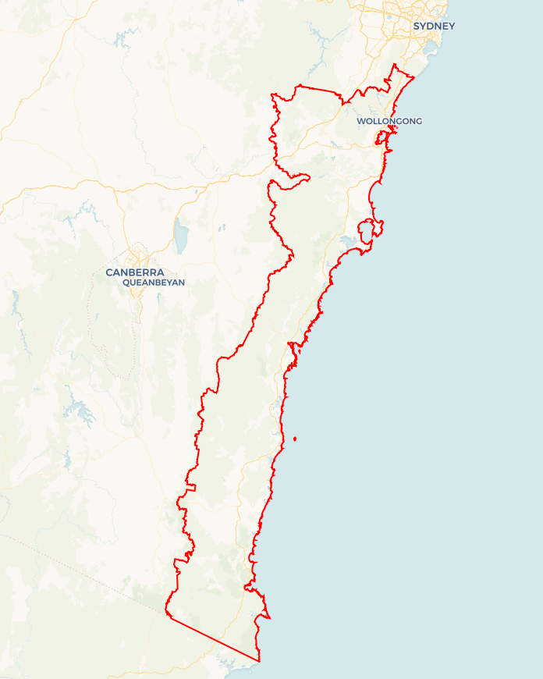Local Jobs Plan

****Illawarra South Coast**** Employment Region | NSW | ****March 2024****

Workforce Australia Local Jobs (Local Jobs) is a program that supports tailored approaches to accelerate   
reskilling, upskilling and employment pathways in response to current and emerging local workforce needs.

## Local Jobs elements

### Local Jobs Plan

The Local Jobs Plan sets out the skills and employment challenges and priorities of the region, and associated strategies that will drive the design and implementation of activities to be implemented to address these challenges.

### Employment Facilitators

Employment Facilitators and Support Officers support the delivery of the program by bringing together key stakeholders including businesses, employment services providers, higher education and training organisations.

### Local Jobs and Skills Taskforce

Each Employment Region has its own Taskforce. Representatives include local stakeholders who have demonstrated experience in upskilling, reskilling, and an ability to represent, connect and collaborate with others in the region to meet labour market needs.

### Local Recovery and National Priority Funds

The Local Recovery Fund supports projects that meet the priorities identified in the Local Jobs Plan. The National Priority Fund provides funding for innovative local solutions to address structural barriers to employment.

Explore labour market insights for the  
[Illawarra South Coast](https://www.jobsandskills.gov.au/data/employment-region-dashboards-and-profiles/monthly-labour-market-dashboards) Employment Region

## Local labour market challenges in the region

* Disengagement by young people in the 15-24 age group is a concern reflected in higher youth unemployment in the region and highlights the need for virtual engagement strategies.
* Limited public transport options in some areas and a lack of consistent learner driver support reduces pathways for young people to sustainable employment and training opportunities.
* Innovative and tailored services are required to increase outcomes for First Nations, mature aged, migrants, youth and long-term unemployed cohorts.
* More streamlined and targeted overseas skilled migration programs are needed to increase access to overseas skilled workers.
* A need for an increased focus on partnerships with businesses to support an improved understanding of the needs of a range of individual cohorts is a priority to increase successful recruitment and retention.
* Housing shortages are restricting workforce capacity across the region.
* To increase workforce capacity, innovative solutions are required to address ongoing difficulties for the care sector, in particular aged care, disability services and childcare.
* The significant growth in the defence, manufacturing, transport and logistics and clean energy industries in the move to a net zero and circular economy future in the Illawarra South Coast region will have significant future workforce needs.
* An ongoing difficulty for hospitality, tourism, and small businesses to recruit workers to meet demand with skilled chefs, bar, front of house staff, cleaners and retail staff all in short supply. The workforce demands for the marine industry will be an emerging need on the Far South Coast.
* The demand for workers is creating challenges for training providers such as Registered Training Organisations and Universities across the region and requires providers to increase linkages with industry to offer relevant flexible micro-credentials and qualifications aligned to industry need.

**Local jobs and skills priorities and strategies in the region**

### Priority 1 – Transport and driver licences

#### What are our challenges and opportunities?

The lack of public transport in the more remote parts of the region combined with inconsistent delivery of learner driver support services is reducing employment opportunities for a range of unemployed cohorts. Improved support particularly for youth, migrants, First Nations and long-term unemployed is required to successfully gain a driver’s licence and pathway to sustainable employment.

#### How are we responding?

* Utilising the Transport Working Group membership to support new Driver Mentoring L2Ps projects in the Shoalhaven and Bega Valley and working with Driver Licensing Access Program (DLAP) providers funded by Transport NSW to ensure the provision of consistent access to driver licence support across the Illawarra South Coast region.
* Utilising the Taskforce and Transport Working Group membership to advocate with Transport NSW and local NSW State members for increased access to bus services aligned to employment and skills opportunities to enable equitable access to skills and jobs.

### Priority 2 – Support education, employment and economic development for First Nations people

#### What are our challenges and opportunities?

Fostering skills and job opportunities to increase sustainable employment for First Nations people in the Illawarra South Coast region needs to be informed by effective community engagement, collaborative partnerships, innovative service delivery and project design and increased support for First Nations businesses.

#### How are we responding?

* Utilising the expertise and the commitment for collaboration of our Taskforce, working groups and key stakeholders including Workforce Australia, Regional NSW, Regional Development Australia (RDA) Illawarra Shoalhaven and Southern Inland National Indigenous Australians Agency, local First Nations communities and organisations to develop and implement innovative and culturally safe skills and employment activities to improve recruitment and retention of First Nations people.
* Working collaboratively across all of our industry focused working groups and with our key stakeholders to increase pathways to employment by utilising Local Recovery Fund activities, pre-employment, traineeship and apprenticeship and higher-level skills programs to offer tailored and integrated support including cultural mentoring programs for First Nations people.
* Supporting First Nations procurement partnerships, land management and growth of jobs by supporting First Nations businesses.

### Priority 3 – Supporting defence, manufacturing, energy, transport and logistics to move to a net zero and circular economy future

#### What are our challenges and opportunities?

The extensive growth of these industries in the Illawarra South Coast region requires a large pool of job-ready, skilled workers to successfully manage the planned project construction and business expansion phase over the next 2-5 years to ensure timely delivery of new and existing projects.

#### How are we responding?

* Continuing to build stronger links with the region’s key stakeholders including Jobs and Skills Councils, i3net, Regional NSW, RDA Illawarra Shoalhaven, RDA Southern Inland, Business Illawarra, Illawarra Shoalhaven Defence Industry Group, Bega Circulatory Centre, University of Wollongong Energy Futures Centre and TAFE Manufacturing Centre of Excellence to increase collaboration, skills and employment opportunities and minimise duplication to help build the workforce capacity of employers in the region.
* Working in partnership with working group members and industry stakeholders to develop innovative opportunities and an increased understanding of people’s needs to maximise job opportunities in these industry areas.
* Supporting strategies that increase the understanding of individuals, school students and parents of the range of job roles, skills and career pathways through increased linkages with employers in these target industries to build skills, improve outcomes and gain sustainable employment.

### Priority 4 – The care sector

#### What are our challenges and opportunities?

The care sector which includes aged care, disability and children’s services is facing ongoing challenges to access a job ready, skilled workforce to meet current and future labour demands while at the same time needing to meet extensive compliance and regulatory requirements.

#### How are we responding?

* Working with strategic partners such as the Jobs and Skills Councils, Community Industry Group, Aged and Community Care Providers Association, NSW Health, the Department of Health and Aged Care and care providers to implement new initiatives that focus on building the capacity of the care workforce.
* Utilising the Local Jobs Care Sector working group members and industry stakeholders to develop campaigns that increase career opportunities in the sector.
* Trialling innovative recruitment strategies to increase pathways for a range of cohorts to maximise job opportunities in the sector.
* Supporting strategies that increase the understanding of individuals, school students and parents of the range of job roles, skills and career pathways through increased linkages with employers in these target industries to build skills, improve outcomes and gain sustainable employment.

### Priority 5 – Hospitality, tourism and small business

#### What are our challenges and opportunities?

This sector has experienced considerable difficulties over several years and is currently experiencing major skilled labour shortages reducing the ability of hospitality, tourism, accommodation, small business including the marine industry to deliver services, maintain financial viability and manage the challenges of seasonality and the effect of cost-of-living pressures.

#### How are we responding?

* Working collaboratively with employers, working group members and key industry stakeholders including Jobs and Skills Council, the Shoalhaven Food Network, Destination NSW Sydney Surround South, Sister Ship Training, chambers of commerce and industry stakeholders to raise awareness of employment opportunities, trial innovative recruitment strategies and seek to build the profile of the sector as a desirable career choice for a range of cohorts.

### Priority 6 – Collaborative jobs and skills activities aligned to regional economic and infrastructure development and workforce needs.

#### What are our challenges and opportunities?

The Illawarra South Coast region includes a range of key stakeholders including the industry peak bodies, Jobs and Skills Council, local councils, Regional NSW, Regional Development Australia, Business Illawarra, chambers of commerce, the University of Wollongong, TAFE NSW and private training providers that can benefit from working collaboratively to ensure skills and employment strategies align with the region’s economic and workforce needs.

#### How are we responding?

* Work collaboratively with the region’s key stakeholder representatives to develop regular two-way sharing of key information about economic development and the large infrastructure and workforce capacity projects that will be implemented in the region to inform skills and employment projects to reduce duplication of resources and maximise outcomes for the Illawarra South Coast region.
* Working with Training Services NSW, Workforce Australia employment service providers, Australian Apprenticeship Support Centres, group training, training providers and schools to ensure school leaver pathways, pre-employment programs, traineeship and apprenticeship programs and higher-level skills align with the needs of current and emerging industries.
* Support strategies that increase the understanding of individuals, school students and parents of the range of job roles, skills and career pathways through increased linkages with employers in our target industries to build skills, improve outcomes and gain sustainable employment.

#### Want to know more?

* Contact: Sandra Gray, Illawarra South Coast Employment Facilitator: [sandra.gray@illawarrasouthcoastemployment.com.au](mailto:sandra.gray@illawarrasouthcoastemployment.com.au).
* Visit: [Local Jobs](https://www.dewr.gov.au/local-jobs) or [Workforce Australia](https://www.workforceaustralia.gov.au/)