

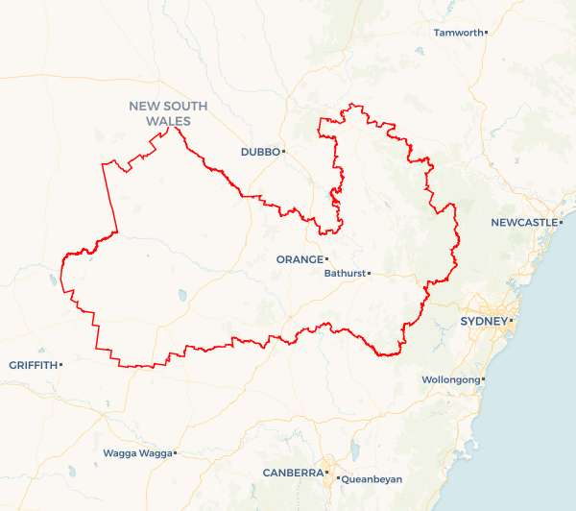Local Jobs Plan

Central West ****Employment Region**** | NSW | ****July 2023****

Workforce Australia Local Jobs (Local Jobs) is a program that supports tailored approaches to accelerate   
reskilling, upskilling and employment pathways in response to current and emerging local workforce needs.

## Local Jobs elements

### Local Jobs Plan

The Local Jobs Plan sets out the skills and employment challenges and priorities of the region, and associated strategies that will drive the design and implementation of activities to be implemented to address these challenges.

### Employment Facilitators

Employment Facilitators and Support Officers support the delivery of the program by bringing together key stakeholders including businesses, employment services providers, higher education and training organisations.

### Local Jobs and Skills Taskforce

Each Employment Region has its own Taskforce. Representatives include local stakeholders who have demonstrated experience in upskilling, reskilling, and an ability to represent, connect and collaborate with others in the region to meet labour market needs.

### Local Recovery and National Priority Funds

The Local Recovery Fund supports projects that meet the priorities identified in the Local Jobs Plan. The National Priority Fund provides funding for innovative local solutions to address structural barriers to employment.

Explore labour market insights for   
[Central West](https://www.jobsandskills.gov.au/work/employment-region-dashboards-and-profiles/monthly-labour-market-dashboards) Employment Region

## Local labour market challenges in the region

* Shortage of qualified skilled and unskilled workers to fill current job vacancies in industries with high workforce demand, such as aged and disability care, tourism and hospitality, construction, retail, engineering, and seasonal agriculture. This has been exacerbated by historically low unemployment levels across the region.
* Difficulties with attracting skilled workers into smaller towns, especially for infrastructure, construction, and mining projects. There is estimated to be around 63,600 full time jobs required to deliver the major capital projects planned over the next five years (Central West and Orana). This issue will be exacerbated by a shortfall of affordable housing needed to support the growing population.
* Preparing those working in emissions-intensive sectors for new employment opportunities as a result of the transition to the Net Zero economy particularly in the Lithgow and Mudgee regions
* Shortage of accommodation due to low housing stock, and a competitive housing market, particularly for workers who are required to relocate to take up employment opportunities.
* High proportion of Indigenous Australians, reflecting the cohort's relative concentration within the region's larger population. This cohort experiences high labour market disadvantage and overrepresentation as long-term registered participants in the Workforce Australia Employment Services caseload.
* Overrepresentation in the Workforce Australia Employment Services caseload of other cohorts – people with a disability, mature aged, and youth who experience labour market challenges such as a lack of workplace experience or underdeveloped soft skills.
* Accessibility to transport links within and between Local Government Areas where employment opportunities are clustered. Necessity of having a licence and a car.
* Poor awareness and access to delivery mechanisms for the range of available skills training and employment support options available to job seekers and employers in the region.

## Local jobs and skills priorities and strategies in the region

### Priority 1 – Meet local business recruitment needs

#### What are our challenges and opportunities?

Effectively meeting the recruitment needs of employers in the ER by ensuring strong avenues to training, upskilling, reskilling, and employment are made available, including in the transition to the Net Zero economy, in a period of historically low unemployment and strong demand for labour.

#### How are we responding?

* We are facilitating engagement and connection between stakeholders, including but not limited to, Employment Service Providers, industry representatives, training providers, business owners and Training Services NSW across the region to support effective solutions to labour shortages.
* We are identifying industries and roles experiencing skills shortages/recruitment difficulties and the core entry level skills required for those roles.
* By identifying Net Zero aligned industries along with roles that will be impacted in the transition to the Net Zero economy, and facilitating linkages between industry representatives, training providers, business owners and Training Services NSW to ensure upskilling and reskilling opportunities are accessible, and transferrable skills are aligned to new or existing workforce opportunities.
* By collaborating with Registered Training Organisations (RTOs), Employment Service Providers and government partnerships to develop targeted pre-employment training and work placements to support sustainable employment, promoting apprenticeships and traineeships as a key employment strategy to grow a skilled workforce and collaborating with Employment Service Providers to develop work ready skills for the long term unemployed.
* We are promoting initiatives to support individuals to relocate, where appropriate, to take up employment opportunities.

### Priority 2 – Leverage infrastructure and development projects

#### What are our challenges and opportunities?

Effectively meeting the recruitment needs and diversity targets of businesses delivering major infrastructure and development projects in the region, including projects fast-tracked by governments as part of economic recovery measures and the transition to the Net Zero economy.

#### How are we responding?

* We are supporting organisations and government agencies leading current and pending infrastructure and development projects to assist with recruitment needs, required skills and timelines.
* We are facilitating engagement and connection between stakeholders, including but not limited to RTOs and government partnerships to:
* target pre-employment training and work placements to support sustainable employment
* provide linkages between industry representatives, training providers, Employment Service Providers, business owners and Training Services NSW to ensure skills are aligned to new industries, development, and infrastructure projects in the Net Zero economy
* promote apprenticeships and traineeships as a key employment strategy to grow a skilled workforce
* collaborate with Employment Service Providers to develop work ready skills for the long term unemployed
* identify and leverage government initiatives to support business growth
* promote initiatives to support individuals to relocate, where appropriate for individuals, to take up employment opportunities.

### Priority 3 – Indigenous Australians in employment services

#### What are our challenges and opportunities?

#### Facilitating pathways for Indigenous Australians in employment services to build required skills and move into available employment opportunities.

#### How are we responding?

* We are collaborating with the Indigenous community to support sustainable employment strategies, including connection to mob and country.
* Facilitating and supporting promotional campaigns targeting local businesses to highlight the benefits of workforce diversity and the range of available resources to support the recruitment and retention of Indigenous Australians seeking employment.
* Collaborating with RTOs, Employment Service Providers, Indigenous stakeholders and government partnerships to develop targeted, culturally safe pre-employment training and work placements to support sustainable employment and promote apprenticeships and traineeships as a key employment strategy to grow a skilled workforce.

### Priority 4 – Support other priority cohorts

#### What are our challenges and opportunities?

Facilitating pathways for youth, mature aged, people with a disability, the long term unemployed and those wanting to return to the workforce, to build required skills and move into available employment opportunities.

#### How are we responding?

* We are facilitating engagement and connection between stakeholders, including but not limited to, Employment Service Providers, industry representatives, training providers, business owners and Training Services NSW across the Employment Region to support labour shortages.
* Identifying industries and roles experiencing skills shortages/recruitment difficulties and the core entry level skills required for those roles.
* Collaborating with RTOs, Employment Service Providers and government partnerships to develop targeted pre-employment training and work placements to support sustainable employment.
* Promoting apprenticeships and traineeships as a key employment strategy to grow a skilled workforce.
* Collaborating with Employment Service Providers to develop work ready skills for the long term unemployed.
* Promote initiatives to support individuals to relocate, where appropriate, to take up employment opportunities.

### Priority 5 – Transport and housing

#### What are our challenges and opportunities?

Assisting to reduce transport and housing related barriers preventing Individuals from accessing employment and training opportunities.

#### How are we responding?

* We are facilitating and supporting utilisation of available funding and resources to support individuals to gain drivers licences in response to employment opportunities.
* Encouraging and facilitating usage of funding opportunities to support transport and housing initiatives.
* Working with employers and stakeholders to incorporate transport support options when designing targeted employment programs.
* Identifying and sharing best practice solutions that seek to solve transport and housing issues.
* Working with existing housing networks to provide intel and promote opportunities.

## Want to know more?

* Contact: Anthony Dawson, Central West Employment Facilitator: [facilitator@localjobscw.com.au](mailto:facilitator@localjobscw.com.au)
* Visit: [Local Jobs](https://www.dewr.gov.au/local-jobs) or [Workforce Australia](https://www.workforceaustralia.gov.au/)