

Local Jobs Plan

Far West Orana (inc. Broken Hill) ****Employment Region**** | NSW | ****July 2024****

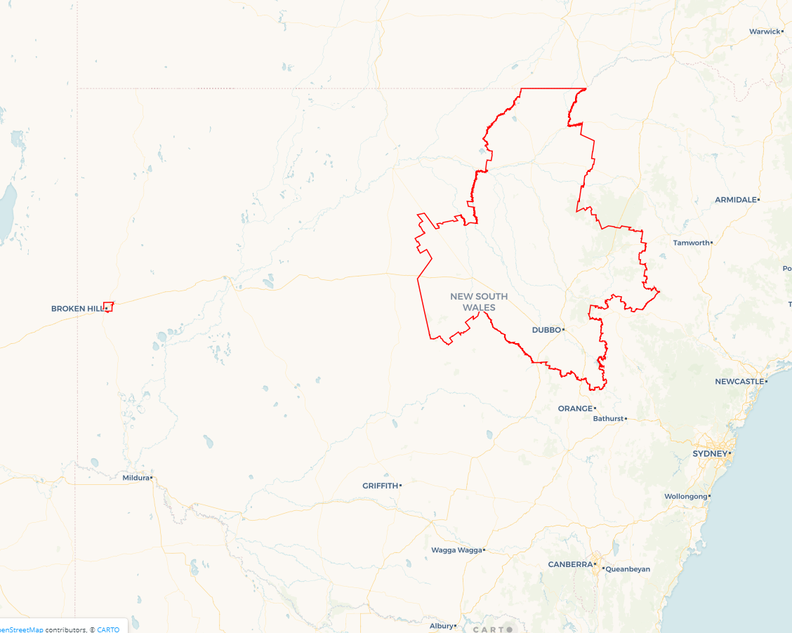Workforce Australia Local Jobs (Local Jobs) is a program that supports tailored approaches to accelerate   
reskilling, upskilling and employment pathways in response to current and emerging local workforce needs.

## Local Jobs elements

### Local Jobs Plan

The Local Jobs Plan sets out the skills and employment challenges and priorities of the region, and associated strategies that will drive the design and implementation of activities to be implemented to address these challenges.

### Employment Facilitators

Employment Facilitators and Support Officers support the delivery of the program by bringing together key stakeholders including businesses, employment services providers, higher education and training organisations.

### Local Jobs and Skills Taskforce

Each Employment Region has its own Taskforce. Representatives include local stakeholders who have demonstrated experience in upskilling, reskilling, and an ability to represent, connect and collaborate with others in the region to meet labour market needs.

### Local Recovery and National Priority Funds

The Local Recovery Fund supports projects that meet the priorities identified in the Local Jobs Plan. The National Priority Fund provides funding for innovative local solutions to address structural barriers to employment.

Explore labour market insights for the  
[Far West Orana (includes Broken Hill)](https://www.jobsandskills.gov.au/work/employment-region-dashboards-and-profiles/monthly-labour-market-dashboards) Employment Region

Explore labour market insights for   
[[Far](https://labourmarketinsights.gov.au/regions/employment-regions/) West Orana (inc. Broken Hill)] Employment Region

## Local labour market challenges in the region

* Limited public and accessible transport options
* Chronic housing shortage across all local government areas (LGAs)
* A considerable number of people engaging with employment services identify as being First Nations or young First Nations people
* High reliance on seasonal work and workers due to predominance of agricultural and agribusinesses in the region
* Critical lack of childcare across most LGAs, combined with workforce retention challenges
* Limited access to local tertiary education and vocational training opportunities – particularly face to face delivery of training in regional, rural and remote locations – identified as critical to engagement and success of individuals
* Low levels of English literacy and comprehension, numeracy and digital literacy can hinder job readiness, training success and access to employment opportunities
* Underemployment and underutilisation of workers

## Local jobs and skills priorities and strategies in the region

### Priority 1 – Infrastructure Projects

#### What are our challenges and opportunities?

We need to develop industry-led and employer focused training and employment initiatives for the multitude of current and projected regional infrastructure projects.

#### How are we responding?

* We’re building stronger pathways to employment in the region through the identification of intervention points. We’re developing a regional register of current, pending, and potential infrastructure and development projects to identify recruitment needs, required skills and timelines to guide local participants into jobs.
* Mapping existing federal, state and local government resources to ensure training and employment opportunities are leveraged, to the fullest extent, locally.
* Developing innovative and agile training, reskilling, upskilling and work experience projects including, where appropriate, the facilitation of micro-credential courses, graduate certificates and employer focused traineeships, apprenticeships and internships.
* Liaising with employers to (a) identify the range of entry levels to jobs and promote the consideration of hiring participants with partial qualifications, who can then learn practical experience and develop their qualifications while employed and, (b) identify opportunities for cross collaboration with like employers to develop entry level and training opportunities, with a focus on building regional capacity through local employment.
* Encouraging collaboration between employers and potential mentors who can assist employers strategise and develop employment solutions through a longer-term lens.

### Priority 2 – First Nations participants

#### What are our challenges and opportunities?

#### We need to support equitable access to the local labour market for First Nations participants by building clearer pathways to employment and training opportunities.

#### How are we responding?

* We are working with Aboriginal Assemblies, Local Aboriginal Lands Councils and Elders in the community to create meaningful employment opportunities in areas that have significance for First Nations people.
* Ensuring educational resources and cultural guidance are provided to assist businesses and employers in their recruitment and onboarding processes.
* Creating local registers of (a) potential projects, including projects that have identified workforce diversity goals and, (b) government, education, health, and youth services that can be used as employment supports.
* Identifying projects with a focus on First Nations participants for training and employment.
* Promoting training, upskilling, workforce diversity and the range of government resources available to support recruitment and participant retention.
* Promoting education, training and employment programs and leverage local partnerships with Charles Sturt University, TAFE NSW, and registered training organisations (RTOs) to provide formal education and training opportunities to geographically dispersed towns in the region, coupled with cultural awareness programs for maximum efficacy. This includes working with First Nations training organisations to provide services in the community.
* Working with First Nations education and training organisations to create sustainable, ongoing employment models and opportunities in the region.

### Priority 3 – Health Care and Social Assistance

#### What are our challenges and opportunities?

We need to promote Australian Government initiatives and leverage key partnerships to facilitate reskilling and upskilling of participants into Health Care and Social Assistance sectors to build a job-ready skilled workforce.

#### How are we responding?

* We are working with government programs, government business development and workforce strategy personnel, and local employers to increase visibility of employment options within the sector and provide training pathways and employment opportunities for participants.
* Working with education and training organisations to ensure there are suitable and attractive options for participants to upskill or reskill to meet industry needs. This includes, where appropriate, the facilitation of micro-credential courses, graduate certificates and industry-led traineeships, apprenticeships, and internships.
* Generating awareness for (a) participants to explore multiple career pathways in this sector, not limited by perceptions of roles being confined to hygiene or personal care and focussing on the diversity of roles, including administrative, operational, or preparatory duties, and (b) youth in the career pathways presented in the sector, linking employment with traineeships, apprenticeships, and internship opportunities to showcase the jobs and careers on offer.
* Holding government and industry-led education sessions for sole traders and start-ups to develop business and local employment options within the care, health, and community services space.

### Priority 4 – Agriculture

#### What are our challenges and opportunities?

We need to facilitate job opportunities within the agriculture sector by connecting local projects, training, and employment pipelines to participants.

#### How are we responding?

* We are exploring opportunities to integrate Agribusinesses with localised infrastructure projects, such as transportation and logistics chains, to boost employment options locally.
* Identifying (a) potential projects and create a workforce map of seasonal labour market needs and, (b) government funding opportunities, including grant options for local businesses.
* Facilitating partnerships with local RTOs, educational institutions, and other training organisations to upskill and train the local labour force, and to investigate and identify transferrable skill sets that can be brought from other sectors into Agriculture.
* Holding government and industry-led education sessions to inform local participants of the various types of work and career pathways offered in the agriculture industry.

### Priority 5 – Youth

#### What are our challenges and opportunities?

We need to develop and implement local strategies to support youth to connect with education and training linked to local employment opportunities.

#### How are we responding?

* We are creating a register of locally available youth services, programs, and initiatives to inform and design potential education, training, and employment pathways.
* Building stronger partnerships between schools, employers, and training organisations to ensure regional specific employment and training opportunities are communicated to students in a timely manner. This includes the facilitation of work placement opportunities within identified local industries.
* Utilising youth support services and First Nations organisations to assist in mentorship programs to help steer youth into sustainable employment pathways.
* Holding industry-led career/education sessions for youth to highlight industry specific career options and link available jobs to young participants.

### Priority 6 – Retail, Hospitality and Tourism

#### What are our challenges and opportunities?

We need to develop industry-led and employer focused training and employment initiatives to decrease severe labour shortages.

#### How are we responding?

* We are exploring opportunities to connect tourism, hospitality, and retail sectors for mutual collaboration around regional events of significance, to meet the demand from anticipated population and workforce increases across the region to 2025, to boost employment options locally.
* Identifying an annual calendar of events in the Region and creating a workforce map of associated labour market needs (e.g. Mundi Mundi Bash in Broken Hill).
* Identifying government funding opportunities for initiatives in the sectors, including grant options for local businesses and explore current and anticipated impediments to attracting potential employees to these sectors.
* Facilitating partnerships with local RTOs, educational institutions, and other training organisations to upskill and train the local labour force, and to investigate and identify opportunities to market roles in the three sectors.
* Holding government and industry-led education sessions to inform local participants of the various types of work and career pathways offered in the tourism, hospitality, and retail sectors.

## Want to know more?

* Contact: Bronwyn Pearson, Far West Orana (inc. Broken Hill) Employment Facilitator: [ef@farwestoranaljp.com](mailto:ef@farwestoranaljp.com) or Visit: [Local Jobs](https://www.dewr.gov.au/local-jobs) or [Workforce Australia](https://www.workforceaustralia.gov.au/)