

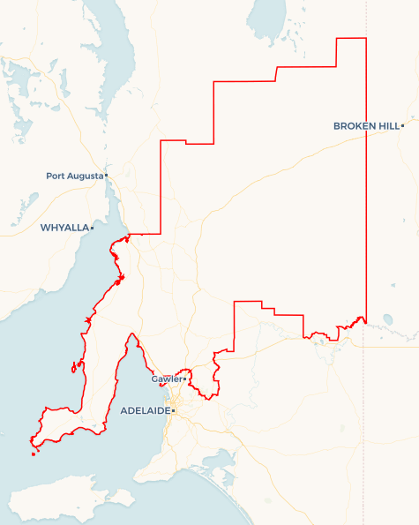Local Jobs Plan

Mid North SA ****Employment Region**** | SA | ****January 2023****

Workforce Australia Local Jobs (Local Jobs) is a program that supports tailored approaches to accelerate   
reskilling, upskilling and employment pathways in response to current and emerging local workforce needs.

## Local Jobs elements

### Local Jobs Plan

The Local Jobs Plan sets out the skills and employment challenges and priorities of the region, and associated strategies that will drive the design and implementation of activities to be implemented to address these challenges.

### Employment Facilitators

Employment Facilitators and Support Officers support the delivery of the program by bringing together key stakeholders including businesses, employment services providers, higher education and training organisations.

### Local Jobs and Skills Taskforce

Each Employment Region has its own Taskforce. Representatives include local stakeholders who have demonstrated experience in upskilling, reskilling, and an ability to represent, connect and collaborate with others in the region to meet labour market needs.

### Local Recovery and National Priority Funds

The Local Recovery Fund supports projects that meet the priorities identified in the Local Jobs Plan. The National Priority Fund provides funding for innovative local solutions to address structural barriers to employment.

Explore labour market insights for the   
[Mid North SA](https://www.jobsandskills.gov.au/work/employment-region-dashboards-and-profiles/monthly-labour-market-dashboards) Employment Region

## Local labour market challenges in the region

* Parts of the region face high levels of socio-economic disadvantage, including historically high unemployment levels, intergenerational unemployment, and high proportions of jobless families.
* Access to private and public transport and support for individuals to gain a driver’s licence.
* Low levels of VET uptake and completion rates and the need for locally-based trainers and training providers aligned to industry skill needs.
* Older population profile and ageing workforce presents opportunities to explore how to attract and retain mature aged people and their skills to address workforce shortages.
* Significant investment pipeline in renewables, resources and construction and unmet demand for entry level roles in health, aged and disability care, hospitality, and retail.
* Untapped labour market potential due to high levels of youth unemployment, part-time and casual work, and people not in the labour force.

## Local jobs and skills priorities and strategies in the region

### Priority 1 – Maximise opportunities for local jobs to be filled by local job seekers, ensuring individuals are adequately skilled and supported to take-up employment opportunities including traineeships and apprenticeships

#### What are our challenges and opportunities?

Parts of the region experience high levels of disadvantage including entrenched unemployment and high levels of socio-economic disadvantage. The barriers faced by individuals include work readiness, fitness for work, transport/driver’s licences, and child care.

#### How are we responding?

* Ensuring local employment initiatives include work readiness skills such as life skills, work hardening, work experience and work exposure activities.
* Supporting individuals to tap into the hidden jobs market, including increasing awareness of local employers, job opportunities and career pathways.
* Supporting individuals to identify their qualities and sell themselves to employers.
* Focusing on addressing non-vocational barriers to employment such as drug and alcohol, fitness for work, transport, and child care access.
* Identifying opportunities to engage with people not in the labour market and untapped labour potential within the region.
* Identifying initiatives that will encourage and motivate employers to prioritise employment of local people. Examples include meet the employer events, development of a care and support sector employment guide, support for the approval of a new Certificate II in Resources and Infrastructure traineeship, and a promotional campaign for the hospitality sector.

### Priority 2 – Maximise opportunities for partnerships between Australian and South Australian governments to create pathways into growth and emerging industries and prepare for future of work changes

#### What are our challenges and opportunities?

The region has a significant investment pipeline including a range of new and emerging projects such as renewable energy, and significant demand in existing industries such as health care and social assistance, education and training, construction, and heavy industry. Workforce responses have historically been reactive, with more focus needed on planning and long-term solutions to address long-term challenges, such as intergenerational unemployment and jobless families, and the decrease in VET uptake and completion rates.

#### How are we responding?

* Working alongside regional bodies such as Regional Development Australia and local government to support workforce needs of major projects and industry developments and maximise local employment.
* Identifying current and emerging occupations and skills in demand, to better align local training, education, and employment initiatives with industry needs.
* Providing intel and ideas to government and other organisations to address structural challenges impacting local workforce, employment and skilling outcomes.
* Proactively developing of a jobs and skills hub concept paper and a care and support sector careers hub concept paper for consideration by the South Australian Government, including quarterly meetings with the South Australian Skills Commissioner.
* Supporting the development of an Upper Spencer Gulf workforce strategy and Upper Spencer Gulf skilling blueprint in mining and resource processing.

### Priority 3 – Support young people to gain employment, addressing specific barriers to employment in the region, such as licences and transportation and other non-vocational barriers

#### What are our challenges and opportunities?

Driver’s licences and a lack of transport within and between towns is one of the most prevalent barriers that prevent young people from gaining employment, yet there are only a small number of programs operating in parts of the Mid North that aim to address this. Part-time and casual employment in young people is high, with more focus needed on supporting people into full-time employment which is hindered by a lack of independent, quality career education and guidance.

#### How are we responding?

* Exploring non-traditional methods of engagement that align to the aspirations and interests of young people.
* Supporting initiatives that seek to address under-employment in young people and increase their ability to secure full-time employment.
* Supporting initiatives that improve access to quality career education and guidance.
* Empowering young people to have a voice and co-design solutions that help increase participation in learning and earning activities.
* Establishing a Taskforce sub-committee focussed on transport and driver’s licences.

### Priority 4 – Support older job seekers including support for reskilling and changing industries

#### What are our challenges and opportunities?

The region has an older population profile and ageing workforce, with the Yorke Peninsula having a significant portion of the population aged over 55. Many older people are not in the labour force and therefore not connected to support to explore work options. There is also an opportunity to support businesses to improve conditions and flexibility to accommodate older workers.

#### How are we responding?

* Identifying barriers that prevent older workers from fully participating in the labour market and developing solutions that will address these barriers.
* Increasing access to adult and community education programs, including support to increase digital and technical capability.
* Identifying underutilised people within the community such as retired, semi-retired, underemployed and volunteers as a potential labour pool.
* Establishing the Lifestyle Jobs Yorke Peninsula to provide a platform to unlock the hidden workforce potential of mature-aged people in the Yorke Peninsula.

**Priority 5 – Support employers and industry in upskilling existing employees to increase capacity and to open opportunities for entry-level jobs for jobseekers**

#### What are our challenges and opportunities?

Workforce shortages include entry level, skilled, trade and professional level roles. Attracting people to the region for work has been challenging due to a lack of housing therefore growing the local workforce is critical. Navigating government programs, services and funding can be challenging, particularly for small and medium sized businesses with limited HR capacity.

#### How are we responding?

* Educating businesses on support available such as government programs, services and funding and better local promotion of support for business.
* Developing bespoke opportunities in partnership with business and industry that reflect the unique needs of employers and the region.
* Developing leadership and mentoring capability in industry to better support entry level workers entering the workforce.
* Sharing personnel, resources, and specialists across the region/industry/business for shared local benefit.
* Supporting local businesses to secure funding from the South Australian Government to upskill existing employers.
* Supporting the Resources and Skills Alliance in establishing Australia’s first higher education traineeship pathway which promotes career development in associate engineer roles.

### Priority 6 – Support the development of local organisations to increase their capability to respond to current and emerging employment, skills and workforce needs of the region

#### What are our challenges and opportunities?

There are a small number of locally-based training providers and industry bodies within the region, and limited capacity within existing organisations to deliver both short- and longer-term solutions to address regional employment and training needs. Attracting organisations from outside of the region is often difficult due to challenges delivering in thin, regional markets.

#### How are we responding?

* Developing more qualified trainers in the region to increase access to quality, industry-relevant training.
* Maximising the use of local training facilities and identifying gaps in local infrastructure and delivery to ensure access to high quality, locally based training.
* Supporting organisations to understand and access government programs, services, and funding.
* Supporting small organisations and businesses to ensure they can maximise their involvement in local workforce initiatives and solutions.

## Want to know more?

* Contact: Lisa Brock, Mid North SA Employment Facilitator: [lisa@usgemployment.com.au](mailto:lisa@usgemployment.com.au)
* Visit: [Local Jobs](https://www.dewr.gov.au/local-jobs) or [Workforce Australia](https://www.workforceaustralia.gov.au/)