TRIM Ref: 17/10/25/6431

25 October 2017

Mr Matthew O’Callaghan

Department of Employment

CANBERRA ACT

**By Email:**  [greenfieldsreview@employment.gov.au](mailto:greenfieldsreview@employment.gov.au)

Dear Mr O’Callaghan

# Greenfields Agreements Review

Please be advised that the Maritime Union of Australia hereby adopts the submissions of the Construction, Forestry, Mining and Energy Union and the Australian Council of Trade Unions.

Should you have any queries regarding this matter please do not hesitate to contact National Legal Director Aaron Neal in the Union’s National Office.

Yours faithfully

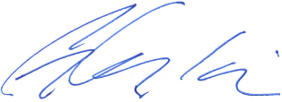

**Padraig Crumlin**

**National Secretary**

**The Maritime Union of Australia**