|  |  |
| --- | --- |
|  | Fair Work Commission logo |

Greenfields Agreements Review

# Introduction

1. This document has been prepared in response to a request for information to assist the independent review of Part 5 of Schedule 1 of the *Fair Work Amendment Act 2015.*
2. The Commission is Australia's national workplace relations tribunal. It is an independent body with powers to carry out a range of functions, including:

* providing a safety net of minimum conditions, including minimum wages in awards;
* facilitating good faith bargaining and approving enterprise agreements;
* dealing with applications in relation to unfair dismissal;
* regulating how industrial action is taken;
* resolving a range of collective and individual workplace disputes through conciliation, mediation and in some cases public tribunal hearings; and
* functions in connection with workplace determinations, equal remuneration, transfer of business, general workplace protections, right of entry and stand down.

1. The work of the Commission is carried out by Commission Members, overseen by the President and supported by administrative staff, in accordance with the *Fair Work Act* 2009 (FW Act).
2. The Commission’s role is to administer its jurisdiction in accordance with the FW Act. It does not enter into the legal policy debate other than to point out where technical changes may make administration of the law simpler.
3. Accordingly, the Commission makes no comment in relation to the questions which have been posed by the Background Paper for the Inquiry. Many of the questions go directly to questions of policy. However, the Commission will assist the enquiry by providing current data in relation to agreement numbers and timeliness associated with the approval of an agreement.

# Undertakings

1. Before turning to the statistics it is important to say something about the role of undertakings in the agreement approval process. Where the Commission has a concern that an enterprise agreement does not meet the approval requirements in ss.186 and 187 of the FW Act (which include the BOOT), it can approve the agreement if it accepts a written undertaking from one or more employers covered by the agreement which meets that concern. An undertaking is not used where the undertaking would result in substantial changes to the agreement but may be accepted to address a potential situation where particular circumstances may mean an individual or class of employees may not otherwise be better off overall under the agreement.
2. Before accepting such an undertaking, the Commission must:

* seek the views of each known bargaining representative for the agreement; and
* be satisfied that the effect of accepting the undertaking is not likely to cause financial detriment to any employee covered by the agreement, or result in substantial changes to the agreement.

1. An undertaking relating to an enterprise agreement must be signed by each employer who gives the undertaking. If an undertaking is accepted, the undertaking is taken to be a term of the agreement. The undertaking is both noted in the decision and forms part of the agreement which is published on the Commission’s website.
2. A Commission Member may accept undertakings that provide for an audit or reconciliation of employees’ earnings under the agreement compared to what their earnings would have been under the relevant modern award. Such an undertaking must specify that reconciliations will be carried out in a timely manner and if a shortfall is identified, the requirement for the employer to compensate the employee must be enforceable. Further, as confirmed by the Full Court of the Federal Court in *Shop Distributive & Allied Employees Association v ALDI Foods Pty Ltd* ([2016] FCAFC 161), the compensation cannot merely equal the amount an employee would have been entitled to under the award; it must ensure they are better off.
3. The following table shows the number of greenfields agreements that have required undertakings to be provided.

**Table 1: Greenfields agreement approvals from 2012-13 to 2016-17**

|  |  |  |
| --- | --- | --- |
| **Year** | **Greenfields agreements approved** | **Greenfields agreements approved with undertakings** |
| 2012-13 | 685 | 111 (16%) |
| 2013-14 | 745 | 113 (15%) |
| 2014-15 | 399 | 47 (12%) |
| 2015-16 | 252 | 31 (12%) |
| 2016-17 | 162 | 29 (18%) |
| Total | 2243 | 331 |

1. The following chart shows the total number of greenfields agreements approved (s.186), approved with undertakings (s.190) and not approved for the period 2012-13 to 2016-17.

**Chart 1: Greenfields agreement approval applications finalised 2012-13 to 2016-17**

# Agreement Triage Pilot

1. Until October 2014 all enterprise agreement approval applications were allocated directly to Commission Members to deal with and determine as they deemed appropriate. Some specialist administrative support was available to Members, for example, to provide some analysis regarding the BOOT. Members sought this assistance in approximately 5 per cent of applications.
2. In October 2014 the Commission piloted an ‘agreement triage process’ to promote greater consistency and improve timeliness in enterprise agreement approval decisions. The triage process involves a team of legally qualified staff conducting a comprehensive analysis of agreements lodged for approval. This analysis assists the Commission Member dealing with the application, in making their decision under the FW Act. At all times the decision as to whether to approve an agreement is made by a Member.
3. In May 2015, the triage pilot was independently reviewed by Inca Consulting in association with Dr George Argyrous, Senior Lecture in Evidence-Based Decision Making, University of NSW.
4. The report of the review of the agreement triage pilot is available on the Commission’s website at [Agreement triage pilot independent review May 2015](https://www.fwc.gov.au/documents/documents/resources/EA-pilot-review-final-report-May-2015.pdf).
5. Initially the triage process was confined to enterprise agreements in a small number of industries and states, but was progressively expanded. By the end of November 2016, the triage process was applied to all applications for approval of agreements, including greenfields agreements.
6. The chart below contains a breakdown of agreement matters by result since the commencement of the triage process. It shows the percentage over time of applications for approval of single enterprise agreements that have been granted, granted with undertakings, withdrawn by the applicant, and dismissed. Prior to the triage pilot, 74% of applications for approval of single enterprise agreements were approved without undertakings compared to 39% in the first six months of 2017. Twenty per cent of applications prior to the pilot were approved subject to one or more undertakings, compared to 43% in 2017, and 4% of applications were withdrawn by the applicant compared to 17% in 2017. The increase in the number of undertakings suggests that the triage process has systematically identified potential shortcomings in agreements lodged with the Commission for approval.

**Chart 2: Agreements by result type**

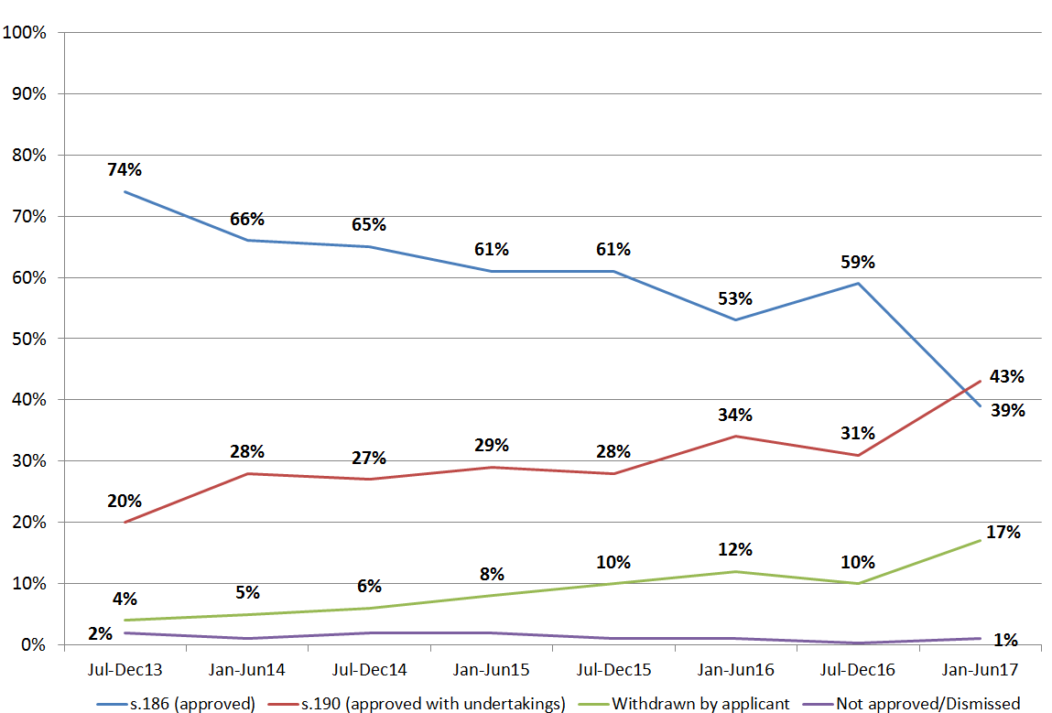

1. At all times the judgment as to whether an agreement should be approved or not is made by Members, to be exercised in accordance with their oath of office and the requirements of the FW Act. The triage process has, however, assisted Members to exercise their function in a consistent and rigorous way.

# Agreement Approval Data

1. Enterprise agreement approval applications constitute a significant part of the Commission’s work. The Commission has dealt with between 5,500 and 8,599 agreement approval applications per year since 2011. Data shows that in 2016–17, 5698 applications to approve enterprise agreements were lodged with the Commission. Of these, 4858 were approved, 39 were not approved, and 709 were withdrawn.
2. The overwhelming majority of enterprise agreement approval applications made to the Commission are for non-greenfields single enterprise agreements. Of the 5606 enterprise agreement applications finalised in 2016-16, 173 were s.185 greenfields agreements. This number accounts for approximately 3% of all agreement applications finalised during the reporting period.

# Enterprise agreement approval—lodgments

**Table 2: Enterprise agreement approval—lodgements**

| **Type of Lodged Approved Not approved Application Total Finalised**  **application withdrawn** | | | | | | | | | | |  |
| --- | --- | --- | --- | --- | --- | --- | --- | --- | --- | --- | --- |
|  | **2016-**  **17** | **2015- 2014-**  **16 15** | **2016-**  **17** | **2015- 2014-**  **16 15** | **2016-**  **17** | **2015- 2014-**  **16 15** | **2016-**  **17** | **2015- 2014-**  **16 15** | **2016-**  **17** | **2015- 2014-**  **16 15** |  |
| s.185— Single- enterprise | 5474 | 5238 5449 | 4663 | 4523 5027 | 39 | 48 114 | 689 | 582 382 | 5391 | 5153 5523 |
| s.185—  Greenfields | 177 | 258 407 | 162 | 252 399 | 0 | 1 2 | 11 | 9 17 | 173 | 262 418 |
| s.185— Multi- enterprise | 47 | 33 66 | 33 | 26 55 | 0 | 4 1 | 9 | 4 8 | 42 | 34 64 |
| **Total** | **5698** | **5529 5922** | **4858** | **4801 5481** | **39** | **53 117** | **709** | **595 407** | **5606** | **5449 6005** |

1. The information that relates to greenfields agreements in Table 2 is shown in the chart below. In particular, the chart illustrates the reduction in applications and approvals for greenfields agreements from 2014-15 – 2016-17.

**Chart 3: Greenfields agreements lodged and finalised 2014-15 to 2016-17**

# Timeliness

1. The Commission’s timeliness in finalising applications is affected, in part, by whether an agreement, as lodged, meets all of the requirements of the FW Act.
2. Where, on the face of the agreement and other information before the Commission, all of the statutory requirements are not met, the matter may be dealt with in a number of ways - the applicant may withdraw the application; the Commission may approve the agreement with undertakings; or the Commission may dismiss the application.
3. The background paper at page 17 indicates that there has been an increase in time from lodgement of an application for approval of a greenfields agreement since 2015, and references Table 2. Table 2 from the background paper is replicated below.

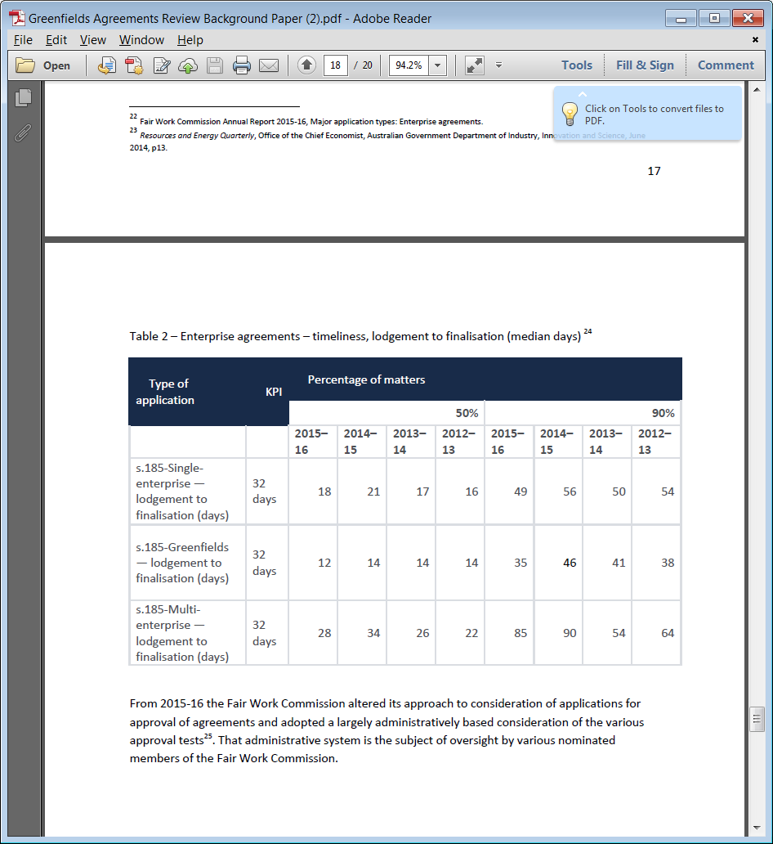

1. Contrary to the observations in the background paper the data in table 2 actually shows an improvement in timeliness in approval of greenfields agreements from 2012-13 to 2015-16. Against a KPI of a median of 32 days, 50% of applications were finalised within 12 days in 2015-16, down from 14 days in each of the 3 preceding years. Similarly, 90% of greenfields agreements were finalised within 35 days in 2015-16, down from 46 days in 2014-15, 41 days in 2013-14 and 38 days in 2012-13.
2. More current data is provided in Table 3 and Table 4 overleaf. Table 3 shows timeliness of approvals for agreements with and without undertakings.
3. The Commission’s overall timeliness performance for agreement approval applications was lower in 2016–17 than in recent years, as seen in Table 4. In part, this reflects the increased rigour applied to all applications adopted through the triage process.
4. One of the legislative requirements for approving a single enterprise or multi enterprise agreement is that the employees must be provided with a notice of employee representational rights (notice) in the prescribed form. One of the most common defects in agreement approval applications is that the notice is not in the prescribed form. As the Act requires strict compliance with the form, the Commission cannot approve such applications.
5. Since May 2017 the Commission has received over 270 applications to approve enterprise agreements that contain a notice that does not comply with the regulations. Of these, the Commission is currently holding approximately 75 matters in abeyance pending further clarity on the passage of the *Fair Work Amendment (Repeal of 4 Yearly Reviews and Other Measures) Bill 2017* (or a related Bill) which will provide the Commission with some discretion to approve agreement applications despite the presence of minor or technical errors, such as the form of the notice.
6. Further information on this matter can be found in the Commission’s submission to the Senate Education and Employment Legislation Committee inquiry into the *Fair Work Amendment (Repeal of 4 Yearly Reviews and Other Measures) Bill 2017*:

<https://www.aph.gov.au/Parliamentary_Business/Committees/Senate/Education_and_Employment/Four-YearlyReviews/Submissions>.

1. The subsequent report of the Committee accepted the Commission’s position that the Bill provide for the new approval discretion to apply to applications made prior to commencement of Schedule 2. The report of the Committee can be accessed here:

<https://www.aph.gov.au/Parliamentary_Business/Committees/Senate/Education_and_Employment/Four-YearlyReviews/Report>

1. At the date of submission of this paper, the Bill (or a related Bill) has not secured passage through the parliament. The delay continues to impact on the parties to the affected agreement applications and the Commission’s capacity to meet its timeliness performance targets for agreement approvals.
2. While there was an increase in the time taken to process greenfields agreement approval applications during 2016-17 the median time of 19 days was still well within the key performance indicator of 32 days from the Commission’s 2016–17 portfolio budget statements.

Table 3: Enterprise agreements—timeliness, approved agreements

|  |  |  |  |  |  |  |
| --- | --- | --- | --- | --- | --- | --- |
| Finalised agreements | Percentage of agreements finalised | Number of days from lodgment to finalisation | | Percentage approved within timeframe | | |
|  | 2016–17 | | | | | |
|  |  | 50% of matters | 90% of matters | 3 weeks | 8 weeks | 12 weeks |
| Approved without undertakings | 51 | 15 | 50 | 58 | 93 | 99 |
| Approved with undertakings | 36 | 48 | 84 | 9 | 66 | 90 |

Note:In 2016–17, 12.4% of agreements were withdrawn and 0.5% were dismissed or not approved.

Table 4: Enterprise agreements—timeliness, type of agreement

|  |  |  |  |  |  |  |  |  |  |
| --- | --- | --- | --- | --- | --- | --- | --- | --- | --- |
| Type of application | KPI1 | Days from lodgment to finalisation | | | | | | | |
|  | 50% of matters (median) | | | | 90% of matters | | | |
|  | 2016–17 | 2015–16 | 2014–15 | 2013–14 | 2016–17 | 2015–16 | 2014–15 | 2013–14 |
| s.185—Single-enterprise | 32 days | 33 | 18 | 21 | 17 | 71 | 49 | 56 | 50 |
| s.185—Greenfields | 32 days | 19 | 12 | 14 | 14 | 59 | 35 | 46 | 41 |
| s.185—Multi-enterprise | 32 days | 42 | 28 | 34 | 26 | 124 | 85 | 90 | 54 |

1 Key performance indicator from the Commission’s 2016–17 portfolio budget statements

1. Since the introduction of the triage process, there has been a steady increase in the proportion of applications that do not appear to meet all of the statutory requirements at the time of lodgment. Analysis and identification of these applications tends to be more complex and take longer. For example, rather than dismissing such applications, Members have sought to assist the parties to address concerns through accepting written undertakings. Generally, the Commission takes longer to approve agreements with written undertakings since it must seek the views of the employer and bargaining representatives before granting approval.
2. As illustrated in Chart 2 the incidence of agreements approved with undertakings has more than doubled since July–December 2013. Currently 43% of agreements are approved with undertakings.
3. In addition, internal resourcing pressures for staff in the agreement triage team have contributed to delays in the approval process. With highly skilled staff regularly achieving promotions, the Commission is streamlining its administrative processes to ensure that appropriate resourcing is maintained.

# Information relating to Greenfields Agreements

1. The Commission also maintains data relating to both the industry and place of lodgment of greenfields agreements. This data is shown overleaf.
2. The data shows that greenfields agreements are found most commonly in the building, metal and civil construction industries.

**Chart 4: Greenfields agreements by industry 2012-13 to 2016-17**

1. Over 40% of greenfields agreement approval applications were lodged in the Commission’s Perth office.

**Chart 5: Place of lodgment of Greenfields agreement approval applications lodged 2012-13 to 2016-17**

# Responses to Specific Questions

*The extent to which the 2015 greenfields agreement amendments have altered bargaining behavior on the part of either employers or unions.*

The Commission has no information on this question.

*Any concerns relating to the effect of the 2015 greenfields agreement amendments on bargaining outcomes and bargaining behavior*

The Commission has no information on this question.

*The extent to which there may be a relationship between these amendments and the number of applications for approval of greenfields agreements*

The Commission has no information on this question.

*The extent to which there may be systemic issues or impediments to the making of greenfields agreements.*

The Commission has no information on this matter.

*Recommendations of the Productivity Commission relating to greenfields agreements*

The Commission does not comment on matters of policy.

*The anticipated effects of returning the to the legislative amendments which applied to the greenfields agreement making prior to November 2015*

The Commission does not comment on matters of policy.

*The impact of the reduction in the number and scale of capital development projects on greenfields agreement making since 2015.*

The Commission has no specific information on this, but does refer to the reduction in the number of applications for greenfields agreements.

*Any other matter relating to the negotiation of, and the approval process for greenfields agreements.*

The Commission has no additional comments.

# Further information

1. Requests for further information should be directed to Bernadette O’Neill, General Manager. Ms O’Neill can be contacted at [bernadette.oneill@fwc.gov.au](mailto:bernadette.oneill@fwc.gov.au) and (03) 8656 4640.