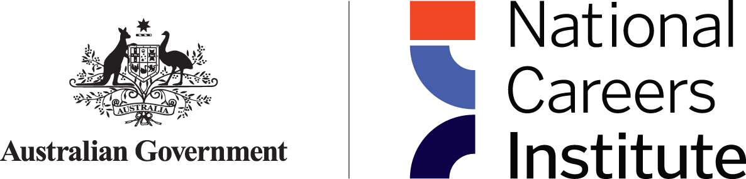

National Careers Institute **Advisory Board** Communiqué

The National Careers Institute (NCI) Advisory Board held a meeting on Thursday 9 February 2023 to discuss priorities which support the strategic direction of the NCI. The agenda included the Forward Work Plan and the House of Representatives Standing Committee on Employment, Education and Training inquiry into the Perceptions and Status Vocation Education and Training (VET).

* The Board agreed to a 2023 forward work plan focussed on enhancing support to priority groups, including First Nations People, people with a disability, people from a culturally and linguistically diverse background and people returning to the workforce. The Board also agreed to the upcoming face to face meeting in June and the proposed professional development session for Board members.
* Board members were provided with background on the House of Representatives Standing Committee on Employment, Education and Training inquiry into the Perceptions and Status of VET. The Board discussed the impacts of the current perceptions and status of VET across market sectors and provided advice related to past and ongoing work in their respective areas of expertise, which may be relevant to the department’s submission to the inquiry.

The Advisory Board welcomed Professor Peter Dawkins, Interim Director of Jobs and Skills Australia as ex-officio member to replace Mr Adam Boyton, former National Skills Commissioner. Board members were also informed that Ms Sarah Agboola submitted her resignation to the board effective November 2022. Ms Ayyuce acknowledged Ms Agboola’s commitment and time on the board and wished her the best in her future endeavours. The department is leading the process to fill the vacancy.

The NCI Advisory Board is next scheduled to meet in person on Thursday 8 June 2023.

*The NCI ensures people have access to authoritative and accurate careers information and support irrespective of their age or career stage*