



Annual Statistical

Report 2020

With the exception of the Commonwealth Coat of Arms, the Department’s logo, any material protected by a trade mark and where otherwise noted all material presented in this document is provided under a [Creative Commons Attribution 4.0 International](http://dnet.hosts.network/education/Resources/Documents/Creative%20Commons%20Attribution%204.0%20International) (http://creativecommons.org/licenses/by/3.0/au/) licence.

The details of the relevant licence conditions are available on the Creative Commons website (accessible using the links provided) as is the full legal code for the [CC BY 4.0 International](http://dnet.hosts.network/education/Resources/Documents/CC%20BY%204.0%20International) (http://creativecommons.org/licenses/by/4.0/legalcode).

The document must be attributed as the VSL Annual Statistical Report 2020

# Introduction

The report focuses on students whose tuition fees were paid (whether in whole or in part) using a VET Student Loan (VSL) in 2020. This report refers to these students as **VSL‑assisted students**.

Information relating to students who have not accessed a VET Student Loan (or non‑VSL‑assisted students) is not included in this report.

This report covers the whole of calendar year 2020, reported as at 13 May 2021. Numbers in this report are not the sums of the corresponding numbers in the two six-monthly reports that cover the same period. Changes to the data provided to the Department since publication of the six-monthly reports have been taken into account in this report. Student counts and enrolment counts are calculated across the entire year, so a student that studied in both halves of the year will only be counted once in this report, whereas they would have been reported in each of the six-monthly reports.

# Background: The VET Student Loans program

The VET Student Loans program commenced on 1 January 2017, replacing the VET FEE-HELP scheme, which closed to new students on 31 December 2016.

This delivered on the Government’s commitment to redesign the VET income contingent loans program so that it is student centred, delivers high quality training, is fiscally sustainable, and holds providers to account. The new program focuses on program integrity, manages risk and promotes confidence in the regulated VET market by ensuring students are both academically suited to their course and are studying under a quality provider.

VET Student Loans offers income contingent loan support to eligible students studying approved diploma level and above vocational education and training qualifications. In 2020, eligible students were entitled to access loans up to a capped amount of either $5,264, $10,528 or $15,793 based on cost of delivery, though the Minister has the power to provide different (and higher) caps for particular courses (for example, aviation related courses).

The list of current VET Student Loans approved courses and maximum loan amount by course is available in the [*VET Student Loans (Courses and Loan Caps) Determination 2016*](https://www.legislation.gov.au/Series/F2016L02016)[1].

# VET Student Loans – 2020

The twelve‑month period covered in this report represents the period during which approved course providers operated with full approval under the VET Students Loans program.

In 2020, 180 registered training organisations (RTOs) operated as approved course providers for VET Student Loans. Table 1 in the Addendum sets out student and loan information for each of these providers.

In addition, this report provides highlights and commentary on the information detailed in Table 1, namely:

* Approved course providers
* Value of VET Student Loans
* VSL‑assisted students
* Completions
* Tuition fees.

# Approved course providers

The 180 approved course providers comprised:

* 24 TAFEs
* 12 other public organisations (including Table A providers), and
* 144 private providers.

The numbers of providers in these different categories is shown in Figure 1.

**Figure 1: Approved course providers by type, 2020**

The names of each of the 180 approved course providers that operated during 2020 are provided in the Addendum (Table 1). Of these approved course providers that operated during the reporting period, 150 had students who accessed a VET Student Loan during that period.

# Value of VET Student Loans

The amount paid to approved course providers in respect of VET Student Loans approved for students studying eligible courses in 2020, was $273.2 million. A breakdown by approved course provider is provided in Table 1.

Figure 2 shows the value of VET Student Loans paid for study undertaken during each month[2].

**Figure 2: Value of VET Student Loans paid for study undertaken in each month of 2020**

# VSL‑assisted students

A total of 50,554 students undertook a part of a course with a census day during 2020, where the part of the course being studied was VSL-assisted (Table 1).

Figure 3 shows, by month, when these 50,554 students had their first part of the course that was VSL-assisted in 2020.

**Figure 3: VSL-assisted student numbers, first time VSL-assisted during 2020**

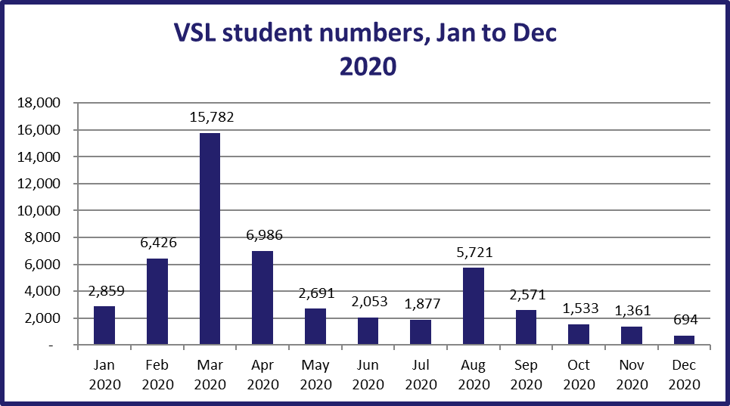

Monthly student commencement numbers peaked in March 2020, while the high level in VSL payments for August and September, suggests that many students studied across the whole year. It should be noted that some students may have had a VSL-assisted unit of study in more than one month. This would occur, for example, if they accessed a VET Student Loan for more than one part of a course, or for more than one course. These students are represented only the first time they accessed a VET Student Loan.

A breakdown of students by provider is shown in Table 1. However, the total of 50,554 only counts each student once, regardless of how many providers they were studying at.

# Completions

A relatively small number of students (14,163) are recorded as having completed a course based on data reported for the year, as shown in Table 1. This is due to the following factors:

* this report only covers students who have paid for study reported within the 2020 year with a VET Student Loan and the majority of these students commenced their courses during 2020
* 230 (97 per cent) of the 237 courses on the VET Student Loans (Courses and Loan Caps) for 2020 were at either the Diploma or Advanced Diploma level, which typically have lengths of one to two years[3]
* This report only includes course completion data reported as at 13 May 2021. Therefore, a completed course that had a final census day occur in 2020 would not be included in this report if the course completion was reported after 13 May 2021.

Thus, most VSL-assisted students reported as having studied in 2020, would not have had time to complete their course by 31 December 2020. For this reason, this report also includes information on unit of study completion rates in Table 1.

A course consists of a number of units of study (referred to as “parts of the course” in the *VET Student Loans Rules 2016*). Thus, reporting on unit of study completion rates provides an alternative way of presenting information on students’ progression through their courses at this early stage of the program.

The unit of study completion rate is the proportion of units of study that were passed, of the total units of study undertaken, with units of study measured in Equivalent Full Time Student Load (EFTSL) rather than student numbers. Units of study undertaken are units that providers have reported as being withdrawn from, failed or successfully completed, as well as units for which providers have failed to report a completion status.

The overall unit of study completion rate for VSL-assisted students is 80.4 per cent for 2020. This is an increase of 2.4 percentage point from the rate reported in the VET Student Loans Six-monthly report 1 July 2020 to 31 December 2020and 11.4 percentage points increased from VET Student Loans Six-monthly report 1 January 2020 to 30 June 2020. Given that the “as at date” for this report is 13 May 2021, four months after the end of 2020, more students will have had a chance to complete units of study than indicated in the six-monthly reports due to the expediency with which those reports are required to be published after the ends of their respective reporting periods[4].

Figure 4 shows a histogram of unit of study completion rates for 2020. Of the 180 VSL providers that had students who accessed a VET Student Loan in 2020, 20 (eleven per cent) had a unit of study completion rate of zero, with 94 (52 per cent) having unit of study completion rates above 70 per cent. A unit of study completion rate could not be calculated for 32 providers (eighteen per cent) that reported all of their students’ units of study as being still in progress.

**Figure 4: Histogram of VSL-assisted student unit of study completion rates, 2020**

# Tuition fees

In 2020, VSL‑assisted students were charged a total of $288.5 million in course tuition fees. VSL‑assisted students paid $15.2 million of their tuition fees up front in addition to the amounts paid in VET Student Loans.

Figure 5 provides a breakdown of tuition fees charged to VSL-assisted students in 2020, by month.

Tuition fees charged peaked in August 2020, commensurate with the peaks in value of loans paid for study undertaken and student numbers.

**Figure 5: Tuition fees charged to VSL-assisted students by month, 2020**

# Additional VET student loan provider and course information

The Addendum table 1, in excel format, provides the Vet Student Loan data listed in the report for the reporting period 1 January 2020 to 31 December 2020.

The Addendum tables 2 to 6, in excel format, provide additional information on approved course providers and the eligible courses they offered during 2020.

In particular, these tables rank providers in order of VSL-assisted students (Table 2), value of VET Student Loans paid (Table 3), and rank courses in order of VSL-assisted students (Table 4) and in order of value of VET Student Loans paid (Table 5).

These tables also provide the following:

* VSL-assisted student numbers (Table 2 and 3)
* course enrolment numbers[5] (Tables 4 and 5)
* Equivalent Full-Time Student Load (EFTSL) by provider and by course
* tuition fees charged
* the amount of the tuition fees paid up-front (paid directly to the provider by the student, rather than deferred through a VSL loan)
* the value of VSL loans
* tuition fees per student (Tables 2 and 3)
* tuition fees per course enrolment (Tables 4 and 5)
* tuition fees per EFTSL
* loan amount per student (Tables 2 and 3)
* loan amount per course enrolment (Tables 4 and 5)
* loan amount per EFTSL
* enrolments, loans, tuition fees, students completing courses and unit of study completion rates by provider and course (Table 6).

Six of the top 10 providers ranked by value of loans paid in Table 3 were public providers (TAFEs/Table A universities). In terms of student numbers, 9 out of the top ten providers were public providers (Table 2).

The Diploma of Nursing is the highest-ranking course both in terms of course enrolments and value of loans paid, as shown in Tables 4 and 5, respectively. Nursing, community services and counselling qualifications are popular with VSL students, as they were under VET FEE-HELP.

Only one in the top ten courses ranked by student enrolements in 2020 compared to 2019. The Diploma of Music Industry is now ranked in the top ten replacing the and Diploma of Building Design.

1. <https://www.legislation.gov.au/Series/F2016L02016>
2. Study undertaken during each month is defined as a part of the course where the census day is in that month, regardless of when payment was made, as at May 2021.
3. Australian Qualifications Framework Second Edition January 2013, <https://www.aqf.edu.au/sites/aqf/files/aqf-2nd-edition-january-2013.pdf>
4. Units reported as still in progress are excluded from the unit of study completion rate calculation. Providers report the final completion status of such units once completed (successfully or otherwise). A unit of study will generally include multiple units of competency (subjects). Unit of study completion rates therefore cannot be compared to subject load pass rates published by the National Centre for Vocational Education Research.
5. Students can enrol in more than one course, so enrolment numbers will always be greater than or equal to student numbers.