Quick Guide – Marketing and Publishing

This quick guide provides information on marketing and publishing requirements related to the VET Student Loans program

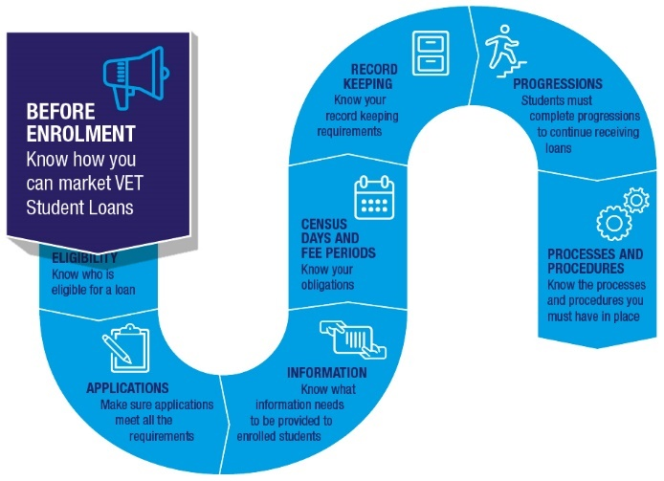

# Marketing

## Marketing that mentions VET Student Loans

Any marketing that mentions the availability of VET Student Loans must prominently mention:

* your name including your legal name and any registered business name or other business name you use
* your registered training organisation (RTO) registration code
* that VET Student Loans are subject to students meeting eligibility requirements
* that a VET Student Loan creates a debt that must be repaid to the Commonwealth.

This information must be in a similar font size to the marketing information it accompanies. The information must be on the same webpage as the other marketing for the course if the marketing is online.

Any marketing that mentions a VET Student Loans approved course must also mention the course’s maximum tuition fees.

An approved course must not be marketed unless its tuition fees have been published on your website in a place easily accessible to the public. Course fees must also be published on [My Skills](https://www.myskills.gov.au/) by 1 December of the year before offering the course or before enrolling students if this date is earlier.

You must make it clear to students that VET Student Loans are loans which need to be repaid.

## Using the VET Student Loans logo

The VET Student Loans logo can be used on marketing materials. The [VET Student Loans Style Guide](https://www.dewr.gov.au/vet-student-loans/resources/vet-student-loans-style-guide) should always be consulted before using the logo to ensure it is in line with the advice given in the Style Guide.

## Social media

Any marketing through social media must **not** mention the availability of VET Student Loans. This includes automated advertisements through sites such as Facebook.

Social media includes, but is not limited to, Facebook, Twitter, Instagram and YouTube.

## Offering benefits to students

You cannot offer or give inducements or benefits to students that would be likely to influence them to apply for a VET Student Loan.

This does not apply to the following benefits:

* the content and quality of the course
* the amount of the tuition fees for the course
* the availability of a VET Student Loan for the course
* marketing merchandise of up to a total value of $30 per person.

You should be careful that any bursaries, scholarships, or other tuition fee discounts offered do not break the rules around offering benefits.

## Brokers and agents

Brokers and agents cannot perform certain tasks for VET Student Loans approved providers. This applies whether or not a student accesses a loan. Brokers and agents may not:

* enrol students, or accept an application to enrol students, in a course
* provide information or advice about VET Student Loans for a course
* assist students to complete or submit applications for VET Student Loans
* assist or support students to complete an assessment to show academic suitability for a course.

## Cold calling

You cannot mention the availability of VET Student Loans when cold calling to market or promote a course.

Cold calling includes making unsolicited contact with a student or prospective students. This could be in person, over the phone, by email, or by another form of electronic communication.

## Third party contact lists

You cannot mention the availability of VET Student Loans when using contact details obtained from a third party to market, advertise or promote a course, or to enrol a person in a course.

This does not apply if the student has given express written consent to be contacted. The student is only taken to have given express consent if the requirements in section 138 of the [VET Student Loans Rules 2016](https://www.legislation.gov.au/Series/F2016L02030) are met.

# Publishing

Where the legislation identifies that you must publish information about VET Student Loans on your website you should ensure the content is published in a way that meets the requirements of both the [Rules](https://www.legislation.gov.au/Series/F2016L02030) and the [Act](https://www.legislation.gov.au/Series/C2016A00098), including that the information must be easily accessible without provision of login information.

## Student entry requirements, withdrawal and cancellation of enrolment

You must publish the student entry procedure specifying the requirements relating to student academic suitability, the process for assessing a student’s competence in reading and numeracy, including the [VET Student Loans approved assessment tool](https://www.dewr.gov.au/vet-student-loans/language-literacy-and-numeracy-lln-assessment-tool-information#toc-approved-lln-assessment-tools) used and communication of the assessment results.

You must also publish how you will treat students and handle students’ personal information, including the information you collect and verify when they apply for a VET Student Loan. You must publish the processes and procedures for a student to withdraw from an approved course and also publish cancellation of enrolment processes.

## Tuition fees

You must publish tuition fees for each part of the approved course (that is unit/subject) on your website in a readily accessible way no later than the day before a student enrols in a course. You must also publish course fees on the [My Skills](https://www.myskills.gov.au/) website.

You must also publish any variation to tuition fees if allowed, and the procedure for charging fees other than tuition fees.

## Census days

You must publish census days for each course you provide, or intend to provide, on or before the earliest enrolment date for a course, or part of a course, enabling students to access information about the census date before they enrol. The information must be in an easily accessible location displayed prominently on your website and which does not require to student to log in.

You must also publish any allowable variation to the census days.

## Student complaints

You must publish your process and procedure with dealing with students’ complaints including how they can seek a review without discrimination. You must also publish how students HELP balances are re‑credited and other information relating to reviewable decisions.

## Tuition protection

You must publish a procedure that ensures students that you will perform required actions when you default in relation to a student and that you will meet your obligations as a replacement provider to students enrolled in a replacement course.

## Information to students

Certain information and notices must be provided to students. Please refer to the [Quick Guide – Information Requirements](https://www.dewr.gov.au/vet-student-loans/resources/quick-guide-information-requirements) and the checklist at Appendix B of the VET Student Loans Manual for Providers.

# Further information

For further information on marketing requirements, refer to the following resources:

* [VET Student Loans Manual for Providers](https://www.dewr.gov.au/vet-student-loans/resources/vet-student-loans-manual-providers) (Chapter 4.10 Marketing)
* [VET Student Loans Style Guide](https://www.dewr.gov.au/vet-student-loans/resources/vet-student-loans-style-guide).

For the legislation governing marketing requirements, please see sections 49 and 60-64 of the [*VET Student Loans Act 2016*,](https://www.legislation.gov.au/Series/C2016A00098) and sections 95-96 and 135-143 of the [VET Student Loan Rules 2016](https://www.legislation.gov.au/Series/F2016L02030).

For further information on publishing requirements, refer to the following resources:

* [VET Student Loans Manual for Providers](https://www.dewr.gov.au/vet-student-loans/resources/vet-student-loans-manual-providers) (Chapter 4.8 Processes and Procedures looks at all processes and procedures that need to be in place and published; Section 4.8.2 looks at Processes and procedures publishing requirements).
* [Quick Guide – Processes and Procedures](https://www.dewr.gov.au/vet-student-loans/resources/quick-guide-processes-and-procedures).

For the legislation governing publishing requirements please see sections 12, 55-59, 68 of the [*VET Student Loans Act 2016*](https://www.legislation.gov.au/Series/C2016A00098) and sections 75-79, 80-82, 84-94, 115, 126-127, 132-134, 144-146, of the [VET Student Loans Rules 2016](https://www.legislation.gov.au/Series/F2016L02030).