Quick Guide – Census Days and Fee Periods

This quick guide provides information on the census day and fee period requirements for VET Student Loans

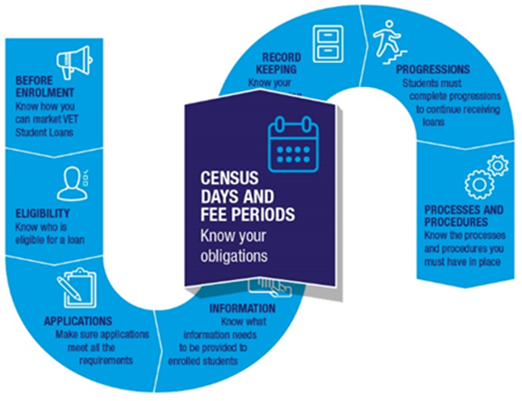

# Census days

A census day is the last day on which a student can withdraw from part of a course without incurring tuition fees. It is also the last day on which a student may complete and submit an eCAF to apply for a VET Student Loan.

If a student is still enrolled after the census day, they will be liable for the tuition fees for that part of the course.

You cannot stop students from withdrawing on or before the census day, and you cannot create barriers, such as fees, to withdrawal.

## Determining census days

You determine the census days for your courses. However, there are rules that must be followed when choosing which days to set as census days.

There must be at least 3 census days for a course. This means that the course will be divided into at least 3 parts.

Each census day can occur no earlier than 20% of the way through its part of the course.

The duration of a course includes any normal study breaks, assessments and/or examination periods. The last day of the examination period should be used if final examination dates are unknown.

Census days must not fall on a day when a student cannot lodge a withdrawal from their course. This means that the census date should not fall on non-business days (that is weekends or public holidays).

A [census day calculator](https://www.dewr.gov.au/vet-student-loans/resources/census-day-calculator) is available on the Department of Employment and Workplace Relations website.

Note: The calculator does not return dates occurring on a Saturday or a Sunday. The date of the following Monday is returned where a calculated date occurs on a weekend. It is your responsibility to check whether the date returned is a public holiday. Where the date returned is a public holiday it is advisable to set the census day on a subsequent business day.

## Publishing census days

You mustpublish the census days for your courses. This must be done by no later than the first day that enrolments are accepted for the course.

The information must be easily accessible and displayed prominently on your website. Students should not need to login to access the information.

## Flexible enrolments

A census day to accommodate rolling intakes or flexible enrolments does not need to be on a calendar date. It can simply be a statement indicating when a census day will fall. For example, if part of the course lasts 12 weeks, a statement that the census day falls on Day 1 of Week 4 would be sufficient.

## Variations to census days

You may change published census days but only under certain conditions. These conditions are that the change must:

* occur before the census day and
* not disadvantage students enrolled in, or seeking to enrol in, the course, and
* be necessary to correct an administrative error or deal with a change in circumstances.

A change that moves the census day to an earlier date disadvantages students. You must publish any change to a census day as soon as practicable and prominently on your organisation’s website.

You must obtain our approval to change the census day if the circumstances above are not met. Further information on varying census days, including how to seek approval, can be found in sections 4.9.4 and 4.9.5 of the [VET Student Loans Manual for Providers](https://www.dewr.gov.au/vet-student-loans/resources/vet-student-loans-manual-providers).

# Fee periods

VET Student Loans approved courses must be split into at least 3 fee periods. Each fee period must contain at least one census day. The course’s tuition fees must be spread approximately equally between each of its fee periods. No tuition fees for the course can be made payable outside of the fee periods.

## Length of fee periods

The length of a fee period will depend on the duration of the course. You should structure your courses so that there is sufficient time between enrolment and the start of a course to accommodate the 2 day business gap for requesting a VET Student Loan and the time period required for issuing VET Student Loans fee notices.

Each of the fee periods must be of approximately equal length and the fee periods must together cover the full duration of the course.

It is possible for you to assign different fee periods to students studying the same course. For example, part-time students may have longer fee periods than full-time students.

## Changes to the length of fee periods

If the length of a course changes after it has already started, then the length of fee periods that have not yet started may also be changed. This should be done in proportion to the change in the length of the course. For example, if a student switches from full-time to part-time study then their course duration will increase. You may therefore increase the length of their fee periods. The changed fee periods must still be of approximately equal length.

## Fee periods and complying with state or territory funding arrangements

If you are in an arrangement with a state or territory authority that is inconsistent with the fee period requirements, you must provide written notice to us that, among other things, explains why you are unable to comply with the fee period requirements. See section 4.8.12 Fee periods, of the [VET Student Loans Manual for Providers](https://www.dewr.gov.au/vet-student-loans/resources/vet-student-loans-manual-providers) for information on how to do this.

In all other instances, you must follow the fee period requirements.

## Further information

For further information on census days and fee periods, refer to the [VET Student Loans Manual for Providers](https://www.dewr.gov.au/vet-student-loans/resources/vet-student-loans-manual-providers) (see Chapter 4.8.12 Fee periods and Chapter 4.9 Census Days).

For the legislation governing the census day and fee period requirements, please see sections 58-59 of the [*VET Student Loans Act 2016*](https://www.legislation.gov.au/Series/C2016A00098) and sections 86-87, 98, 122, 123 and 130-134 of the [VET Student Loans Rules 2016](https://www.legislation.gov.au/Series/F2016L02030).