`



JSA Quality Standards Pilot

Evaluation Report

employment.gov.au

Contents

Executive Summary 5

1. Introduction 12

1.1 The Existing model 12

1.2 The Quality Assurance Framework 12

1.3 The JSA Quality Standards Pilot 16

1.4 Pilot status 16

2. Evaluation of the Quality Standards Pilot 17

2.1 Authority 17

2.2 Evaluation scope 17

2.3 Data sources and limitations 18

3. Preparation for Pilot Quality Assurance Framework implementation 22

3.1 Sources of information 22

3.2 Appropriateness of information 28

3.3 Summary 30

4. Implementation of the Pilot Quality Assurance Framework 32

4.1 Choice of Quality Standard by Providers 32

4.2 Auditor selection 34

4.3 Communication with auditor 35

4.4 Conduct of the audit 36

[4.5 Challenges undertaking the Pilot and implementing the Pilot Quality   
Assurance Framework 40](#_Toc389200928)

4.6 Summary 49

5. Impact of the Pilot Quality Assurance Framework on delivery of employment services 51

5.1 Data limitations 51

5.2 Client impacts 55

5.3 Impact on Provider operations 60

5.4 Cost / benefit considerations 69

5.5 Summary 71

[6. Considerations for the future implementation of a Quality Assurance Framework   
for employment services 75](#_Toc389200936)

6.1 Preparation of Providers and auditors for audit process 75

6.2 The Quality Standards and the Quality Principles 76

6.3 Monitoring and evaluating the impact of the QAF into the future 77

7. Conclusion 79

Appendix A: Quality Assurance Framework 81

Appendix B: Data sources 82

Appendix C: Data tables 87

# Executive Summary

The performance of Employment Service Providers (Providers) under Job Services Australia (JSA) is currently monitored, measured and evaluated against three Key Performance Indicators (KPI), the Code of Practice and the Service Guarantees for the Services. KPI 1 and 2 form the basis of the current Star Ratings model. KPI 3 performance is assessed using five quality measures covering manually rejected special claims, Individualised Employment Pathway Plans, active engagement of participants, participant experience and department received complaints.

Feedback from industry and contract management activity suggested that the existing KPI 3 Quality Framework used to assess Provider performance does not provide enough practical information to support continuous improvement in service quality. In response, the Department of Employment (the department) developed a new approach to supporting quality improvement through establishing a new Quality Assurance Framework. The department flagged in the 2012-15 JSA Request for Tender its intention to move towards independent assessment against industry standards.

The new Quality Assurance Framework was designed with an emphasis on quality service delivery within the Employment Services Deed, containing two audit components:

* Certification by an independent auditor against one of four Quality Standards deemed acceptable by the department: Standard ISO 9001, Employment Services Industry Standards, Disability Service Standards and Investors in People.
* Adherence to eight overarching Quality Principles (as detailed in Table 1.3) with supporting Key Performance Measures.

Relationships between elements of the new Quality Assurance Framework and the audit components are depicted in Appendix A.

A pilot test commenced on 1 January 2013 to enable Providers and the department to work together to test the proposed Quality Assurance Framework. The Quality Standards Pilot (the Pilot) was intended to operate for 12 months but on request from some Providers was extended to 31 March 2014.

A total of 48 Providers initially commenced in the Pilot, made up of two groups: Providers who were required to participate due to poor performance in the Programme Assurance Audit of Provider Brokered Outcome claims (12 Providers) and Providers who volunteered to participate (36 Providers). As at 26 May 2014, 14 volunteer Providers had withdrawn from the Pilot leaving a remaining 34 Providers to be considered for certification. Of these Providers, 25 had received certification against the Pilot Quality Assurance Framework and nine were awaiting certification.

**Evaluation of the Quality Standards Pilot**

It was initially anticipated that an external consultant would be engaged to complete an evaluation by July 2014. In late December 2013 the department determined that evaluation would be conducted internally to give Providers an extended lead-time to prepare for certification under the new contract. Evaluation of the Pilot was conducted by the department’s Evaluation, Industry Adjustment and Workplace Development Branch.

Evaluation of the Pilot has aimed to inform the department and Minister of Employment of the suitability of the new Quality Assurance Framework for the whole of industry as part of the new employment services contract which is planned to be introduced from 1 July 2015.

**Evaluation scope**

The Pilot Management Plan states that the Pilot’s success would be measured against two key criteria:

* Did the Pilot achieve its goals and will the resulting QAF drive continuous improvement?
* The impact of Quality Standards on Providers: Does the adoption of Quality Standards result in improvements to services delivered by Providers to participants, employers and the department? Is there benefit realisation between the cost to Providers and improvements to the services?

The evaluation concentrated on reviewing the implementation of the new Quality Assurance Framework through the Pilot process with a view to answering, as far as possible, the two overarching questions. It has considered lessons to be learned from the process and any improvements required to ensure an effective national roll-out of a Quality Assurance Framework as part of the new employment services contract.

Evaluation focused on the following key areas to assess the Pilot’s success:

1. Preparation of Providers for implementation of the Pilot Quality Assurance Framework, including consideration of the effectiveness and appropriateness of information disseminated to Providers and auditors.
2. Implementation of the Pilot Quality Assurance Framework, examining Provider choice of Quality Standard, preparation for and conduct of the audit as well as challenges experienced.
3. Impact of the Pilot Quality Assurance Framework on Providers’ delivery of employment services, in terms of their clients and the Provider organisation.
4. Considerations for future implementation of a Quality Assurance Framework.

Data from a number of sources was examined, including administrative data (specifically, available KPI 3 data), Provider experiences, auditor experiences and departmental Account Manager feedback. Further information about the data collection methods used in this evaluation is contained in Appendix B. The data supporting this analysis is contained in Appendix C.

It has not been possible to objectively measure for this evaluation all of the benefits associated with the Pilot Quality Assurance Framework, as the effect on job seeker experiences and outcomes within the relatively short timeframe of the Pilot is likely to be limited. The evaluation was also unable to measure and report on direct impacts on services received by job seekers and employers.

The evaluation has considered in broad terms the benefits and value of the Pilot Quality Assurance Framework by relying primarily on Providers’ perceptions. Participating Providers were not a random sample of Providers. There is some risk that the views expressed do not represent the full range of views that would exist among all Providers on issues highlighted by the Pilot. There could also be an element of ‘pilot effect’ reflected in the results because Pilot participants are generally enthusiastic about the impact that their increased efforts will have (noting that this is less likely for Pilot Providers who were required to participate).

The timeframe available to evaluate the Pilot Quality Assurance Framework imposed a number of limitations.

* The capacity to design a comprehensive evaluation and supporting data collection tools was limited and data collected prior to the involvement of the evaluation branch was of limited use.
* Some surveys were in the field for shorter periods than would ideally have been the case, ultimately limiting the number of respondents and the capacity for detailed analysis (this was particularly the case for auditors).
* It was not possible to assess the full impact of the Pilot Quality Assurance Framework or to capture medium to long-term effects. The evaluation has assessed the *potential* of the Pilot Quality Assurance Framework to improve service experiences and outcomes for job seekers and employers indirectly, through the feedback of participating Providers.

**Summary of findings**

**Main finding**

An aim of the Pilot Quality Assurance Framework was to encourage Providers to strive for continuous improvement in the delivery of employment services. Feedback collected through this evaluation suggests respondents believe that the Pilot Quality Assurance Framework will drive continuous improvement and may have greater potential than the current KPI 3 Quality Framework.

* 86 per cent of Quality Managers did not disagree that the audit focused on continuous improvement; a minority (11 per cent) thought it was ‘too early to tell’.
* Quality Managers were given the opportunity to identify the main benefit of participating in the Pilot. One in four who responded said that continuous improvement had been a key benefit.

While there is no administrative data available to objectively measure the impact of the Pilot Quality Assurance Framework, Provider Chief Executive Officers (CEO), Quality Managers (who were Provider nominated staff within the organisation tasked with the responsibility of managing the Pilot process) and front line staff reported positive impacts on their businesses and service delivery. They were also optimistic about the longer term prospects of the revised Quality Assurance Framework for delivering improved services to job seekers and, perhaps to a lesser extent, employers.

Balanced against these benefits, the time and cost to participate in the Pilot exceeded some Providers’ expectations and does appear to have been significant in some cases: two-thirds of Providers indicated that time and costs associated with the Pilot were greater than expected (for more details refer to *Implementation issues* below).

Some of this can be accounted for in a lack of preparedness for the audit, for instance, a poor choice of Quality Standard for the organisation to certify against or not having correct documentation on hand for the auditor. Factors beyond the control of Providers also contributed, including overlap between the Quality Standards and Quality Principles (and the Key Performance Measures within them), waiting for the Employment Services Industry Standards to be certified and an apparent lack of understanding of the process, the Deed and JSA more generally, among some auditors.

It is noted that the Pilot process was intended to refine both the Quality Assurance Framework and its implementation. The department has already commenced work to address a number of the issues the evaluation has identified to streamline the process to reduce costs and ease large-scale implementation of a new national Quality Assurance Framework.

**Detailed findings**

***Information and communication***

The department disseminated information about the Pilot via a number of sources. Providers and auditors generally agreed that the communication was suitable and useful. Opportunities for improvement were identified for webinar information sessions, which worked well for auditors but less so for Providers, and Govdex, with many Providers and auditors either not aware or not seeing value in this resource.

***Certification process***

Providers were able to select one of four Quality Standards to certify against within the 12 month Pilot period. The process of selecting a Quality Standard to certify against was not simple and one-fifth of Providers reported they had switched from their original choice. A number of Providers withdrew from the process as they were not able to meet the required timeframes.

Challenges around Quality Standard selection arose because the requirements vary for each Standard and some are more appropriate for particular business models and caseload sizes. Comments suggest that certification against Disability Service Standards for JSA purposes was more onerous than the other Quality Standards, particularly in terms of the job seeker interview requirement. The time required to certify against Employment Services Industry Standards was especially problematic and also impacted upon selection.

Job seeker interviews were raised by several auditors as having disrupted the audit process and contributed to delays. However, Providers were generally positive about the knowledge obtained directly from job seekers. As Providers become more aware and better prepared for the audit process it is expected that the process of interviewing job seekers will be less challenging for auditors.

Auditors and Providers agree the audit should focus more on how the Providers managed the process rather than sampling a specified number of transactions.

***Implementation issues***

Half of the responding Providers indicated that 12 to 18 months is a reasonable timeframe for implementation. There was significant variation in the responses for the amount of time spent supporting the audit process, ranging from zero to 6,088 hours of staff time. The median reported preparation time was 500 hours.

Financial costs associated with the Pilot (as reported by Providers) varied significantly. To prepare for an audit the:

* highest cost reported by a Quality Manager was $260,000 and $250,000 by a CEO
* lowest cost quoted by both a Quality Manager and a CEO was $10,000, and
* overall median cost was $47,500.

Reported costs for conducting an audit were lower than for audit preparation. The:

* highest cost reported by a Quality Manager was $150,000 and $100,000 by a CEO
* lowest cost reported by a Quality Manager was $2,700 and $4,000 by a CEO, and
* overall median cost was $36,000.

A further challenge documented by Providers and auditors was the duplication between the Quality Principles and the Quality Standards, as well as some Key Performance Measures within. While it is important to capture multiple aspects of a Provider’s business to gauge quality, duplicating the assessment of any part of the business is inefficient and places a greater burden on Providers’ time, money and resources. Identification of areas of duplication would have better prepared the Providers and auditors to conduct a more efficient audit.

Account Managers offered limited insight into the impact that the Pilot had on the delivery of employment services. As with KPI 3 data, Account Managers have not yet observed any significant changes to Provider performance, possibly because their feedback was collected too early in the process. Almost half observed improvements to business processes and a quarter identified changes to staff engagement. Account Managers who responded to questions on the potential value of the Pilot Quality Assurance Framework were mostly positive but a relatively high number of neutral or “don’t know” responses possibly indicates that Account Managers were not heavily involved in the Pilot Quality Assurance Framework development process.

***Cost / benefit considerations***

The evaluation considers that reasonable balance between benefits and cost is a critical issue but it has been difficult to ascertain if this has been achieved.

Participating Providers indicated that they have seen short-term improvements to client services and business operations and most expect to see positive long-term effects. There was overwhelming agreement that involvement in the Pilot had been a worthwhile investment of time. Feedback from Providers should not be relied upon exclusively to provide an objective assessment of whether the Pilot Quality Assurance Framework has driven improvements to service delivery. This level of analysis cannot be undertaken until the views of clients, such as job seekers and employers are collected and considered.

On the question of whether the audit represented ‘value for money’ Providers were more reserved: just over one-third of CEOs agreed or strongly agreed and over one quarter disagreed.

As the department and Providers become more familiar with the intricacies and processes involved in establishing and maintaining a Quality Assurance Framework it is reasonable to expect that costs will reduce or at least become more predictable. The reaction of the wider field of Providers to this aspect of the Pilot is likely to be a key factor in the successful promotion and implementation of a new Quality Assurance Framework.

**Recommendations**

In conclusion, if cost and time requirements are managed to be within reasonable limits it is anticipated that a national Quality Assurance Framework based on independent assessment against Quality Standards will benefit all parties and may prove superior to the current KPI 3 Quality Framework. To help Providers strike a reasonable balance between benefits and costs it is recommended that the department:

1. Explore options to better educate Providers about the administration of the audit and the certification process, including the time it takes to achieve certification. In particular, re-evaluate webinar content for Providers to include more practical information (real world examples from Providers who have already gone through the process) and make them more interactive.
2. Explore options to ensure auditors are better prepared for the audit, in terms of their knowledge of employment services, the JSA model and the Employment Services Deed, and understand the quality and level of detail required in audit reports. For instance:
   * Provide copies of best practice audit reports.
   * Provide an initial face-to-face information session for auditors on the panel, as well as regular information sessions to provide updates regarding audit practices.
   * For the purpose of certifying against the Quality Assurance Framework, restrict the auditor panel maintained by the department to auditors who have some working knowledge of employment services.
   * Provide an Auditor Portal, or access to a section of the Provider Portal, to make information readily available to auditors.
   * Schedule auditor webinar presentations well in advance and provide sufficient notice.
   * Promote the availability of recorded webinar presentations on Govdex.
3. Tailor the content and amount of written information available to auditors and Providers and consider options to supplement written information, for example by continuing (and promoting) the availability of the central Quality Assurance Framework phone number and email address.
4. Provide information on the requirements of each Quality Standard to guide Providers in their selection of a Quality Standard for their business model. Supply information that maps the departmental Quality Principles with each of the Quality Standards.
5. Continue the work already commenced to streamline the sampling requirements and reduce the duplication between the Quality Standards and the Quality Principles (and the Key Performance Measures within).
6. Consider how best to monitor and evaluate the effectiveness of a future Quality Assurance Framework on an ongoing basis, taking into account the appropriateness and relevance of retaining the current KPI 3 as a measure of quality assurance, given the requirements of Quality Standards and Quality Principles. Explore options to ensure the views of Account Managers, job seekers, employers and auditors are better captured.
7. Consider options to increase Account Managers’ involvement in Quality Assurance Framework development and implementation.

***Response to the Recommendations***

*The overall finding of the Evaluation is encouraging.Results of the Evaluation confirm that the introduction of industry standards into the employment services market will drive continuous improvement to enhance the quality of services delivered to job seekers, employers and the department. However the recommendations made by the Evaluation indicate that the QAF could benefit from some modification in order to improve its operation and strengthen its capability. In that context the department is taking a number of steps to address the recommendations:*

* *The department is proposing to conduct training webinars for providers to assist them in understanding of what is involved in seeking certification.*
* *The department is establishing the QAF Auditor List which will comprise Conformity Assessment Bodies who can:* 
  + *certify providers against at least one of the approved Quality Standards; and*
  + *assess providers against the department’s Quality Principles.*
* *The department is preparing information to assist auditors to conduct audits under the QAF, including details in relation to employment services, as well as templates to assist with developing Audit Plans and Audit Reports.*
* *The department will also facilitate webinars for auditors to address changes between the Pilot and the QAF, discuss examples of best practice and the department’s expectations of auditors under the QAF.*
* *The department has conducted a review of the Quality Principles to remove areas of duplication identified during the Pilot and introduced the concept of Standard Centric Principles which align more closely with Quality Standards and Deed Centric Principles which bridge the gap between the generic requirements of the Standards and the qualitative requirements of the Deed.*

*By broadening the Key Performance Indicator 3 in the 2015-20 Employment Services, the QAF has become one of the three key elements in assessing quality and assurance. The QAF in the new Employment Programme will become a fundamental tool for Account Managers.*

*While the benefits of achieving certification have been well documented, the ongoing success of the QAF and indeed each provider’s Quality Management System relies on a continued focus on improvement and genuine engagement of employees at all levels.*

# Introduction

The Job Services Australia (JSA) Quality Standards Pilot (the Pilot) was established to enable Employment Services Providers (Providers) and the Department of Employment (the department) to work together to finalise the operational detail of a revised Quality Assurance Framework (the QAF) for the next employment services contracts[1].

## The Existing model

Under the existing model, Provider performance is monitored, measured and evaluated against Key Performance Indicators (KPI) (see Table 1.1), the Code of Practice and the Service Guarantees (as relevant).

Table .1: Key Performance Indicators

|  |  |
| --- | --- |
| KPI | Description |
| KPI 1 | The average time that the Provider takes, compared to the time taken by other employment services providers, to assist relevant participants into employment. |
| KPI 2 | The proportion of relevant participants for whom job seeker placements, job seeker outcomes, off-benefit outcomes and social outcomes are achieved, in accordance with the requirements of the Deed. |
| KPI 3 | The delivery of quality services under this Deed, the Service Guarantees and the Code of Practice. |

KPI 1 and 2 form the basis of the current Star Ratings model. KPI 3 performance is assessed using five quality measures covering claims, Employment Pathway Plans, active engagement of participants, participant experience and department received complaints.

Providers focus heavily on Star Ratings and less on improving their performance against KPI 3. This is because Star Ratings are integral to Providers’ formal performance assessments and are used to inform the department’s business reallocation process and purchasing decisions.

## The Quality Assurance Framework

On the basis of feedback from industry and contract management activity, in 2012 the department identified that the existing KPI 3 Quality Framework was not providing practical information for Providers to continuously improve their quality of service delivery. In response, the department proposed to develop and test a new approach to quality measurement, monitoring and assurance. Three main stages were identified:

1. Establish a revised QAF (conceptualised at Appendix A) following extensive consultation with industry.
2. Pilot test and evaluate the proposed framework.
3. Introduce the new QAF across the whole of industry following the evaluation of the Pilot.

The Pilot QAF differed from the existing model in that it placed greater emphasis on quality service delivery within the Employment Services Deed and imposes two new requirements in addition to KPI 3 (three key requirements in total).

1. **Certification against one of four Quality Standards**

A new feature under the revised QAF, required Providers to gain certification in one of four Quality Standards deemed acceptable by the department (Table 1.2). Certification was conducted by an independent auditor, selected by the Provider from an audit panel maintained by the department (which was made up of organisations who were registered against the Joint Accreditation System of Australia & New Zealand (JAS-ANZ) and were willing to participate in the Pilot). The cost was borne by the Provider. Consistent with the existing model, Quality Standards certification included a self-audit requirement, the details of which varied according to the Quality Standard adopted by the Provider.

Initially, three Quality Standards were agreed upon for inclusion in the Pilot by the department:

* Standard ISO 9001, which is the most commonly-used world-wide standard.
* Disability Service Standards, which is a standard that is used extensively by Disability Employment Services (DES) Providers.
* Employment Services Industry Standards, which was chosen in consultation with National Employment Services Association because it was designed ‘for industry by industry’.

After consultation with Jobs Australia, the department also considered standards used in the United Kingdom. After conducting a gap analysis, Investors in People was included in the Pilot which is the most commonly used United Kingdom standard.

With the exception of the Employment Services Industry Standards, these standards are not specifically designed for employment services. Providers with existing contracts may also be disability services providers, Registered Training Organisations, and provide any number of other services where their business model is suited to one of the different standards offered.

Table 1.2: Quality Standards Providers choose for certification

|  |  |
| --- | --- |
| Quality Standard | Description |
| Standard ISO 9001 | ISO 9001 is an internationally recognised quality standard that enshrines a quality management system as an integral part of the organisation’s operations. The Australian Standard is identical to the ISO 9001. Both are acceptable and are recognised within Australia as an appropriate continuous improvement tool for use by a range of industry sectors. |
| Employment Services Industry Standards (ESIS) | ESIS has been developed by the National Employment Services Association (NESA) and is a quality standard developed by the employment services industry for the employment and related service industries. ESIS is a Joint Accreditation System of Australia & New Zealand (JAS-ANZ) endorsed quality standard and a recognised Standard for the employment services industry. |
| Disability Service Standards (DSS) | The DSS provides the basis for the DES Quality Framework, which is based on the same four quality measures as JSA (provider capability, service delivery, engagement, and client experience). The DSS covers a range of aspects that would be required under the new QAF, where a Provider is already certified against the DSS for its JSA business, no additional Quality Standard certification would be required. |
| Investors in People (IiP) | The IiP Standard is a business improvement tool designed to advance an organisation's performance through its employees. The Quality Standard is outcome focused, outlining what needs to be achieved, but not how. IiP Australia is licensed by the governing body in the United Kingdom (Commission for Employment and Skills) to grow and deliver the Quality Standard. |

1. **Meet overarching Quality Principles with supporting key performance measures**

Providers needed to meet eight Quality Principles, as detailed in Table 1.3. Adherence to the Quality Principles is determined by a department-approved auditor.

The Quality Principles were designed to reflect the requirements of the Employment Services Deed and bridge the gaps between the requirements in each Quality Standard. When the Quality Principles were drafted it was anticipated there would be some overlap with the Quality Standards. This was to be revisited after the Pilot process when it was better understood which Quality Standards the Providers preferred and where overlaps existed between the Quality Principles and the Quality Standards.

Table 1.3: The eight departmental Pilot Quality Principles

|  |  |
| --- | --- |
| Principle | Description |
| Satisfaction with services and provision of individualised and tailored services | Provider has in place strategies for monitoring and measuring participant satisfaction. The monitoring of this satisfaction will inform continuous improvement in service delivery to participants and employers. Provider also has in place mechanisms and strategies to ensure that each participant and employer receives a service that is designed to meet their individual needs and, where appropriate, personal goals. These needs and goals are then used as the basis for service provision with the Provider undertaking a process of planning, implementation, review and adjustment to facilitate the achievement of these goals. |
| Effective corporate governance arrangements, including management systems | Strong governance, operational effectiveness and efficiency through corporate arrangements and management systems, practices that optimise outcomes for themselves, participants and employers. This includes a supportive organisational culture and effective financial controls and communication mechanisms. |
| High level of leadership | Strong leadership that establishes organisational direction and purpose and supports a positive organisational reputation. |
| Effective planning strategies | Effective planning mechanisms that support continuous improvement across the organisation including people and performance management and financial capability including fraud prevention. |
| A supportive working environment that values the development of its people through staffing and organisational development plans | Each person employed to deliver services by the Provider has the relevant skills and competency. Plans and mechanisms are in place to identify these skills and competencies, and to ensure that these skills are maintained and enhanced through training and skills development. This also includes Indigenous and Disability Employment Strategies. |
| An effective set of measurement tools across all areas of operations | Adopts quality management systems and practices that optimise outcomes for participants and employers. This also includes mechanisms to ensure that practices adopted by the Provider result in quality, robust services and adhere to the principles of privacy and confidentiality and support better practice. |
| Effective arrangements for communicating with clients, including facilitating resolution of client complaints. | Employs systems and technologies that allow for communication with all participants and employers, including access to interpreters and/or disability assistance services. In addition, participants and employers are encouraged to raise, and have resolved without fear of retribution, any complaints or disputes he or she may have regarding the Provider or the service. |
| An understanding of and ability to develop and build strong labour market presence. | Builds strong labour market presence, in both their local area and the wider community with a variety of stakeholders. |

1. **Satisfy the five KPI 3 performance measures**

KPI 3 was retained as a measure of quality under the Pilot QAF as it was envisaged that the introduction of the Quality Standards and the Quality Principles would build on existing policy.

The existing KPI 3 performance measures include:

* *Claims:* This measure will initially focus on the rejection rate of Manual Special Claims but has scope to include other claims as data is tested and reported and becomes available.
* *Individualised Employment Pathway Plans (EPPs):* This measure assesses the individualised nature of EPPs and their compliance with legislative Deed requirement.
* *Active Engagement of Participants:* While reporting for this measure is still under development, it will focus on key aspects of service such as time from referral to commencement.
* *Participant Experience:* This measure will consider feedback received from participants through the department’s Post-Program Monitoring surveys.
* *Department Received Complaints:* This measure will provide a score based on complaints received by the department, where a Provider has been contacted to respond to a complaint.

## The JSA Quality Standards Pilot

In the 2012-15 JSA Request for Tender, the department flagged that it was moving towards introducing industry standards that would be independently assessed. Following the outcome of the Provider Brokered Outcome Audit the department reviewed its arrangements for monitoring and managing risks in relation to service delivery. As a result, the department decided to undertake the Pilot to test the efficacy of the proposed QAF, mandating that Providers who had performed poorly in the Provider Brokered Outcome Audit participate.

The Pilot was intended to operate for 12 months from January to December 2013 but at the request of some Providers the period was extended to 31 March 2014. There were two groups of Providers involved in the Pilot:

* Group 1 was required to participate due to poor performance in the Programme Assurance Audit of Provider Brokered Outcome claims. This group was required to demonstrate adherence (as determined by an audit) to Quality Principles 2, 4 and 5 (excluding Key Performance Measure 5.4) by 31 March 2013 (known as ‘Activity 1’) before seeking certification against a Quality Standard and seeking auditor verification that they had adhered to all eight Quality Principles (known as ‘Activity 2’).
* Group 2 consisted of Providers who volunteered to participate. The volunteer group participated only in Activity 2.

## Pilot status

The status of the Pilot at various points in the process is provided in Table 1.4 below.

|  |  |
| --- | --- |
| **Progress** | **Number of Providers** |
| Providers who participated in the Pilot |  |
| As at 1 January 2013 | 48 (12 Activity 1 and 36 Activity 2) |
| As at 31 December 2013 | 43 (12 Activity 1 and 31 Activity 2) |
| As at 31 May 2014 | 34 (12 Activity 1 and 22 Activity 2) |
| Providers who withdrew from the Pilot |  |
| As at 31 December 2013 | 5 |
| As at 26 May 2014 | 14 |
| Providers who have submitted audit reports |  |
| As at 1 January 2014 | 20 |
| As at 26 May 2014 | 34 |
| Providers who have been approved and notified of certification |  |
| As at 26 May 2014 | 25 |

# Evaluation of the Quality Standards Pilot

## Authority

In February 2013, the department agreed to a detailed Pilot Management Plan which outlined the approach to managing the Pilot, including a strategy to measure its success. It was initially anticipated that an evaluation of the Pilot would be finalised by July 2014. Having originally considered engaging an external consultant to conduct the evaluation, in late December 2013 the department agreed it would be carried out internally in a shorter timeframe to allow Providers an extended lead-time to prepare for certification under the new contract. This was agreed on the basis of feedback received from Pilot participants and peaks which suggested that, for some Providers, the one year timeframe had not been enough to achieve certification against a Quality Standard.

The department’s Evaluation, Industry Adjustment and Workforce Development Branch was engaged to undertake the evaluation as they had the required expertise and had different reporting lines from the policy area. The limited notice provided to the Evaluation Branch and the restriced timeframe in which to conduct the evaluation of the Pilot has imposed a number of limitations on the scope of the evaluation.

Firstly, the capacity to design a comprehensive evaluation and supporting data collection has been limited. This has meant some data that was collected prior to engagement of the Evaluation Branch has only been used in a restricted manner, or in some cases precluded altogether.

The shortened timeframe has also restricted the time available to collect data for the evaluation. Some surveys were in the field for shorter periods than would have ideally been the case, which has limited the number of respondents and ultimately meant this data can only be used qualitatively (particularly the case for auditors). The timeframe to analyse the data and present the findings of this evaluation has also been restricted.

Further, the extent to which the Pilot QAF can be evaluated in its entireity has been impacted by the compressed timeframes. As the evaluation report was due within one month of the end of the Pilot extension, it was not possible to capture medium to long term effects. The evaluation was unable to assess whether the Pilot QAF was associated with measurable changes in the service experiences of job seekers, and other clients, such as employers, other than indirectly through the feedback of participating Providers.

## Evaluation scope

The Pilot Management Plan states the Pilot’s success would be measured against two key criteria:

* Did the Pilot achieve its goals and will the resulting QAF drive continuous improvement?
* The impact of Quality Standards on Providers: Does the adoption of Quality Standards result in improvements to services delivered by Providers to participants, employers and the department? Is there benefit realisation between the cost to Providers and improvements to the services?

The aims of the Pilot QAF, as outlined in the Pilot Instructions, were to:

* encourage Providers to strive for continuous improvement in the delivery of employment services
* clarify the department’s expectation of Providers on the delivery of quality employment services, and
* provide a transparent metric for service quality.

The evaluation concentrated primarily on reviewing the implementation of the revised QAF through the Pilot process with a view to answering, as far as possible, the overarching questions detailed in the Pilot Management Plan. It has considered lessons to be learned from the process and where improvements can be made to more effectively roll out the QAF in the future.

The evaluation has considered, to the extent possible given the limitations above, the benefits and value of implementing a new QAF for the department. While the impact of the QAF on Pilot participants has been considered, any effect on job seeker experiences and outcomes is expected to be limited given the relatively short timeframe in which the Pilot has operated and the inability of this evaluation to observe medium to long term impacts.

With this in mind, the evaluation has focused on the following key areas to assess the Pilot’s success:

1. Preparation of Providers and auditors for implementation of the Pilot QAF, including consideration of the effectiveness and appropriateness of information disseminated to Providers and auditors.
2. Implementation of the Pilot QAF, which examines Provider choice of Quality Standard, preparation for and conduct of the audit as well as challenges experienced while undertaking the Pilot and implementing the revised QAF.
3. Impact of the Pilot QAF on Providers’ delivery of employment services, in terms of job seekers and employers and the Provider organisation.

## Data sources and limitations

* + 1. **Sample**

The Pilot sample consisted of Activity 1 and Activity 2 Providers (refer Section 1.3). Given the purposive nature of selection into the Pilot, there is a risk that participating Providers are not a representative sample of all Providers. In this case it would not be appropriate to extrapolate results to the wider Provider population.

Providers who withdrew from the Pilot were in scope for the evaluation. Providers who completed the Pilot in the extension period (1 January 2014 to 31 March 2014) remained in scope for the evaluation.

* + 1. **Administrative data**

The baseline data available for the evaluation is limited to the five quantitative measures collected six-monthly for KPI 3 assessment (as mentioned in Section 1.1, this was the only quantitative measure of quality used by the department prior to the Pilot).

To see any indicative changes resulting from the Pilot, data from four six monthly periods was examined:

* 1 January 2012 to 30 June 2012
* 1 July 2012 to 31 December 2012
* 1 January 2013 to 30 June 2013, and
* 1 July 2013 to 31 December 2013.

The methodology for collecting the data changed between the six-monthly periods and they are therefore not directly comparable. It is also important to note that the full impact, if any, of the Pilot will take some time to be realised, therefore data available for KPI 3 is unlikely to provide sufficient information to evaluate in terms of the questions raised for this evaluation.

* + 1. **Feedback from stakeholders**

Table 2.1 provides an overview of each method used to collect data from stakeholders to inform the evaluation.

Table 2.1 Data collection methods used in evaluation

|  |  |  |  |  |
| --- | --- | --- | --- | --- |
| Type | Survey | Number of respondents | Survey start date | Survey end date |
| Provider | Chief Executive Officer Pre-Pilot Survey | 41 from 41 orgs | 7 Mar 2013 | 10 Jul 2013 |
|  | Mid-Pilot Review | 36 from 36 orgs | 8 Jul 2013 | 19 Sep 2013 |
|  | Chief Executive Officer Post-Pilot Survey | 22 from 22 orgs | 10 Feb 2014 | 24 Feb 2014 |
|  | Quality Manager Post-Pilot Survey | 40 from 34 orgs | 10 Feb 2014 | 24 Feb 2014 |
|  | Provider Staff Post-Pilot Survey | 339 from 37 orgs | 10 Feb 2014 | 24 Feb 2014 |
| Account Manager | Account Manager Pre-Pilot Survey | 18 for 47 providers | 28 Mar 2013 | 18 Sep 2013 |
|  | Account Manager Post-Pilot Survey | 15 for 44 providers | 4 Feb 2014 | 13 Feb 2014 |
|  | Observer Feedback for Pilot Audits | 18 | 20 Sep 2013 | 18 Mar 2014 |
| Auditor | Auditor Focus Group 1 | 12 from 9 orgs | 31 Jan 2014 | N/A |
|  | Auditor Focus Group 2 | 7 from 5 orgs**[2]** | 6 Feb 2014 | N/A |
|  | Auditor Post Pilot Survey | 9 from 5 orgs | 5 Mar 2014 | 17 Mar 2014 |

* + 1. **Provider experiences**

A total of 48 Providers participated in the Pilot, including 12 Activity 1 and 36 Activity 2 Providers. Information concerning Provider experiences was collected through surveys with Provider staff at varying levels, including:

* a pre-Pilot and post-Pilot survey with Provider Chief Executive Officers (CEO)
* a mid-Pilot Review completed by Provider CEOs or Quality Managers (who were Provider nominated staff within the organisation tasked with the responsibility of managing the Pilot process)
* a post-Pilot survey of Provider Quality Managers, and
* a post-Pilot survey of Provider staff.

While response rates for each survey were generally high and provide some valuable insights into Provider experiences with the Pilot, response rates for CEOs were relatively low. This should be taken into account when comparing survey data between CEO and Quality Managers. Notes are attached to graphs where response rates are low.

* + 1. **Auditor experiences**

Over 40 auditors from 15 organisations were involved in audits under the Pilot. Feedback was sought from auditorsaboutthe Pilot and the certification process, consisting of:

* two focus groups held via webinar, and
* a survey disseminated to all auditor organisations engaged in the Pilot.

There is limited information available for the auditor group. Less than half (44 per cent) of the auditors involved in the Pilot participated in a focus group and there was a very low level of response to the auditor survey, with only nine completed responses received (by auditors from only five organisations). As a result, the responses may not be representative of the full group of auditors in the Pilot and their feedback has only been used anecdotally.

* + 1. **Account Manager Feedback**

A total of 18 Account Managers (or Contract Managers) from the department were initially involved in the Pilot. The number of Account Managers involved in the Pilot reduced to 15 towards the end of the process.

Feedback from Account Managerswas considered through examination of information collected via a pre-Pilot and post-Pilot survey. A number of Account Managers had the opportunity to observe audits performed under the Pilot and feedback forms completed by Account Managers after attendance at audits have also been considered as part of this evaluation.

It was anticipated that Account Managers would offer an objective assessment as to whether participation in the Pilot had led to improvements in a Providers’ quality of service. However, feedback collected through the Account Manager Post-Pilot Survey in February 2014 may have been collected too early in the process to sufficiently determine the impact of the Pilot on the operation of Providers.

Many Providers had only recently or not yet received certification at the time the survey was conducted. Therefore, as with KPI 3 data, Account Managers did not observe any cultural or business change at their most recent Provider site visits. To fully appreciate changes implemented by the Pilot, it would be useful to consider Account Manager views at a later time.

# Preparation for Pilot Quality Assurance Framework implementation

The focus of this section is on how the department assisted the preparation of auditors and Providers for the Pilot process and implementation of the revised QAF. Consideration will be given to the methods used to disseminate information to auditors and Providers, how useful it was and how it could be improved for the future.

Though evidence in this section primarily relates to information disseminated for the purpose of undertaking the Pilot, it is pertinent to the evaluation as clear, concise, timely and relevant information is critical to the implementation of the QAF under the new employment services contract.

## Sources of information

The department disseminated information to Providers and auditors through a variety of sources. Background information on the Pilot QAF was given to Providers and auditors primarily through the Pilot Instructions and the Activity 2 Instructions. To assist Providers and auditors prepare for the audit, the department supplied an Evidence Guide (accompanying Activity 2 Instructions) and a Provider Preparation Kit. Information that needed to be communicated by the department over the course of the Pilot period was released using the Provider Portal, newsletters, www.govdex.gov.au and webinars. Information sessions were run by the department specifically for auditors.

Feedback mid and post-Pilot suggests that the majority of participating Providers rated the quality of the information to be at least adequate and useful (Figure 3.1)[3].

Figure 3.1: Quality Manager responses (per cent) on the quality of various departmental information

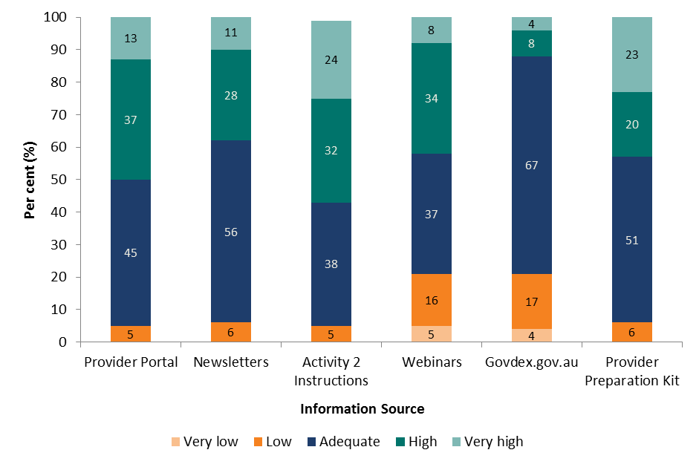

Source: Quality Manager Post-Pilot Survey (Appendix Table C2)   
Note: The “don’t know” category has been removed from the graph, values recalculated.

Providers also considered the information to be useful when asked in the Mid-Pilot Review, 2013 (Figure 3.2)[4].

Figure 3.2: Provider responses (per cent) on the usefulness of various departmental information sources on providing adequate information in understanding the audit requirements

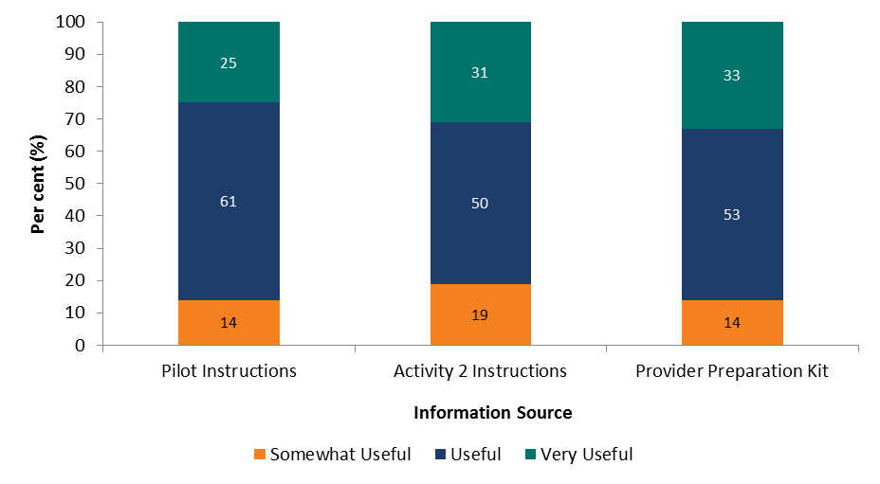

Source: The Mid Pilot Review, 2013 (Appendix Table C1)

While auditors were generally positive about the information made available to them, specific feedback concerning each information source was not identifiable given the low response rate received through the Auditor Post-Pilot Survey, 2014. Where available, anecdotal comments provided in the post-Pilot survey or made at the focus groups have been considered.

Each information source is considered in more detail below.

* + 1. **Pilot** **Instructions**

When asked mid-Pilot about the Pilot Instructions, 86 per cent of Providers indicated they considered the information to be very useful or useful, while the remainder considered the information to be somewhat useful (Figure 3.2).

Just over one-quarter (28 per cent) of Providers indicated in the Mid-Pilot Review, 2013 that they had queries that were not addressed by the Pilot Instructions (Figure 3.3). While 19 per cent of these respondents had not raised the query with anyone, the majority (51 per cent) sought information by calling or emailing the Pilot QAF Support Team in the department.

Figure 3.3: Provider responses (per cent) on how they seek clarification for questions not raised in the audit

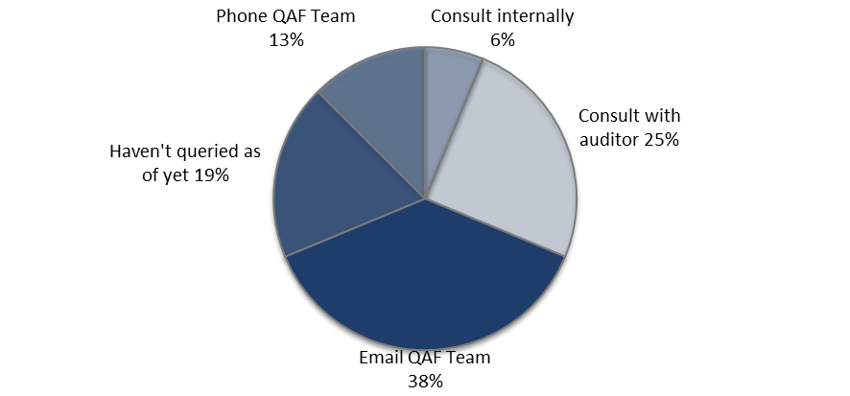

Source: The Mid-Pilot Review, 2013 (Appendix Table C3)

* + 1. **Activity 2 Instructions**

Of all information sources, the quality of information in the Activity 2 Instructions was generally rated high or very high (56 per cent) by the highest number of Quality Managers (Figure 3.1). Only five per cent considered the quality of the information to be low.

The responses on the usefulness of the Activity 2 Instructions were similar to the Pilot Instructions. Eighty-one per cent of Providers indicated the Activity 2 Instructions were very useful or useful and the remaining respondents thought they were somewhat useful (Figure 3.2).

* + 1. **Evidence Guide**

The Evidence Guide outlined the evidence required for Providers to meet each departmental Quality Principle in the Pilot QAF. Feedback collected mid-Pilot from Providers was very positive with over 92 per cent agreeing or strongly agreeing it helped them prepare for the audit and was relevant to their organisation (Figure 3.4).

Figure 3.4: Quality Managers’ assessment (per cent) of usefulness of the Evidence Guide

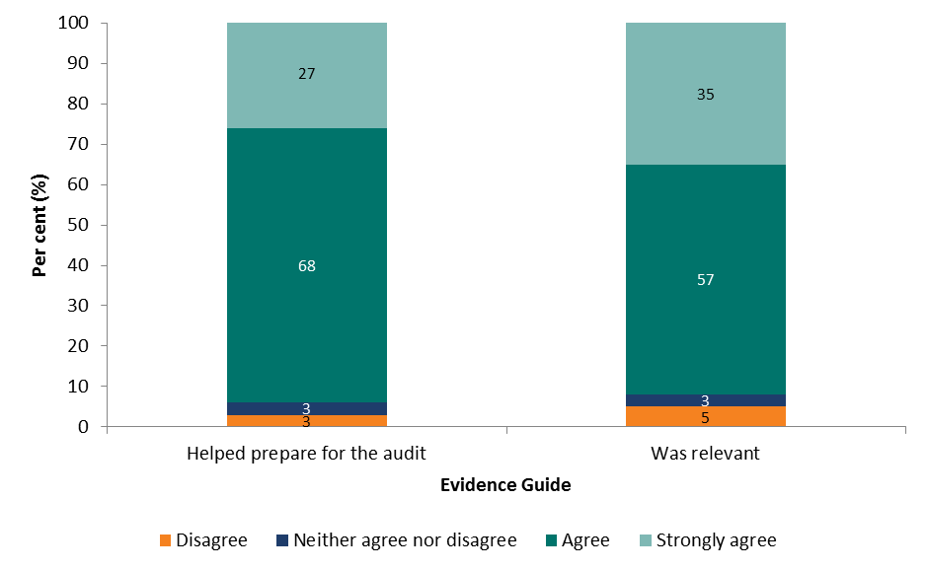

Source: Quality Manager Post-Pilot Survey, 2014 (Appendix Table C4)

Note: The “don’t know” category has been removed from the graph, values recalculated.

* + 1. **Provider Preparation Kit**

Positive feedback was also received for the Provider Preparation Kit with 43 per cent of Providers agreeing the quality of the information was high or very high. Only five per cent indicated the quality was low (Figure 3.1).

All JSA Providers found the Provider Preparation Kit to be at least somewhat useful, with 86 per cent finding the document useful or very useful (Figure 3.2).

* + 1. **Newsletters**

Newsletters were also a favoured source of information by Providers, with 95 per cent of Quality Managers considering the quality of information in newsletters to be at least adequate (39 per cent high or very high). Newsletters were distributed bi-monthly and this frequency was satisfactory for three-quarters (74 per cent) of Quality Managers. The remaining 26 per cent wanted the newsletter distributed more frequently (Quality Manager Post-Pilot Survey, 2014).

Auditors also favoured the Newsletters as a form of disseminating information. In focus groups they overwhelmingly agreed they were the most effective means of providing information and were mostly in agreement as to the frequency (Auditor Focus Groups, 2014):

“For me the Newsletters were of great value especially in the clarification of those cloudy areas”.

Auditor (Auditor Focus Group, February 2014)

“I preferred newsletters to Govdex as Govdex requires interaction with other auditors.”

Certification Body (Auditor Focus Group, February 2014)

“I found the newsletters quite good cause they actually summarised a lot of the things into smaller pieces.”

Auditor (Auditor Focus Group, January 2014)

* + 1. **Provider Portal**

The quality of information on the Provider Portal was rated high or very high by half of Providers. Only the *Activity 2 Instructions* were rated high or very high in more instances. Only five per cent of respondents considered the quality to be low (Figure 3.1).

* + 1. **Provider Webinars**

While 42 per cent of Providers considered the quality of webinar information to be high or very high, webinar quality was considered one of the lowest, with 21 per cent of Quality Managers surveyed indicating it was low or very low (Figure 3.1). Suggestions for improvement from the Quality Managers who rated the quality of webinar information as low or very low included providing more practical information and allowing more interaction between participants (Quality Manager Post-Pilot Survey, 2014):

“I rarely got any nuggets of gold from the webinars. More practical information would have been helpful.”

Quality Manager, Provider (Quality Manager Post-Pilot Survey, 2014)

“The webinars did not provide any real information that was useful at the time. More practical hands-on information would have been appreciated and would have assisted in the audit process itself. For example, how the audits were expected to be conducted in relation to the DEEWR Quality Framework, how much detail the auditors would be expected to look at.”

Quality Manager, Provider (Quality Manager Post-Pilot Survey, 2014)

“(The department should) provide specific information prior to the webinars which Providers need to look at and prepare input so that it can lead to greater discussion. Have those Providers who have gone through the exercise talk openly about what worked well and what didn’t and the reasons and then get input from others.”

Quality Manager, Provider (Quality Manager Post-Pilot Survey, 2014)

* + 1. **Govdex**

There were mixed Provider views on the success of www.govdex.gov.au in communicating information, with over one-third (38 per cent) of Quality Managers not knowing how to rate the quality of information on the website (refer Appendix Table C2). This may indicate Govdex was unknown to a proportion of Quality Managers, resulting in their unwillingness to rate its quality.

Only 12 per cent of Providers who rated the quality of Govdex information considered it to be high or very high; 21 per cent rated the quality as low or very low (Figure 3.1).

Auditors also had mixed views on the usefulness of Govdex for the implementation of the Pilot QAF. In focus groups, some auditors indicated they did not use or even know about Govdex. Those who were aware of it had concerns about its usefulness and did not use it to its full capacity:

“Govdex navigation wasn't great but useful info there - chat facilities not used so really just a storage facility.”

Auditor (Auditor Focus Group, January 2014)

“I preferred newsletters to Govdex as Govdex requires interaction with other auditors.”

Auditor (Auditor Focus Group, January 2014)

“I think Govdex would be a great resource but was messy.”

Auditor (Auditor Focus Group, January 2014)

* + 1. **Auditor Information Sessions**

The general consensus from auditors in the focus groups was that the information sessions conducted by the department were “well run, useful and informative” (Auditor Focus Group, January 2014). Suggestions for improvement included:

* Making the information sessions available online for auditors to access at any time (it is noted the sessions were actually available online via Govdex, however, given the analysis above suggests awareness of Govdex was low auditors may not have realised this information was available):

“If they were available in a webinar format that trainees could log into in the future that would be good. Certification bodies could then run them if they wanted to up skill their staff. Sorry - accessible at any time. Not on specific days and times.”

Auditor (Auditor Focus Group, January 2014)

* Providing more notice for the scheduling of information sessions, as some auditors noted they can be pre-booked for three to six months in advance (Auditor Focus Group, February 2014).
* Including more practical information with best practice and real world examples to highlight traps that auditors could fall into.

## Appropriateness of information

* + 1. **Information for Providers**

Feedback from Providers suggests the department delivered a great deal of information in a timely fashion. Mid-way through the Pilot, 89 per cent of Providers thought information provided to them was sufficient (Mid-Pilot Review, 2013). Post-Pilot the majority of Quality Managers (82 per cent) felt the volume of information to support their understanding of the Pilot QAF was about right (Quality Manager Post-Pilot Survey, 2014).

However, post-Pilot feedback from Quality Managers suggests there is some opportunity for improvement in terms of information content (Quality Manager Post-Pilot Survey, 2014):

* Approximately one-quarter (23 per cent) of surveyed Quality Managers indicated there was information missing from the documents provided by the department.
* A third of responding Quality Managers either disagreed or indicated they neither agreed nor disagreed that information was available when it was needed.

However, the comments do not suggest any specific areas for improvement.

* + 1. **Information for Auditors**

Although auditors on the Activity 2 Panel consisted of auditing bodies from Joint Accreditation System of Australia & New Zealand (JAS-ANZ) and were supplemented with recommendations from Providers, there was no guarantee that auditors who conducted the audits had any experience of employment services. Indeed, feedback through this evaluation suggests that some auditors were not familiar with employment services, the JSA model or the Employment Services Deed. Auditors recognised this lack of knowledge was a challenge for them in conducting the audit:

“As we did not have knowledge of JSA and JSA Principles we were on the back foot at the beginning with a lot of the learning taking place on the way.”

Auditor (Auditor Focus Group, February 2014)

“The information was adequate … however if the Auditor had only a little knowledge of JSA and JSA Principles it would have been very difficult for them. If the exercise were to be done again, I would suggest that the Department produce a training package for the Certification Bodies to review and administer”.

Certification Body (Auditor Focus Group, February 2014)

In addition, many Providers identified a challenge during the audit process was needing to educate auditors who did not have the required knowledge or understanding to carry out the audit. This had flow-on effects for the timeliness (and subsequent cost) of the audit reports to the Provider for certification against a Quality Standard and the Quality Principles:

“Our auditor was also on a learning curve in terms of getting an understanding of the Deed beyond the boundaries of ISO 9001 requirements. Therefore an on-going investment by the Department in training auditors will reap benefits in ensuring the effectiveness of the service wide implementation of the QSP in 2015.”

CEO, Provider (CEO Post-Pilot Survey, 2014)

“The additional requirements by using DSS as the certification standard along with the Auditors lack of program knowledge resulted in inefficiencies and additional cost to [Provider name].”

Quality Manager, Provider (Quality Manager Post-Pilot Survey, 2014)

“Also a big challenge was [Provider name] and its members having to 'educate' the Auditors in the JSA program, particularly with claims and participation requirements.”

Quality Manager, Provider (Quality Manager Post-Pilot Survey, 2014)

I'm not sure if it was the information or the process that was not the best. I believe expecting external auditors to have a practical understanding of the requirements of the DEEWR Quality Framework was unrealistic. I don't believe there was any real benefit from having the Quality Framework audited as the understanding of any external auditor would have been extremely limited and would have only a superficial understanding of the requirements of the contract. Particularly in relation to auditing claims and files. I am not sure what was provided to Auditors but there was not clarity in the process.”

Quality Manager, Provider (Quality Manager Post-Pilot Survey, 2014)

Account Managers also suggested Providers had these experiences:

“One of the main challenges that [Provider name] experienced was in relation to the auditor's understanding of what was required in terms of the items to be reviewed and the context of the report to be generated. Feedback from the auditor indicated that they believed the department could have done a better job providing resources and explaining the required content of the reports to them”.

Account Manager, Department of Employment (Account Manager Post-Pilot Survey, 2014)

“Some auditors were not fully briefed”.

Account Manager, Department of Employment (Account Manager Post-Pilot Survey, 2014)

Although many auditors agreed the information they required was generally available, feedback suggests there was a significant amount of information they were required to familiarise themselves with in order to become knowledgeable enough about t he subject matter to undertake the audit in a timely manner:

“There was lots of information, but it required a lot of work to go through that information, and sort of put it into an understanding for myself to be able to use quickly in an audit … it required a lot of work to syphon through it. Oh, huge. Just the deed in itself is huge. So then there were the guidelines and there was a lot of duplication.”

Auditor (Auditor Focus Group, January 2014)

“Note that auditors are out auditing most of the time, not sitting in an office so accessing web sites, Govdex etc. is done when time permits between audits. Knowing exactly what is important and where to find it is useful information - perhaps a short 'where is what' list(would be useful)”.

Auditor (Auditor Focus Group, January 2014)

The knowledge, in terms of the level of detailed knowledge required of auditors, will be an ongoing challenge for the department. Some suggestions made by auditors to assist their preparation for the QAF process include:

* More structured information, with checklists where appropriate:

“Better organised information would have been helpful with possibly some key checklists.”

Auditor (Auditor Focus Group, January 2014)

“What I had to do to have a successful efficient and quick audit was to get that information and to put it into tech lists. Things I was going to ask the client, things – the documents I wanted to see. Records I wanted to see, the types of questions I had to ask the staff, management and all levels of staff just to be able to put it into your findings, your report, which were quite specific, in the types of information and the amount of information that you wanted. That was quite a lot in itself.”

Auditor (Auditor Focus Group, January 2014)

* Provision of a best practice audit report:

“Example audit reports (best practice) would be very useful.”

Auditor (Auditor Focus Group, January 2014)

“Examples of reports would be useful, particularly in regards to content for the quality principles. E.g. what is adequate evidence, what is not enough, what is too much.”

Auditor (Auditor Focus Group, January 2014)

* A departmental contact (it is noted a phone number and email address was available to auditors, however, comments suggest it could have been more effectively communicated to auditors):

“It would have been more helpful to someone available before the audit as part of the planning process before you go on site e.g. to understand the Deed, confirm sites etc.”

Auditor (Auditor Focus Group, January 2014)

“A general contact – phone and email query ‘hot line’ would be wonderful.”

Auditor (Auditor Focus Group, January 2014)

## Summary

There are a number of ways the department disseminated information about the Pilot process and the revised QAF to Providers and auditors. The findings suggest that while all methods were effective, some were more favoured by Providers and auditors than others.

Survey feedback from Quality Managers suggests the Pilot Instructions, Activity Two Instructions, Evidence Guide, Provider Preparation Kit, Newsletters and Provider Portal were effective forms of communication and assisted Providers in preparing for the Pilot, and by extension, the QAF. Indications are that these types of documentation should be factored in when considering ways of informing Providers and auditors about the new QAF.

Webinar information sessions worked well for auditors but less so for Providers. Providers would like to see information sessions improved by providing more hands-on practical information and more interaction. Auditors also noted webinars could be improved by providing the information from the sessions online and giving more notice about the timing of webinars.

Although the potential for Govdex was recognised, many Providers and auditors were not aware of the resource or did not see value in it. There are opportunities for this communication tool to be used more effectively in the future and better promotion of its benefits may support this.

A key challenge for auditors is they have limited knowledge and understanding of employment services, the JSA Model and the Employment Services Deed. While there is a significant amount of information available to auditors it is difficult to become familiar with it all in a short timeframe. This has impacted on Providers’ timeliness and resourcing requirements for obtaining certification.

Given these issues, consideration about the degree of knowledge the auditor is expected to have prior to an audit may need to be addressed for a future QAF model. This should include the extent to which individual auditors are required to be familiar with the Employment Services Deed if they are to be on a panel and whose responsibility it is to train them: the department or the auditing body.

Improvements in communication with auditors could also be made through tailoring information to auditor requirements and providing more practical examples, with auditors specifically requesting copies of ‘best practice’ audit reports. Auditors also requested the webinar information sessions be made available online and a departmental contact be available to answer their queries. Interestingly, these were both already available to auditors – the information sessions via govdex and a general QAF phone number and email address. This further suggests the department needs to consider opportunities to better promote the resources available on govdex. It also suggests the department should continue maintaining the QAF phone number and email address, or provide a specific departmental contact for auditors, and more effectively communicate the availability of this service.

# Implementation of the Pilot Quality Assurance Framework

This section considers the general experiences of Providers participating in the Pilot and auditors undertaking the certification process. The challenges associated with implementation of the Pilot QAF are also examined.

Feedback received from departmental Account Managers, auditors and Provider front-line staff, Quality Managers and CEOs is addressed where relevant.

## Choice of Quality Standard by Providers

To implement the Pilot QAF, Providers could choose one of four Quality Standards against which to certify their organisation. The most commonly selected Quality Standard was Standard ISO 9001 (66 per cent). While only one Provider was certified against Employment Services Industry Standards as at 26 March 2014, a further six Providers were working towards certification against this Quality Standard. If all are certified against this Quality Standard, Employment Services Industry Standards will be the second most commonly selected standard (Table 4.1).

Table 4.1: Standard that Providers were certified against or working towards (as at 30 April 2014)

| **Standard** | **No. certified** | **No. withdrew from certification** | **Total** |
| --- | --- | --- | --- |
| Standard ISO 9001 | 28 | 4 | 32 |
| Disability Service Standards | 4 | 2 | 6 |
| Investors in People | 1 | 2 | 3 |
| Employment Services Industry Standards | 1 | 6 | 7 |

Evidence collected for this evaluation suggests that selection of a Quality Standard for certification was not a simple exercise for Providers. Almost one-fifth (19 per cent) of Quality Managers reported working toward, or being certified in, a different Quality Standard from the one initially selected (Quality Manager Post-Pilot Survey, 2014). A number of Providers withdrew from the process as they were not able to meet the required timeframes.

The key challenge associated with selecting a Quality Standard appears to relate to the differing requirements of each Quality Standard, with flow-on implications for the audit. Some Quality Standards may be better aligned to the business model of the Provider. An example that recurred in the Pilot related to Providers with both Disability Employment Services and JSA interests. Given these Providers were already familiar with the Disability Service Standards some initially considered this Quality Standard for the JSA arm of their business. However, these Providers found that Disability Service Standards had onerous job seeker sampling requirements that were impractical and costly for larger JSA caseloads. Providers who originally chose Disability Service Standards cited the excessive on-site audit requirements as their motivation to switch:

“Once we got to the stage of submitting an audit plan it was clear that the amount of job seeker interviews and other on-site audit requirements (in DSS) were far too excessive for a JSA business caseload in excess of 30,000 … the time and cost involved made it untenable”

Quality Manager, Provider (Quality Manager Post-Pilot Survey, 2014)

“Initially it was thought that DSS would be appropriate as we had previously achieved certification for our DES contracts in remote ESAs. However once we got to the stage of submitting an audit plan it became clear that the amount of job seeker interviews and other on site audit requirements were far too excessive for a JSA business with a caseload in excess of 30,000. This was because of the formula used by DSS to establish the number of job seeker interviews required. The time and cost involved made it untenable. This was not made apparent to us by the chosen auditors until late in the process.”

Quality Manager, Provider (Quality Manager Post-Pilot Survey, 2014)

Specific feedback from auditors regarding the Quality Standards and Quality Principles is limited. However, one auditor also acknowledged the problems associated with the Disability Service Standards:

“DSS consumer sampling methodology was not designed for JSA - high numbers of job seekers required….Sampling requirement is too much for DSS as compared to other standards, It is extra financial burden on the Service provider.”

Auditor (Auditor Focus Group, January 2014)

The Employment Services Industry Standards was a problem for those who selected it as it had not been accredited when the Pilot began. Providers who initially selected Employment Services Industry Standards cited excessive delays. While some of these Providers switched to other Quality Standards, some ultimately withdrew, or could not complete the Pilot QAF certification process in the allotted timeframe (six Providers in total):

“Because initially we were working with ESIS and assumed that it was an accredited standard. The delays with JAS- ANZ were frustrating. We had a local auditor on board but it wasn’t until late December that they had to pull out due to the costs and extra administrative burden that would be imposed by JAS-ANZ. When this happened we did some research on other options and then decided that IiP was aligned a bit more with the culture of our organisation.”

Quality Manager, Provider (Quality Manager Post-Pilot Survey, 2014)

In addition, selection was difficult for Providers as they felt there was overlap between the Quality Standards and the Quality Principles (refer Section 4.5.3). Due to the complexities involved, Providers and auditors suggested the department supply a document mapping the departmental Quality Principles with each of the Quality Standards to aid selection of a Quality Standard and administration of the audit:

“There should be detailed mapping of the Principles against each of the selected Standards, with Principles or KPMs within Principles identified as being fully covered by the Standard, and therefore not requiring additional audit - Every effort should also be made to simplify the documentation and the process in every possible way.”

CEO, Provider (CEO Post-Pilot Survey, 2014)

“I think if there was a mapping exercise of the actual KPIs across the various standards (ISO 9001, ESIS, Quality Principles etc.) this may assist.”

Auditor (Auditor Focus Group, January 2014)

## Auditor selection

Once a Quality Standard is selected, Providers are required to engage an auditor from the department-supplied auditor panel and bring together the appropriate documentation for certification against both the chosen Quality Standard and the Quality Principles.

When asked to rank factors important in selecting an auditor, Quality Managers surveyed saw how well auditors fit with the Provider’s organisation as being most important, followed by the auditor’s reputation and having engaged them previously. The auditor’s comprehension of the process and cost incurred were the least important factors considered when selecting an auditor (Figure 4.1).

Figure 4.1: Provider responses (frequency) on ranking factors of choice of auditor

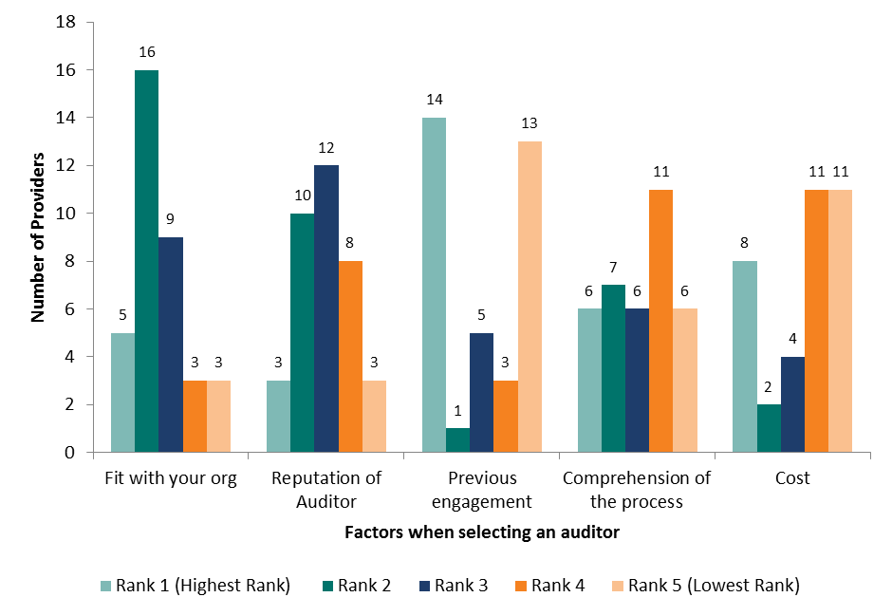

Source: The Mid-Pilot Review, 2013 (Appendix Table C5)

Interestingly, while only eight per cent of Quality Managers surveyed post-Pilot indicated they would not choose the same auditor in the future, almost half (42 per cent) reported not knowing whether they would engage the same auditor again (Figure 4.2).

Figure 4.2: Quality Managers’ views (per cent) on whether they would engage with the same auditor in the future

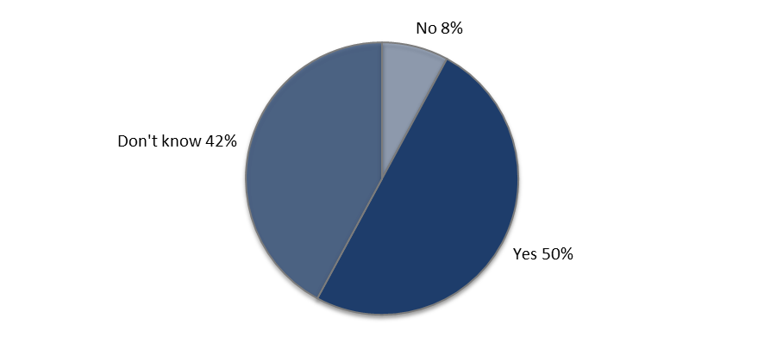

Source: Quality Manager Post-Pilot Survey, 2014 (Appendix Table C6)

Of the Providers who indicated they would engage the same auditor in the future, similar reasons were reported as those indicated for initial selection in the Mid-Pilot Review, 2013. Providers reported the professionalism in the auditors’ service, their comprehension of the process and fit with their organisation as the main reasons for engaging the same auditor in the future:

“Our auditors were knowledgeable, comprehensive and fair in their dealings with us throughout the process.”

Quality Manager, Provider (Quality Manager Post- Pilot Survey, 2014)

“Experience they brought to the table and the care they demonstrated when dealing with clients and interview process.”

Quality Manager, Provider (Quality Manager Post-Pilot Survey, 2014)

“They have a comprehensive understanding of our organisation by conducting the ISO and DSS audits.”

CEO, Provider (CEO Post-Pilot Survey, 2014)

“The auditor was fair and focused on ‘Continuous Improvement’ and process-based rather than purely compliance and made the staff feel at ease.”

Quality Manager, Provider (Quality Manager Post-Pilot Survey, 2014)

Given that this was the first time Providers selected an auditor for the purposes of certification, that there was no obvious pattern of factors especially important to Providers is perhaps not surprising. As Providers and auditors become more familiar with the audit process the qualities that Providers are looking for in an auditor, such as those mentioned above in the comments, may become more apparent.

## Communication with auditor

The volume of communication between Providers and auditors varied while preparing for the audit. Of those Providers who had consulted with the auditor at the time of the Mid-Pilot Review, 2013, one-third (33 per cent) reported having less than six hours of communication time between their organisation and the auditor prior to audit, while just over half (56 per cent) had 11 hours or more (Figure 4.3).

Figure 4.3: Hours of communication time between organisation and the auditor prior to audit (per cent)

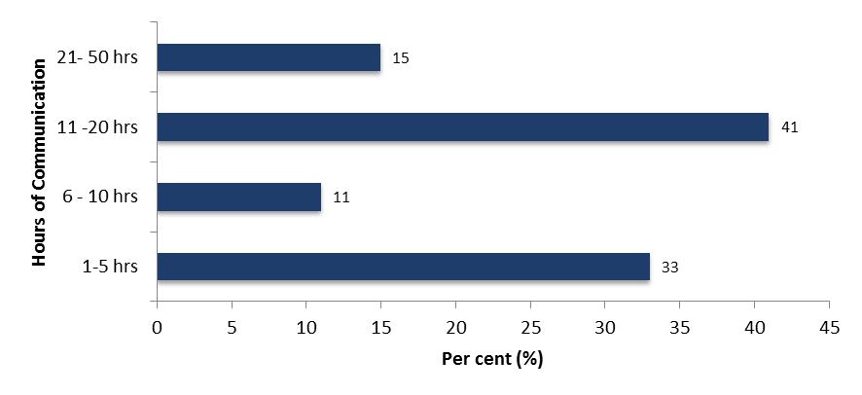

Source: The Mid-Pilot Review, 2013 (Appendix Table C7)

Note: Those respondents who had yet to consult with an auditor were removed, values recalculated.

## Conduct of the audit

* + 1. **Auditor views**

Feedback received from auditors in the focus groups suggested most had good relationships with Providers. They attributed this to management being committed to the Pilot QAF:

“We were fortunate to have a client who was very proactive in managing the process and communicating with staff and us. They had a dedicated Project Manager and team and a Working Party with staff representatives from across the business. A best practice change management approach with regular site interaction and communications across the business. On-site awareness was high and people welcomed the opportunity to be interviewed by the auditors.”

Auditor (Auditor Focus Group, January 2014)

“Communication with the providers has been excellent as the contact has been an existing client from a DSS or 9001 point of view- have generally been communicating with (from a planning point of view) with the GM and the quality representative.”

Auditor (Auditor Focus Group, February 2014)

“We found providers to be very helpful and understanding. We were learning and so were they so there was ease in communication. One provider was an existing client and their contact was very helpful in allowing us to understand the industry. (I had) No understanding (of the industry) at all.”

Auditor (Auditor Focus Group, February 2014)

The main Provider point of contact for auditors was Quality Managers however CEOs, Site Managers and other staff were also frequently contacted throughout the preparation and audit processes:

“With me there were about 5 sites involved and the QM [Quality Manager] came with me to each of the sites. At the HO [Head Office] which was where the QM was located I generally contacted one-on-one with a person like the CEO etc. But the QM was always there to assist if needed which really helped a lot.”

Auditor (Auditor Focus Group, February 2014)

“[We communicated to] all levels from CEO to state and site managers to support staff - As well as finance, HR, QA.”

Auditor (Auditor Focus Group, January 2014)

“I had the 3 top management - Director of Employment Service, Site Manager (Senior) and Quality Manager - was at my disposal for all site visits and for the whole 7 days. This assisted with ensuring appropriate records were available.”

Auditor (Auditor Focus Group, January 2014)

Departmental staff on occasion observed auditors undertaking site visits. While the insight the staff provided and the ability of the Account Managers to give feedback was appreciated, some auditors offered mixed views about their presence:

**“**We did have a few people for few days. They were basically observing and didn’t have anything to say, in fact they were learning the process. I think the whole process to them was fairly new to them and the auditors. They were mainly interested in as to what the auditors were looking for, and what evidence they were looking for. The request was made by the department and the provider agreed so this is why we agreed. But at the end of the day I think it was a good thing they were there. At the start I was apprehensive but at the end I was happy that they were there.”

Auditor (Auditor Focus Group, January 2014)

“Sometimes at small sites there were too many assessors or Department representatives.”

Auditor (Auditor Focus Group, February 2014)

“I had representatives from the Department on all three Audits and I found them to be most informative, even though they were supposed to be a fly on the wall. However … it is difficult for the client to experience a one-on-one conversation and it becomes more difficult for them to have multiple people in the interview.”

Auditor (Auditor Focus Group, February 2014)

* + 1. **Provider views**

As shown in Figure 4.4, Quality Managers surveyed post-Pilot were generally satisfied the audit was conducted in line with the intention of the audit process.

Figure 4.4: Quality Manager views on the conduct of the audit being aligned with the aims of the process (per cent)

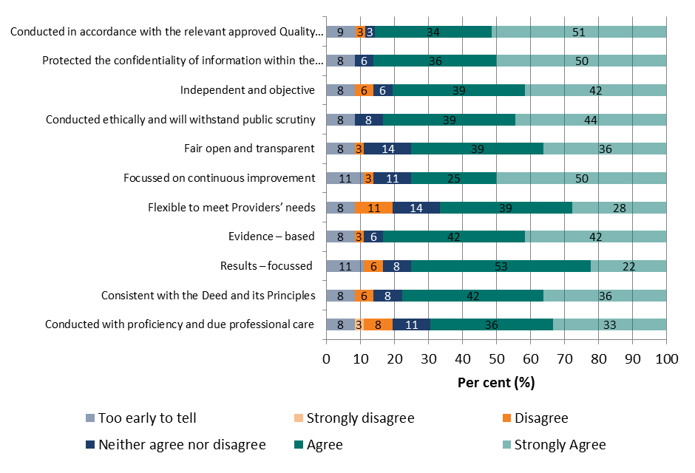

Source: Quality Manager Post-Pilot Survey, 2014 (Appendix Table C8)

Note: The “don’t know” category has been removed from the graph, values recalculated.

Rating particularly high, over 80 per cent of Quality Managers agreed or strongly agreed the audit:

* protected the confidentiality of information within the boundaries of the Deed (86 per cent)
* was conducted in accordance with the relevant approved Quality Standard (85 per cent)
* was evidence based (84 per cent)
* was conducted ethically and will withstand public scrutiny (83 per cent), and
* was independent and objective (81 per cent).

While a small proportion of Quality Managers disagreed with the following statements, approximately three-quarters of Quality Managers agreed or strongly agreed the audit was:

* consistent with the Deed and its Principles (78 per cent)
* fair open and transparent (75 per cent)
* results focused (75 per cent), and
* focused on continuous improvement (74 per cent).

Lower, though still positive results, were expressed by Quality Managers that the audit was:

* always conducted with proficiency and due professional care (69 per cent), and
* flexible to meet Providers’ needs (67 per cent).

***The commitment of the audit to continuous improvement***

An aim of the Pilot QAF, as outlined in the *Pilot Instructions*, was to encourage Providers to strive for continuous improvement in the delivery of employment services. Feedback collected through this evaluation suggests respondents perceive the Pilot QAF achieved this.

Quality Managers were in agreement the audit was or had been focused on continuous improvement (75 per cent agreed or strongly agreed). However, a proportion (11 per cent) recognised that it was ‘too early to tell’ (Figure 4.4 above).

Quality Managers also had the opportunity to comment as part of the post-Pilot survey about the main benefit of participating in the Pilot. Approximately a quarter of Quality Managers who provided comments indicated they believed continuous improvement was a key benefit of the audit:

“Embedding culture of continuous improvement across the organisation. Identification of skills gaps and addressing with staff through training and professional development.”

Quality Manager, Provider (Quality Manager Post-Pilot Survey, 2014)

“Identifying areas to continue to improve in our QMS, and put us in a good position moving forward to keep improving our practices and a better service to all stakeholders.”

Quality Manager, Provider (Quality Manager Post-Pilot Survey, 2014)

“Implementation of a QA system that will lead to a full continuous improvement process. Establish fully documented best practice processes for all sites.”

Quality Manager, Provider (Quality Manager Post-Pilot Survey, 2014)

“Formal recognition of continuous improvement being a central tenet of services. A heightened awareness of quality principles by staff.”

Quality Manager, Provider (Quality Manager Post-Pilot Survey, 2014)

Some departmental Account Managers also noted the benefit to continuous improvement activities of the Providers:

“Provides an opportunity for [Provider] to review processes with a view to continuous improvement.”

Account Manager, Department of Employment (Account Manager Post-Pilot Survey, 2014)

“[Provider] were very positive about participating in the QSP (sic). QSP has assisted them to improve their weaknesses and celebrate and build on their strengths. They have recently restructured their organisation to implement continuous improvement, especially in their administrative procedures. Whilst the respondent to this survey has not indicated any improvement, it is to be noted that there has not been enough time elapsed to correctly gauge or measure this. We do note that the recent CAP results showed a 3 per cent improvement. We will be noting with interest any improvement in PAU and site monitoring results over the next 6 months.”

Account Manager, Department of Employment (Account Manager Post-Pilot Survey, 2014)

## Challenges undertaking the Pilot and implementing the Pilot Quality Assurance Framework

Implementing the Pilot QAF within the required timeframe was a challenge for Providers, in terms of financial cost, staff time and resources. This was acknowledged by all respondents involved in the evaluation. In addition, concern was expressed regarding the duplication between the Quality Standards and the Quality Principles and the sampling requirements for audits.

* + 1. **Financial cost**

As shown in Figures 4.5 and 4.6, there was a significant range of responses from Provider CEOs and Quality Managers when asked to consider the costs associated with the audit.

In terms of the cost of preparing for certification, the highest cost specified by a Quality Manager was $260,000 and $250,000 by a CEO. The lowest cost quoted by both a Quality Manager and a CEO was $10,000.

A high proportion of Quality Managers (55 per cent) were not aware of the preparation costs of the audit but those that were aware generally specified a higher cost than CEOs (Figure 4.5).

Figure 4.5: Cost of preparation for certification, as reported by CEOs and Quality Managers

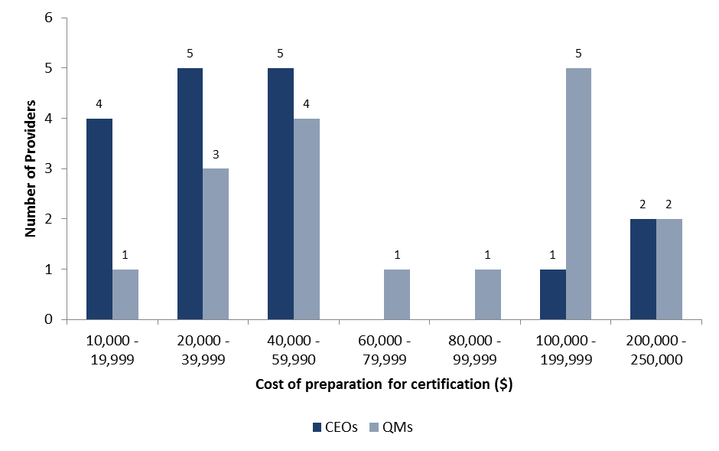

Source: CEO Post-Pilot Survey, 2014 and Quality Manager Post-Pilot Survey, 2014 (Appendix Table C9)

Note: The “don’t know” category has been removed from the graph, values recalculated.

The cost of the audit was considered to be less than the cost of preparing for the audit. The highest cost identified by a Quality Manager was $150,000 and $100,000 by a CEO. The lowest cost quoted by a Quality Manager was $2,700 and $4,000 by a CEO (Figure 4.6).

Figure 4.6: Cost of the audit, as reported by CEOs and Quality Managers

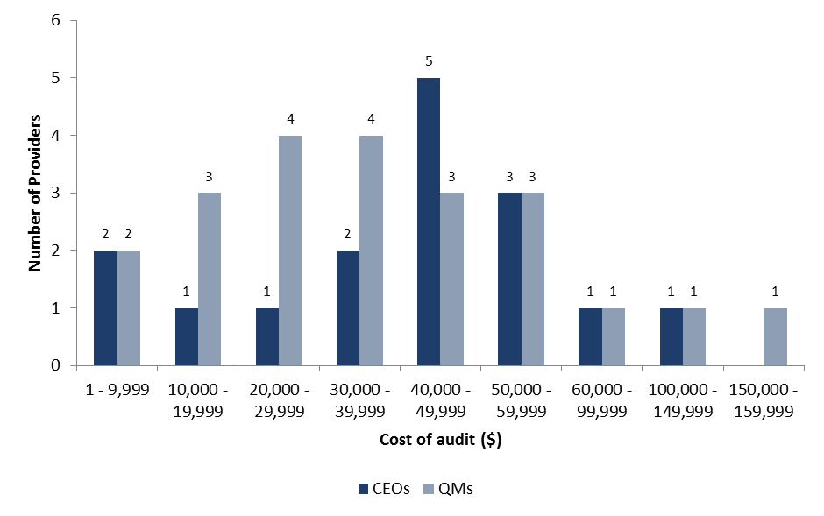

Source: CEO Post-Pilot Survey, 2014 and Quality Manager Post-Pilot Survey, 2014 (Appendix Table C10)  
Note: The “don’t know” category has been removed from the graph, values recalculated.

As the recorded preparation costs and audit cost varied significantly the average is perhaps not the most reliable indicator of cost. It is therefore more appropriate to consider the recorded median. The overall median audit cost was $36,000, with the medians recorded by CEOs and Quality Managers being relatively similar (Table 4.2).

While the overall median cost for audit preparation was $47,500, Quality Managers recorded a higher median of $60,000, as opposed to the CEO median of $30,000 (Table 4.2). This may reflect the higher level of Quality Manager involvement in the process and the greater knowledge they have regarding the preparation involved. However, it is noted the majority of respondent Quality Managers (55 per cent) did indicate that they “didn’t know” the preparation costs of the audit. More than likely it reflects the fact that audit costs are set and known, while preparation costs are more subject to a Providers’ view of the level of staff involvement required for certification.

Table 4.2: Average and median cost of preparation and audit, as reported by Quality Managers and CEOs

| **Reported by** |  | **Preparation Cost** | **Audit Cost** |
| --- | --- | --- | --- |
| Provider CEO | Average  Median | $58,721  $30,000 | $41,000  $40,000 |
| Quality Manager | Average  Median | $89,529  $60,000 | $40,194  $35,000 |
| Total | Average  Median | $74,125 $47,500 | $40,545 $36,000 |

Source: CEO Post-Pilot Survey, 2014 and Quality Manager Post-Pilot Survey, 2014

Even though Providers understood the benefits of the Pilot QAF and survey results showed they generally endorsed it, comments suggest that costs were a significant challenge in implementing the Pilot QAF:

“The financial cost of the pilot is significant.”

Quality Manager, Provider (Quality Manager Post-Pilot Survey, 2014)

“We have mixed feelings about our participation in the Pilot, whilst I believe our participation in the ability has provided us with the opportunity to improve the quality of our services, I am yet to see the results in our financial statements. We could have the highest quality service and go broke implementing and maintaining a quality standard.”

CEO, Provider (CEO Post-Pilot Survey, 2014)

“Overall we have appreciated taking part in the Quality Standards Pilot, but the costs associated with resourcing this are immense. The time taken to resource participation in the Pilot is time taken away from supporting job seekers. It should be noted that the audit principles and key performance measures were too open to interpretation, causing confusion between auditors and the Department.”

CEO, Provider (CEO Post-Pilot Survey, 2014)

“The Quality Standards Team was very professional, helpful and efficient. However the prescriptive process for participation in the QS Pilot made this an administration and compliance exercise for us rather than a great opportunity to instil a quality focus and culture. This was a significant distraction, cost and burden to the organisation.”

CEO, Provider (CEO Post-Pilot Survey, 2014)

For almost two-thirds (64 per cent) of respondent Providers the cost of participating in the Pilot was more than expected. Only one in 10 thought the cost was less than expected (Figure 4.7).

Figure 4.7: Cost against expectation (per cent) of participating in the Pilot, as reported by Quality Managers

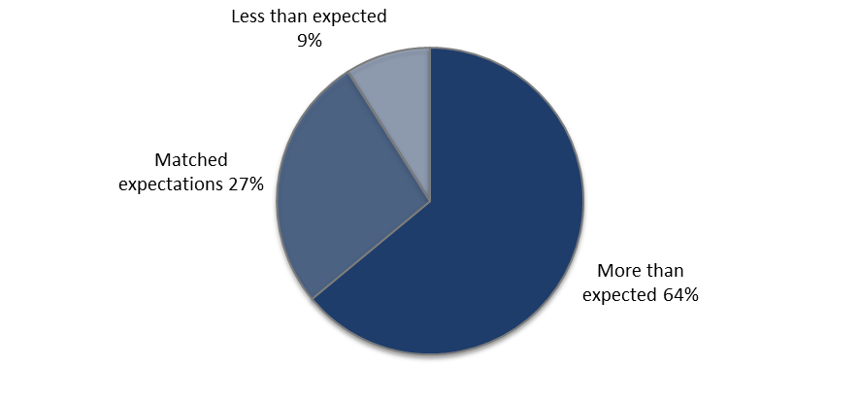

Source: Quality Manager Post-Pilot Survey, 2014 (Appendix Table C11)

* + 1. **Time**

The length of time Providers considered appropriate to prepare for certification against the Pilot QAF varied. Based on Quality Managers’ experience during the Pilot, half (51 per cent) considered an appropriate timeframe to be 12 months or more but less than 18 months. This is not unexpected given the original 12 month timeframe for certification was extended to 31 March 2014 to accommodate some Provider requests.

Figure 4.7: Appropriate timeframe for certification against a Quality Standard and the Quality Principles

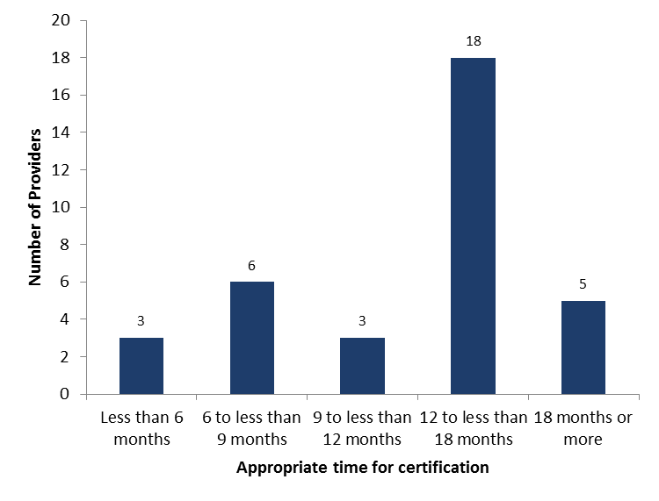

Source: Quality Manager Post-Pilot Survey, 2014 (Appendix Table C15)

Note: The “don’t know” category has been removed from the graph, values recalculated.

Estimations of the amount of time spent supporting the Pilot QAF process also varied. One Quality Manager reported that no staff time was spent preparing for and supporting the audit. The highest reported figure was 6,088 hours of staff time. This variation results in significant differences between the median and average hours of staff time preparing for and supporting the audit – the reported median was 500 hours[5] and the average was 1,111 hours[6] (Figure 4.9).

Figure 4.8: Hours of staff time spent preparing for and supporting the audit, as reported by Quality Managers

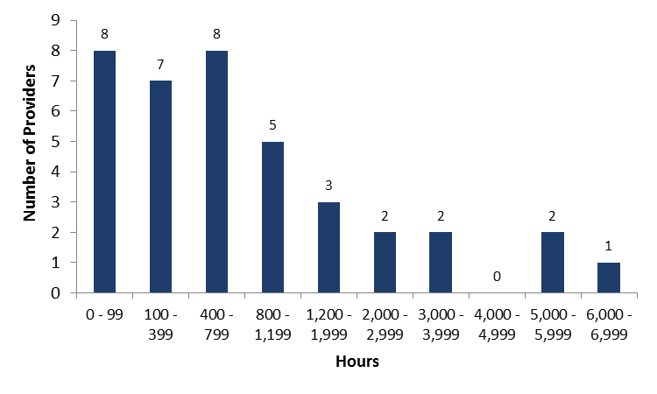

Source: Quality Manager Post-Pilot Survey, 2014 (Appendix Table C13)

Similar to the financial impost, the time spent preparing for and supporting the audit exceeded the expectations of over two-thirds (68 per cent) of Quality Managers (Figure 4.9).

Figure 4.9: Time spent preparing for and supporting the audit compared to expectations, as reported by Quality Managers

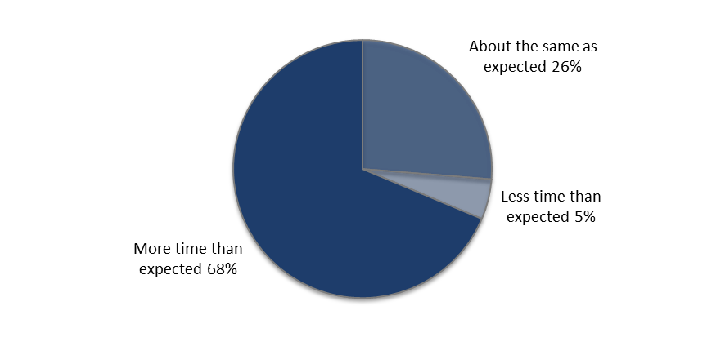

Source: Quality Manager Post-Pilot Survey, 2014 (Appendix Table C14)

Delays to the audit and certification process were considered a key contributing factor to the significant amount of time spent on the audit and a large proportion of Quality Managers (41 per cent) reported delays (Quality Manager Post-Pilot Survey, 2014). These delays resulted in some Providers being granted an extension in their timeframe and some Providers ultimately withdrawing from the Pilot altogether:

“The time taken to prepare for audits, calming the worries of staff at those sites that were audited, meeting the DEEWR timeline when changes to scheduled auditors delayed the audit process [were the biggest challenges].”

Quality Manager, Provider (Quality Manager Post-Pilot Survey, 2014)

“[The biggest challenges were] time and resources within a highly competitive performance based environment. The deadline for the pilot was challenging due to the enormity and detail outlined in the principles.”

CEO, Provider (CEO Post-Pilot Survey, 2014)

Account Managers also noted, on behalf of Providers, the time (and cost) pressures associated with the audit requirements:

“[The biggest challenges were] time and resources. There has been a lot time needed to participate in audit and implement business improvement processes.”

Account Manager, Department of Employment (Account Manager Post-Pilot Survey, 2014)

“…time and financial stresses were the most challenges aspects. Staff involved often stated the requirements appeared excessive and that it cost the organisation a substantial amount of money to meet the standards”

Account Manager, Department of Employment (Account Manager Post-Pilot Survey, 2014)

“The provider discussed the financial impact of gaining certification, and also queried whether the range of Program Assurance activities currently undertaken by the Department would be reviewed (or possibly scrapped) if the policy was implemented, particularly given the ‘reduction of red tape’ environment.”

Account Manager, Department of Employment (Observer Feedback for Pilot Audits)

Auditors reported delays to the audit process, particularly as a result of Providers being unprepared for the audit. In particular, job seeker interviews were raised by several auditors as having disrupted the audit process:

“One of our JSAs did not prepare well for the audit. The job seekers did not arrive and the auditors had to pick walk-ins. This was very disruptive to the audit as it was stop and start on the interviews. More onus should be placed on the provider to make sure this area is covered.”

Auditor (Auditor Focus Group, February 2014)

“On a couple of sites the staff did not appear at all and there was no communication with either SP or audit team.”

Auditor (Auditor Focus Group, January 2014)

While auditors gave this feedback about job seeker interviews, Providers have indicated through the Pilot Reference Group meetings that sourcing feedback directly from job seekers has provided them with better insight and knowledge about their service delivery.

Providers found the most time consuming aspects of the process were usually audit-associated administrative tasks along with evidence gathering and booking interviews with job seekers:

“The time spent on administration - i.e. letter sending, organising interviews for high amount of clients (some exited and working full time and difficult to contact), high volume of face to face interviews.”

Quality Manager, Provider (Quality Manager Post-Pilot Survey, 2014)

“Time, evidence gathering and finding a suitable auditor.”

Quality Manager, Provider (Quality Manager Post-Pilot Survey, 2014)

Providers expressed concern the commitment of time and resources would extend into the future beyond the life of this process:

“Time and resources required. As a small organisation this has been particularly difficult, and it will be hard to maintain this commitment into the future.”

Quality Manager, Provider (Quality Manager Post-Pilot Survey, 2014).

“Resourcing, time, cost and our future ability to maintain accreditation given the small size of our organisation.”

CEO, Provider (CEO Post-Pilot Survey, 2014)

Providers and Account Managers, when considering challenges on behalf of Providers, noted that other priorities competed for the time available to undertake the Pilot QAF process. Some businesses had other major requirements occurring at the same time as the Pilot QAF. Other Providers noted the diversion of funds and resources into the Pilot QAF inevitably had an impact upon their business processes and service delivery. These concerns are enduring for Providers and will need to be considered as a new QAF is built into future employment services contracts:

“Time consuming. It did interrupt the running of the business.”

Quality Manager, Provider (Quality Manager Post-Pilot Survey, 2014)

“Time that operational staff were required to dedicate towards the pilot, which took away the focus from actual service delivery.”

Quality Manager, Provider (Quality Manager Post-Pilot Survey, 2014)

“Finding the time to prepare, manage and complete the process at a time when compliance requirements have increased, revenue is falling dramatically, and maintaining acceptable star ratings is increasingly difficult.”

CEO, Provider (CEO Post-Pilot Survey, 2014)

“Manageing the pilot while still completing intensive assurance activity.”

CEO, Provider (Quality Manager Post-Pilot Survey, 2014)

“The main challenge has been competing priorities such as implementation of RJCP for this provider.”

Account Manager, Department of Employment (Account Manager Post-Pilot Survey, 2014)

“Competing priorities. Keeping the business going while implementing change and introducing greater rigour whilst also dealing with major financial viability issues.”

Account Manager, Department of Employment (Account Manager Post-Pilot Survey, 2014)

* + 1. **Duplication**

Under the Pilot QAF, Providers were required to certify against both an approved Quality Standard and the eight departmental Quality Principles. The auditor was engaged to assess a Provider against both components of the Pilot QAF.

The generic nature of the Quality Standards meant all requirements of the Employment Services Deed could not be met through certification solely against the Quality Standard. The Quality Principles were designed to bridge this gap. At the time of drafting the Quality Principles it was anticipated there would be some overlap with the Quality Standards. The Pilot process was expected to assist in identifying the areas of duplication.

Through this evaluation, Providers and auditors have acknowledged the duplication between the Quality Principles and all four Quality Standards as well as between each of the Quality Principles themselves. The difficulty for Providers and auditors has been to determine where the gaps and the overlays between the Quality Standards and the Quality Principles have occurred as these vary depending on the Quality Standard:

“In respect to the reporting requirements between the department and the JAS-ANZ (for ISO 9001) there appears to be duplication and the two do not ‘lay on top of one other’ as much as we have first envisaged.”

Quality Manager, Provider (Quality Manager Post-Pilot Survey, 2014)

“The process is complicated in that 2 separate standards have to be met. This means that 2 separate gap analyses need to be undertaken in order to ensure that all items are covered. This is time consuming and adds to the expense of the accreditation process.”

Quality Manager, Provider (Quality Manager Post-Pilot Survey, 2014)

“Some of the Key Performance Measures overlap or are sufficiently similar that they could be combined. Providing a clear focus for providers will ensure a higher level of compliance and support an improved ability to meet all the requirements.”

Quality Manager, Provider (Quality Manager Post-Pilot Survey, 2014)

A Provider also outlined the duplication between the Quality Principles and the ongoing KPI3 assessment:

“Some of the items listed in the DEEWR Ongoing KPI 3 Assessment are already included in the Principles. Either the Principles or the DEEWR Ongoing KPI3 Assessment focus areas should be simplified, or the DEEWR KPI 3 Assessment is removed and incorporated into the Principles.”

Quality Manager, Provider (Quality Manager Post-Pilot Survey, 2014)

Further, an auditor noted that certifying against the Principles took longer than certifying against the Standard:

“Our experience was with 9001 and the 8 principles takes longer to cover than ISO. It takes longer to cover the requirement for the 8 than it does to cover the requirements of ISO. Particularly the reporting.”

Auditor (Auditor Focus Group, January 2014)

The overlap between the Quality Standards and the Quality Principles could account for some of the time and cost burdens for participation in the Pilot expressed by Providers. While it is important to capture multiple aspects of the Provider’s business to gauge quality, duplicating the assessment of any part of the business is inefficient, placing a greater burden on Providers’ time, money and resources.

Given the importance of this issue, the department has already acknowledged the concerns raised by Providers and consultation with the industry has commenced to streamline the Quality Principles and reduce overlap with the Quality Standards.

* + 1. **Compliance**

The sampling requirements for job seekers, claims reviews and file reviews were also critiqued aspects of the audit. Both auditors and Providers agree the focus of a large audit should be more on how the Providers managed the process rather than sampling the amount of transactions as required under the Pilot.

“It’s important to do job seeker interviews, but overall it’s not necessary in this pilot there’s an overemphasis of oversampling … and if you’re talking to any more than 10 people you’re really not getting any more useful information out of it.”

Auditor (Auditor Focus Group, January 2014)

“They (The requirements for the principles certification) have a lot of questions relating to all the KPMs so that is prescriptive and that may be the amount of information so not everyone may have gone through and really itemized everything they wanted but it is a general thing with the audit you do look at the process and the sufficient of evidence you feel is necessary to comply or not comply.”

Auditor (Auditor Focus Group, January 2014)

This issue has also been acknowledged by the department and Provider consultation is being undertaken to review the compliance and sampling requirements.

## Summary

Providers were able to select one of four Quality Standards to certify against within the 12 month Pilot period.

Selection of a Quality Standard for certification was a complex exercise for Providers and one-fifth reported they had changed from their original choice through the process. A number of Providers also chose to withdraw from the process as they were not able to meet the requirements in the timeframe.

Challenges arose because the requirements of each Quality Standard vary and some Quality Standards are more suited to different business models and caseload sizes. Comments suggest certification against Disability Services Standards for JSA purposes was considered to be more onerous than the other Quality Standards, particularly in terms of the job seeker interview requirement. The time required to certify against the Employment Services Industry Standards, given the delay in this Quality Standards certification, also impacted upon selection.

More generally, job seeker interviews were raised by several auditors as having disrupted the audit process and contributing to lengthy delays. Although job seeker satisfaction data is available from the department’s Post-Programme Monitoring Survey (KPI 3), Providers have been positive about the knowledge they have obtained through the collection of feedback directly from job seekers. It is expected that as Providers become more aware and prepared for the audit process, job seeker interviews will be less challenging for auditors to undertake.

Overall, feedback suggests Providers need to be fully informed as to the appropriateness of the Quality Standard they choose for their business model and understand its implications for the audit.

Providers were generally satisfied the audit was conducted in line with the intention of the audit process. A specific aim of the Pilot QAF was to encourage Providers to strive for continuous improvement in the delivery of employment services. Feedback collected through this evaluation suggests the audit is focused on continuous improvement and in this regard may provide evidence that a QAF shows more potential for driving continuous improvement than the existing KPI 3 Quality Framework measures.

The key challenges identified for implementation of the Pilot QAF within the required timeframe were costs, staff time and resources. Approximately two-thirds of Quality Managers indicated the cost of participating in the Pilot and the time spent preparing and supporting the audit was more than expected.

There was significant variation in estimations of the associated costs and time involved in the audit:

* The average median cost for audit preparation was $47,500 and $36,000 for the cost of the audit. While there was similarity between the median audit costs recorded by CEOs and Quality Managers, higher costs associated with audit preparation were recorded by Quality Managers.
* The reported median for the time spent supporting the Pilot QAF process was 500 hours. An appropriate timeframe for certification against a Quality Standard and the Quality Principles was considered to be 12 months or more but less than 18 months.

While it would have been valuable for the evaluation to consider whether the reported costs and time associated with the audit varied according to selected Quality Standard, this analysis was not possible. Comparisons between responses could not be drawn as the number of survey responses for each Quality Standard varied significantly and there was a particularly low number of respondents for Investors in People and the Employment Services Industry Standards.

The generic nature of the Quality Standards meant that there were gaps between the Quality Standards and the requirements of the Employment Services Deed, which were designed to be bridged by the Quality Principles. A further challenge documented by Providers and auditors was the duplication between the Quality Principles and the Quality Standards, as well as within some Quality Principle Key Performance Measures. Identification of areas of duplications would have better prepared the Providers and auditors to conduct a more efficient audit. To assist Providers in selecting a Quality Standard and the administration of the audit generally, Providers and auditors have requested information be available that maps the departmental Quality Principles with each of the Quality Standards.

In addition, the sampling requirements for job seekers, claims reviews and file reviews were also critiqued aspects of the audit. Both auditors and Providers agree the focus of an audit should be more on how the Providers managed the process rather than the number of transactions that need to be sampled as required under the Pilot.

The issues with duplication between the Quality Standards and Quality Principles and specified sampling requirements have been acknowledged by the department and consultation with Providers has already commenced with a view to improving these aspects of a new QAF.

# Impact of the Pilot Quality Assurance Framework on delivery of employment services

The Pilot Management Plan indicated that measurement of the Pilot’s success would consider whether the adoption of the revised QAF resulted in improvements to the services delivered by Providers.

While the impact of the Pilot QAF on participants has been considered, a full assessment has not been possible within the short timeframe available. Initially this section will explore some of the limitations identified with measuring the impact of Pilot QAF on service delivery.

The remainder of this section addresses whether the Pilot had an immediate impact on Providers, as well as the potential future impact of the revised QAF on Providers, and the industry more generally. The key areas examined as part of this assessment include:

* The impact of the Pilot on the Providers’ delivery of employment services to their clients: job seekers and employers.
* The impact of the Pilot on the internal business operations of the Provider.

The current impact of the Pilot has been assessed through consideration of the views of departmental Account Managers and Provider Quality Managers and front line staff. In relation to the potential future impact of the Pilot QAF, data considered in this section takes account the views of Account Managers and Provider Quality Managers and CEOs. It is noted that while a comparative analysis treating each group equally has been undertaken for survey responses by Account Managers, Quality Managers and CEOs, response rates for all surveys, and indeed all survey questions were not equal, therefore results should be treated with caution (refer Appendix C).

Finally, this section analyses the overall value of the Pilot through considering any identified benefits against costs.

## Data limitations

* + 1. **KPI 3 data**

In making an assessment of the impact of the Pilot QAF on Providers’ delivery of employment services, the department considered the administrative data presently collected to assess performance against KPI 3 for the current five quality measures. To determine whether any indicative changes were evident as a result of the Pilot, data from four six-monthly periods from 1 January 2012 to 31 December 2013 was examined.

For each quality measure, comparisons were drawn over the four-six monthly periods for Pilot participants, Providers that withdrew from the Pilot and Providers that did not participate in the Pilot. The following analysis was undertaken when examining this data:

Table 5.1: Data used to measure KPI 3

|  |  |
| --- | --- |
| Quality Measure | Analysis |
| 1. Claims | Consideration of the rejection rate of Manual Special Claims. |
| 1. Individualised Employment Pathways Plans (EPPs) | Consideration of the proportion of EPPs that passed compliance requirements. |
| 1. Active engagement of participants | Consideration of two different measures – the first relates to active engagements (the percentage of Skills Assessments completed within the 30 week timeframe). The second relates to job seekers’ minimum contact requirements with their Provider (percentage of Stream Services placements where minimum requirements are met). |
| 1. Participant experience | Consideration of two different scores (calculated based on Post Program Monitoring (PPM) data) – the first relates to the services the job seeker received in relation to the Service Guarantee and the second relates to the job seeker’s perception of their EPP and how satisfied they were with various aspects of the service they received. |
| 1. Department received complaints | An assessment of complaints received by the department, which are assessed on the basis of Provider responsiveness in helping the department resolve these complaints also taking into account the severity of the complaint. |

Analysis of this data did not reveal any discernable patterns to determine whether the Pilot had impacted (positively or negatively) on the performance (in terms of the five quality measures) of Providers participating in the Pilot. It is expected the changes required to introduce the revised QAF within a Provider organisation will take time to implement and wider cultural change across the organisation will be required to support these changes. Ultimately there will be a lag between implementation and evidence being available to demonstrate the changes have impacted on Provider performance.

Additional data over a longer timeframe (of 12 to 24 months) would need to be examined to be able to detect any impact the revised QAF may have on the performance of Providers participating in the Pilot. It is however acknowledged that examination of KPI 3 data (in its current form) in the future may not yield any observable changes. The basis for introducing the Pilot QAF was that the current KPI 3 framework does not effectively measure, monitor or assure continuous improvement in Provider quality of service delivery. Therefore, if it is used as the sole basis to measure Provider performance in the future, it is unlikely to be reliable or effective. Consequently, the value of the current KPI 3 as a measure of quality is perhaps an issue the department should address in addition to consideration of alternative measures to monitor improvement in the future.

Although the available administrative data does not provide evidence to evaluate the impact of the Pilot on Provider performance, feedback obtained from stakeholders directly as part of this evaluation can assist to determine the current and expected impact. It is noted, however, that the Pilot sample is not necessarily representative of the Provider population and the views expressed may not account for the range of views within this population (refer Section 2.3.1). Further, it is important to recognise that there may be an element of ‘pilot effect’ reflected in the results. It is often observed that Pilot participants are enthusiastic about the impact of their increased efforts in a pilot environment. Though Providers are at the front-line of the implementation of the Pilot QAF, as previously indicated, measurable evidence of change will take time manifest.

* + 1. **Current changes observed by Account Managers**

As part of the post-Pilot survey, Account Managers were asked to consider overall the extent to which they agreed that a Provider’s participation in the Pilot had led to improvements in the quality of service delivered. While only seven per cent disagreed the Pilot had led to improvements, 39 per cent provided a neutral response and one-fifth (20 per cent) indicated they did not know (Figure 5.1). These results indicate many Account Managers are yet to see the impact of the Pilot QAF on Provider performance.

Figure 5.1: Account Managers perception of the extent to which the Pilot has led to improvements in the Providers’ quality of service

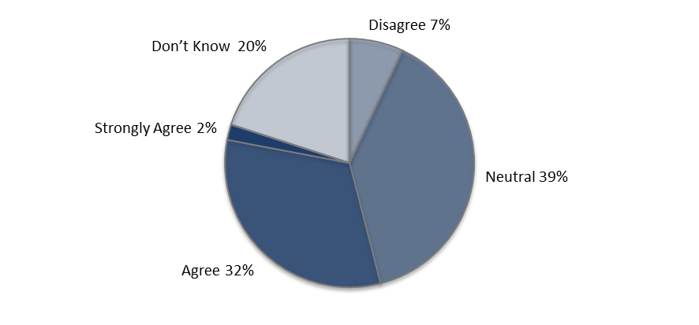  
Source: Account Manager Post-Pilot Survey, 2014 (Appendix Table C17)

Account Managers also had the opportunity to consider changes to particular aspects of Providers’ business performance compared to 12 months ago. Low awareness was reported for changes in stakeholder engagement, service to job seekers, training and employment outcomes for job seekers, job seeker engagement and service to employers.

Encouragingly however 48 per cent of Account Managers indicated business processes were better than they were 12 months previously and there were higher levels of staff engagement evident for 25 per cent of Account Managers (Figure 5.2). The changes to business processes would likely have occurred in the initial stages of the Provider implementing the Pilot QAF. As with KPI 3 data, improvements to staff and client engagement will take longer to flow through given the cultural and business changes required.

Figure 5.2: Account Manager awareness of changes to aspects of Provider performance compared to 12 months ago (per cent)

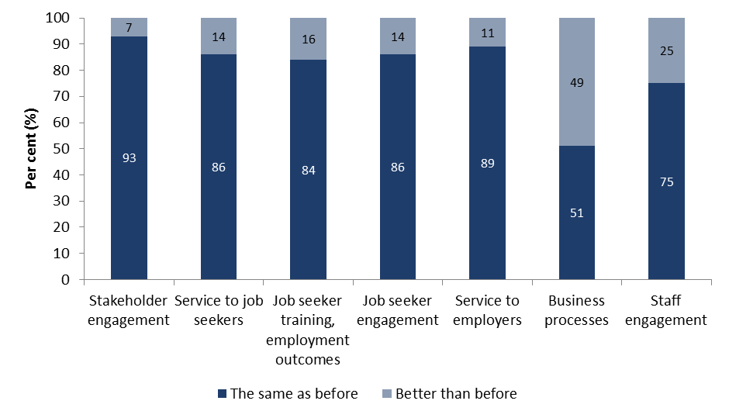

Source: Account Manager Post-Pilot Survey, 2014 (Appendix Table C18)

In relation to the future impact of the revised QAF, Account Managers’ responses in the post-Pilot survey were more positive than those provided when considering the current impact. However, they did continue to provide a high level of neutral and “don’t know” responses, possibly indicating a ‘wait and see attitude’ (Figures 5.4, 5.5, 5.7 and 5.10).

On occasions, Account Managers had the opportunity to attend Provider audits being conducted. Account Managers were subsequently requested to provide feedback to the department and some of this feedback suggests more optimism than was evident in the post-Pilot survey results. For instance, comments were generally supportive when asked “Based on the audit today, do you believe Quality Standards will provide further assurance to DEEWR and the industry as a whole that the appropriate processes are in place for Providers to deliver Quality Services to Participants, employers and DEEWR?”:

“Yes. I think the Quality Standards has a twofold effect. First, the process gave the Providers an opportunity to focus on their ability to deliver Quality Services to participants, employers and the Department. Therefore, during the process of demonstrating to auditors their ability to deliver Quality Services, against the 8 principles, Providers are in a position to identify inadequacies in their processes and hence able to implement strategies to improve their operations. Second, I think having an independent body assess a Provider’s delivery of Quality Services provides assurances to the Department that quality employment services and practices are being delivered.”

Account Manager, Department of Employment (Observer Feedback for Pilot Audits)

“This no doubt builds on assurance to the Department and the JSA Industry as a whole that appropriate services are in place for providers to Deliver Quality Services to all stakeholders. The auditor provides a fresh perspective and while not intimately acquainted with all of the system, the interventions and support and associated processes, is able to utilise his own skill set to understand the tasks and see any possible flaws.”

Account Manager, Department of Employment (Observer Feedback for Pilot Audits)

“Yes, As previously stated, some of the audit findings complimented Contract Management Priorities and monitoring activity. There is little doubt that receiving consistent feedback from an external auditor that aligns with feedback received from the Department will reinforce the Department’s findings and give provider’s strategies for improving the quality of their service.”

Account Manager, Department of Employment (Observer Feedback for Pilot Audits)

It is understood that Account Managers were not heavily involved in the policy development process for the Pilot QAF. This may account for some of the non-comittal responses provided in the post-Pilot survey.The comments provided by Account Managers who had observed the audits being conducted tend to support this conclusion.

* + 1. **Overall adherence to the Quality Assurance Framework**

As described in the Quality Standards Pilot Instructions, “DEEWR has defined eight QAF Principles (the Principles) for the delivery of quality services to participants, employers and DEEWR….Each Principle aims to focus on the overall/critical goal; that is to maximise the delivery of high quality employment services” (Department of Employment 2012, p.4).

As the Quality Principles aim to outline the department’s expectations of service quality, data was collected from Provider CEOs and department Account Managers on the adherence to all Key Performance Measures of the Quality Principles before and after certification. The survey scale provided four categories of response to measure changes to Quality Standard and Quality Principles adherence. Given the limited range of response, it was not possible to identify significant changes through analysis of the pre-Pilot and post-Pilot survey results. This analysis has therefore not been considered as part of this evaluation.

## Client impacts

* + 1. **General Observations**

Interestingly, while Account Managers had observed a limited impact on participants, and administrative data clearly shows it is too early to track any changes, survey data indicates the majority of Quality Managers and Provider staff agreed the Pilot had an immediate impact on the services delivered to job seekers and employers.

Quality Managers and CEOs also generally agreed the revised QAF will lead to improvements for clients in the future. When comparing observations made by Quality Managers, CEOs and Account Managers about the future impact of the Pilot QAF on clients, the responses provided by Quality Managers tended to be most optimistic. However, for all categories the negative responses were very low, indicating that even though there is no administrative data to endorse the implementation of the Pilot QAF, Providers felt generally positive about it and Account Managers did not feel negative towards it.

Quality Managers also had the opportunity to consider the impact on the industry more generally in the future. Responses by and large suggest they considered there will be an even greater impact in this respect.

* + 1. **Relationships with stakeholders**

The trends noted above are evident when considering views regarding Providers’ relationships with stakeholders. For example, 60 per cent of Quality Managers agreed or strongly agreed the Pilot had led to improvements in their relationships with stakeholders (Figure 5.3). This is one of the lowest recorded current impacts by Quality Managers. However, the response increases to 82 per cent when considering stakeholder relationships in the future and 84 per cent when considering the industry in general.

While Quality Managers and CEOs tended to rate this aspect of Providers’ business high in comparison to other aspects, Account Managers consider this to be one of the lowest impacts with high levels of neutral response (48 per cent) (Figure 5.3).

Figure 5.3: Improvements from the Pilot on Providers’ relationships with stakeholders, comparison between CEOs, Quality Manager and Account Manager (per cent)

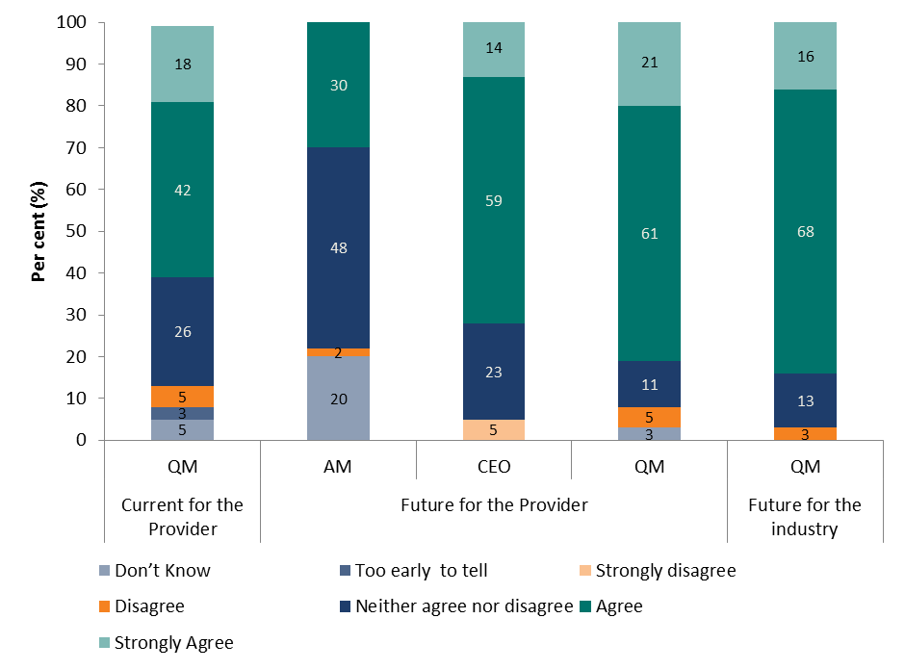

Source: Account Manager Post-Pilot Survey, 2014; CEO Post-Pilot Survey, 2014 and Quality Manager Post-Pilot Survey, 2014 (Appendix Table C19)

* + 1. **Job seeker servicing**

In terms of job seekers, surveys focused on the impact or the potential future impact of the Pilot QAF on the Providers’ ability to service job seekers and provide improved training and employment outcomes for this client group.

Similar patterns to those noted above were observed (Figures 5.4 and 5.5). Approximately two-thirds of Quality Managers agreed or strongly agreed improvements were currently evident in respect of both of these aspects of job seeker servicing. This rose to approximately three-quarters of Quality Managers in the future for the Provider and over 84 per cent for the industry in general (Figure 5.4 and 5.5).

In comparison to other responses, Account Managers were particularly confident about the impact of the revised QAF on job seekers in the future. Over 40 per cent agreed there would be an impact on the Providers’ ability to service job seekers and provide them with improved training and employment outcomes. CEOs and Quality Managers were also optimistic in this respect (Figures 5.4 and 5.5).

Figure 5.4: Improvements from the Pilot on Providers’ ability to deliver services to job seekers, comparison between CEOs, Quality Managers and AMs (per cent)

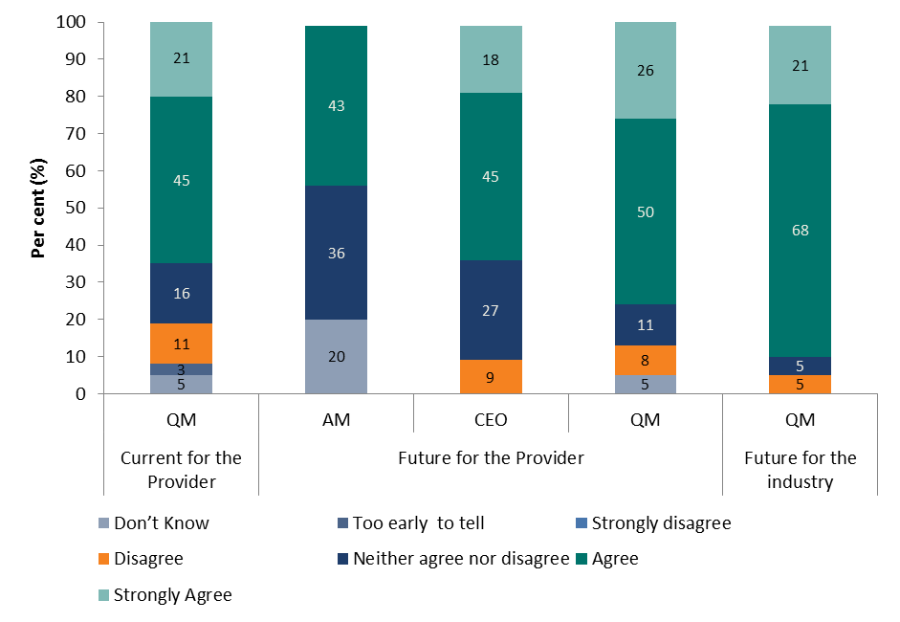

Source: Account Manager Post-Pilot Survey, 2014; CEO Post-Pilot Survey, 2014 and Quality Manager Post-Pilot Survey, 2014 (Appendix Table C20)

Figure 5.5: Improvements from the Pilot on Providers’ ability to deliver training and employment outcomes for job seekers, comparison between CEOs, Quality Managers and Account Managers (per cent)

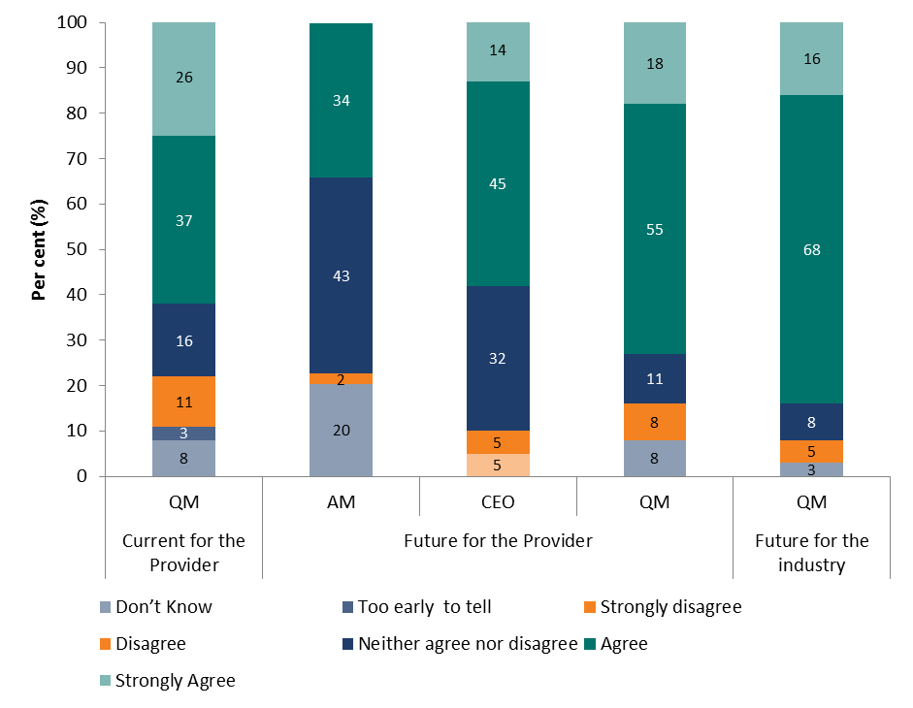

Source: Account Manager Post-Pilot Survey, 2014; CEO Post-Pilot Survey, 2014; and Quality Manager Post-Pilot Survey, 2014 (Appendix Table C21)

The Provider Staff Post-Pilot Survey (2014) also supported findings relating to Quality Manager observations about the current impact of the Pilot. When asked about improvements in their business compared to 12 months ago, approximately four-fifths of Provider staff indicated they were aware within their organisation there had been changes in job seeker satisfaction with service received, systems and technologies that enable communication with job seekers (and employers) and strategies for monitoring job seeker (and employer) satisfaction. The highest level of increase (86 per cent) was observed in relation to job seeker satisfaction (Figure 5.6).

Figure 5.6: Provider staff awareness of changes to aspects of Provider business (compared to 12 months ago)

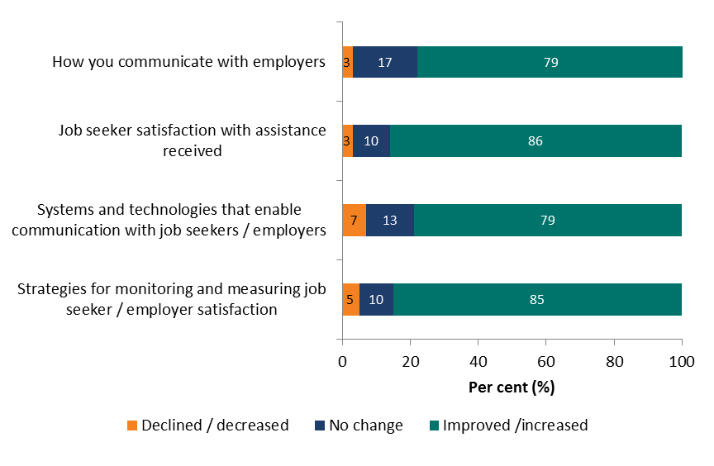

Source: Provider Staff Post-Pilot Survey, 2014 (Appendix Table C22)  
Note: The “don’t know” category has been removed from the graph, values recalculated.

* + 1. **Employer servicing**

In terms of the level of service provided to employers, the trends are aligned with those outlined in the general observations section. Half of Quality Managers reported they agreed or strongly agreed the Pilot had led to improvements in the ability of a Provider to deliver services to employers. While this figure is comparably low against other responses considering Provider improvement, it does increase when considering the impact on the Provider in 12 months time (to 73 per cent) and the impact on the industry more generally in the future (84 per cent) (Figure 5.7).

Quality Managers have provided a higher level of neutral response in relation to current improvements to employer servicing than for other questions considering Provider improvements (Figure 5.7). This may indicate Quality Managers are less sure about the immediate impact the Pilot has had on servicing employers.

Figure 5.7: Improvements from the Pilot on Providers’ ability to deliver improved services to employers, comparison between CEOs, Quality Managers and Account Managers (per cent)

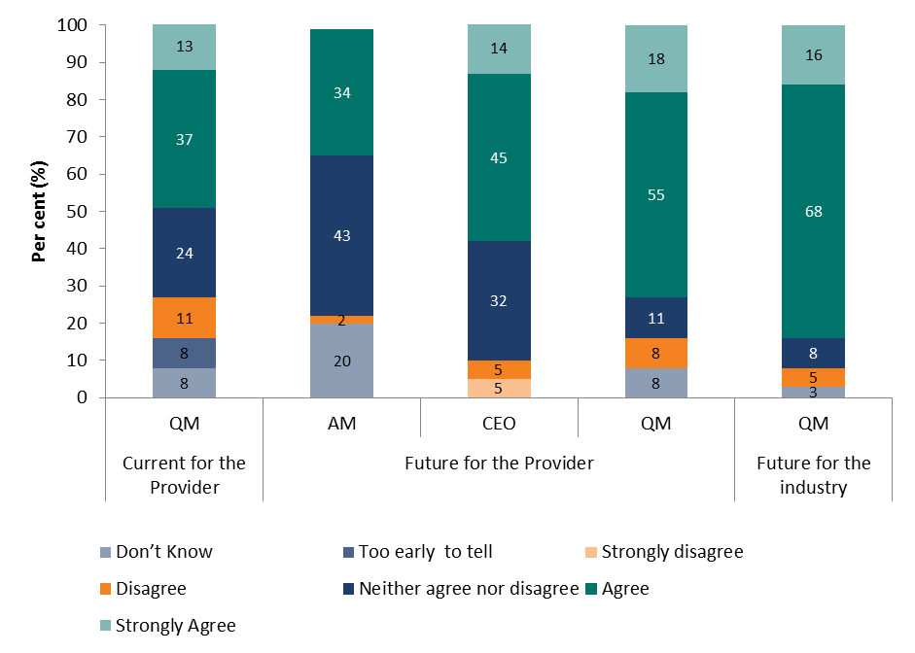

Source: Account Manager Post-Pilot Survey, 2014; CEO Post-Pilot Survey, 2014; and Quality Manager Post-Pilot Survey, 2014) (Appendix Table C23)

As noted in Figure 5.6, Provider staff indicated they had observed an overall improvement (79 per cent) in the way Providers communicate with employers. While this is a positive result, in comparison to job seeker considerations the level of improvement against this aspect was not rated as highly.

## Impact on Provider operations

* + 1. **Improved understanding of the Deed**

The Employment Services Deed and accompanying guidelines specify the department’s expectations regarding the quality of employment services that Providers are contractually obligated to provide. The Pilot QAF brought the details of the Deed to the fore through the introduction of Provider certification against a Quality Standard as well as adherence to a set of Quality Principles specified by the department.

Indications from Quality Managers in the post-Pilot survey suggest the Pilot has already led to improvements in staff understanding of the Deed and departmental guidelines (63 per cent agreed or strongly agreed). This figure increases to 81 per cent when considering the impact in 12 months’ time. More generally, the response increases to 90 per cent when considering the impact on the industry in the future. CEOs responses in the post-Pilot survey also support the likelihood that improvement to staff understanding will occur in the future (Figure 5.8).

Figure 5.8: Improvements from the Pilot on Provider staffs understanding of the Deed and Departmental Guidelines, comparison between Quality Managers, CEOs and Account Managers (per cent)

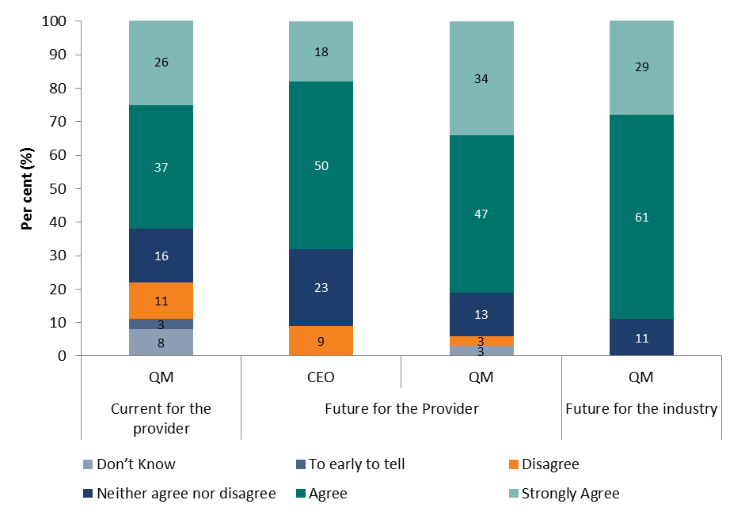

Source: CEO Post-Pilot Survey, 2014 and Quality Manager Post-Pilot Survey, 2014 (Appendix Table C24)

An overwhelming majority of Provider staff at all levels also indicated post-Pilot they had a greater level of awareness of the Deed and departmental guidelines (Figure 5.9).

Figure 5.9: Provider Staff awareness of changes to aspects of Provider business (compared to 12 months ago)

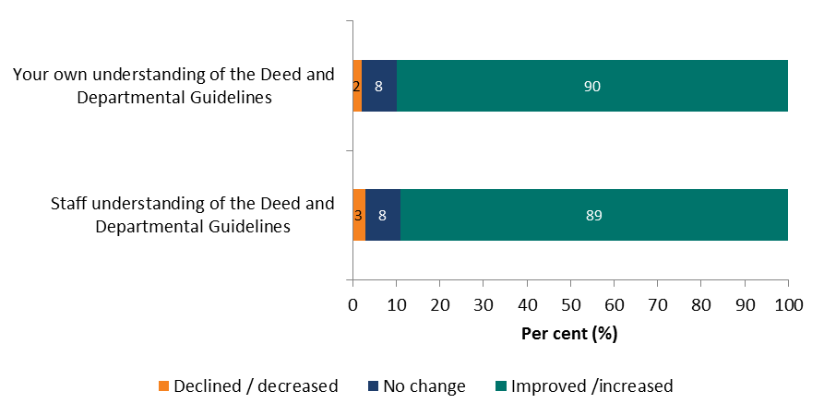

Source: JSA Provider Staff Post-Pilot Survey, 2014 (Appendix Table C25)

Note: The “don’t know” category has been removed from the graph, values recalculated.

Comments submitted by Provider staff in the post-Pilot survey support this assessment:

“As the General Manager I found it invaluable for the staff to gain a greater understanding of why we do what we do and how important it is for our job seekers to have fully qualified staff working with and for them.”

Manager, Provider (Provider Staff Post-Pilot Survey, 2014)

“We as a site now have a better understanding and continue to improve our service delivery to internal and external clients by implementing the quality standards and the departmental quality principals.”

Manager, Provider (Provider Staff Post-Pilot Survey, 2014)

“Implementing the Quality Standards and the Departmental Quality Principles has ensured that I have been staying up to date with company policies & procedures each time that I perform a task. I feel that this has also been the same with each staff member throughout [provider name].”

Administrative staff, Provider (Provider Staff Post-Pilot Survey, 2014)

“More knowledge around standards and quality principles has changed the processes and procedures I work from, the dissemination of knowledge to others in the organisation, the recording of information, and my team’s understanding of how they contribute to, and how they can uphold these quality standards and principles.”

Manager, Provider (Provider Staff Post-Pilot Survey, 2014)

“I believe it made everyone more aware of the need for quality standards and principles to be followed. It made all staff take note of what they have been doing compared to what they should be doing.”

Manager, Provider (Provider Staff Post-Pilot Survey, 2014)

In addition to assisting the operation of the Provider, a greater knowledge of the Deed and departmental Guidelines will likely result in improved service to the department and other clients.

* + 1. **Internal processes**

Quality Managers were very positive about the impact the Pilot already had on Providers’ internal business processes. Four-fifths (81 per cent) agreed or strongly agreed they had observed improvements. This increased to 91 per cent when considering business improvements in the future and 93 per cent when considering the industry in general.

As previously noted, internal businesses processes were an area Account Managers recognised had improved, with 49 per cent indicating they had seen changes over the last 12 months (Figure 5.2). This suggests initial changes are occurring within Provider businesses and it is anticipated client impacts should be observed in the future as a result of these changes.

When considering the future impact on internal business processes an overwhelming majority of respondents in each category agree or strongly agree the Pilot QAF will have an impact on the Providers’ internal business processes (Figure 5.10). CEOs were particularly positive about this future impact of the Pilot QAF.

Figure 5.10: Pilot has led to improvements in: Internal business processes, comparison between CEOs, Quality Managers and Account Managers (per cent)

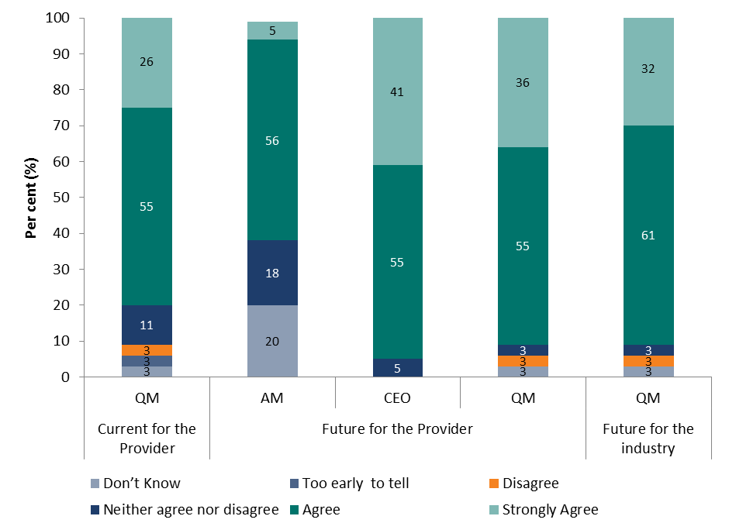

Source: Account Manager Post-Pilot Survey, 2014; CEO Post-Pilot Survey, 2014; and Quality Manager Post-Pilot Survey, 2014) (Appendix Table C26)

Comments by Provider staff in the post-Pilot survey suggest they too have observed an impact on Provider processes. In terms of the way the implementation of the Pilot changed their performance in their role, staff comments suggest the structure resulted in them having a better understanding of policies, procedures and guidelines:

“Implementing the Quality Standards and the Departmental Quality Principles has ensured that I have been staying up to date with company policies & procedures each time that I perform a task. I feel that this has also been the same with each staff member throughout [Provider name].”

Administrative staff, Provider (Provider Staff Post-Pilot Survey, 2014)

“Increased understanding of guidelines and deed. In particular an increased understanding of documentary evidence required and the importance of training staff in fraud prevention.”

Manager, Provider (Provider Staff Post-Pilot Survey, 2014)

“More knowledge around standards and quality principles has changed the processes and procedures I work from, the dissemination of knowledge to others in the organisation, the recording of information, and my teams understanding of how they contribute to, and how they can uphold these quality standards and principles”

Manager, Provider (Provider Staff Post-Pilot Survey, 2014)

Changes to business processes were recognised by some Account Managers who had the opportunity to provide observer feedback after attending Provider audits. When asked ‘by attending the Quality Standards, was further assurance offered to you as a Contract Manager that the right processes and systems were being undertaken at site?’:

“Yes, the visit provided an insight into the organisations claiming processes. The organisation appear[s] to have in place well documented procedures and tracking claim processes.”

Account Manager, Department of Employment (Observer Feedback for Pilot Audits)

“Yes, The provider appeared to be acting to assist clients and processes were being followed and interactions and interventions being recorded. As clients moved through various phases the consultants appeared to be adhering to the requirements. Staff appeared focused on the task and aware of recording events in addition to the management of the client.“

Account Manager, Department of Employment (Observer Feedback for Pilot Audits)

“…attending the audit did provide further assurance that processes and systems undertaken at the site were right. The provider in question has been overall trending upwards in their performance and much of the increase has been due to the managerial restructure and implementation of new processes. It was good to see these processes in action and to see the depth of knowledge and resources that staff has at their disposal to ensure that standards of compliance are being met.

Account Manager, Department of Employment (Observer Feedback for Pilot Audits)

* + 1. **Staff engagement and support**

A large majority of Provider staff agreed in the post-Pilot survey that they, as well as staff at their site, had been engaged in the roll out of the Quality Standards and Quality Principles.

Figure 5.11: Provider staff engagement in roll out of Quality Standards and Quality Principles (per cent)

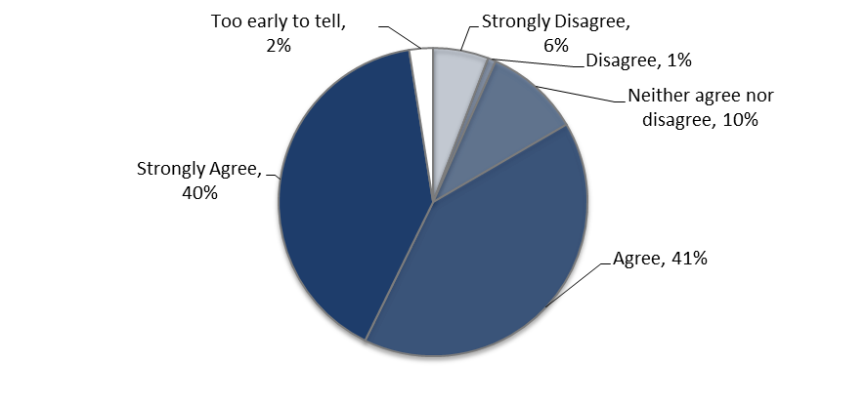

Source: Provider Staff Post-Pilot Survey (Appendix Table C27)

Provider staff agreed introduction of the Pilot QAF had resulted in improvements concerning their role within the organisation (Figure 5.12):

* 74 per cent of Provider staff indicated the introduction of the Pilot QAF helped them better understand their role.
* Approximately two-thirds of Provider staff agreed or strongly agreed there was improved support available to their role (68 per cent).
* 62 per cent of staff indicated they had changed the way they performed their role as a result of the implementation of the Pilot QAF.

Figure 5.12: Provider Staff awareness of changes to aspects of their role (compared to 12 months ago)

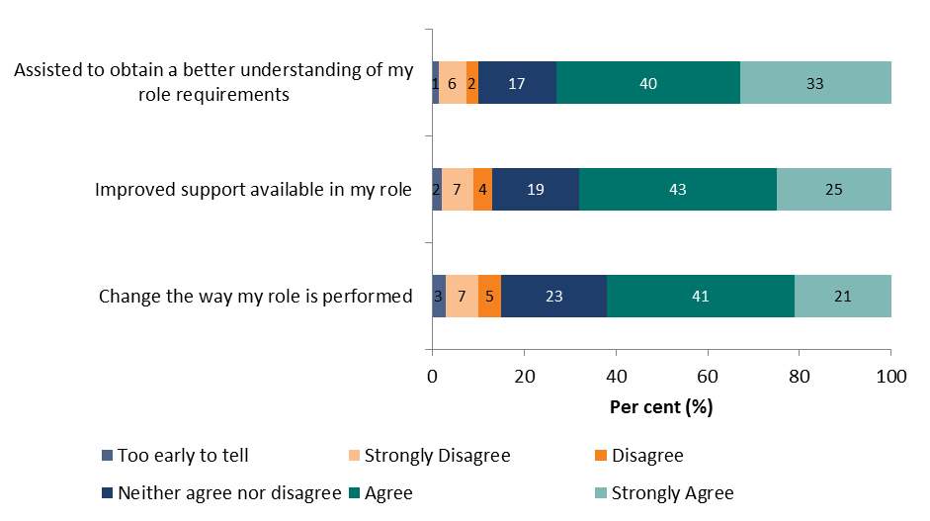

Source: Provider Staff Post-Pilot Survey, 2014 (Appendix Table C28)

Comments received as part of the Provider Staff Post-Pilot Survey, 2014 support this:

“[The QAF] gave me an understanding of the requirements needed which in turn enhanced my teaching/learning abilities.”

Manager, Provider (Provider Staff Post-Pilot Survey, 2014)

“[The QAF] encourage[d] me to obtain relevant information in order to perform my role, and the quality standards within our organisation provides the added support.”

Manager, Provider (Provider Staff Post-Pilot Survey, 2014)

“It [the QAF]… made our staff more accountable for the actions they were taking on a day to day basis. We also introduced multi-layer checking mechanisms to improve compliance and identify deficiencies.”

Manager, Provider (Provider Staff Post-Pilot Survey, 2014)

“It helped me with better understanding of my role and made it easier.”

Manager, Provider (Provider Staff Post-Pilot Survey, 2014)

Although Provider staff were generally positive about the impact of the Pilot QAF on their role, there was a small proportion (nine per cent) who did not feel the Pilot QAF had an effect on their understanding of, or conduct in, their role:

“I don’t believe it is the Quality Standards principles that result in quality services being delivered to job seekers/clients and/or employers. I believe it is the people who are passionate about changing the lived of their clients who have the endurance and courage to see beyond the bureaucracy and pressure of ridiculous auditing processes and standards”.

Employment consultant, Provider (Provider Staff Post-Pilot Survey, 2014)

In addition to role clarification, results from the Provider Staff Post-Pilot Survey, 2014 indicated improvements to staff support have been observed internally. These changes suggested opportunities are being explored to improve Provider operations, which can be expected to ultimately improve the way the Providers deliver employment services. Compared to 12 months earlier (Figure 5.13):

* 89 per cent of staff reported changes to the visibility of leadership within their organisation, with 93 per cent of these reporting that leadership was more visible in the organisation.
* 81 per cent saw a change in their access to workplace support, with 95 per cent of these reporting their access to workplace support had increased.
* 80 per cent reported a change to access to training and development, with 95 per cent of these reporting that access had increased.

Figure 5.13: Provider staff awareness of changes to aspects of Provider business (compared to 12 months ago) 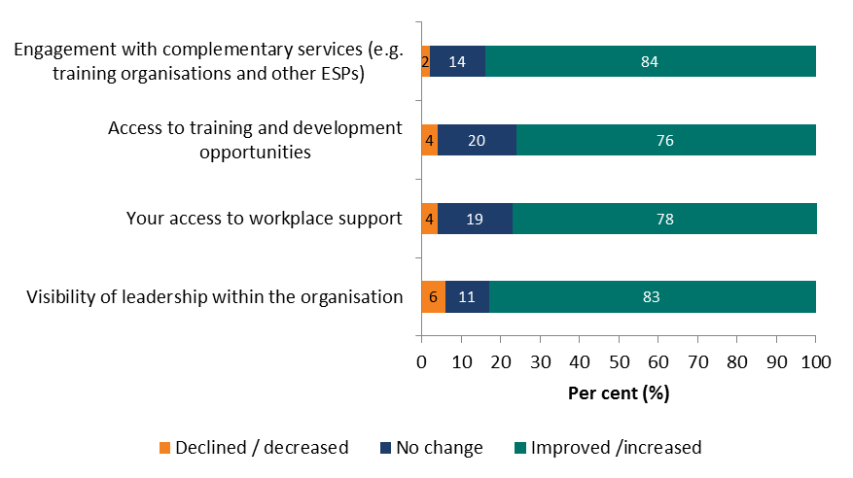

Source: Provider Staff Post-Pilot Survey 2014, (Appendix Table C29)

Note: The “don’t know” category has been removed from the graph, values recalculated

In relation to training, a staff member reported in the Provider Staff Post-Pilot Survey, 2014 that:

“The implementation of training relating to the standards and principles gave me a greater understanding of these key areas. Re- focusing on the requirements has provided me with more confidence within my role. The organisation is keen to ensure every staff member is provided with quality training to assist with the service delivery.”

Manager, Provider (Provider Staff Post-Pilot Survey, 2014)

* + 1. **Staff performance**

Survey results suggest the Pilot resulted in improvements to current staff performance and that performance levels will continue to improve in the future for the Provider, as well as the industry. The internal changes to Provider operations noted above would have supported these observed improvements.

Though still positive, CEOs were slightly less optimistic than Quality Managers when considering the role of the revised QAF in improving staff performance in the future (64 per cent as compared with 81 per cent of Quality Managers agreed or strongly agreed). A higher proportion also had a neutral response (27 per cent of CEOs compared with 11 per cent of Quality Managers), indicating CEOs are perhaps more cautious, or less sure of the impact the revised QAF will have on staff performance (Figure 5.14).

Figure 5.14: Pilot has led to improvements in: Staff performance, comparison between CEOs and Quality Managers

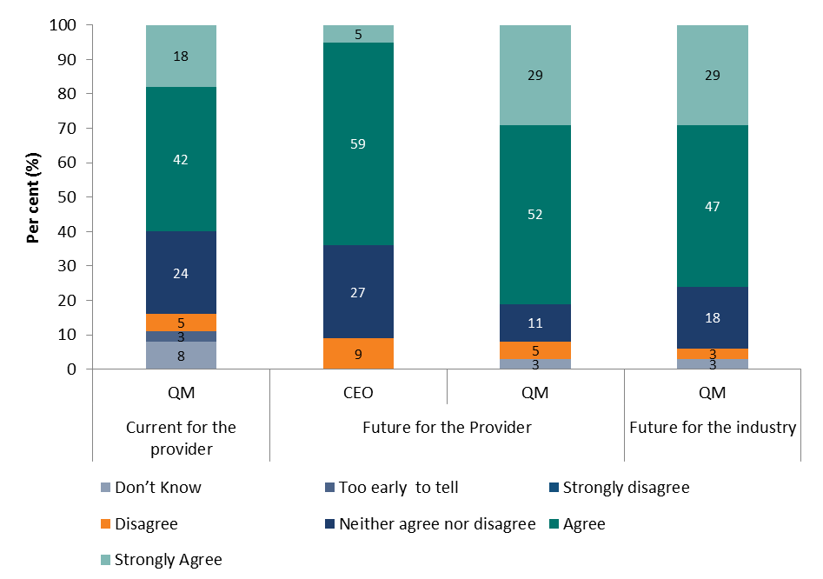

Source: CEO Post-Pilot Survey, 2014 and Quality Manager Post-Pilot Survey, 2014 (Appendix Table C30)

Results in the Provider Staff Post-Pilot Survey (2014) also suggest the Pilot had an impact on current levels of staff performance (Figure 5.15), although it is noted that a very small proportion though their own performance (2 per cent) and that of staff more generally (9 per cent) had decreased.

Figure 5.15: JSA Provider Staff responses (per cent) to their awareness to changes to aspects of their businesses’ compared to 12 months ago

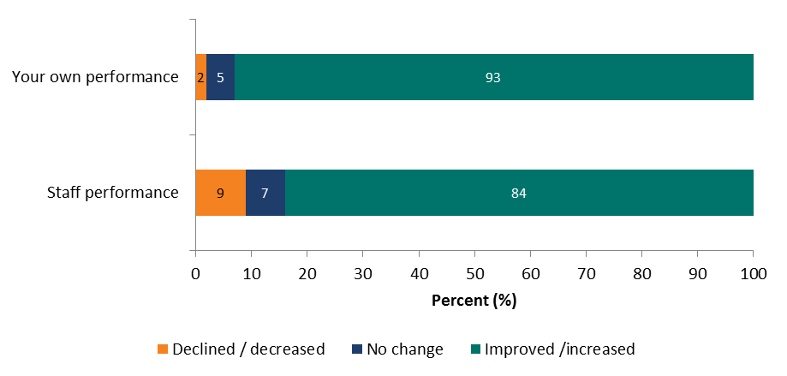

Source: Provider Staff Post-Pilot Survey, 2014 (Appendix Table C31)

Note: The “don’t know” category has been removed from the graph, values recalculated.

Comments provided by Provider staff support this:

“It has improved my performance, and my confidence to keep improving in my role.”

Administrative Staff, Provider (Provider Staff Post-Pilot Survey, 2014)

“I am now more aware of my role in upholding the quality standards and have been able to monitor the sites performance more accurately against this measure”

Employment Consultant, Provider (Provider Staff Post-Pilot Survey, 2014)

## Cost / benefit considerations

As detailed above, Provider Quality Managers and staff perceive there have been a number of immediate benefits as a result of the Pilot, specifically in relation to servicing of clients and internal business operations. CEOs and Quality Managers are also optimistic about the impact the revised QAF will have in future both in terms of their businesses and the industry more generally.

In addition, as previously outlined in section 4.4.2 of the report the Pilot has established that there is evidence that a QAF may show more potential for driving continuous improvement than the existing KPI 3 Quality Framework has previously been able to achieve.

These benefits need to be balanced against the cost and time requirements reported by Providers participating in the Pilot which were in excess of Provider expectations.

While there was a large range of response from Providers concerning associated costs of the audit, the costs reported by some Providers were sometimes significant (see Figures 4.5 and 4.6). Approximately one-third of CEOs (five in total) and Quality Managers (six in total) who were aware of the costs of the audit reported the cost to be $50,000 or more (the highest cost reported being $150,000 by a Quality Manager and $100,000 by a CEO). In particular, preparation for the audit was considered to be very costly:

* Of the Quality Managers who were aware of the costs, 42 per cent (seven Quality Managers) reported these costs to be $100,000 or more.
* 12 per cent of CEOs (two in total) and Quality Managers (two in total) who were aware of the costs reported these costs to be $200,000 or more.
* The highest cost specified by a Quality Manager was $260,000 and $250,000 for a CEO.

Given these reported costs, it is unsurprising that there were relatively low levels of agreement when Providers were asked to consider if the Pilot represented value for money. Just over one-third (35 per cent) of CEOs agreed or strongly agreed the audit process did provide value for money, while almost one-third (30 per cent) disagreed or strongly disagreed. Of the Quality Managers who responded, nearly half (47 per cent) agreed or strongly agreed the audit represented value for money, while a quarter (24 per cent) felt it did not (Figure 5.16).

Figure 5.16: CEO and Quality Managers views (per cent) on whether the audit process has provided value for money

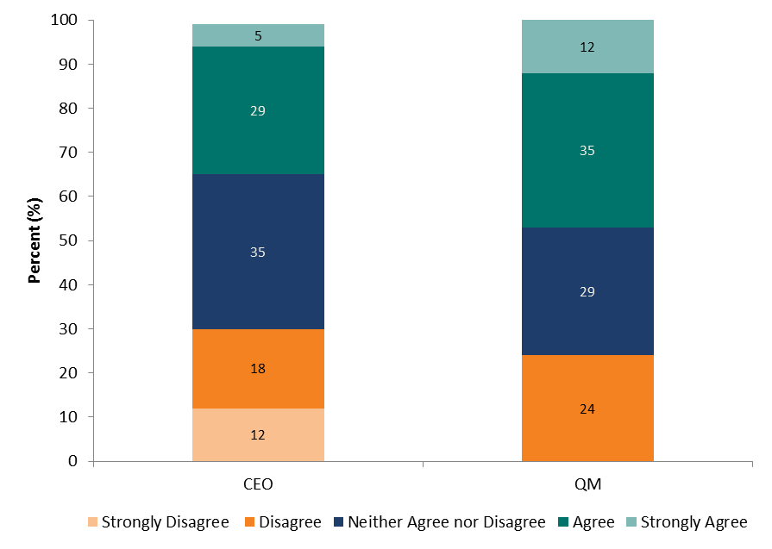

Source: CEO Post-Pilot Survey, 2014 and Quality Manager Post-Pilot Survey, 2014 (Appendix Table C12)

Note: The “don’t know” category for Quality Managers has been removed from the graph, values recalculated

The time taken to implement the Pilot QAF within the required timeframe was also a reported challenge for Providers. While the reported median hours spent preparing for and supporting the audit was 500 hours:

* 18 per cent of Quality Managers (seven in total) indicated they spent 2,000 hours or more
* 8 per cent of Quality Managers (three in total) indicated they spent 5,000 hours or more, and
* the highest recorded hours was 6,088.

In the time since the Pilot was introduced, the Australian Government has committed to reduce the amount of red tape to ease the regulatory burden for Australian businesses. The evaluation notes that the department is cognisant of the ongoing need to monitor the requirements and benefits of the QAF.

Encouragingly, in spite of the concerns raised by Providers in relation to time and resources, an overwhelming majority of CEOs (71 per cent) and Quality Managers (92 per cent) agreed or strongly agreed the audit had been a positive investment of time. Only three per cent of Quality Managers disagreed the Pilot had been a positive investment of time. This figure is higher for CEOs (18 per cent disagree or strongly disagree) suggesting the negative aspects associated with the Pilot had a greater impact on them (Figure 4.12).

Figure 5.17: CEO and Quality Manager views (per cent) on whether the audit and certification process has been a positive investment of time

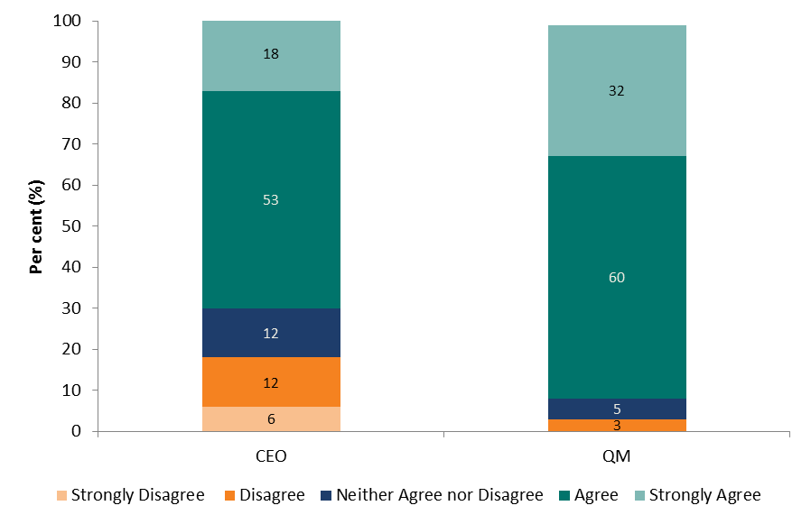

Source: CEO Post-Pilot Survey, 2014 and Quality Manager Post-Pilot Survey, 2014 (Appendix Table C16)

Given the data limitations for this evaluation it is not possible to determine whether the potential benefits resulting from the Pilot QAF, as identified by Providers directly through this evaluation, outweigh the reported costs. While Providers perceive there will be improvements to client services and Provider operations, the costs of achieving these results were in some cases significant.

Comments made by two Provider CEOs as part of the post-Pilot survey are particularly concerning:

* “We could have the highest quality service and go broke implementing and maintaining a quality standard” and
* “The time taken to resource participation in the Pilot is time taken away from supporting job seekers”.

These comments along with the limited cost / benefit analysis undertaken and findings of this evaluation suggest work is required to ensure a future QAF model enables Providers to efficiently and effectively implement the requirements with minimal impact to costs, time and resources. If costs can be reduced, it is anticipated introduction of a national QAF model will be beneficial for Providers and their service delivery to clients.

## Summary

The assessment of whether the Pilot QAF has positively or negatively impacted the performance of Providers participating in the Pilot has been limited by the following factors:

* No discernable patterns were identified through analysis of KPI 3 data. It is recognised this is due to the lag between implementation of the Pilot QAF and changes to the impact on Provider performance being evident.
* The time taken for new policies and procedures to permeate the organisation’s culture and manifest into a tangible impact on performance.
* Account Managers have not yet generally observed improvements to the relationships Providers have with clients, such as job seekers and employers, or the level of service provided to them. This reflects the likelihood that information collected in February 2014 in the Account Manager Post-Pilot Survey was collected too early in the process for Account Managers to have observed changes that can be attributed to the Pilot QAF.
* While data was collected from CEOs and Account Managers on the adherence to all Key Performance Measures of the Quality Principles before and after certification, it was not possible to identify significant changes.
* While feedback obtained from stakeholders directly as part of this evaluation can assist to determine the current and expected impact, caution should be applied as:
  + The Pilot sample is not necessarily representative of the Provider population in which case the views expressed might not reflect the range of views on issues highlighted by the Pilot.
  + There may be an element of ‘pilot effect’ reflected in these results as Pilot participants are generally enthusiastic about the impact that their increased efforts will have.

Given these limitations, the department may wish to consider options to assess the impact of any future QAF on the performance of Providers. It is acknowledged KPI 3 data alone (in its current form) may not be an appropriate measure of service quality given the Pilot QAF was introduced because the existing KPI 3 framework did not effectively measure, monitor or assure continuous improvement in Provider quality of service delivery.

Provider Quality Managers and staff generally agree the Pilot had an immediate impact on the quality of service delivery with levels of disagreement low (at between five and 11 per cent) when considering Provider relationships with clients, job seeker servicing and employer servicing.

Sixty per cent of Quality Managers agreed or strongly agreed the Pilot had led to improvements in their relationships with stakeholders. The results for job seeker servicing were most encouraging:

* Approximately two-thirds of Quality Managers agreed or strongly agreed improvements were evident in the Providers’ ability to service job seekers and provide improved employment outcomes for these clients.
* Four-fifths of Provider staff indicated they were aware within their organisation there had changes been changes in the last 12 months in job seeker satisfaction with service received, systems and technologies that enable communication with job seekers and strategies for monitoring job seeker satisfaction.

In comparison, the results for servicing of employers are lower but still promising:

* 50 per cent of Quality Managers reported they agreed or strongly agreed the Pilot had led to improvements in the ability of the Provider to deliver services to employers.
* 79 per cent of Provider staff indicated they had observed an overall improvement in the way Providers communicate with employers.
* Quality Managers also provided a higher level of neutral response when considering current improvements to employer servicing, possibly suggesting they are less sure about the Pilot’s immediate impact on employer servicing.

Provider staff and Quality Managers are also very positive about the impact the Pilot had on current business operations in the Provider organisations, with strong improvements evident for:

* the level of understanding of the Deed and accompanying guidelines
* staff understanding of their role and conduct in their role
* leadership visibility, access to workplace support and training and development, and
* staff performance.

The survey responses Account Managers provided in relation to improvements observed for changes to business processes and staff engagement suggest changes have commenced at an internal business level to support implementation of the Pilot QAF. It is anticipated this would be the initial step in implementing the revised QAF and it is reasonable to expect the impact on clients will become more apparent as time progresses.

Account Managers, CEOs and Quality Managers generally agree the Pilot QAF will lead to improvements in future, both in terms of the impact on clients as well as the internal operation of Providers. The views of Quality Managers are the most positive, followed by CEOs then Account Managers. Quality Managers are also positive about the impact of the Pilot QAF on the industry in general in the future.

In terms of the future impact of the introduction of the Pilot QAF, Account Managers have provided a higher level of neutral and “don’t know” responses when considering potential improvements for Providers. This non-committal response may indicate that Account Managers were not heavily involved in the Pilot QAF development process.

While this evaluation has considered costs and benefits, the data limitations make it difficult to ascertain if the potential benefits of the Pilot QAF outweigh the reported costs. The feedback received from Providers as part of this evaluation cannot be relied upon to provide an objective assessment of whether the Pilot QAF has actually driven improvements to service delivery. This level of analysis cannot be undertaken until the views of clients, including job seekers and employers, are collected and considered.

It is noted that Providers themselves have indicated they have seen short term improvements to client services and Provider operations, and expect longer term impacts to be more favourable. They also overwhelming agree that involvement in the Pilot had been a positive investment of time.

Opportunities for improvement were recognised by many Providers, particularly by CEOs with 18 per cent disagreeing or strongly disagreeing the Pilot had been a positive investment of time and only 35 per cent agreeing the Pilot represented value for money. On occasion, the costs of achieving the perceived benefits have been significant and for the majority of Providers more than expected.

Some of these views can be accounted for on the basis that certification for the Pilot QAF was a new process unknown to Providers and has more components than Providers have been required to undertake previously. There was also a relatively large amount of administrative work and red tape required to become certified under the Pilot QAF, particularly given the duplication issues with the Quality Standards and Quality Principles. While for some Providers the cost and time burdens may be considered significant, it is expected that improvements can be made as the department and Providers become more familiar with the intricacies and processes involved in establishing and maintaining a QAF.

To better balance benefits against costs and time pressures the department may also consider some changes to the Pilot model for future rollout of the QAF on a large scale. It would also be useful to consider the requirements of a national QAF model in line with the Government’s commitment to reduce red tape. The considerations outlined in Section 6 of the report are recommended to support large scale roll out of a national QAF model.

# Considerations for the future implementation of a Quality Assurance Framework

This section summarises some of the learnings from the Pilot process for the implementation of the QAF across the industry. It also includes considerations for how the framework might be monitored and evaluated into the future.

## Preparation of Providers and auditors for audit process

The communication tools for dissemination of information to both Providers and auditors were generally well received. The Activity 2 Instructions, Evidence Guide, Provider Preparation Kit, Provider Portal and Newsletters were considered to be the most effective communication tools.

Webinars are an effective means of disseminating information and worked well for auditors but not Providers. The department will need to consider how to improve the content and presentation of webinars for Providers if they are to be a more valuable tool in the future implementation of the QAF. Specifically, Providers requested the webinars provide more practical information and allow more interaction between participants. While auditors considered the information sessions presented via webinar to be an effective communication tool, they would appreciate more flexibility in the timing of future presentations.

The department also has opportunities to improve the use of govdex.gov.au in the future implementation of the QAF. Govdex has the potential to be an interactive forum but Providers and auditors were unaware of it or did not see any value utilising it. It is difficult to determine from this evaluation what the underlying issues were with Govdex. However, given the high proportion of Providers that were unable to rate its quality, better promotion of the tool and the benefits will assist Providers and auditors to utilise it more in future.

In terms of the flow and relevance of information, a future challenge for the department is to consider how best to provide relevant and appropriate information directly to the different parties involved in the process, particularly auditors. By way of an example, consideration could be given to whether auditors need a copy of the entire Employment Services Deed or whether it would be more pertinent provide a summary with access to a Contract Manager or an expert from the department who could answer a Deed-related question should the need arise.

**Future considerations:**

1. Explore options to better educate Providers about the administration of the audit and the certification process, including the time it takes to achieve certification. In particular re-evaluate webinar content for Providers to include more practical information (real world examples from Providers who have already gone through the process) and make them more interactive.
2. Explore options to ensure auditors are better prepared for the audit, in terms of their knowledge of employment services, the JSA model and the Employment Services Deed, and understand the quality and level of detail required in audit reports. For instance:
   * Provide copies of best practice audit reports.
   * Provide an initial face-to-face information session for auditors on the panel, as well as regular information sessions to provide updates regarding audit practices.
   * For the purpose of certifying against the QAF, restrict the auditor panel to only those auditors only who have some working knowledge of employment services.
   * Provide an Auditor Portal, or access to a section of the Provider Portal, to make information readily available to auditors.
   * Schedule auditor webinar presentations well in advance and provide sufficient notice.
   * Promote the availability of recorded webinar presentations on Govdex.
3. Tailor the content and amount of written information available to auditors and Providers and consider options to supplement written information, for example by continuing (and promoting) the availability of the central QAF phone number and email address.

## The Quality Standards and the Quality Principles

Some Providers had difficulty selecting and completing certification with their chosen Quality Standard throughout the Pilot process as evidenced by the one in five Providers that reported switching part way through the process. In addition, a number of Providers also withdrew from the process as they were not able to meet the required timeframes (14 Providers in total).

The different requirements of each Quality Standard and the amount of work and preparation required for certification comparative to the business model was a key consideration in selecting a Quality Standard. For example, Providers with both Disability Employment Services and JSA interests initially considered the Disability Service Standards for certification, however they found it to be onerous due to the proportion of client interviews required. Employment Services Industry Standards was also a problem for those who selected it as it had not been accredited when the Pilot began.

Other considerations in selection of a Standard were the reported overlap between the Quality Standards and the Quality Principles and within the Quality Principles themselves. This issue is already being considered by the department and is expected to be improved in the future QAF. While it is acknowledged that some duplication may be unavoidable due to the generic but different content of each Quality Standard, it will need to be minimised as far as possible to streamline the audit process and ensure reported time and cost burdens are reduced.

Providers should be made aware how the Quality Standard they choose relates to the Quality Principles, for example, by identifying gaps and overlays and how their choice will impact the audit and longer term resourcing implications.

Whatever their choice, there was a large amount of administrative work required to become certified under the Pilot QAF. This is expected to decrease as the process improves but would be useful to consider the national QAF in line with the Government’s commitment to reduce red tape.

**Future considerations:**

1. Provide information on the requirements of each Quality Standard to guide Providers in their selection of a Quality Standard for their business model. Supply information that maps the departmental Quality Principles with each of the Quality Standards.
2. Continue the work the department has already commenced to streamline the sampling requirements and reduce the duplication between the Quality Standards and the Quality Principles (and the Key Performance Measures within).

## Monitoring and evaluating the impact of the QAF into the future

Anecdotally, auditors have raised the issue of whether the Pilot QAF was intended to assess Provider compliance or assess the quality of services delivered by Providers. This issue has been raised in particular given the apparent duplication and overlap of the Quality Standards and Quality Principles.

For this evaluation there is no distinguished measure of quality for the Pilot QAF. The delay between implementation of the revised QAF and observable changes to Provider performance has meant available KPI 3 data does not identify any discernable trends to determine whether the Pilot had a positive or negative impact on the delivery of employment services. Further, it is unclear whether the use of current KPI 3 data in the future will be sufficient to measure and monitor the quality of Providers’ delivery of services as the Pilot QAF model was considered on the basis that the current KPI 3 Quality Framework did not effectively assure continuous improvement.

Feedback collected from Account Managers suggested information collected via the post-Pilot survey was sought too early in the process for them to observe changes resulting from the Pilot QAF. Future evaluation should consider how the views of Account Managers can be considered noting that options to ensure greater involvement of Account Managers should be pursued.

Future evaluation of a QAF should also collect feedback directly from Providers’ clients, including job seekers and employers, and not rely solely on Provider perspectives to determine the impact.

In addition, auditors views were not thoroughly canvassed as part of this evaluation given the low level of feedback received through the Auditor Post-Pilot Survey, 2014 and the Auditor focus groups. The department may wish to consider how it can better capture auditor feedback as part of the new QAF, given they have a key role in the process.

Given the limitations of this evaluation, consideration may also be given as to whether it is worthwhile monitoring the performance of Providers who participated in the Pilot. This would enable the department to monitor any medium to long term impacts on the servicing of clients and support any future evaluation conducted of the new QAF.

**Future considerations:**

1. Consider how best to monitor and evaluate the effectiveness of a future QAF on an ongoing basis, taking into account the appropriateness and relevance of retaining the current KPI 3 as a measure of quality assurance, given the requirements of Quality Standards and Quality Principles. Explore options to ensure the views of Account Managers, Provider clients (such as job seekers and employers) and auditors are better captured.
2. Consider options to increase Account Managers’ involvement in QAF development and implementation.

# Conclusion

The Pilot Instructions specified that an aim of the Pilot QAF was to encourage Providers to strive for continuous improvement in the delivery of employment services. Feedback collected through this evaluation suggests that key informants believe the revised QAF will drive continuous improvement and may have greater potential in this regard than the KPI 3 Quality Framework.

Quality Managers generally considered that the audit was or had been focused on continuous improvement (86 per cent did not disagree). A minority (11 per cent) recognised that it was ‘too early to tell’. Quality Managers also had the opportunity to comment on the main benefit of participating in the Pilot. One quarter of Quality Managers who provided comments indicated they believed continuous improvement had been a key benefit.

For this evaluation, it is not possible to identify any discernable trends in KPI 3 data to determine whether the Pilot has had a positive or negative impact on the delivery of employment services. A shift in business processes and culture will be required for a change of this nature and there will be a lag between implementation of the Pilot QAF and an observable impact on Pilot Provider’s performance.

The relevance of using current KPI 3 data in the future to appropriately measure, monitor or assure continuous improvement in Provider quality of service delivery is questionable, given the Pilot QAF was introduced because the existing KPI 3 framework did not effectively do this. To more effectively monitor and evaluate the impact of any future QAF, the department may need to consider the methods and indicators that will be adopted in the future.

While there is no administrative data available to measure the impact of the Pilot QAF on Providers and their clients, for the purposes of drawing findings together for this report the evaluation has relied on Providers’ perceptions to measure how well the Pilot QAF has been implemented and whether it has, or will in the future, improve the quality of Providers’ services.

Survey results are promising. Provider Quality Managers and staff felt very positive about the impact the Pilot had on their business, both in terms of improvements to service delivery, as well as changes at an internal operational level. Quality Managers, and to a lesser extent CEOs, were also optimistic about the impact the Pilot QAF would have longer-term.

Balanced against these benefits, the time and cost to participate in the Pilot exceeded Providers’ expectations and does appear excessive in some cases. Some of the resources can be accounted for in lack of preparedness, for example, a poor choice of Standard for the organisation to certify against, or not having correct documentation on hand for the auditor.

Some factors, however, added unnecessary time and consequent cost to the audit and were beyond Providers’ control. In particular, the overlap between the Quality Standards and Quality Principles (and the KPIs within them) could account for some of the time and cost burdens. While it is important to capture multiple aspects of the Provider’s business to gauge quality, duplicating the assessment of any part of the business is inefficient and places a greater burden on Providers’ time, money and resources. It is recommended that this aspectbe addressed in any new QAF and it is noted the department has commenced work on this.

Other factors the Provider was unable to regulate may also have contributed to the cost and time burdens of the audit. For instance, waiting for Employment Services Industry Standards to be certified, excessive sampling requirements for compliance and the lack of understanding auditors had about the process, the Deed and JSA more generally.

This Pilot process was intended to refine both the future QAF and its implementation. While the shortcomings of the Pilot QAF are acknowledged, an overwhelming majority of Providers recognised involvement in the Pilot was a positive investment of time. This suggests that if changes are made to the Pilot model to reduce costs and ease large-scale implementation Providers will be more engaged and committed to the future QAF.

On the basis of this result and the known shortcomings of the current KPI 3 Quality Framework, the evaluation finds in favour of a revised QAF to drive continuous improvement in service delivery. The adoption of the recommendations in this report will assist to ensure a QAF rolled out nationally operates as efficiently and effectively as possible.

# Appendix A: Quality Assurance Framework

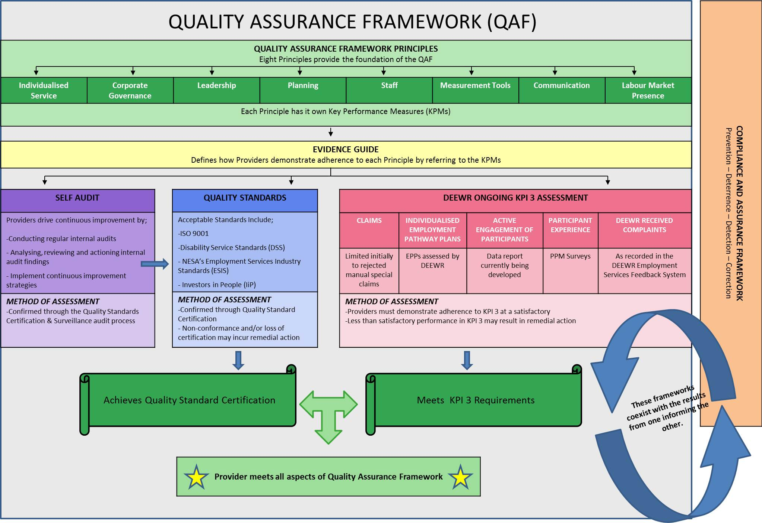

# Appendix B: Data sources

There have been eight online surveys and two auditor focus groups undertaken specifically to inform this evaluation. In addition, ongoing KPI 3 measures have also been used for the evaluation.

**KPI 3**

The baseline data considered as part of the evaluation is limited to the five quantitative measures collected six-monthly for KPI 3 assessment. To see any indicative changes resulting from the Pilot, four sets of data were compared:

* 1 January 2012 to 30 June 2012
* 1 July 2012 to 31 December 2012
* 1 January 2013 to 30 June 2013
* 1 July 2013 to 31 December 2013

There are some limitations in using this data. The methodology for collecting the data changed between the six monthly periods and they are therefore not directly comparable.

**Provider feedback**

As at 31 March 2014, 48 Providers had participated in the Pilot. This includes 12 Activity 1 and 36 Activity 2 Providers. Information was collected from various staffing levels of the Provider organisation.

**CEO Pre-Pilot Survey**

The CEO Pre-Pilot Survey, 2013 was conducted online to seek feedback from Provider Chief Executive Officers (CEOs) participating in the Pilot. In the survey, CEOs assessed their organisations’ adherence to each of the Key Performance Measures across the Quality Principles prior to certification. The performance strengths and weaknesses of the Providers’ business processes were examined to inform the baseline assessment for the evaluation of the Pilot QAF.

***Table B1: Survey Statistics – CEO Pre-Pilot Survey***

|  |  |  |
| --- | --- | --- |
| Number of respondents | Survey start date | Survey end date |
| 41 | 7 March 2013 | 10 July 2013 |

**Mid Pilot Review**

The Mid Pilot Review, 2013 was an online survey that sought feedback about the certification process from Providers participating in the Pilot. CEOs or Quality Managers completed this survey on behalf of a Provider organisation.

Providers were asked about their current activities in implementing the Pilot QAF, their preparation for the certification process, their choice of Quality Standards and anticipated timeframes for certification.

Feedback was given on the quality, volume, availability and gaps of various information sources from the Department. Providers reported on how they selected their auditor, their communications with the auditors and their activities in preparing for the audit.

Open ended feedback was collected on the benefits and challenges from participating in the Pilot. Recommendations were provided regarding the implementation of a new QAF as part of the next employment services contract, planned to be implemented on 1 July 2015.

***Table B2: Survey Statistics – Mid Pilot Review***

|  |  |  |
| --- | --- | --- |
| Number of respondents | Survey start date | Survey end date |
| 36 | 8 July 2013 | 19 September 2013 |

**CEO Post-Pilot Survey**

Provider CEOs were also surveyed online post-Pilot to observe the differences in adherence levels to the Key Performance Measures under the Quality Principles from the baseline. The survey was reviewed by peak bodies prior to being administered.

Additionally, the CEO Post-Pilot Survey, 2014 explored their decisions and experiences with their chosen Quality Standards and auditors. Specific questions were administered to providers who experienced delays or exited from the Pilot.

Data was collected on the resource demands in the Pilot and if they were consistent with CEO’s expectations for the implementation of the Pilot QAF. CEOs provided perspectives on the value of the Pilot QAF for improvements in their business. Open ended feedback in relation to the benefits and challenges in their participation in the Pilot were provided along with suggestions to improve the implementation process.

***Table B3: Survey Statistics – CEO Post-Pilot Survey***

|  |  |  |
| --- | --- | --- |
| Number of respondents | Survey start date | Survey end date |
| 22 | 10 February 2014 | 24 February 2014 |

**Quality Manager Post-Pilot Survey**

The Quality Manager Post-Pilot Survey, 2014 was an online survey to form a comprehensive source of feedback from the Quality Managers of providers participating in the Pilot. The survey was reviewed by peak bodies prior to being administered.

Quality Managers provided feedback on the quality, volume, availability and gaps of various information sources from the department. The survey explored Quality Managers’ experiences with the certification process, their decisions of choosing an appropriate quality standard, and their perspectives on the benefits and challenges associated with a choice of Quality Standards.

Data was collected on the resource demands in the Pilot and if they were consistent with the Quality Managers’ expectations for the implementation of the Pilot QAF. Quality Managers were asked if they experienced any delays and unexpected events in the certification process, and what timeframes are appropriate for certification. Quality Managers provided feedback on the audit process, including auditor selection and their relationships with auditors.

The survey explored Quality Managers perspectives of the role of the Pilot QAF in improving facets of their business processes in their organisation and the industry. Open ended feedback in relation to the benefits and challenges in their participation in the Pilot were provided along with suggestions to improve the implementation process.

***Table B4: Survey Statistics – Quality Manager Post-Pilot Survey***

|  |  |  |
| --- | --- | --- |
| Number of respondents | Survey start date | Survey end date |
| 40 | 10 February 2014 | 24 February 2014 |

**Provider Staff Post-Pilot Survey**

The Provider Staff Post-Pilot Survey, 2014 was an online survey conducted in February 2014 that asked Pilot site office staff about their awareness of changes to business practices. The survey was reviewed by peak bodies prior to being administered.

The survey assessed whether Provider staff experienced changes to the aspects of their business addressed by the Pilot QAF over the past 12 months. Provider staff reported their engagement with the implementation of the Pilot QAF and the effect it had on their roles. Open ended feedback in relation to their participation was also provided to inform the ongoing refinement of any QAF over the new employment services contract.

***Table B5: Survey Statistics – Provider Staff Post-Pilot Survey***

|  |  |  |
| --- | --- | --- |
| Number of respondents | Survey start date | Survey end date |
| 339 | 10 February 2014 | 24 February 2014 |

***Table B6: Respondent occupation – Provider Staff Post-Pilot Survey***

|  |  |
| --- | --- |
| Position occupied | Respondents |
| Employment Consultant | 135 |
| Manager | 114 |
| Administrative Staff | 31 |
| Other | 59 |

**Account Manager feedback**

As at 30 March 2014, a total of 15 Account Managers (or Contract Managers) from the department had been involved in the Pilot.

**Account Manager Pre-Pilot Survey**

The Account Manager Pre-Pilot Survey, 2013 was conducted online and examined participating Account Managers’ assessments of Providers’ current adherence to Key Performance Measures of the Quality Principles before certification. Account Managers provided their views on the performance strengths and weaknesses of Providers’ business processes.

Feedback was also taken from Account Managers regarding areas of focus to measure the effectiveness of the introduction of a new QAF.

***Table B7: Survey Statistics – Account Manager Pre-Pilot Survey***

|  |  |  |
| --- | --- | --- |
| Number of respondents | Survey start date | Survey end date |
| 49 | 28 March 2013 | 18 September 2013 |

**Account Manager Post-Pilot Survey**

Account Managers were also surveyed online post-Pilot to observe the differences in adherence levels from the baseline in this survey.

Account Managers were asked about the changes of various facets of the Provider’s business processes over the last 12 months. Account Managers reported if the Pilot impacted their relationships with Providers and if they believed the Pilot led to improvements in Providers’ service quality. Additional open ended feedback on the benefits and challenges in relation to Providers’ participation in the Pilot were also collected.

***Table B8: Survey Statistics – Account Manager Post-Pilot Survey***

|  |  |  |
| --- | --- | --- |
| Number of respondents | Survey start date | Survey end date |
| 44 | 4 February 2014 | 13 February 2014 |

**Auditor feedback**

As at 30 March 2014, over 40 auditors from 15 organisations had been involved in audits under the Pilot.

**Auditor Focus Groups**

Two webinar based focus groups were conducted in early 2014 with the auditors and certification body representatives participating in the Pilot. The department’s focus group conductor verbally asked the questions based on a discussion guide. The respondents communicated to the conductor predominantly by the ‘chat’ feature of the webinar software package and these messages were then communicated to other attendees. Respondents were also given the opportunity to ask questions or provide responses verbally if they desired.

Feedback was given on the quality, volume, availability and gaps of various information sources from the department. The views of auditors on the audit process were explored, which included their communication with Providers, their opinions on the evidence and sampling requirements, and their experience with certifying against the Quality Standards and the Quality Principles.

Data was collected on the timeframes of various stages in the audit process and what auditors believe to be sufficient time for an audit. Auditors were given the opportunity to ask questions and give feedback on any topics not covered in the discussion guide in relation to their experience in participating in the Pilot.

Auditors were informed of an upcoming online survey which would address issues raised in the focus group and provide further opportunities to offer feedback about the Pilot QAF.

***Table B9: Statistics – Auditor Focus Groups***

|  |  |  |
| --- | --- | --- |
| Session | Session date | Number of attendees |
| Focus Group 1 | 31 January 2014 | 12 |
| Focus Group 2 | 06 February 2014 | 7 |

**Auditor Post-Pilot Survey**

The Auditor Post-Pilot Survey, 2014 was an online survey carried out in late February 2014 following the Auditor focus groups. The question themes reflect the additional insight gained from the focus groups on the information provision by the department, the audit process and certification requirements.

There was a low level of response, with only nine completed responses received (by auditors from only five organisations). As a result, the responses are unlikely to be representative of the full group of auditors in the Pilot. Thus the information used from this survey consists of quotes from the open ended feedback, to provide qualitative perspectives on evidence gained from other data sources informing the evaluation.

Open ended feedback were collected for various areas of interests, including areas of duplication in certification requirements, auditors’ opinions on the importance in various sources of evidence required in the audit, the information provided to them and other comments or suggestions in regarding the Pilot.

***Table B10: Statistics – Auditor Post-Pilot Survey***

|  |  |  |
| --- | --- | --- |
| Number of respondents | Survey start date | Survey end date |
| 9 | 05 March 2014 | 17 March 2014 |

# Appendix C: Data tables

Table C1: Provider responses (per cent) on the usefulness of various departmental information sources on providing adequate information in understanding the audit requirements

|  | Not Useful | Somewhat Useful | Useful | Very Useful |
| --- | --- | --- | --- | --- |
| **Pilot Instructions** | - | 14 | 61 | 25 |
| **Activity 2 Instructions** | - | 19 | 50 | 31 |
| **Provider Preparation Kit** | - | 14 | 53 | 33 |

Source: The Mid Pilot Review, 2013

Note: 36 responses

Table C2: Quality Managers responses (per cent) on the quality of various departmental information sources

|  | Very low | Low | Adequate | High | Very high | Don’t Know |
| --- | --- | --- | --- | --- | --- | --- |
| **Provider Portal** | - | 5 | 45 | 37 | 13 | - |
| **Newsletters** | - | 5 | 53 | 26 | 11 | 5 |
| **Activity 2 Instructions** | - | 5 | 37 | 32 | 24 | 3 |
| **Webinars** | 5 | 16 | 37 | 34 | 8 | - |
| **Govdex.gov.au** | 3 | 11 | 42 | 5 | 3 | 37 |
| **Provider Preparation Kit** | - | 5 | 47 | 18 | 21 | 8 |

Source: Quality Manager Post-Pilot Survey, 2014

Note: 38 responses

Table C3: Provider responses (per cent) on how they seek clarification for questions not raised in the audit

| **Response** | Proportion (%) |
| --- | --- |
| **Consult internally** | 6 |
| **Email esqualitystandards@deewr.gov.au** | 38 |
| **Phone DEEWR Quality Assurance Framework Team** | 13 |
| **Consult with auditor** | 25 |
| **Haven’t queried as of yet** | 19 |

Source: The Mid Pilot Review, 2013

Note: 16 responses

Table C4: Quality Managers assessment (per cent) of usefulness of the Evidence Guide

|  | Strongly disagree | Disagree | Neither agree nor disagree | Agree | Strongly Agree | Don’t Know |
| --- | --- | --- | --- | --- | --- | --- |
| **The Evidence Guide helped you prepare for the audit** | - | 3 | 3 | 66 | 26 | 3 |
| **The Evidence Guide was relevant to your organisation** | - | 5 | 3 | 55 | 34 | 3 |

Source: Quality Manager Post- Pilot Survey, 2014

Note: 38 responses

***Table C5: Provider responses (frequency) on ranking factors of choice of auditor***

|  | RANK 1 | RANK 2 | RANK 3 | RANK 4 | RANK 5 |
| --- | --- | --- | --- | --- | --- |
| **Fit with your organisation** | 5 | 16 | 9 | 3 | 3 |
| **Reputation of Auditor** | 3 | 10 | 12 | 8 | 3 |
| **Having engaged auditor previously** | 14 | 1 | 5 | 3 | 13 |
| **Auditors’ comprehension of the process** | 6 | 7 | 6 | 11 | 6 |
| **Cost** | 8 | 2 | 4 | 11 | 11 |

Source: The Mid Pilot Review, 2013

Note: 36 Responses

***Table C6: Quality Managers views (per cent) on whether they would engage the same auditor in the future***

| Response | Proportion (%) |
| --- | --- |
| **Yes** | 50 |
| **No** | 8 |
| **Don’t know** | 42 |

Source: Quality Manager Post-Pilot Survey, 2014

Note: 38 Responses

Table C7: Hours of communication time between organisation and the auditor prior to audit (per cent)

| Response | Proportion (%) |
| --- | --- |
| **0 Hours** | 3 |
| **1 – 5 Hours** | 25 |
| **6 – 10 Hours** | 8 |
| **11 – 20 Hours** | 31 |
| **21 – 50 Hours** | 11 |
| **Have not consulted yet** | 22 |

Source: The Mid Pilot Review, 2013

Note: 36 responses

Table C8: Quality Manager views on the conduct of the audit being aligned with the aims of the process (per cent)

|  | Strongly disagree | Disagree | Neither agree nor disagree | Agree | Strongly Agree | Don’t Know | Too early to tell |
| --- | --- | --- | --- | --- | --- | --- | --- |
| **Conducted with proficiency and due professional care** | 3 | 8 | 11 | 34 | 32 | 5 | 8 |
| **Consistent with the Employment Services Deed 2012 – 2015 and its Principles** |  | 5 | 8 | 40 | 34 | 5 | 8 |
| **Results – focussed** | - | 5 | 8 | 50 | 21 | 5 | 11 |
| **Evidence – based** | - | 3 | 5 | 40 | 40 | 5 | 8 |
| **Flexible to meet Providers’ needs** | - | 11 | 13 | 37 | 26 | 5 | 8 |
| **Focussed on continuous improvement** | - | 3 | 11 | 24 | 47 | 5 | 11 |
| **Fair open and transparent** | - | 3 | 13 | 37 | 34 | 8 | 8 |
| **Conducted ethically and will withstand public scrutiny** | - | - | 8 | 37 | 42 | 5 | 8 |
| **Independent and objective** | - | 5 | 5 | 37 | 40 | 5 | 8 |
| **Protected the confidentiality of information within the boundaries of the Employment Services Deed 2012 – 2015** | - | - | 5 | 34 | 47 | 5 | 8 |
| **Conducted in accordance with the relevant approved Quality Standard** | - | 3 | 3 | 32 | 47 | 8 | 8 |

Source: Quality Manager Post-Pilot Survey, 2014

Note: 38 responses

Table C9: Cost of preparation for certification, as reported by CEOs and Quality Managers

| **Cost** | **Proportion (%) of QMs** | **Proportion (%) of CEOs** |
| --- | --- | --- |
| **$10,000 - $19,999** | 3 | 24 |
| **$20,000 – 39,999** | 8 | 29 |
| **$40,000 – 59,999** | 11 | 29 |
| **$60,000 - $79,999** | 3 | - |
| **$80,000 - $99,999** | 3 | - |
| **$100,000 - $199,999** | 13 | 6 |
| **$200,000 - $250,000** | 5 | 12 |
| **Don’t know** | 55 | - |

Source: CEO Post-Pilot Survey, 2014 and Quality Manager Post-Pilot Survey, 2014

Note: 17 responses for CEO, 38 responses for Quality Manager

Table C10: Cost of the audit, as reported by CEOs and Quality Managers

| **Cost** | Proportion (%) of QM | Proportion (%) of CEOs |
| --- | --- | --- |
| **$- $9,999** | 5 | 12 |
| **$10,000 - $19,999** | 8 | 12 |
| **$20,000 - $29,999** | 11 | 6 |
| **$30,000 - $39,999** | 11 | 12 |
| **$40,000 - $49,999** | 8 | 29 |
| **$50,000 - $59,999** | 8 | 18 |
| **$60,000 - $99,999** | 3 | 6 |
| **$100,000 - $149,999** | 3 | 6 |
| **$150,000 - $159,999** | 3 | 0 |
| **Don’t know/ unable to respond** | 42 | - |

Source: CEO Post-Pilot Survey, 2014 and Quality Manager Post-Pilot Survey, 2014

Note: 17 responses for CEO, 38 responses for Quality Manager

Table C11: Cost against expectation (per cent) of participating in the Pilot, as reported by Quality Managers

| **Response** | Proportion (%) |
| --- | --- |
| **More than expected** | 37 |
| **Matched expectations** | 16 |
| **Less than expected** | 5 |
| **Don’t know** | 42 |

Source: Quality Manager Post-Pilot Survey, 2014

Note: 38 responses

Table C12: CEO and Quality Manager views ( per cent) on whether the audit process has provided value for money

| **Response** | CEO | QM |
| --- | --- | --- |
| **Strongly Disagree** | 12 | - |
| **Disagree** | 18 | 21 |
| **Neither agree nor disagree** | 35 | 26 |
| **Agree** | 29 | 32 |
| **Strongly Agree** | 6 | 11 |
| **Don’t know** | - | 11 |

Source: CEO Post-Pilot Survey, 2014 and Quality Manager Post-Pilot Survey, 2014

Note: 17 Responses for CEO, 38 responses for Quality Manager

Table C13: Hours of staff time spent preparing for and supporting the audit, as reported by Quality Managers (per cent)

| **Hours** | **Proportion (%)** |
| --- | --- |
| **0 – 99 hours** | 21 |
| **100 – 399 hours** | 18 |
| **400 – 799 hours** | 21 |
| **800 – 1199 hours** | 13 |
| **1200 – 1999 hours** | 8 |
| **2000 – 2999 hours** | 5 |
| **3000 – 3999 hours** | 5 |
| **4000 – 4999 hours** | 0 |
| **5000 – 5999 hours** | 5 |
| **6000 – 6999 hours** | 3 |

Source: Quality Manager Post-Pilot Survey, 2014

Note: 38 responses

Table C14: Time spent preparing for and supporting the audit compared to expectations, as reported by Quality Managers

| **Response** | **Proportion (%)** |
| --- | --- |
| **More than expected** | 68 |
| **About the same as expected** | 26 |
| **Less than expected** | 5 |

Source: Quality Manager Post-Pilot Survey, 2014

Note: 38 responses

Table C15: Appropriate timeframe (in percent) for certification against a Quality Standard and the Quality Principles, as reported by Quality Managers

| **Response** | **Proportion (%)** |
| --- | --- |
| **Less than 6 months** | 8 |
| **6 to less than 9 months** | 16 |
| **9 to less than 12 months** | 8 |
| **12 to less than 18 months** | 47 |
| **18 months or more** | 13 |
| **Don’t know** | 8 |

Source: Quality Manager Post-Pilot Survey, 2014

Note: 38 responses

Table C16: CEO and Quality Manager views (per cent) on whether the audit and certification process has been a positive investment of time

| **Response** | **CEO** | **QM** |
| --- | --- | --- |
| **Strongly Disagree** | 6 | - |
| **Disagree** | 12 | 3 |
| **Neither agree nor disagree** | 12 | 5 |
| **Agree** | 53 | 58 |
| **Strongly Agree** | 18 | 32 |
| **Don’t know** | - | 3 |

Source: CEO Post-Pilot Survey, 2014 and Quality Manager Post-Pilot Survey, 2014

Note: 17 Responses for CEO, 38 responses for Quality Manager

Table C17: Account Managers perception of the extent to which the Pilot has led to improvements in the Providers’ quality of service (per cent)

| **Response** | **Proportion (%)** |
| --- | --- |
| **Strongly Disagree** | - |
| **Disagree** | 7 |
| **Neither agree nor disagree** | 39 |
| **Agree** | 32 |
| **Strongly Agree** | 2 |
| **Don’t know** | 20 |

Source: Account Manager Post-Pilot Survey, 2014  
Note: 44 responses (by 15 Account Managers)

***Table C18: Account Manager awareness of changes to aspects of Provider performance compared to 12 months ago (per cent)***

|  | Worse than before | The same as before | Better than before |
| --- | --- | --- | --- |
| **Service to job seekers** | - | 86 | 14 |
| **Service to employers** | - | 89 | 11 |
| **Business processes** | 2 | 50 | 48 |
| **Training and employment outcomes for job seekers** | - | 84 | 16 |
| **Job seeker engagement** | - | 86 | 14 |
| **Stakeholder engagement** | - | 93 | 7 |
| **Staff engagement** | - | 75 | 25 |

Source: Account Manager Post-Pilot Survey, 2014

Note: 44 responses (by 15 Account Managers)

Table C19: Improvements from the Pilot on Providers’ Relationships with stakeholders, comparison between CEOs, Quality Managers and Account Managers (per cent)

|  |  | Strongly disagree | Disagree | Neither agree nor disagree | Agree | Strongly Agree | Don’t Know | Too early to tell |
| --- | --- | --- | --- | --- | --- | --- | --- | --- |
| **Current for the Provider** | **QM** | - | 5 | 26 | 42 | 18 | 3 | 5 |
| **Future for the Provider** | **AM** | - | 2 | 48 | 30 | - | 20 | - |
|  | **CEO** | 5 | - | 23 | 59 | 14 | - | - |
|  | **QM** | **-** | 5 | 11 | 61 | 21 | 3 | - |
| **Future for the industry** | **QM** | - | 3 | 13 | 68 | 16 | - | - |

Source: Account Manager Post-Pilot Survey, 2014; Quality Manager Post-Pilot Survey, 2014 and CEO Post-Pilot Survey, 2014

Note: 44 responses (by 15 Account Managers) for Account Manager, 17 Responses for CEO, 38 responses for Quality Manager

Table C20: Improvements from the Pilot on Providers’ ability to deliver services to job seekers, comparison between CEOs, Quality Managers and Account Managers (per cent)

|  |  | Strongly disagree | Disagree | Neither agree nor disagree | Agree | Strongly Agree | Don’t Know | Too early to tell |
| --- | --- | --- | --- | --- | --- | --- | --- | --- |
| **Current for the Provider** | **QM** | - | 11 | 16 | 45 | 21 | 3 | 5 |
| **Future for the Provider** | **AM** | - | - | 36 | 43 | - | 20 | - |
|  | **CEO** | - | 9 | 27 | 45 | 18 | - | - |
|  | **QM** | - | 8 | 11 | 60 | 26 | 5 | - |
| **Future for the industry** | **QM** | - | 5 | 5 | 68 | 21 | 8 | - |

Source: Account Manager Post-Pilot Survey, 2014; Quality Manager Post-Pilot Survey, 2014 and CEO Post-Pilot Survey, 2014

Note: 44 responses (by 15 Account Managers) for Account Manager, 17 Responses for CEO, 38 responses for Quality Manager

Table C21: Improvements from the Pilot on Providers’ ability to deliver training and employment outcomes for job seekers, comparison between CEOs, Quality Managers and Account Managers (per cent)

|  |  | Strongly disagree | Disagree | Neither agree nor disagree | Agree | Strongly Agree | Don’t Know | Too early to tell |
| --- | --- | --- | --- | --- | --- | --- | --- | --- |
| **Current for the Provider** | **QM** | - | 11 | 21 | 39 | 18 | 8 | 3 |
| **Future for the Provider** | **AM** | - | 2 | 43 | 34 | - | 20 | - |
|  | **CEO** | 5 | 5 | 32 | 45 | 14 | - | - |
|  | **QM** | - | 5 | 16 | 45 | 29 | 5 | - |
| **Future for the industry** | **QM** | - | 5 | 13 | 61 | 21 | - | - |

Source: Account Manager Post-Pilot Survey, 2014; Quality Manager Post-Pilot Survey, 2014 and CEO Post-Pilot Survey, 2014

Note: 44 responses (by 15 Account Managers) for Account Manager, 17 Responses for CEO, 38 responses for Quality Manager

***Table C22: Provider staff awareness of changes to aspects of Provider business (compared to 12 months ago)***

|  | No change | Declined / decreased | Improved /increased | Don’t Know |
| --- | --- | --- | --- | --- |
| **Strategies for monitoring and measuring job seeker and/or employer satisfaction** | 9 | 5 | 80 | 6 |
| **Systems and technologies that enable communication with job seekers and / or employers** | 13 | 7 | 76 | 5 |
| **How you communicate with employers** | 17 | 2 | 73 | 7 |
| **Job seeker satisfaction with assistance received** | 10 | 3 | 77 | 11 |

Source: Provider Staff Post-Pilot Survey, 2014

Table C23: Improvements from the Pilot on Providers’ ability to deliver improved services to employers, comparison between CEOs, Quality Managers and Account Managers (per cent)

|  |  | Strongly disagree | Disagree | Neither agree nor disagree | Agree | Strongly Agree | Don’t Know | Too early to tell |
| --- | --- | --- | --- | --- | --- | --- | --- | --- |
| **Current for the Provider** | **QM** | - | 11 | 24 | 37 | 13 | 8 | 8 |
| **Future for the Provider** | **AM** | - | 2 | 43 | 34 | - | 20 | - |
|  | **CEO** | 5 | 5 | 32 | 45 | 14 | - | - |
|  | **QM** | - | 8 | 11 | 55 | 18 | 8 | - |
| **Future for the industry** | **QM** | - | 5 | 8 | 68 | 16 | 3 | - |

Source: Account Manager Post-Pilot Survey, 2014; Quality Manager Post-Pilot Survey, 2014 and CEO Post-Pilot Survey, 2014

Note: 44 responses (by 15 Account Managers) for Account Manager, 17 Responses for CEO, 38 responses for Quality Manager

Table C24: Improvements from the Pilot on Provider staff understanding of the Deed and Departmental Guidelines, comparison between CEOs, Quality Managers and Account Managers (per cent)

|  |  | Strongly disagree | Disagree | Neither agree nor disagree | Agree | Strongly Agree | Don’t Know | Too early to tell |
| --- | --- | --- | --- | --- | --- | --- | --- | --- |
| **Current for the provider** | **QM** | - | 11 | 16 | 37 | 26 | 8 | 3 |
| **Future for the Provider** | **CEO** | - | 9 | 23 | 50 | 18 | - | - |
|  | **QM** | - | 3 | 13 | 47 | 34 | 3 | - |
| **Future for the industry** | **QM** | - | - | 11 | 61 | 29 | - | - |

Source: Quality Manager Post-Pilot Survey, 2014 and CEO Post-Pilot Survey, 2014

Note: 17 Responses for CEO, 38 responses for Quality Manager

Table C25: Provider Staff awareness of changes to aspects of Provider business (compared to 12 months ago)

|  | No change | Declined / decreased | Improved /increased | Don’t Know |
| --- | --- | --- | --- | --- |
| **Staff understanding of the Deed and Departmental Guidelines** | 7 | 3 | 81 | 9 |
| **Your own understanding of the Deed and Departmental Guidelines** | 8 | 2 | 87 | 3 |

Source: Provider Staff Post-Pilot Survey, 2014

Note: 245 responses

Table C26: Pilot has led to improvements in: Internal business processes, comparison between CEOs, Quality Managers and Account Managers (per cent)

|  |  | Strongly disagree | Disagree | Neither agree nor disagree | Agree | Strongly Agree | Don’t Know | Too early to tell |
| --- | --- | --- | --- | --- | --- | --- | --- | --- |
| **Current for the Provider** | **QM** | - | 3 | 11 | 55 | 26 | 3 | 3 |
| **Future for the Provider** | **AM** | - | - | 18 | 56 | 5 | 20 | - |
|  | **CEO** | - | - | 5 | 55 | 41 | - | - |
|  | **QM** | - | 2 | 2 | 55 | 37 | 3 | - |
| **Future for the industry** | **QM** | - | 3 | 3 | 61 | 32 | 3 | - |

Source: Account Manager Post-Pilot Survey, 2014; Quality Manager Post-Pilot Survey, 2014 and CEO Post-Pilot Survey, 2014

Note: 44 responses (by 15 Account Managers) for Account Manager, 17 Responses for CEO, 38 responses for Quality Manager

Table C27: Provider Staff engagement in roll out of Quality Standards and Principles (per cent)

| **Response** | **Proportion (%)** |
| --- | --- |
| **Strongly Disagree** | 6 |
| **Disagree** | 1 |
| **Neither agree nor disagree** | 10 |
| **Agree** | 40 |
| **Strongly Agree** | 40 |
| **Too early to tell** | 2 |
| **Don’t know** | 2 |

Source: Provider Staff Post-Pilot Survey, 2014

Note: 245 responses

Table C28: Provider Staff awareness of changes to aspects of their role (compared to 12 months ago)

|  | Strongly disagree | Disagree | Neither agree nor disagree | Agree | Strongly Agree | Don’t know | Too early to tell |
| --- | --- | --- | --- | --- | --- | --- | --- |
| **Change the way my role is performed** | 7 | 5 | 23 | 40 | 20 | 2 | 3 |
| **Improved support available in my role** | 7 | 4 | 19 | 42 | 25 | 2 | 2 |
| **Assisted to obtain a better understanding of my role requirements** | 6 | 2 | 16 | 40 | 33 | 2 | 1 |

Source: Provider Staff Post-Pilot Survey, 2014

Note: 245 responses

Table C29: Provider Staff awareness of changes to aspects of Provider business (compared to 12 months ago)

|  | No change | Declined / decreased | Improved /increased | Don’t Know |
| --- | --- | --- | --- | --- |
| **Visibility of leadership within the organisation** | 10 | 6 | 79 | 5 |
| **Your access to workplace support** | 18 | 4 | 75 | 4 |
| **Access to training and development opportunities** | 19 | 4 | 75 | 2 |
| **Engagement with complementary services (e.g. training organisations and other ESPs)** | 14 | 2 | 81 | 3 |

Source: Provider Staff Post-Pilot Survey, 2014

Note: 245 responses

Table C30: Pilot has led to improvements in: Staff Performance, comparison between CEOs, Quality Managers and Account Managers

|  |  | Strongly disagree | Disagree | Neither agree nor disagree | Agree | Strongly Agree | Don’t Know | Too early to tell |
| --- | --- | --- | --- | --- | --- | --- | --- | --- |
| **Current for the provider** | **QM** | - | 5 | 24 | 42 | 18 | 3 | 8 |
| **Future for the Provider** | **CEO** | - | 9 | 27 | 59 | 5 | - | - |
|  | **QM** | - | 5 | 11 | 53 | 29 | 3 | - |
| **Future for the industry** | **QM** | - | 3 | 18 | 47 | 29 | 3 | - |

Source: Account Manager Post-Pilot Survey, 2014; Quality Manager Post-Pilot Survey, 2014 and CEO Post-Pilot Survey, 2014

***Table C31: Provider Staff responses (per cent) to their awareness to changes to aspects of their businesses’ compared to 12 months ago***

|  | No change | Declined / decreased | Improved /increased | Don’t Know |
| --- | --- | --- | --- | --- |
| **Staff performance** | 7 | 3 | 81 | 9 |
| **Your own performance** | 8 | 2 | 87 | 3 |

Source: Provider Staff Post-Pilot Survey, 2014

Note: 245 responses

1. Planned to be introduced from 1 July 2015.
2. One auditor organisation attended both focus groups, resulting in a total of 13 organisations being represented at the sessions.
3. Survey feedback was not requested for every information source and was limited to these.
4. Survey feedback was not requested for every information source and was limited to these three.
5. This is equivalent to 1 FTE staff member working eight hours per day, five days a week for 12.5 weeks.
6. This is equivalent to 1 FTE staff member working eight hours per day, five days a week for 27.775 weeks.