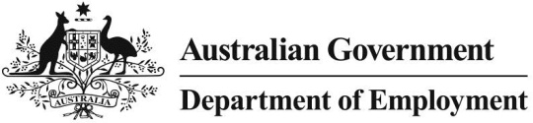

Non-quantifiable wage increases in federal enterprise agreements

# Executive summary

The main wage statistic of the Department of Employment’s quarterly *Trends in Federal Enterprise Bargaining* (*Trends*) report is the Average Annualised Wage Increase (AAWI). The AAWI can only be confidently calculated for those agreements that provide quantifiable wage increases over the life of the agreement. At present these agreements represent around 70 per cent of agreements.

While the AAWI for the remaining 30 per cent of agreements cannot be confidently calculated using the usual methodology, the exclusion of these agreements from the AAWI calculations could undermine the representativeness of this worthwhile wages growth measure. In order to examine whether this is the case, this paper tests alternative methods to derive an AAWI for ‘non-quantifiable’ agreements. It also reports the characteristics, trends and detailed reasons for the agreements being non-quantifiable, in order to provide users with more information on these agreements. This paper concludes that the estimate of the AAWI for non-quantifiable agreements is not sufficiently robust to publish but the exclusion of these agreements from official AAWI calculations is likely to have a small impact on the representativeness of the published data.

# Introduction

Although the Australian Bureau of Statistics’ Wage Price Index is the official and preferred measure of overall wages growth, the AAWI is an important measure in determining trends in wages growth for people employed on enterprise agreements. Federally registered collective agreements cover 32.6 per cent[1] of Australian workers.

The AAWI in an agreement is the average of wage increases across all employees and over the life of the agreement. If the average cannot be calculated, the agreement is excluded from the *Trends* AAWI . The Department calls these agreements ‘non-quantifiable agreements’.

At 31 December 2015, there were 4,465 current ‘non-quantifiable’ enterprise agreements representing 30.6 per cent of all agreements current at that time and covering 769,549 employees or 32.9 per cent of all employees under current agreements.

Given this reasonably large proportion, the Department has conducted an analysis to see if it could estimate the AAWI for ‘non-quantifiable agreements’ to be published as part of the quarterly *Trends* report.

# Reasons for non-quantifiable agreements

## Reasons agreements are ‘non-quantifiable’

Broadly, the Department determines an agreement to be ‘non-quantifiable’ if:

* The agreement contains increases that are not consistent between groups of employees; or
* The agreement contains increases that are linked to performance; or
* The agreement contains increases that are linked to the Fair Work Commission’s (FWC) Annual Wage Review (AWR); or
* The agreement contains increases that are linked to the Consumer Price Index (CPI); or
* The agreement contains increases that are non-quantifiable for any other reason.

The charts below show the breakdown of agreements that are non-quantifiable by number of current agreements and number of employees employed under them.

Reason for being non-quantifiable by current agreements – as at 31 December 20151

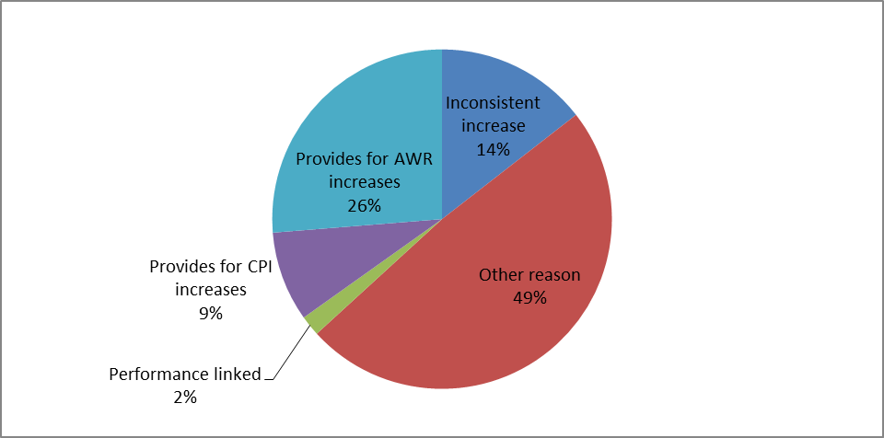Source: Department of Employment, Workplace Agreement Database

1. Percentages rounded

Reason for being non-quantifiable by current employees – as at 31 December 20151

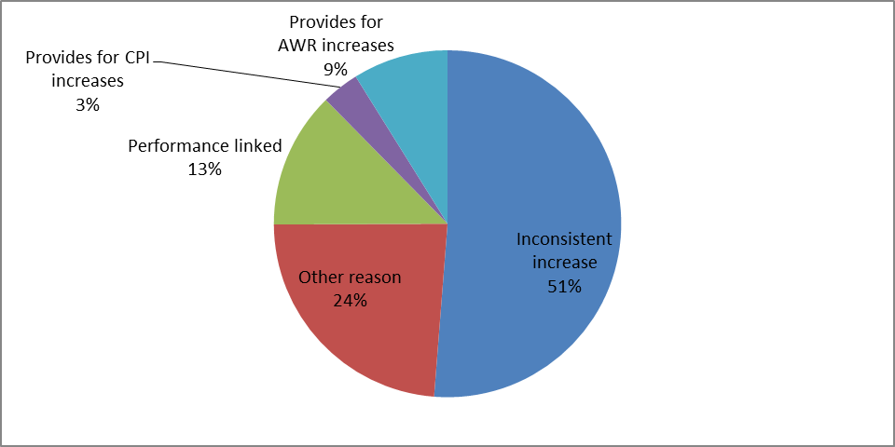

*Source: Department of Employment, Workplace Agreement Database*

1. Percentages rounded

### Wage increases are not consistent across employees

Some agreements contain multiple classification groups or employee types that receive different sized wage increases. This makes it impossible to determine an agreement-wide wage increase, because the number of employees in each cohort is not specified in an agreement. Unless additional information is available to the Department, for example the different levels of wage increase are funded from a guaranteed and quantified wage pool or the agreement averages the total wage increases across all employees, these agreements are considered non-quantifiable.

As at 31 December 2015, 51.2 per cent of employees covered by current non-quantifiable agreements had inconsistent wage increases. This represented 14.5 per cent of all current agreements at that time.

This category includes proportionally more large or very large agreements because they are more likely to cover diversified workforces containing several different categories of workers performing different functions, all covered by a single agreement.

### Increases are performance linked

Where pay increases are linked to staff performance, the AAWI for these agreements cannot be calculated unless the agreement notes that pay increases will be funded from a guaranteed remuneration pool, and the size of that pool is known.

As at 31 December 2015, 12.7 per cent of employees covered by non-quantifiable agreements had performance linked wage increases. Only 1.9 per cent of non-quantifiable agreements were performance linked.

Performance-linked agreements are most common among large and non-union agreements. The industry mix of this category is surprisingly varied. Most major banks fall into this category, as do some insurers and heavy industry. Agreements may be less prescriptive in terms of the link between pay increases and performance. For example, in this manufacturing industry agreement:

*The Base Salary is subject to an annual review process which enables the Company to recognise and reward Employees for their performance during the year and for their contribution to achieving business objectives. Reviews are determined by considering a combination of factors including individual performance, the performance of the Company, and market factors. These reviews will not result in a decrease to base salaries.*

Conversely, the following agreement includes a typical performance provision, allowing for a fixed increase in the total remuneration pool, with pay increases distributed based on employee’s performance rating:

*Fixed Pay Increase Pool means a pool of funds equivalent to 3.75% of the total annual value of Fixed Pay for Employees […].*

*[…]*

*Subject to [the performance clauses] the Employers will together distribute the Fixed Pay Increase Pool as increases to Fixed Pay for Applicable Employees of at least the following amounts […]:*

*(i) Employees rated 'Effective', 'High Achievement' or 'Outstanding' (or an equivalent rating in place from time to time) a minimum of 3.75%;*

*(ii) Employees rated 'Needs Development' (or an equivalent rating in place from time to time) a minimum of 2%.*

### Increases are linked to other external determinants

Agreements may have their increases linked to decisions made by external bodies or linked to economic indicators. The most common linkages are to Fair Work Commission Annual Wage Review decisions and to the Consumer Price Index or the Wage Price Index.

Given these changes are unknown at the time the agreement is made, these agreements cannot be quantified in the AAWI calculation. For both the Annual Wage Review and CPI-linked increases the Department is able to calculate increases after their respective events have occurred. Prediction of future increases, however, is not possible.

It should be noted that these external determinants may not necessarily apply to all wage increases provided in an agreement. For example, an agreement may provide a percentage increase in the first year, and linking to Annual Wage Reviews thereafter. In this instance overall AAWI will still be incalculable.

#### Linking to Annual Wage Review

In its most recent Annual Wage Review, the Fair Work Commission increased all pay rates and classifications by 2.4 per cent, effective 1 July 2016.

In December quarter 2015, 8.9 per cent of non-quantifiable employees had Annual Wage Review linked increases, compromising 26.3 per cent of non-quantifiable agreements.

Agreements in this category tend to be small in size. It is also quite likely that as pay rates reflect Modern Awards (or at least maintain increases consistent with Modern Award increases) this category is common in lower skilled, traditionally award-dominated industries like Retail Trade (where 19 per cent of non-quantifiable agreements are linked to external determinants).

Almost all agreements in this category are for private sector employers.

This passage from a retail enterprise agreement is typical of the link to the Annual Wage Review:

On [first pay on or after 1 July each year] the Enterprise Agreement’s wages will increase by the same percentage the General Retail Industry Award’s wage level increases by as a result of FWC’s […] annual wage review. [The employer] will publish and circulate a revised wage table once FWC’s decision is announced.

#### Linking to CPI

Some agreements link wage increases to an economic indicator, most commonly the CPI (and to a lesser extent the Wages Price Index (WPI)). Some agreements go further, pegging wage increases to a specific component of one of these indices. Some employers, for example link the CPI basket for their respective city to more accurately match cost of living increases for their employees.

As at December quarter 2015, 3.5 per cent of employees covered by non-quantifiable agreements and 8.6 per cent of non-quantifiable agreements were CPI-linked.

The characteristics of CPI-linked agreements are, by and large, similar to those for Annual Wage Review Linked agreements, including that they generally cover lower skilled jobs.

A Victorian community services employer’s enterprise agreement is typical in its wording:

*52.3 The salary rates for each classification in this Agreement will be increased by CPI (if CPI increases), on the dates set out in clause 52.4 below. The percentage increase in CPI will be as per Australian Bureau of Statistics (ABS) CPI, All Group Index Numbers and Percentage Changes (Table 6401.0) yearly percentage change for Melbourne (or relevant ABS modified rate) as at the most recent quarter published prior to the dates set out in clause 52.4 below.*

*52.4 Any increased salary rates referred to in clause 52.3 above will come into effect [on 1 July each year].*

### Other reasons

Where the reason that an agreement is non-quantifiable is not one of those listed above, the WAD will code it as non-quantifiable for ‘other reasons’.

In December quarter 2015 48.7 per cent of non-quantifiable agreements had inconsistent wage increases covering 23.7 per cent of employees.

“Other reasons” that the WAD has coded include that:

#### Increases are based on internal annual wage reviews or at the company discretion, and may be dependent on company performance.

For example, in this mining agreement, the company notes a number of factors it will consider when deciding on annual increases, including corporate performance:

*Annual Salaries will be reviewed annually. Any adjustment will be at the Company's discretion. The review will be based on the Company's performance, market conditions, industry salary movements generally, and other relevant factors.*

#### Increases are dependent on funding.

Businesses that are dependent on funding for wage agreements -mainly contractors reliant on particular new or renewed contracts - however businesses dependent on government grants (such as service providers) and businesses that bid for work (such as various contractors) may also be included here.

#### The mechanism for wage increases is ambiguous, or multi-factored.

Some agreements contain multiple methodologies to calculate wage increases. This may be because different cohorts of employees have their increase calculated in different ways, or a single employee may see their pay increase in several ways. This agreement from a small professional services firm is typical, and provides separate mechanisms to increase the components listed:

*10.2 Total remuneration*

*Your base salary is only one part of the total remuneration you receive for the work you perform […]. As an […] employee your total remuneration may comprise a number of direct and indirect components including:*

* + *base salary;*
  + *performance increases; and*
  + *incentive schemes.*

Due to the broad range of reasons included as part of the ‘other reasons’, there are few common characteristics of agreements or employers in this category.

# Characteristics of non-quantifiable agreements

## Industry

There are four industries where employees on agreements are most likely to be employed under a non-quantifiable agreement.

In Accommodation and Food Services, 90.3 per cent of employees have non-quantifiable wage increases from 67.8 per cent of agreements. The high proportion of non-quantifiable increases on this sector is accounted for by the fact that many agreements in this sector allow for increases based on Fair Work Commission wage reviews. The low skilled nature of the industry and low occurrence of union agreements contribute to the high incidence of non-quantifiable agreements.

In the Financial and Insurance Services industry, 86.1 per cent of employees with an agreement have non-quantifiable wage increases, despite only 42.3 per cent of agreements in the sector being non-quantifiable. Based on current agreements, the most common reason that agreements are non-quantifiable in this sector is ‘other reasons’, however performance-linked agreements are also very common. About 64 per cent of employees in the Financial and Insurance Services industry with non-quantifiable agreements are covered by very large agreements (43 per cent are covered by the largest four agreements alone).

Information, Media and Telecommunications has 79.8 per cent of agreement-reliant employees on non-quantifiable agreements. This includes the Telstra enterprise agreement, which covers 28,299 employees, representing 61 per cent of employees in the sector. Despite the significant majority of employees being on non-quantifiable agreements, only 27.3 per cent of current agreements themselves include non-quantifiable wage increases. ‘Other reasons’ is the most common reason for the agreements being non-quantifiable.

In the Mining industry 61.5 per cent of employees on current agreements have non-quantifiable wage increases, representing 48.1 per cent of agreements.

The Electricity, Gas, Water and Waste Services sector has the lowest incidence of both proportion of employees (8.5 per cent) and proportion of agreements (9.7 per cent) being non-quantifiable among current agreements. Current agreements are dominated by a small number of large union agreements with clear and fixed wage increases.

While a long time series industry analysis has not been conducted, over the last few quarters the industry distribution of non-quantifiable agreements seems relatively consistent.

The following chart shows non-quantifiable agreements disaggregated by industry for both proportion of agreements and proportion of employees.

Proportion of current non-quantifiable agreements and employees by industry – as at December quarter 2015

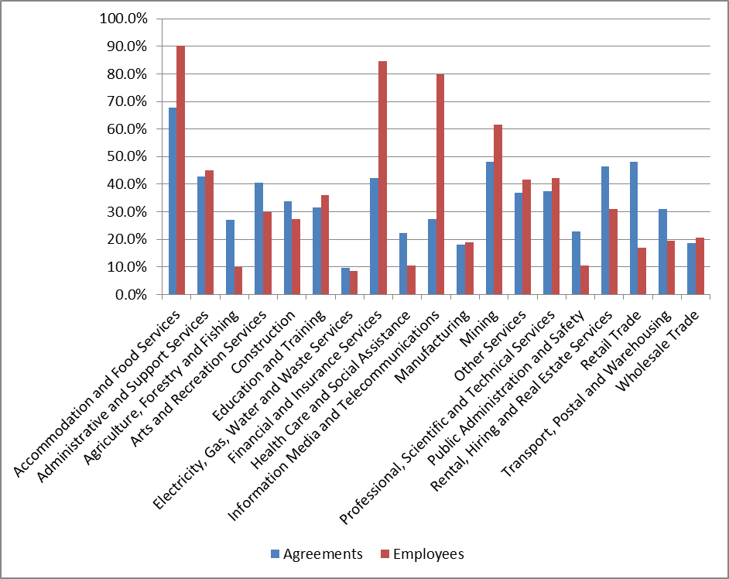

Source: Department of Employment, Workplace Agreement Database, current agreements Dec 2015

## Other characteristics

Non-quantifiable agreements are more likely to be non-union agreements. In 2015, 51.3 per cent of non-union agreements were non-quantifiable and 64.9 per cent of non-union employees were covered by non-quantifiable agreements, compared to 20.7 per cent of union agreements covering 28.7 per cent of employees with union agreements.

In terms of both number of agreements and number of employees covered, agreements with non-quantifiable wage increases are much more likely to be in the private than the public sector. In 2015, 32.1 per cent of private sector agreements were non-quantifiable and 37.2 per cent of private sector employees were covered by non-quantifiable agreements, compared to 11.6 per cent of public sector agreements covering 6.9 per cent of employees covered by public agreements. Much of this discrepancy could be linked to the larger size, higher union density, and industrial composition of public sector agreements.

By size, non-quantifiable agreements make up approximately one quarter of all medium-sized agreements (20-99 employees) and large agreements (100 and over employees). Non-quantifiable agreements represent a third of all small agreements (19 or fewer employees covered).

When considering the proportion of employees covered by non-quantifiable agreements of particular sizes, employees under very large agreements are the most likely to have non-quantifiable wage increases. This is likely due to very large agreements covering diverse businesses that necessitate many classifications and worker types on a single agreement.

# Trends over time

In general, since 2011, non-quantifiable agreements have tended to become more common in both proportion of agreements and proportion of employees.

Variations in the proportion of employees covered by non-quantifiable agreements may appear quite inconsistent however this is accounted for by very large agreements (those with up to tens of thousands of employees, which have the potential to greatly distort trends) expiring or becoming active.

Non-quantifiable agreements as a proportion of all approved agreements by proportions of agreements and employees – to December quarter 2015

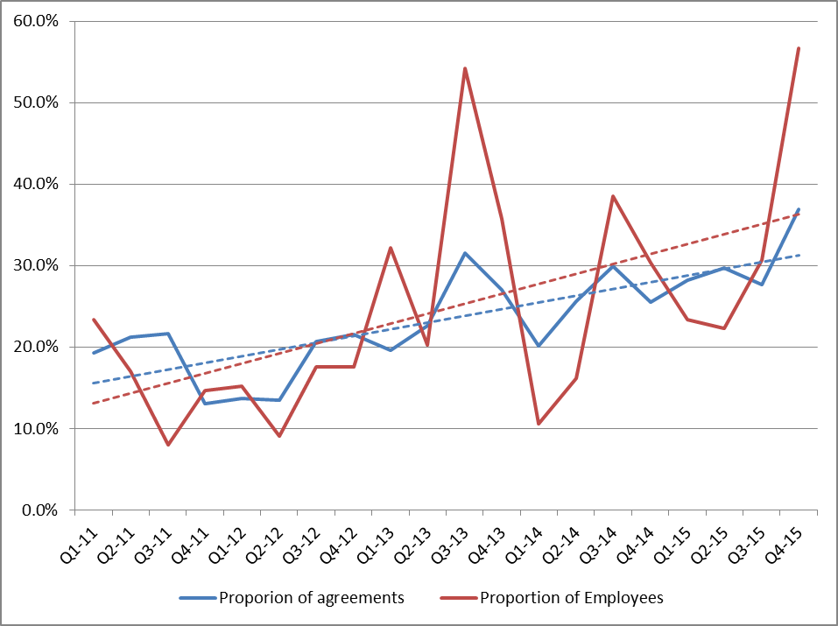Source: Department of Employment, Workplace Agreement Database, approved agreements 2015

Since 2011, all reasons that agreements are non-quantifiable (by number of agreements) have trended slightly downward for all reasons except ‘other reasons’. This may point to less established ways of setting wages (such as internal wage reviews, funding-dependant wage increases, or multiple-factor wage increases) becoming more popular in agreement making. It is possible that this suggests that a growing priority in agreement negotiations is ensuring a greater level of flexibility in wage setting.

Proportion of agreements by reason agreement is non-quantifiable – to December quarter 2015

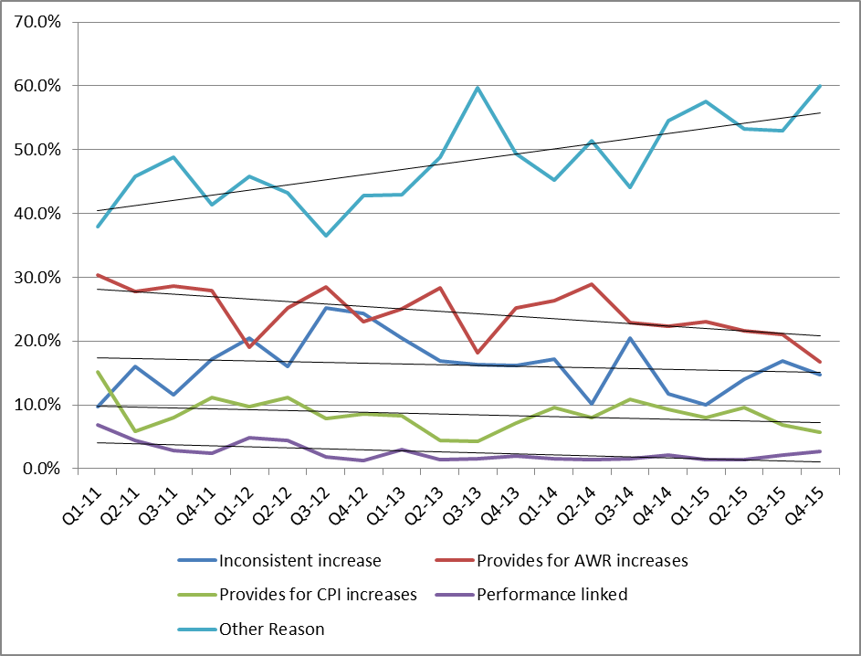Source: Department of Employment, Workplace Agreement Database, approved agreements 2015

# Methods to estimate the quantum of non-quantifiable agreements

To better understand the wage increases in non-quantifiable agreements, in 2015 the Department conducted an analysis to test the proximity of wage growth in non-quantifiable agreements with the published AAWI.

## Methods

Using March 2015 current agreements data, the Department derived a best estimate of wage increases for each category of non-quantifiable agreements. For some categories, we were only able to examine a sample of the agreements. However we have ensured that a sufficient proportion of agreements in these categories, and the agreements covering a large number of employees in these categories were examined.

These methods, along with the results, are set out in the table below.

| Type of non-quantifiable agreement | Number of agreements | Number of employees (‘000) | Proxies | Number of agreements in sample* | Number of employees in sample (‘000) | Estimated AAWI |
| --- | --- | --- | --- | --- | --- | --- |
| Inconsistent increase | 752 | 306.9 | Increases within agreements, averaged to produce an increase for each agreement. Process repeated and averaged over all agreements in the sample | 100 | 38.7 | 2.2% |
| Performance linked | 155 | 101.7 | Calculated average increase in wages between the pay rates at commencement of the agreement and the pay rates at the commencement of the agreement it replaced | 49* | 201.3 | 3.2% |
| Linked to AWR | 1251 | 75.1 | Average of 3 most recent Annual Wage Reviews | 1251 | 75.1 | 2.9% |
| Linked to CPI | 389 | 22.8 | Treasury inflation forecasts as part of 2015-2016 Federal Budget | 389 | 22.8 | 2.8% |
| Other reasons | 2151 | 172.2 | Maintaining relative to awards: Average of 3 most recent Annual Wage Reviews | 260 | 17.9 | 2.9% |
| Maintaining market rates: AAWI | 71 | 6.3 | 3.1% |
| Calculated average increase in wages between the pay rates at commencement of the agreement with the pay rates at the commencement of the agreement it replaced | 110** | 12.3 | 3.5% |
| Weighted AAWI for ‘Other reasons’ | Not applicable | Not applicable | 3.1% |

* 84 agreements were initially considered; however only for 49 an AAWI can be reasonably estimated.

**125 agreements were initially considered; however only for 110 an AAWI can be reasonably estimated.

For the agreements with inconsistent wage increases between employee groups, a sample of 100 agreements, covering 38,736 employees, was drawn from 752 current applicable agreements as at 31 March 2015. As the agreements did not contain the number of employees in each employee category for each agreement in the sample, a simple average of different increases was calculated. The combined AAWI for the sample agreements was 2.2 per cent.

A sample of 84 agreements from a total of 155 performance linked agreements was studied. Of these agreements, there were no reasonable methods that could be applied to calculate an estimate for 35 agreements.

It was possible to estimate an average wage increase for the other 49 agreements. This is because either these agreements specified a fixed percentage pool of its total remuneration to fund wage increase, or an estimated AAWI can be derived by comparing the starting wage rates of the agreement and those at the commencement of its immediate predecessor.

The average AAWI for the 49 agreements was 3.2 per cent which was then applied to all performance linked agreements.

For all 1,251 agreements linked to the Annual Wage Review current as at 31 March 2015, an average increase of past reviews for 2012, 2013 and 2014 was applied. The average AAWI produced for this category was 2.9 per cent.

For all 389 agreements linked to the CPI current as at 31 March 2015, inflation estimates and forecasts by Treasury were used as the basis for calculating pay increases. The average AAWI produced for this category was 2.8 per cent.

Calculating an AAWI for ‘other reason’ agreements was particularly difficult due to the many types of agreements in this category, and the level of information provided in the agreements.

For the 260 agreements that maintain wage level relativity to their awards, a three year average of minimum wage increases was used as a proxy, resulting in an AAWI of 2.9 per cent.

For the 71 agreements that commit to maintaining parity with market rates, the AAWI itself, as a measure of market rates, can be used as a proxy. In this case it’s 3.1 per cent.

From the remaining agreements in the ‘other reasons’ category, 424 agreements had an immediate predecessor agreement, allowing the comparison of starting wages in the two generations of agreements. A sample of 125 agreements was analysed, a valid AAWI was able to be calculated for 110 of these 125 agreements. This returned an AAWI for these agreements of 3.5 per cent.

Combining these methodologies, weighting by number of employees yielded a total AAWI of 3.1 per cent for agreements not quantifiable for ‘other reasons’.

Combining the estimates for each category, an AAWI for all the non-quantifiable agreements that were current at March 2015 was 2.6 per cent. The AAWI for quantifiable agreements approved in the March quarter 2015 was 3.1 per cent.

If non-quantifiable agreements were included in the March 2015 AAWI, it would have shown a total wage increase of 3.0 per cent in that quarter.

| Agreement type | Employees (‘000) | Proxy wage increase |
| --- | --- | --- |
| Inconsistent increase | 306.9 | 2.2% |
| Performance linked | 101.7 | 3.2% |
| AWR increases | 75.1 | 2.8% |
| CPI increases | 22.8 | 2.8% |
| Other reasons | 172.2 | 3.3% |
| Total (weighted average of non-quantifiable agreements) | Not applicable | 2.6% |
| Quantifiable agreements | Not applicable | 3.1% |
| Hypothetical AAWI for quantifiable and non-quantifiable agreements combined | Not applicable | 3.0% |

While each method used provides a reasonable AAWI estimation, they do have significant limitations.

For agreements with inconsistent increases, the estimation does not account for the varying number of employees at each classification and hence is not accurate.

The derivation of some estimation, for example comparing the wage rates with those in the replacement agreement and referring to the Annual Wage Reviews decisions, is retrospective and unsuitable for calculating current AAWIs. For CPI-linked agreements, the methodology relied on predictive forecasts, which usually differ from the actual rates.

Lastly, for many agreements, there is no reliable way to calculate a reasonable wage increase.

# Conclusions

Based on the limitations explained above, it is not prudent or feasible to include non-quantifiable agreements into the official AAWI published in *Trends*.

The analysis demonstrates that the difference between non-quantifiable agreements and quantifiable agreements in aggregate does not have a particularly significant impact on the overall reported AAWI, altogether yielding only a difference of 0.1 percentage points. The exclusion of non-quantifiable agreements is therefore unlikely to materially reduce the accuracy of the wage increases statistics in the *Trends* reports.

In order to enable users to better understand the potential influence of non-quantifiable agreements on the reported AAWI, the *Trends* report will include more details on large non-quantifiable agreements approved in each quarter, such as the number of employees, and a summary of the wage increase arrangement.

The Department will also continue to monitor the trends in non-quantifiable agreements, particularly their prevalence among all agreements and any likely impact of their exclusion from overall AAWI calculations.

1. *ABS Employee Earning and Hours (Cat. No. 6306.0), May 2014*