‘Employee-like’ forms of work and stronger protections for independent contractors

Consultation paper

**April 2023**

Title

Creative Commons

With the exception of the Commonwealth Coat of Arms, the Department’s logo, any material protected by a trade mark and where otherwise noted all material presented in this document is provided under a [Creative Commons Attribution 4.0 International](https://creativecommons.org/licenses/by/4.0/) (https://creativecommons.org/licenses/by/4.0/) licence.

The details of the relevant licence conditions are available on the Creative Commons website (accessible using the links provided) as is the full legal code for the [CC BY 4.0 International](https://creativecommons.org/licenses/by/4.0/legalcode) (https://creativecommons.org/licenses/by/4.0/legalcode)

The document must be attributed as the *Australian Government ‘Employee-like’ forms of work and stronger protections for independent contractors consultation paper*.

Contents

Overview 4

How to provide your feedback 5

Introduction 6

Empowering the Fair Work Commission to set minimum standards for workers in ‘employee-like’ forms of work, including the gig economy 9

Improving avenues for workers to challenge unfair contractual terms 16

Working towards a road transport industry that is safe, sustainable and viable 19

Appendix 1 20

# Overview

At the end of 2022, the Australian Government enacted the *Fair Work Legislation Amendment (Secure Jobs, Better Pay) Act 2022* to ‘get wages moving, boost job security, tackle gender inequality and restore fairness and integrity to Fair Work institutions’[1].

In February 2023, the Hon Tony Burke MP, Minister for Employment and Workplace Relations announced that the Government would introduce a further tranche of legislation in the second half of 2023 to ‘close the loopholes’ that can undercut the principles of the Fair Work Legislation Amendment (Secure Jobs, Better Pay) Act 2022.[2] A key ’loophole’ is the significant difference between the rights and protections afforded to employees compared to workers who perform work as independent contractors.

Ahead of the May 2022 Federal Election, the Government committed to empowering Australia’s workplace tribunal, the Fair Work Commission, to set minimum standards for workers in ‘employee-like’ forms of work, including the gig economy.

At the Jobs and Skills Summit in September 2022, the Government further committed to progress work to:

* consider allowing the Fair Work Commission to set fair minimum standards to ensure the Road Transport Industry is safe, sustainable and viable; and
* amend relevant legislation to give workers the right to challenge unfair contractual terms.

The Australian Government Department of Employment and Workplace Relations (the department) is now seeking feedback on the direction the Government should take in implementing these three commitments. Discussion questions are included throughout the consultation paper and a full list is at **Appendix 1** for ease of reference.

Each of these commitments is separate and may require different solutions. However, as they share an objective of strengthening protections for contractors in need of minimum standards, the public’s views are being sought on all three commitments together.

# How to provide your feedback

The department will use your views to help develop the final measures for introduction in legislation in the second half of this year.

Please provide your written comments via email to WRSubmissions@dewr.gov.au. All submissions will be treated as confidential and will not be published. You can choose to remain anonymous.

**Closing date:** Submissions close at 11:00pm AEST on Friday 12 May 2023.

Please keep informed of progress of these reforms at [www.dewr.gov.au](http://www.dewr.gov.au), including opportunities to be involved in later stages of consultation.

# Introduction

## Work arrangements under Australia’s workplace relations system

Australia’s labour market is diverse. From a population of nearly 26 million, there are 13.7 million workers, of which 11.7 million (84 per cent) are employees who are engaged under a variety of arrangements – permanent, casual and fixed term work, working directly for an employer or working indirectly via labour hire and outsourcing arrangements.[3] Employees are engaged under a *contract of service* and entitled to a safety net of minimum conditions under the *Fair Work Act 2009* (Cth) (the Fair Work Act), modern awards and other workplace legislation.

The labour market also includes independent contractors who are engaged under a *contract for services*. These workers play a crucial role in the workforce by delivering services to businesses and consumers. The latest data show 8.3 per cent of the workforce or 1.1 million workers were engaged as independent contractors in 2022.[4] Compared to employees, these workers may have more autonomy to choose when they work, the rates they charge and the conditions they work under, while also taking responsibility for things like the purchase and maintenance of equipment, insurance and meeting their legal obligations as a small business.

A worker’s status as an employee (contract of service) or an independent contractor (contract for service) is set at common law. Until recently, courts applied a multifactor test so that a worker’s status was set having regard to the ‘totality of the relationship’ after considering multiple factors. This ‘multi-factor test’ evolved over time, and included things like control and authority over work, and whether the worker could delegate work, wear a uniform or be responsible for their own tools and equipment (see Figure 3 for a non-exhaustive list).

Recent decisions of the High Court clarified that the ‘totality of the relationship’ is in fact the rights and obligations set out in the terms of the contract, rather than the outcome of a process of reviewing the whole of the conduct of the parties once the contract has been established.[5] The latter process (what was previously considered the multi-factorial test) is then only used in limited circumstances, such as when the contract is made orally or where it is a sham.

Independent contractors are not entitled to the safety net of minimum conditions that applies to employees, with some limited exceptions. The Hon Tony Burke MP, Minister for Employment and Workplace Relations, has described the effect of being classified as an independent contractor for some as “falling off a cliff”:

“Because one of the loopholes that has arisen over the years, is we've gone to a system where if you meet the definition of the employee-employer relationship, a whole lot of rights are assigned to you – I'd argue not enough – but a whole lot of rights are assigned to you. If you fail to meet that first test, all of those rights fall off a cliff.”[6]

The degree of autonomy contractors can exercise in relation to their work can also vary. Some may possess a high degree of bargaining power, putting them in a strong position to negotiate pay and conditions, and when, how and with whom they perform work. Others may, for example, be largely dependent on a single business for ongoing work or engaged under standard form contracts over which there is little scope for negotiation.

## The Government’s commitments

### ‘Employee-like’ forms of work

In the lead up to the 2022 Federal Election, the Government committed to giving the Fair Work Commission, Australia’s national workplace tribunal, new powers to set minimum standards for workers in ‘employee-like’ forms of work, including the gig economy. The department is seeking views on how this new jurisdiction should operate, the workers it should cover, the matters the Fair Work Commission should consider in its decision-making, and the potential content of minimum standards.

### Improving avenues to dispute unfair contractual terms

At the Jobs and Skills Summit held in September 2022, the Government announced that an area of further work would be to ‘amend relevant legislation to give workers the right to challenge unfair contractual terms’. [7] The department is seeking views on potential options to afford greater protections for independent contractors to challenge unfair contractual terms, including the types of workers that should be covered.

### Making the road transport industry safe and sustainable

Another Jobs and Skills Summit outcome was to ‘consider allowing the Fair Work Commission to set fair minimum standards to ensure the road transport industry is safe, sustainable and viable’. This followed a road transport roundtable convened by the Minister for Employment and Workplace Relations in August 2022 which resulted in a broad industry coalition releasing the ‘Agreed principles for a safe, sustainable and fair road transport industry’[8] (Box 1). This coalition included diverse representatives from across the road transport industry, supply chain businesses, gig economy platforms, the union movement and academia.

The department is seeking views on the merits of this proposal, in the context of the Government’s separate commitment to introduce minimum standards for workers in ‘employee-like’ forms of work and unfair contractual terms.

Box 1. Agreed principles for a safe, sustainable and fair road transport industry: Call for Action

|  |
| --- |
| This road transport roundtable of clients, transport operators, on-demand and rideshare platforms, transport associations, transport workers and academics calls for urgent action to ensure a safe, sustainable, viable and fair road transport industry for all supply chain participants, including independent contractors, and non-employee transport workers in the on-demand and rideshare economy. As such the roundtable calls on the Australian Government to investigate a range of options to achieve this outcome, which may include adequately resourcing an independent body administered by persons with industry expertise or better empowering existing bodies, to:   1. establish and maintain appropriate and enforceable standards in relation to both traditional transport operations and on-demand delivery and rideshare platform work; 2. promote best practice supply & contract chain industry standards; 3. effectively and efficiently resolve disputes; 4. ensure transport workers are able to access and contribute to an effective collective voice; 5. convene as necessary specialist advisory groups drawn from the industry to provide advice and recommendations; and 6. provide appropriate enforcement to ensure standards and objectives are met. |

## Guiding Principles

The Government has set five Guiding Principles as relevant for the development of its three commitments (Box 2). The options outlined in this consultation paper have been developed based on these Guiding Principles, and the department encourages consideration of these in feedback to this consultation process.

Box 2. Guiding Principles

|  |
| --- |
| 1. Australia’s workplace relations system must reflect modern working arrangements and be capable of evolving with emerging forms of work and business practices. 2. All workers should have access to minimum rights and protections regardless of whether they are characterised as an employee or an independent contractor, including access to freedom of association and dispute resolution. 3. Businesses should benefit from a level playing field among industry participants while promoting competition and innovation. 4. The Fair Work Commission should set minimum standards that:    * + are fair, relevant, proportionate, sustainable and responsive      + reflect workers’ independence and flexible working arrangements, for example choosing which tasks to accept and refuse, how to undertake their work, where and when they work, and which businesses to contract with      + mitigate to the greatest extent possible unintended consequences for workers, businesses, consumers and other aspects of the labour market 5. The standard-setting framework should be accessible, transparent, fair and offer a high degree of certainty to affected parties. |

# Empowering the Fair Work Commission to set minimum standards for workers in ‘employee-like’ forms of work, including the gig economy

This measure involves empowering the Fair Work Commission to consider applications and make orders setting enforceable minimum standards for defined cohorts of workers in ‘employee-like’ forms of work. The origin of this commitment was to address the disparity between the rights of employees and contractors in need of minimum standards – specifically where independent contractors are engaged to do the job at a cheaper rate than an employee. In February 2023, the Hon Tony Burke MP, Minister for Employment and Workplace Relations stated:

“There are many reasons why people want different levels of flexibility in non-employee circumstances. Nobody makes that decision because they are yearning to be paid less than the minimum wage. So we will be expanding the capacity of the Fair Work Commission to close that loophole. To close the loophole that awards that are meant to set minimum standards, somehow create a situation where if you're not an employee in an employee relationship, there are no need for any minimum standards at all.”[9]

These ‘loopholes’ have been highlighted over the past decade with the emergence of the gig economy (also referred to as the ‘on-demand’ economy). Workers in the gig economy are generally engaged as independent contractors, rather than employees. This is despite many of these workers not exhibiting all of the characteristics which are traditionally associated with independent contracting, such as control over their work, stronger bargaining power and freedom to set their own prices. The term ‘employee-like’ is used to refer to workers in such arrangements.

Today, the gig economy is growing across most sectors of the labour market, beyond rideshare services, food delivery and ad hoc tasks. There are platforms that connect workers, businesses and consumers to do almost any kind of work, from last mile delivery to personal care work, from building furniture to translation and web-based services, and beyond. The gig economy offers a range of benefits – it has benefitted thousands of workers who can now earn extra income or access labour market opportunities. It has also provided tens of thousands of businesses the opportunity to expand their reach and was integral to managing the impacts of restrictions to manage the impacts of the COVID-19 pandemic. Digital platforms have also provided consumers with innovative and efficient services. However, the gig economy needs to operate fairly and sustainably.

The gig economy has highlighted that some workers may be engaged as independent contractors but exhibit a lack of bargaining power and autonomy over their own work that is more closely associated with employment.

The Government’s commitment is intended to be future focused with the Fair Work Commission able to assess the working arrangements or characteristics of specific cohorts of workers (regardless of their status) and set minimum standards accordingly. As Minister Burke has said:

“What’s happened in some parts of the world is that part of this has evolved and we’ve said we’ll just expand the definition of “employee” to include the platforms that are already doing it. And they can always change their algorithm faster than we can legislate, so they need to change how they operate to avoid the new definition. The whole idea of this is to give the Commission as much flexibility as the platforms have, so if they try to evade, the Commission can follow them and chase them to make sure no matter how the new rules are being applied, no matter what the platforms respond with, the Commission makes sure that minimum standards are followed wherever they go.”[10]

## Options for implementation

The following provides an overview of the key elements of the Fair Work Commission’s proposed new jurisdiction and powers, and the associated issues that the Government is considering.

### Scope of workers

As already identified, the gig economy is a priority for the Government. However, there is no universal definition of the ‘gig economy’. Though it is often defined by reference to work performed that has been sourced via a digital platform (an online app or website), the actual work performed may be similar to work performed by individuals not using a platform.

The nature of platforms also differs between a ‘vertical’ on-demand model where the platform exercises control over how the work is performed, and a ‘horizontal’ model where the platform provides a ‘marketplace’ for workers and consumers to connect on specific ad hoc tasks. Both models may exist in the same sector, depending on the nature of the business operating the platform.

Work involved in the ‘sharing economy’ – the sharing of accommodation, cars or tools, etc. – is not intended to be within scope of this measure as the value is generally derived from the asset, rather than the work performed. Platforms that merely advertise services or products without any need to register or facilitate payments are also generally not considered to be part of the gig economy. The different models are displayed in **Figure 1**.

Figure 1. Working concept of the gig economy

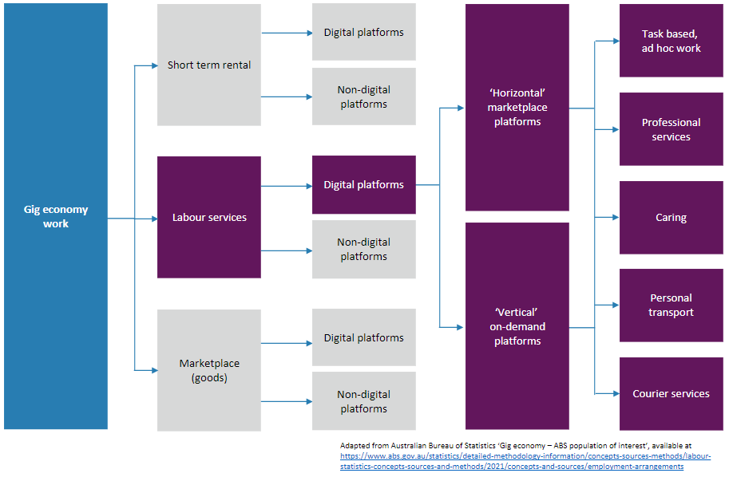

The department is interested in views on an approach which positions the engagement of a worker through a platform as the primary factor in determining coverage.

The department is also interested in whether there are other factors, in addition to engagement via a platform, that should be used in framing the scope of the new jurisdiction. This could include the performance of work under arrangements that resemble aspects of employment relationships, such as the degree of control or autonomy over work.

|  |
| --- |
| 1. What is the best approach to defining the scope of the Fair Work Commission’s new functions, taking into account the engagement of a worker through a platform as the primary factor? 2. What other factors should be considered? |

### Parameters for the Fair Work Commission

The Fair Work Commission could be empowered to exercise its functions in a broad way but balanced by ‘guardrails’ set by the Australian Parliament. Under this approach, an appropriate level of guidance would be provided to parties and the Fair Work Commission as to how the jurisdiction is intended to operate, while avoiding a highly prescriptive or technical approach. The jurisdiction would need to be able to respond to future changes in business operating practices and worker preferences. The process should also be accessible, fair and transparent, while outcomes should be clear and certain.

For example, the ‘guardrails’ could consist of:

* legislation that clearly sets out the scope of workers covered and functions the Fair Work Commission should exercise
* an ‘objective’ or set of factors that the Fair Work Commission should have regard to in making its decisions, operating in a broadly similar way to the modern awards objective
* requirements around the process of making orders and performing certain functions (e.g. the parties that can make applications for standards, agreement-making, etc.), and
* the making of a work plan to help prioritise the Fair Work Commission’s work.

In terms of an ‘objective’ that would guide the Fair Work Commission in its decision-making, the department is considering the following factors, but would welcome feedback on any further suggestions.

Standards should:

* be tailored to the needs of specific sectors
* be fair, relevant, proportionate, sustainable, responsive
* reflect workers’ independence and desire for flexible working arrangements
* take into account the needs of workers
* promote innovation, productivity and competition
* mitigate negative impacts on businesses, their viability and unique business models
* avoid as far as possible unintended consequences on workers, consumers and the labour market
* be accessible, transparent and offer high degree of certainty to all parties

|  |
| --- |
| 1. What ‘guardrails’ should be set to guide the Fair Work Commission in exercising its functions? 2. What factors should be included in the Fair Work Commission’s ‘objective’ for setting standards? |

### Content of minimum standards

The Fair Work Commission would likely set minimum standards through an Order or a Decision of the Commission. Consistent with the purpose and other functions of the Fair Work Commission, it is expected that the content of minimum standards would be limited to work-related matters and not the commercial matters that may feature in service agreements.

It is intended that any minimum standards made by the Fair Work Commission would be tailored to the needs of the workers and businesses they cover. The Fair Work Commission could be directed to make minimum standards in respect of, but not limited to:

* minimum rates of pay
* concepts of ‘work’ time (e.g. which activities performed by a worker should attract compensation)
* payment times (e.g. timeframes between performance of work and payment)
* workplace conditions, such as portable leave, rest breaks, etc.
* treatment of business costs, including vehicles and maintenance, insurances, licences, etc.
* record keeping
* training and skill development, and
* dispute resolution.

|  |
| --- |
| 1. What kinds of minimum standards are needed and why? |

### Process for making minimum standards

Designing Fair Work Commission processes that are similar to those that it takes in relation to other functions, such as setting and reviewing modern awards, would enable it to utilise its expertise in those other functions and create a sense of familiarity for the parties.

A process like the Fair Work Commission’s modern award process would allow it to not only respond to applications from workers or businesses or their representatives to make minimum standards in relation to ‘employee-like’ forms of work, but also commence making minimum standards on its own accord if necessary. An example process is shown at Figure 2.

Such a process could involve:

* An eligible party makes an application for a new or revised minimum standard. Eligible parties could be a narrow or a broad concept, for example registered organisations entitled to represent the interests of workers or businesses proposed to be covered by the standard.
* For the Fair Work Commission to consider an application, the eligible party would need to make a case for the new or revised standard, for example arguing a case for why minimum standards are required (or required to be revised and reissued) for a specific cohort of workers within scope of the Fair Work Commission’s jurisdiction.
* In considering applications, the Fair Work Commission could undertake the kinds of activities it would normally do in considering applications, for example taking submissions, conducting hearings and assessing research.
* The Fair Work Commission could have the option of making draft orders or publishing draft or preliminary decisions and seeking feedback on these, but the intention would be to ensure the Fair Work Commission had maximum discretion to conduct its work.
* The process for revising, renewing or revoking standards could generally be the same as for the making of new standards, and discretion given to the Fair Work Commission as to how it conducts these proceedings.

Enforcement of Fair Work Commission orders would ensure workers are provided their new entitlements and enact meaningful change across industries. Australia’s workplace regulator, the Fair Work Ombudsman, could be primarily responsible for education, compliance and enforcement of the Fair Work Commission’s Orders, with individuals or their representatives also playing a role (per current enforcement approaches under the Fair Work Act).

Figure 2. Example Fair Work Commission minimum standard-setting process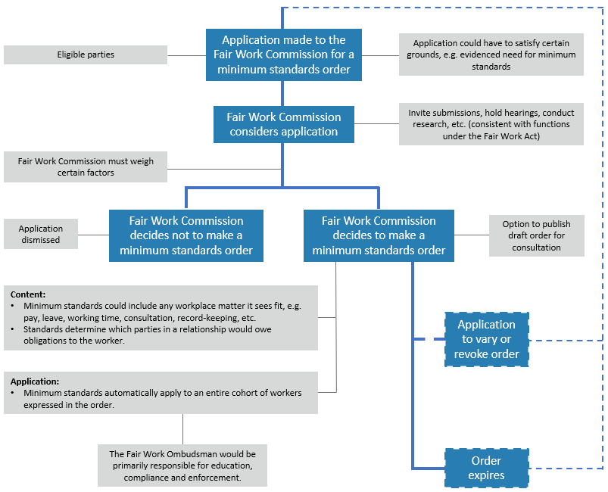

|  |
| --- |
| 1. How can the standard-setting process in the Fair Work Commission be designed to deliver efficient, reliable, sustainable and fair outcomes? 2. How can the Fair Work Commission’s processes reflect the character of ‘employee-like’ workers and engage with them appropriately? 3. How can potential unintended negative impacts for workers, businesses, consumers and the labour market be mitigated? 4. How could the Fair Work Commission’s orders be enforced? |

### Agreement-making

A fundamental aspect of Australia’s workplace relations system is the freedom for workers and their representatives to bargain collectively with an employer. Making agreements governing workplace pay and conditions is nearly the exclusive right of employees and employers. For small businesses and independent contractors and their principals, the inherent advantages in allowing groups of small businesses to bargain collectively with a single principal has been recognised under competition law. The recent small business class exemption[11] put in place under the *Competition and Consumer Act 2010* (Competition and Consumer Act) allows groups of small businesses to bargain with a single larger business after notifying the Australian Competition and Consumer Commission.

Major gig platforms Uber, DoorDash and Menulog have signed in-principle agreements[12] with the Transport Workers’ Union to jointly recognise the importance of industry standards for their sector and their willingness to agree common principles. The Government is considering a framework to allow the Fair Work Commission to approve consent agreements reached between individual businesses and groups of independent contractors that supply services to them, without necessarily creating a parallel agreement-making stream for independent contractors. Agreements could be made after the Fair Work Commission sets standards for covered workers, or they could be made before that occurs, provided appropriate safeguards are in place to ensure standards are not undermined.

|  |
| --- |
| 1. What should be the features of a best practice agreement-making framework, including the role of the Fair Work Commission and worker and business representatives? 2. In what circumstances should agreements be able to be made before minimum standards are in place and what safeguards should apply? |

### Dispute resolution

A key area of the Fair Work Commission’s expertise is its capacity to deal with and resolve disputes. In the employment context, the Fair Work Commission deals with a variety of disputes including those arising under awards and agreements, in relation to unfair dismissal and general protections, and under recent jurisdictions relating to sexual harassment and bullying (which also apply to independent contractors). Depending on the jurisdiction, the Fair Work Commission’s method of dealing with disputes can include conciliation, mediation or consent arbitration of the matter (subject to constitutional limitations). The Fair Work Commission is somewhat constrained in its ability to settle disputes over a worker’s status as an employee or independent contractor, as it is a tribunal and not a court of law.

The Government is considering providing the Fair Work Commission with a dispute resolution function, including in relation to disputes about the application of, or arising under dispute resolution terms contained in, minimum standards orders.

|  |
| --- |
| 1. What disputes should the Fair Work Commission be able to help resolve? 2. What remedies and roles could the Fair Work Commission have available to it to resolve disputes? |

# Improving avenues for workers to challenge unfair contractual terms

Generally, independent contractors agree services contracts with their principals that set out the work they will perform and the conditions under which they will perform that work. Compared to employment relationships, there are much more limited safeguards that apply to the content of these contracts.

In practice, many independent contractors have limited ability to negotiate contractual terms with the businesses that engage them, whether due to inexperience, lack of bargaining power or lack of resources. For example, where work is performed under standard form contracts, they may be formed on a ‘take it or leave it’ basis. An imbalance of bargaining power between principals and contractors can also lead to termination of contracts without notice and due process, resulting in sudden loss of income.

Independent contractors are currently required to seek recourse through a court to address unfair contractual terms. However, there are significant obstacles to accessing these remedies due to the time, complexity and costs that can be associated with court processes. Perhaps for these reasons, since its commencement in 2006, the unfair contracts jurisdiction under the Independent Contractors Act 2006 has rarely been used. The Inquiry into the Victorian On-Demand Workforce described this jurisdiction as “little used” and having “produced few positive outcomes”.[13]

The Australian Consumer Law (ACL) (Schedule 2 of the Competition and Consumer Act) also provides protections for small businesses (including independent contractors) against unfair contractual terms in standard form contracts. The *Treasury Laws Amendment (More Competition, Better Prices) Act 2022* which amended the Competition and Consumer Actand ACL to strengthen unfair contractual terms protections, including by introducing a civil penalties regime (due to commence on 10 November 2023). However, these protections only apply to independent contractors operating under standard form contracts (as opposed those engaged under individual services contracts). Recourse must be sought through the courts – there are generally no enforceable alternatives for challenging an unfair contract term under the ACL for independent contractors (such as mandatory alternative dispute resolution processes).

Other dispute resolution mechanisms also exist, for example via voluntary industry-based codes of conduct and business’ internal complaints procedures. However, workers’ access to such dispute resolution is subject to the principal with which they engage, and the measure of goodwill and adherence the principal commits to those procedures. In many cases, access to independent procedures (with avenues for enforcement) could be more beneficial.

Some states and territory governments have limited dispute resolution powers for certain classes of workers, including road transport workers.

Improving access to appropriate and effective remedies could support more workers to challenge unfair contract terms or contract terminations, improving their working conditions and financial and job security. For example, such an avenue could help contractors challenge terms around how often they are paid, how much time can pass between performing work and receiving payment, or when and how often they need to work. Improving access to dispute resolution may also encourage businesses to take greater care to ensure their contracts are fair, and that terminations are conducted with due process. Over time, this could lead to fairer working conditions and ensure businesses compete on service, quality and innovation, rather than on how they engage their workforce.

## Options for implementation

The Government has indicated that a low-cost jurisdiction could be introduced for the Fair Work Commission to deal with unfair contract disputes for certain classes of independent contractors. The Fair Work Commission has existing individual dispute resolution functions, including in relation to unfair dismissal, general protections, sexual harassment and bullying.

The department is seeking views on the merits, practicality and scope of this approach, particularly in the context of the other proposals outlined in this consultation paper.

### Scope of workers

A new unfair contracts jurisdiction in the Fair Work Commission could be made available to all independent contractors. Conversely, it could be restricted to a limited cohort of independent contractors where the demonstrated need is greatest (e.g. only those engaged in particular sectors (e.g. cleaning or security) or workers who may be dependent on a single business).

Such a jurisdiction could complement the minimum standards-setting framework by recognising that it will take time for a comprehensive safety net of conditions to be established for all workers within scope. Establishing this jurisdiction now could allow for the Fair Work Commission to help resolve contractual disputes in the absence of minimum standards or it could apply to a different, broader cohort of workers.

|  |
| --- |
| 1. What workers should be covered by any new protections and why? |

### Scope of powers to consider contractual matters

Independent contractors could have expanded access to dispute resolution and recourse through the Fair Work Commission in relation to challenging:

* contract terms that are ‘unfair’, for example in the way they deal with payment times or the circumstances in which the contract can be terminated; and
* ‘unfair’ termination of services contracts, especially under circumstances where independent contractors were terminated without adequate notice, right of reply or compensation.

Disputes could be dealt with through information and support, conciliation, mediation and arbitration, or a combination of these.

Consideration will be required in relation to interactions with the ACL (in relation to standard form contracts) or relevant sector specific laws of the Commonwealth.

|  |
| --- |
| 1. What kinds of disputes occur for independent contractors? 2. How should disputes be resolved (e.g. Fair Work Commission conciliation, mediation, arbitration or through the courts, remedies, etc)? |

# Working towards a road transport industry that is safe, sustainable and viable

The road transport industry has a workforce of over 260,000 people. This includes over 40,000 independent contractors, the majority of whom operate as ‘owner-drivers’ and represent a key plank in Australia’s road transport system.[14]

As with most sectors, there are differences between the minimum entitlements of employees and owner-drivers. These working conditions commonly reflect the way workers operate in the industry. Employees drive the vehicles of their employers and perform work as directed. Owner-drivers have invested in their own vehicles and may perform work for one or more principals. These differences can create cost factors that can drive business decisions around engagement of owner-drivers or employees.

The extended impacts of the COVID-19 pandemic highlighted how integral the road transport industry is to the functioning of Australia’s economy and global supply chains. The ‘Agreed principles for a safe, sustainable and fair road transport industry’ (refer Box 1) highlight the growing support from industry to introduce minimum standards to ensure the viability of the road transport sector.

The Jobs and Skills outcome was for the Government to consider giving the Fair Work Commission the power to set minimum standards for the road transport industry. The department is seeking feedback on the key challenges in this industry, and the optimal settings that could be considered to address them. Regard should be had to the other measures canvassed in this consultation paper, particularly around the nature and scope of the Fair Work Commission’s powers to set minimum standards for ‘employee-like’ forms of work (particularly in relation to workers engaged within the ‘gig economy’) and opportunities to increase the avenues for independent contractors to challenge unfair contract terms.

|  |
| --- |
| 1. If the Fair Work Commission were to be given powers to set minimum standards for the road transport industry: (a) what factors should they cover; and (b) which workers should they apply to (for example, only those in specific sectors of the industry)? 2. What institutional arrangements could best capture the views of the road transport industry, now and in the future? 3. How can supply chains pressures be best dealt with while avoiding potential unintended negative impacts for workers, businesses and consumers? 4. What are the key disputes for road transport workers and businesses (e.g. around contract terms) and how would they be best resolved? 5. What is the optimal role for the Commonwealth and what impact can state and territory-based laws have for the industry? |

# Appendix 1

## Discussion questions

|  |
| --- |
| **Empowering the Fair Work Commission to set minimum standards for workers in ‘employee-like’ forms of work, including the gig economy**   1. What is the best approach to defining the scope of the Fair Work Commission’s new functions, taking into account the engagement of a worker through a platform as the primary factor? 2. What other factors should be considered? 3. What ‘guardrails’ should be set to guide the Fair Work Commission in exercising its functions? 4. What factors should be included in the Fair Work Commission’s ‘objective’ for setting standards? 5. What kinds of minimum standards are needed and why? 6. How can the standard-setting process in the Fair Work Commission be designed to deliver efficient, reliable, sustainable and fair outcomes? 7. How can the Fair Work Commission’s processes reflect the character of ‘employee-like’ workers and engage with them appropriately? 8. How can potential unintended negative impacts for workers, businesses, consumers and the labour market be mitigated? 9. How could the Fair Work Commission’s orders be enforced? 10. What should be the features of a best practice agreement-making framework, including the role of the Fair Work Commission and worker and business representatives? 11. In what circumstances should agreements be able to be made before minimum standards are in place and what safeguards should apply? 12. What disputes should the Fair Work Commission be able to help resolve? 13. What remedies and roles could the Fair Work Commission have available to it to resolve disputes?   **Improving avenues for workers to challenge unfair contractual terms**   1. What workers should be covered by any new protections and why? 2. What kinds of disputes occur for independent contractors? 3. How should disputes be resolved (e.g. Fair Work Commission conciliation, mediation, arbitration or through the courts, remedies, etc)?   **Minimum standards to ensure the road transport industry is safe, sustainable and viable**   1. If the Fair Work Commission were to be given powers to set minimum standards for the road transport industry: (a) what factors should they cover; and (b) which workers should they apply to (for example, only those in specific sectors of the industry)? 2. What institutional arrangements could best capture the views of the road transport industry, now and in the future? 3. How can supply chains pressures be best dealt with while avoiding potential unintended negative impacts for workers, businesses and consumers? 4. What are the key disputes for road transport workers and businesses (e.g. around contract terms) and how would they be best resolved? 5. What is the optimal role for the Commonwealth and what impact can state and territory-based laws have for the industry? |

1. Explanatory Memorandum to the Fair Work Legislation Amendment (Secure Jobs, Better Pay) Bill 2022
2. The Hon Tony Burke MP, Address - National Press Club, 1 February 2023: <https://ministers.dewr.gov.au/burke/address-national-press-club>
3. Labour Force, December 2022, and Labour Force Detailed, December 2022.
4. Australian Bureau of Statistics, Characteristics of Employment, August 2022.
5. *Construction, Forestry, Maritime, Mining and Energy Union & Anor v Personnel Contracting Pty Ltd [2022] HCA 1* and *ZG Operations & Anor v Jamsek & Ors [2022] HCA 2.*
6. The Hon Tony Burke MP, Chifley Research Centre Conference Speech, 5 February 2023.
7. Jobs and Skills Summit September 2022 – Outcomes.
8. Road Transport Roundtable August 2022 participants, ‘Agreed principles for a safe, sustainable and fair road transport industry’, 2022.
9. The Hon Tony Burke MP, Minister for Employment and Workplace Relations, Address to Chifley Research Centre Conference, 1 February 2023.
10. The Hon Tony Burke MP, Minister for Employment and Workplace Relations, Address to Transport Workers’ Union Delegates Conference, 26 August 2022.
11. Competition and Consumer (Class Exemption – Collective Bargaining) Determination 2020.
12. Uber-Transport Workers’ Union of Australia, ‘Statement of principles and future commitments for workers in the on-demand economy’, 22 June 2022; Uber-Transport Workers’ Union of Australia, ‘Statement of principles to ensure safety and fairness for workers in the on-demand economy’, 10 May 2022; Menulog-Transport Workers’ Union of Australia, ‘Charter of principles and ongoing commitments to ensure safety and fairness for on-demand delivery couriers’, 27 March 2023.
13. Victorian Government, Report of the Inquiry into the Victorian On-Demand Workforce, June 2020.
14. Australian Bureau of Statistics, Characteristics of Employment, August 2022, Cat. No. 6330.