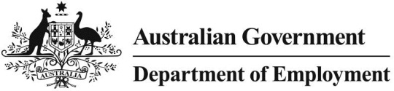

REPORT ON ENTERPRISE BARGAINING

**FEBRUARY 2017**

***Data in the Workplace Agreements Database is subject to revision from time to time, and therefore the results from analysis in this report may change.***

# INTRODUCTION

The Workplace Agreements Database (WAD) is maintained by the Department of Employment and contains data on wage increases and conditions of employment in around 150,000 collective agreements, past and present. The department publishes quarterly [*Trends in Federal Enterprise Bargaining*](https://www.employment.gov.au/trends-federal-enterprise-bargaining) reports derived from this data.

As shown in recent Trends reports, there has been a decline in the number of private sector agreements. However, coverage in the public sector has not changed significantly.

This paper focuses on the private sector and reports on the observed trend in greater detail including by agreement size, industry and union coverage.

# IMPORTANT NOTE

The expiry date of an enterprise agreement is a notional expiry date. The agreement remains legally operational after expiry until it is either terminated or replaced. However, agreements can also cease to be operational in circumstances where the enterprise has undergone changes such that no employees are covered by the agreement (e.g. the enterprise has ceased to trade, with no transfer of business). These agreements and the relevant data including the notional expiry date still exist on the database.

As WAD data are unable to determine the operational status of an expired agreement, the analysis in this paper is based on current agreements that are not expired or terminated. As at 30 June 2016, there were 13,948 private sector current agreements that had not expired or been terminated.

# ANALYSIS

## OVERALL TRENDS

As shown in Chart 1, the number of current (not expired or terminated) agreements peaked in Q4‑2010. Between Q2-2014 and Q2-2016, the number of agreements declined by 30.8 per cent to 13,955 agreements. The number of employees covered by these agreements declined by 13.1 per cent over the same period. This shows that the decline is skewed toward small and medium agreements (agreements covering from 0-99 employees).

The number of agreements in Q2-2016 is now slightly higher (by three per cent) than the number of agreements in Q2-2006, and employee coverage is 36 per cent higher. Over the same period, the number of employing business in the private sector has been relatively stable (a little over 800,000) and the total employment in the private sector has increased by around 18 per cent.

**Chart 1: Current private sector agreements and employees covered by these agreements, 2006-2016**

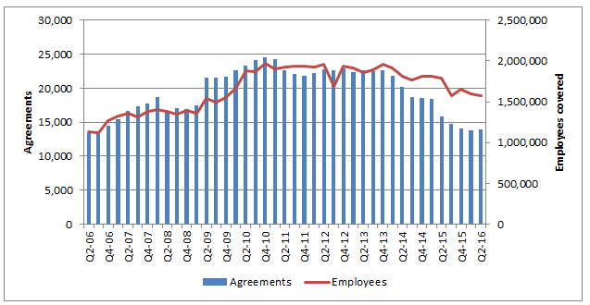

Chart 2 shows new agreements, disaggregated by the quarter in which they were approved. Although the numbers fluctuate from quarter to quarter, in part due to normal bargaining cycles, the number of new agreements being made is, on average, smaller in 2015 and 2016 than in previous years.

**Chart 2: Private sector agreements by quarter of approval, 2006-2016**

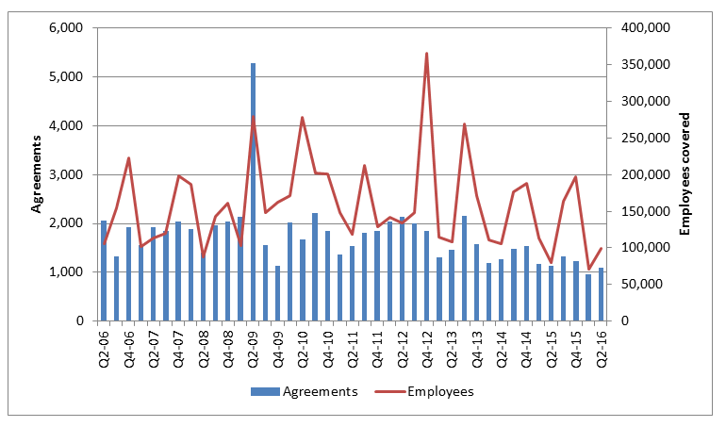

## BY AGREEMENT SIZE

Chart 3 demonstrates that the decline in agreements is primarily driven by small agreements (covering 0‑19 employees) and medium agreements (covering 20-99 employees). Small agreements have had the most significant decline (by 41.6 per cent in the two years to Q2-2016 and by 43.5 per cent since Q2-2009).

**Chart 3: Current private sector agreements by agreement size, 2006-2016**

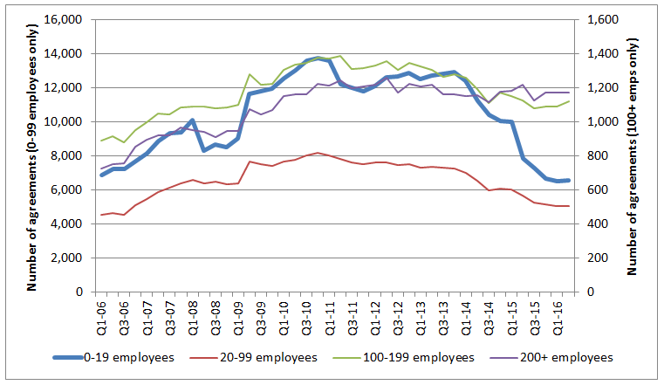

Chart 4 confirms that the decline in new private sector agreements is driven primarily by a decline in new agreements covering 0-19 employees. In the two years to Q2-2016, the average number of small agreements approved was 595 per quarter. In the two years prior to that (Q3-2012 – Q2-2014), the average was 850 per quarter, and in the two years prior to that (Q3-2010 – Q2-2012), the average was 989.

**Chart 4: Private sector agreements by agreement size and quarter of approval, 2006-2016**

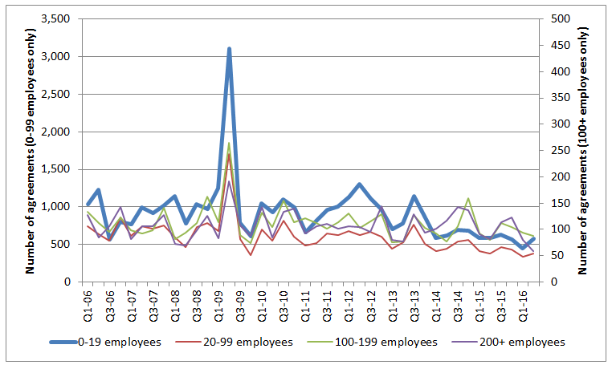

## BY INDUSTRY

Table 1 compares the coverage of private sector agreements by industry in the June quarter 2016 with the coverage of agreements at three other points in time: the June quarter 2014 (two years ago); the June quarter 2009 (immediately prior to the commencement of the *Fair Work Act 2009*); and the June quarter 2006 (ten years ago).

Retail trade (see below) and Construction declined by 49.1 per cent and 47.9 per cent respectively. Construction agreements are almost universally small agreements; the decline in Construction represents 57.8 per cent of the total decline in terms of agreement numbers, but only 13.8 per cent in terms of employee coverage.

Electricity, gas, water and waste services industry had an increase in the number of agreements between June 2014 and June 2016 rising by 2 per cent to 396 current agreements.

**Table 1:** **Comparing current private sector agreements with previous levels, by industry**

| **Industry** | **June 2016** | **Change since 2014** | **Change since 2009** | **Change since 2006** |
| --- | --- | --- | --- | --- |
| Accommodation and Food Services | 432 | -23.0% | -70.6% | -38.1% |
| Employees | 144,996 | -1.9% | 159.9% | 158.4% |
| Administrative and Support Services | 552 | -25.6% | -17.0% | 113.1% |
| Employees | 44,925 | -14.2% | -23.0% | 123.3% |
| Agriculture, Forestry and Fishing | 150 | -29.6% | -62.2% | 47.1% |
| Employees | 9,297 | 24.0% | -21.2% | 99.7% |
| Arts and Recreation Services | 148 | -9.8% | -45.0% | 35.8% |
| Employees | 42,757 | 10.2% | 3.2% | 102.7% |
| Construction | 3,907 | -47.9% | -44.1% | -32.0% |
| Employees | 102,411 | -24.3% | -30.5% | 5.1% |
| Education and Training | 570 | -10.1% | -18.0% | 214.9% |
| Employees | 137,711 | 11.5% | 124.9% | 246.8% |
| Electricity, Gas, Water and Waste Services | 396 | 2.1% | 19.3% | 97.0% |
| Employees | 25,934 | -14.1% | 11.8% | 62.5% |
| Financial and Insurance Services | 129 | -23.2% | -48.8% | 17.3% |
| Employees | 99,001 | -26.4% | 61.7% | 24.7% |
| Health Care and Social Assistance | 1,455 | -19.5% | 7.9% | 71.6% |
| Employees | 302,830 | 10.2% | 66.4% | 240.6% |
| Information Media and Telecommunications | 94 | -35.2% | -62.8% | -44.7% |
| Employees | 41,887 | -14.7% | 19.9% | 19.9% |
| Manufacturing | 2,437 | -21.1% | -33.4% | -17.0% |
| Employees | 162,768 | -18.1% | -33.0% | -28.0% |
| Mining | 443 | -18.4% | -21.6% | 59.4% |
| Employees | 49,962 | -13.6% | 20.0% | 107.9% |
| Other Services | 384 | -20.2% | -7.0% | 116.9% |
| Employees | 48,499 | 22.1% | 160.0% | 301.8% |
| Professional, Scientific and Technical Services | 397 | -32.0% | 22.2% | 331.5% |
| Employees | 36,372 | 3.6% | 90.5% | 346.4% |
| Public Administration and Safety | 212 | -24.3% | -35.2% | 73.8% |
| Employees | 17,568 | 3.8% | -15.5% | 78.1% |
| Rental, Hiring and Real Estate Services | 268 | -31.1% | -2.5% | 170.7% |
| Employees | 8,086 | -11.8% | 62.8% | 270.1% |
| Retail Trade | 259 | -49.1% | -84.4% | -23.8% |
| Employees | 126,632 | -57.1% | -67.5% | -60.4% |
| Transport, Postal and Warehousing | 1,213 | -14.9% | -15.5% | 24.7% |
| Employees | 132,586 | 2.5% | 14.6% | 46.8% |
| Wholesale Trade | 507 | -7.7% | 53.6% | 302.4% |
| Employees | 36,158 | 9.7% | 137.3% | 384.1% |
| Total | 13,953 | -30.8% | -35.6% | 2.8% |
| Employees | 1,570,380 | -13.2% | 1.6% | 35.6% |

### *RETAIL TRADE AGREEMENTS*

Chart 5 shows that agreement numbers in the Retail trade industry have been declining since 2011, down to 259 agreements from a peak of 2,015 agreements in Q1-2011.

Employee coverage in the Retail trade industry declined significantly in 2014 and 2015, due to the expiry of some large Retail trade agreements that have not yet been replaced.

Some of these large agreements may still be operational, despite having expired (as stated in the Important Notes section earlier) meaning the number of employees covered by enterprise agreements (both current and expired but still operational) is likely to be higher than the figures in Chart 5.

**Chart 5: Current private sector agreements and employees in the Retail trade industry, 2006-2016**

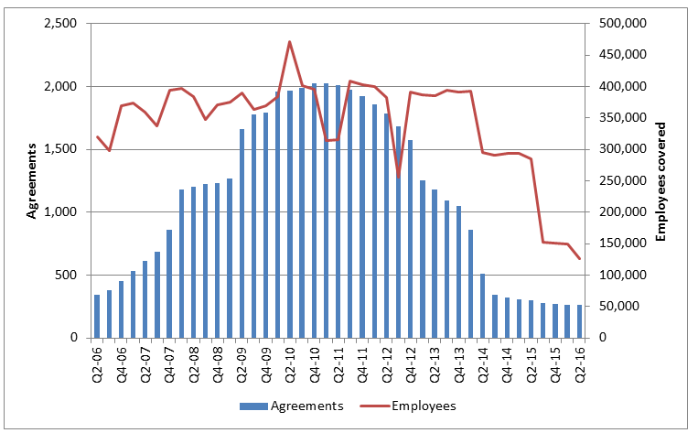

#### ACCOMMODATION AND FOOD SERVICES AGREEMENTS

As Chart 6 shows, the number of current Accommodation and food services agreements has been declining since 2011, down to 432 agreements from a peak of 1,833 agreements in Q1-2011.

The variation in Q1 2013 is primarily due to the *McDonald's Australia Enterprise Agreement 2013*, which covers almost half of all employees covered by agreements in the industry.

**Chart 6: Current private sector agreements and employees in the Accommodation and food services industry, 2006-2016**

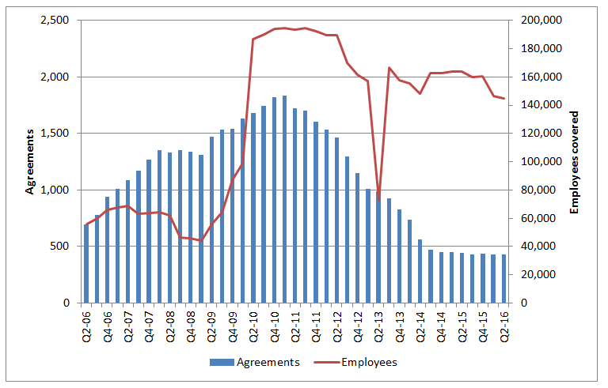

#### HEALTH CARE AND SOCIAL ASSISTANCE AGREEMENTS

Health care and social assistance has seen ongoing growth in collective agreement coverage. Despite a number of agreements expiring in 2015, Chart 7 shows that employee coverage has been consistently trending up for most of the last ten years.

**Chart 7: Current private sector agreements and employees in the Health care and social assistance industry, 2006-2016**

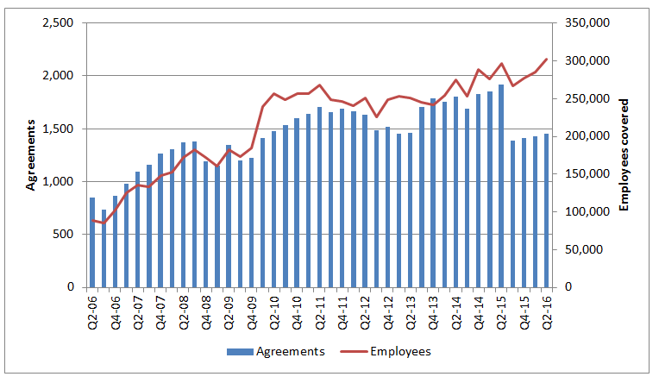

Chart 8 demonstrates that this growth is almost entirely due to growth in Residential care services (a sub-division of the Health care and social assistance industry which primarily covers aged-care facilities). This has been trending upwards for almost a decade, with significant spikes in employee coverage in 2010/2011 and 2014/2015.

**Chart 8: Employees covered by private sector enterprise agreements in the Health care and social assistance industry, by ANZSIC sub-division, 2006-2016**

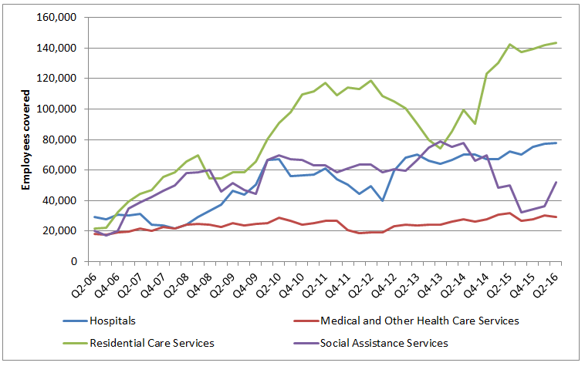

## BY UNION COVERAGE

Chart 9 shows that agreements that cover unions and agreements that do not cover a union have both declined in recent years. Agreements that cover a union peaked in 2014, and have since declined. Agreements that do not cover a union declined between 2010 and 2014, and have been reasonably stable since then.

**Chart 9: Current private sector agreements by union coverage, 2006-2016**

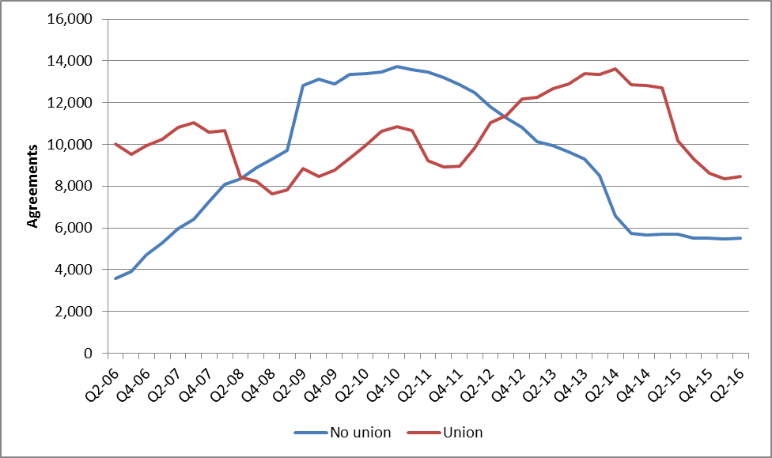

## REPLACEMENT AGREEMENTS

Chart 10 shows the proportion of agreements that are being replaced after expiry.

Around 35 per cent of agreements that expired in 12 months to Q3-2015 have been replaced, compared to an average rate of around 50 per cent from Q1-2011 to Q4-2011.

As stated earlier, a lack of replacement could be due to reasons such as the enterprise ceasing to exist, or because the agreement continues to operate after its notional expiry date and has not yet been replaced.

**Chart 10: Replacement rate of expired private sector agreements, by quarter of expiry, 2011-2015**

