

# A Practical Approach to Job Crafting

## Forms of Job Crafting

There are three ways you can reshape your role to be more meaningful and engaging. You can choose to adopt one, or a combination or methods to recraft your role.

**Cognitive Crafting:** In this instance, you begin by reframing what you think about work, creating a new narrative for your role that feels personal and meaningful.

Ask yourself: How can I create a ‘purpose story’ that feels personal and meaningful to me?

**Task Crafting:** In this instance, you experiment with the type, scope, sequence or number of tasks done at work. By choosing to do fewer, more, or different tasks than are in their formal job, you can create a different job that is more aligned with their motivations and values.

Ask yourself: How can I bring in tasks that will generate energy and enhance my work process?

**Relational Crafting:** This form of crafting involves altering the quality and/or frequency of interaction with others at work. In this instance, you decide how often they interact with others, who they interact with, and the quality of these interactions.

Ask yourself: How can I focus on, and invest more time in the relationships that inspire me and my work?

*See page 9 for an example on how to apply these three job crafting behaviours in practice.*

|  |  |  |  |
| --- | --- | --- | --- |
|  | COGNITIVE CRAFTING  Altering how you interpret tasks and their broader purpose | TASK CRAFTING  Altering the type, scope, sequence and number of tasks that make up your work | RELATIONAL CRAFTING  Altering who you interact with and who you learn from in your work |
| **Example** | A construction worker chooses to think of their job in two separate parts: one part is the mundane administration; the other part is meaningfully contributing to building a family’s future home. | Design engineers tailoring a process to best suit their needs, capacity and capability to achieve the desired output. | Hospital cleaners actively caring for patients and families through the work they do; integrating themselves into the workflow of their hospital. |
| **Effect on meaning of work** | Changing how we view our job in this way fundamentally changes how we approach it. There is acknowledgement that some aspects of a role will always be less enjoyable but there is also a more meaningful aspect, which is *why* we do the work. | Work is completed in a timely manner as the number, scope, or completion of tasks are adapted to suit your way of working.  You can change the meaning of your job to be a ‘guardian’ or movers of projects, rather than viewing your contribution as a single stage. | By interacting with patients and medical staff, you can change the meaning of your job to be helpers of the sick and see yourself as an integral part of the patient care cycle. |

**Adapted from: Wrzesniewski&Dutton, 2001, p. 185**

## Crafting Your Role: Selena’s Story

Selena is in sales and has been in her customer-facing role for 18 months. She has had a conversation with her manager about taking on more responsibility and is interested in building the capability of her team, but isn’t sure how to fit this into her current role.

Follow Selena’s journey to craft the job she wants at her current organisation. Navigate through the steps she takes to find tools and templates for you to use on your own journey.

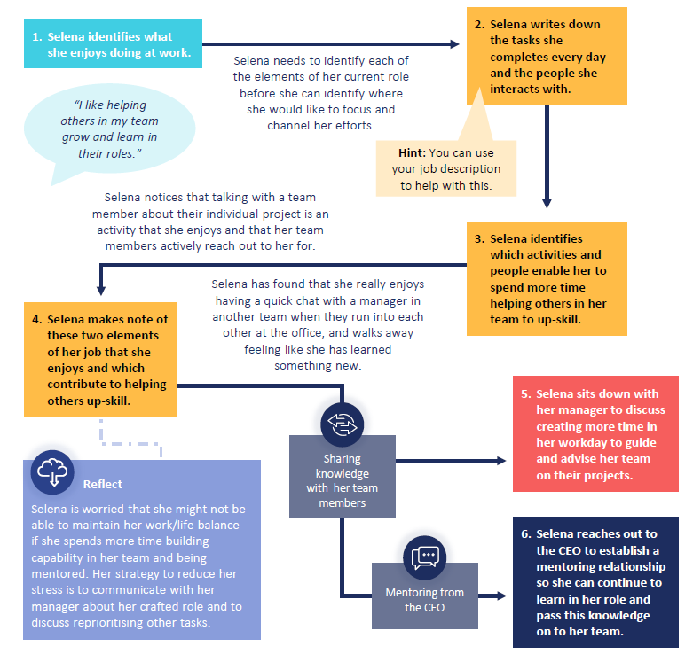

## Identify Your Strengths

Identifying your strengths (if you don’t already know them) and areas of enjoyment is an important step to make sure you craft your job into one which brings you joy. The prompt questions below can help you navigate this process.

What tasks or activities at work make me lose track of time?

|  |
| --- |
|  |

What do my co-workers rely on me most for?

|  |
| --- |
|  |

What am I working on right now that I’m excited about?

|  |
| --- |
|  |

What is an accomplishment that I’m proud of? Why?

|  |
| --- |
|  |

What is a task or behaviour that I have received positive feedback for?

|  |
| --- |
|  |

Your strengths, passions and motivations may change overtime. The activities and items you have listed here are a starting point for you to reflect on your role. Consider taking the time each day to think about what brings you joy at work and how you can keep doing it.

## Visualise Your Role

The template below can be used to visualise the tasks you undertake and interactions you have in your role day-to-day.

To help you think about how you can ‘craft’, once you’ve identified the tasks you do and the people you work with / learn from / talk to, reflect on which of those you want more or less of.

|  |  |
| --- | --- |
| **Tasks I do** | People I interact with |
|  |  |
| **Tasks I want to do more** | **People I want to interact with more** |
|  |  |
| **Tasks I want to do less** | **Tasks that I can deprioritise/ Am spending too much time on** |
|  |  |

## Talking To Your Manager

You can use this template to plan out the conversation with your manager about your crafted job.

|  |
| --- |
| **How are you crafting your role? What, if anything, is changing about how you like to work?** |
|  |
| **How has / will your crafted job enhance your experience at work?** |
|  |
| **How has / will your crafted job add value to your team and / or organisation?** |
|  |
| **What, if anything, does your manager need to do to support you?** |
|  |