

**QUARTERLY PILOT BULLETIN: Q4**

Welcome to the last quarterly update for 2020 on the Mining Skills Organisation Pilot (MSOP).

2020 has been a busy year, from initiating the administrative, operational and organisational structure of the MSOP through to the extensive stakeholder engagement and consultation that provided a platform for project ideation, design and development.

This would not have been possible without the significant time, interest and commitment that the [Steering](https://minerals.org.au/msop-steering-group-members)  [Group](https://minerals.org.au/msop-steering-group-members) and [Working Group](https://minerals.org.au/msop-working-group-members) have invested. Through their invaluable contributions, the MSOP is gearing up to activate [project hubs](https://minerals.org.au/project-hubs) in 2021.

This bulletin features a brief summary of the live events hosted during the last quarter and importantly launches the procurement of specialist/expert partners and services that the MSOP is seeking to help deliver the pilot, including the apprenticeships, digital transformation, and attraction and retention project hubs.

**Procurement**

The MSOP, under the auspices of the Minerals Council of Australia, is undertaking a significant selection process to procure the expert/specialist partners and services to deliver outcomes across the pilot.

***What you need to know***

The approach to procurement is an open, competitive request for quote (RFQ) process from 18 December 2020 to 8 March 2021.

There are eight RFQs as follows:

* RFQ1: Evaluation and sustainability partner
* RFQ2: Digital and design partner
* RFQ3: Digital transformation project hub **–** embedding material into the training package framework
* RFQ4: Apprenticeships project hub **–** program design and resources specification initiative.
* RFQ5: Attraction and retention **–** transferable skills initiative
* RFQ6: Attraction and retention **–** pathways initiative
* RFQ7: Attraction and retention **–** mining knowledge fundamentals skill set
* RFQ8: Attraction and retention **–** workforce planning initiative.

Vendors applying to be the evaluation and sustainability partner (RFQ1) or digital and design partner (RFQ2) are required to forfeit making a submission to the project hub initiatives (RFQ3-RFQ8 inclusive).

Quotations for delivery of multiple project hub initiatives (RFQ3-RFQ8 inclusive) will be accepted and considered.

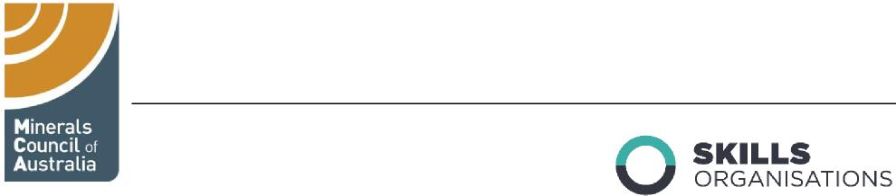

***Making a submission***

The procurement will be open for submissions from 18 December 2020 to 25 January 2021.

To view the RFQs and submit a quote, visit the MSOP procurement page.

**Workforce of the future: focus on mining**

The Department of Education, Skills and Employment hosted a series of live, *Workforce of the Future* events, bringing together business leaders and experts working with the Skills Organisation Pilots to discuss the opportunities and challenges facing Australia's workforce.

The third event in the series [*Workforce of the future: focus on mining*](https://www.employment.gov.au/workforce-future-focus-mining) was produced in partnership with the MSOP and attracted 247 viewers interested in the mining related skills, training and future employment opportunities.

The live event was recorded and can be viewed via the department’s website.   
**More to mining: let’s talk skills and careers**

On Thursday 26 November, the MSOP hosted a live webinar event. Panellists Kathryn Young (BHP), Val Madsen (St Barbara Limited), Rachel Wolfe (Newcrest Mining) and Scott Browne (Rio Tinto) commented on the MSOP attraction and retention hub, Respect@Work report, careers engagement and technology.

A recording of the webinar is available on the [MCA YouTube channel](https://www.youtube.com/watch?v=N4La-2fhDH8&feature=youtu.be) and a Q&A document answering some of the main questions arising from the webinar will be available on the [MSOP web page](https://minerals.org.au/mining-skills-organisation-pilot) during the next quarter.

**Coming up**

In 2021, the MSOP will secure critical pilot partners and services, activate project hubs and build on engagement and consultation activity.

**Questions? Comments? Feedback?**

Email us: [MiningSkillsPilot@minerals.org.au](mailto:MiningSkillsPilot@minerals.org.au) or visit the [MSOP web page](https://minerals.org.au/mining-skills-organisation-pilot)

You can also visit the [Skills Organisations](https://www.employment.gov.au/SO) page on the Department of Education, Skills and Employment website to learn more.