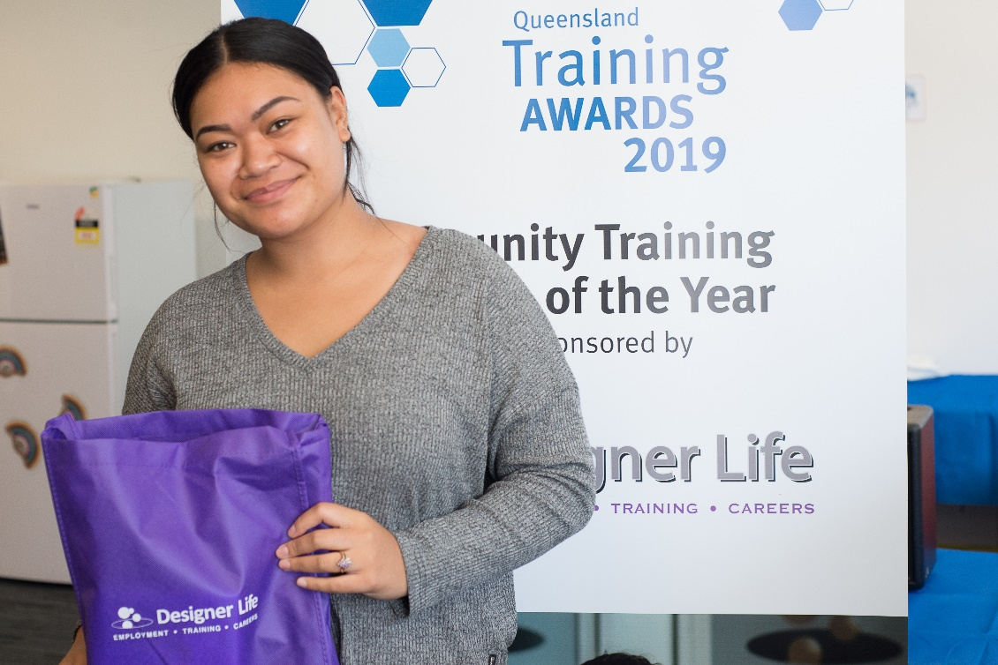Employability Skills Training

Helping you with real skills   
that lead to real jobs.

# EST Participant Service Delivery Plan

The Designer Life Employability Skills Training (EST) course will help you discover the right pathway in to work and a great career.

# Is EST for me?

Designer Life offers EST courses as follows, allowing us to focus on specific career stages:

* for young people 15 to 24 years of age
* for all ages over 25 years

We also run courses to meet the needs of groups within the community such as Indigenous Australians, Refugees/Migrants, Parents and Carers.

You can complete a Designer Life EST course if you are participating in Workforce Australia Services (including Digital Services or Enhanced Services), Transition to Work or Disability Employment Services and we ensure accessibility for people with a disability.

We will design a program that improves your capacity to search for work, navigate interviews, support your career interests, and build confidence to gain real skills. We will also support you to maintain resilience, give you feedback and prepare you for your work transition.

So even if you have completed EST Block One training with another provider, we can guarantee that you will still benefit from our **EST Block Two course**.

A group of young students sitting at a table reading documents on the table.




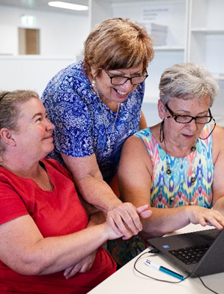**Designer Life EST Block Two Courses**

**Designer Life EST Block Two courses build on job search foundations, to provide activities with direct links to the workplace and employers, providing you with the chance to showcase your skills. Our EST Block Two course is designed to provide you with a personal link to local employers.**

# **EST Block Two Courses**

**Supported by a designated trainer, you will complete industry-focused activities designed to help you understand the jobs in demand in Townsville and the surrounding regions, including those with entry-level employment opportunities.**

**We will focus on growth sectors and offer accredited training units in industries such as: building and construction, mining, cleaning operations, hospitality, community services, disability support, retail, business and transport.**

****Block Two courses will be either:****

* **a Generalist course with the focus on providing you with a taste of a few industries**
* **a Specialist course focused on a single industry where we will partner with employers who have opportunities available, such as job vacancies.**

**Activities undertaken in these courses will include virtual job exploration experiences and work place visits. This will help you to understand the duties, job requirements, career pathways and employer expectations.**

**To support the conversion into permanent jobs, both Generalist and Specialist courses will provide:**

* **Industry awareness experiences and employer tours and presentations**
* **Job creation strategies to seek and apply for work in the industries covered**
* **Tailored industry-specific resumes, job applications, cover letters and interview coaching**
* **Assistance with industry-required psychometric and aptitude screening**
* **Digital skill assessments relevant to entry-level employment opportunities**
* **Assistance to access micro-credential skills to meet entry requirements and accredited training by our Registered Training Organisation.**

**In partnership with employers, we will work with you to develop the skills needed to become   
competitive in the job market and you will learn how to best market yourself for selected job opportunities.**

**FOR MORE INFORMATION Call: 07 3333 2055 or Email:** [**est@designerlife.com.au**](mailto:est@designerlife.com.au)