Delivering Training and Assessment Programs in India with Kangan Institute, in partnership with International Automobile Centre of Excellence (iACE)

The IST Program was designed to assist in building capacity of iACE trainers and assessors with the skills required to deliver and assess practical, skills-based training. The Program provided better understanding of the vocational education and training sector in which they work and promoted workplace learning.

**When:** October – December 2021   
**Where:** India  
**Who:** Trainers and managers **Learners:** 13  
**Courses:** TVET Trainer & TVET Assessor

The IST program delivery included three steps: the Pre-course workshops, the Trainer and Assessor Courses and the Return to Work Project.

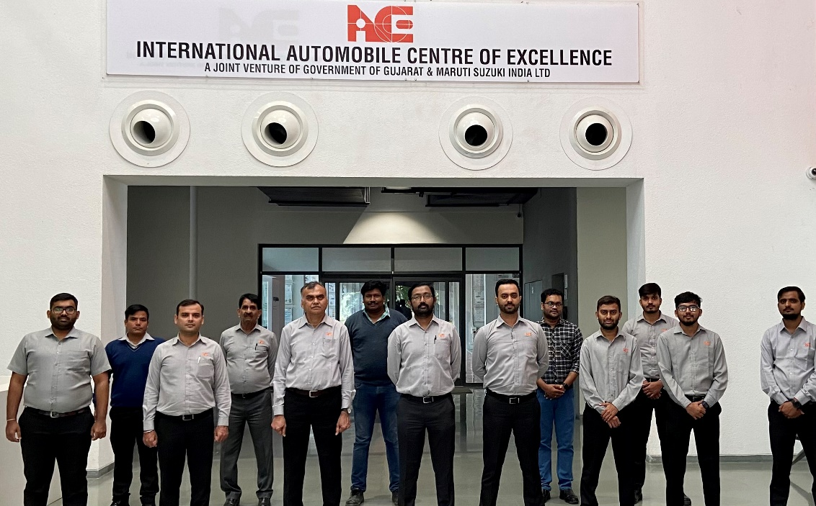The Pre-course workshops provided introduction to the IST Program and prepared participants for delivery of the IST courses by introducing some phrases and concepts used in vocational education and training.

The IST Trainer and Assessor Courses reflected the roles of individuals responsible for the development and delivery of training and assessment in the technical vocational education and training sector. The delivery was customised for automotive industry, ensuring the learning was relevant to the needs of the participants.

*“The IST training program focuses on further reinforcing the pedagogy of our skilled team members at iACE. The program also complements the spirit of partnership between the two countries and supports our vision to work together on upskilling people to improve their employability, which will enable the industry to improve the productivity and quality.”*- Mr. M. M. Singh, Chief Executive Officer, iACE.

The participants were required to develop and implement the Return to Work Projects in their workplace and incorporate new techniques from the Trainer and Assessor programs into their teaching and assessment practices.

*“The IST blended learning model was developed by Bendigo Kangan Institute and iACE as an effective and agile approach to upskill our experienced workforce. The iACE team gains expertise supported by the virtual learning environment and interactive practical learning to refine their skills to meet international standards.” -* Mr. Sudeep Ambare, IST Program Manager, iACE.

