Delivering Training and Assessment Programmes in Myanmar with Melbourne Polytechnic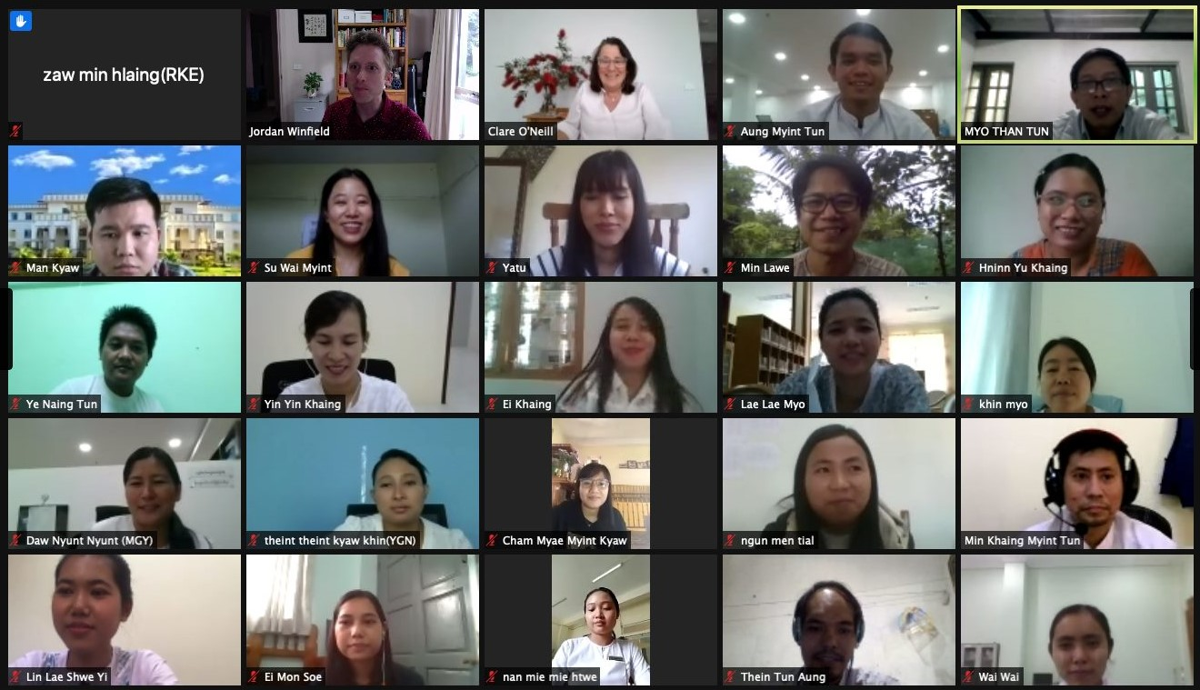

From 2018-2021, Melbourne Polytechnic has worked in partnership with the United Nations Development Programme to support the Myanmar legislature (Hluttaw) with capacity development among parliamentary support staff. The project’s intent was to deliver the IST course suite to support staff from the Hluttaw and ministerial departments to promote capacity development and strengthen representative initiations at the state and regional level in Myanmar.

**When:** 2018 - 2021   
**Where:** Myanmar, South East Asia   
**Who:** Myanmar legislature (Hluttaw) staff  
**Learners:** 86  
**Courses:** TVETC001 & TVETC002

Melbourne Polytechnic delivered the TVETC001 Trainer and TVETC002 Assessor programs to three groups of trainees across the life of the program. The training was delivered in country in 2018 and in a blended, synchronous format in 2020 and 2021. The program was adjusted to place particular emphasis on mentoring and a return to work plan. Feedback was extremely positive from the trainees and all stakeholders.

For example, a participant from the Assessor programs in 2018 found that the program gave her the capability to prepare materials, session plans, timetables and record information and report to her director more efficiently due to the systematic training style taught in the program.

Unfortunately, the program was interrupted in early 2021 following the Myanmar general election.