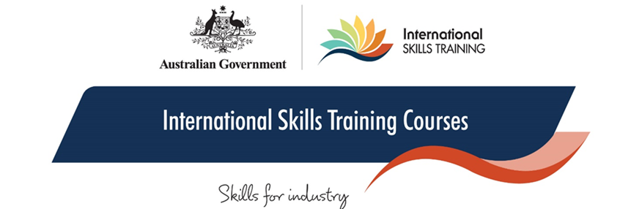Delivering Training and Assessment Programmes in Bhutan with   
TAFE Directors Australia,   
in partnership with TAFE QLD and Melbourne Polytechnic

Since March 2021, TAFE Directors Australia has been supporting the Government of Bhutan to strengthen their TVET system through the DFAT funded Australia-Bhutan TVET Sector Reform Project. The project, implemented in partnership with TAFE Queensland and Melbourne Polytechnic, focuses on two key sectors: Tourism and Hospitality, and Occupational Health and Safety.

**When:** 2021   
**Where:** Bhutan, Eastern Himalayas   
**Who:** Bhutanese trainers  
**Learners:** 105  
**Courses:** TVETC001 & TVETC002 **Source of funding:** Department of Foreign Affairs & Trade (DFAT)

Trainers meeting virtually to participate in blended learning of the course.
Capacity building of Bhutanese trainers is one of the key components of the project, with the delivery of the IST course suite at the heart of the support provided by Australia. Three groups of 35 trainers from sectors including Tourism and Hospitality, Building and Construction, Electrical and Welding Fabrication have participated in the delivery of the ISTC001 Trainer Course between June and August 2021 in a blended format and two groups are expected to take the ISTC002 Assessor Course by the end of the year.

The feedback from the participants and the Bhutanese Ministry of Human Resources and Labour has been very positive., A key takeaway has been the strengthened ability of Bhutanese trainers to embed competency-based training and assessment into their teaching practice. Participants also highlighted the benefits of experiencing firsthand a course delivery in a blended format, particularly as Bhutan is looking at developing this delivery model in the future.