

National Foundation Skills Framework 2022 to 2032

# Introduction

In August 2020, all Australian governments agreed through the Heads of Agreement for Skills Reform[1] to improving the VET sector. One of the agreed priorities is to provide stronger support for foundation skills and ensuring access for all Australians with low levels of language, literacy, numeracy, and digital literacy.

The National Foundation Skills Framework (Framework) sets out a 10 year model for collective action by governments working with stakeholders to improve the foundation skills of Australian adults. It recognises the critical role foundation skills play in equipping Australian adults to participate confidently in the community, the workplace, and in education and training and provides a transparent approach for Australian governments and other stakeholders to achieve the aspirational vision that ensures:

*Australians can access quality education and training to continuously develop the foundation skills they need to actively and confidently participate in the economy and the community.*

Foundation skills are core skills or competencies that underpin workforce participation, productivity, and social inclusion. They include[2]:

* English language, literacy, numeracy and digital (LLND) – listening, speaking, reading, writing, numeracy (the use of mathematical ideas) and digital literacy; and
* Employability skills, such as initiative and innovation, planning and organising, problem solving and teamwork.

This Framework complements work being undertaken by all governments to improve foundation skills for all Australians through the early childhood, schools and tertiary sectors. It also supports commitments by governments to Closing the Gap and to the United Nations Sustainable Development Goal 4.6.[3]

The Framework sets out:

* an ambitious vision for the provision of Foundation Skills across Australia to achieve positive change over the long term
* a set of outcomes that can focus and direct the efforts of all governments and stakeholders to improve outcomes for Australian adults
* outcome indicators that will ensure effective monitoring and reporting of progress
* the development of jurisdictional action plans with specific activities, encompassing accredited and non-accredited training, to encourage governments and stakeholders to work towards the outcomes
* effective governance mechanisms to ensure commitment to, and accountability for, progress against the outcomes.

At its core the Framework seeks to improve outcomes for learners across three domains:

* **Access and inclusion** – addressing barriers to participation by supporting learners to access training appropriate to their needs, increasing their ability to participate in society.
* **Economic security** – supporting adults to reach their full potential, share in economic prosperity and to improve national productivity by developing their foundation skills.
* **Sustainable foundation skills sector** – providing a foundation skills sector that is supported to meet the needs of learners, employers and community.

# Why do Foundation Skills matter?

*An individual’s ability to adapt and thrive in a fast-evolving world rests on their having acquired strong foundation skills, the willingness to learn and a habit of learning (lifelong learning). These skills and attitudes are vital for individuals to absorb and expand the knowledge and skills required to navigate new labour market needs and life circumstances.[4]*

The changing demand for skills is transforming Australia’s key industries, impacting career pathways for many Australians. A key challenge for workers going forward will be to develop the skills necessary to evolve with jobs as they change, and as new jobs are created.[5] These newly acquired skills will need to be supported by a broad set of core foundation skills. Research by AlphaBeta (Future Skills) showed that basic foundational knowledge, such as mathematics and English language, will remain a pillar of a worker’s skill set in 2040.[6]

## Impact of COVID-19

The need to develop new skills has been highlighted during the COVID-19 pandemic, which accelerated changes already transforming the workplace such as digitalisation and automation. In the longer term the effect of the pandemic will likely interact with existing structural changes and our ageing population to increase demand for digital skills in a variety of sectors.

## The future of work

Strong foundation skills are essential if Australians are to meet the challenge of the future of work, with a strong body of research linking poor foundation skills to low overall and lifelong educational attainment. People with low literacy and numeracy levels or with low educational qualifications are less likely to be employed or more likely to be employed in low-skills insecure occupations with a higher risk of being offshored or automated, and at greater risk of redundancy. They may also face difficulties in participating in social and community life, where a range of communication skills are required for confidence and meaningful relationships.

Research has shown that even small gains in adult literacy can have long lasting impacts. From an economic perspective, evidence suggests that government investment in increasing the literacy skills of adults has a direct and positive impact on labour productivity and gross domestic product per capita and that the greatest impact can be gained by investing in improving the skills at the lower levels.[7] Research also suggests that an increase in literacy and numeracy by one skills level is associated with a 10% increase in wages.[8]

While teaching foundation skills is the primary domain of primary and secondary schools, acquisition of these skills may need to occur later on in an adult’s life, for a variety of reasons, including English not being their first language, disability, or having a disrupted education. Furthermore, social and economic transformations will impact the future demand for skills necessary for work and life; for example, the increasing need to possess at least basic digital skills. Given this, it is clear that foundation skills for adult learners are a worthwhile investment with high returns.

# Why an outcomes-based Foundation Skills Framework?

The Framework is based on an outcomes logic model that demonstrates clear linkages between outcomes and positive social and economic impact at both the individual and system levels. It draws on similar frameworks being successfully used by several jurisdictions.

An outcomes-based approach will deliver greater transparency and understanding of the impact of foundation skills policies and programs at the population level. This approach puts people’s needs at the centre of the Framework, asking the question “what outcomes are we trying to achieve for people with the programs and activities we deliver?”.

Over time, the approach is expected to lead to more effective and efficient investment in foundation skills programs and activities, and better outcomes for learners.

The benefits of implementing an outcomes-based Framework are:

* Raised awareness of the benefits of strengthening foundation skills, developing a culture where people both aspire - and are supported - to improve their skills
* Increased collaboration between and across all levels of government, minimising duplication or gaps in support
* An integrated approach across accredited and non-accredited domains
* Resources being aligned to support programs demonstrating good progress towards outcomes
* Improved data collection and reporting, providing better understanding of the needs of different cohorts
* Improved monitoring as measures are linked to key outcomes to give visibility regarding the progress being made.

# A national approach

The Framework is part of a broader agenda to reform the Vocational Education and Training (VET) system. This reform will play a critical role in supporting Australia’s growth and prosperity, including our economic recovery from the COVID-19 pandemic. There is work underway across all governments, and across industry and community sectors, to support the development of foundation skills.

Policies that promote high-quality education, effective vocational education and training, and continuous work-based training generate opportunities for skills development in everyday life.[9] And for adults developing these skills, place-based training that recognises local needs and settings is most effective.

The Framework is a high level document that can be used to align jurisdiction and sector level priorities with national goals, while providing flexibility to address local needs. It recognises that there is mix of learners engaging in foundation skills education and training and that a one size fits all approach is not practicable in all jurisdictions. Training is most effective when it is contextualised, and certain approaches will work best in particular places and with different groups of people.

Jurisdictional action plans will address specific cohort requirements and it is expected that a range of modes of delivery will be required to ensure the foundation skills needs of different groups are addressed; such as culturally and linguistically diverse communities, Aboriginal and Torres Strait Islander peoples, people with low levels of LLND skills in the workplace, and learners with disabilities.

## Population level outcomes

The Framework sets outcomes at the population level, however it will enable monitoring and reporting of outcomes related to different population groups or cohorts of learners via reporting mechanisms at both the jurisdictional, and national level.

An outcomes approach supports flexible place-based and person-centred responses. Jurisdictional action plans may be tailored to reflect the needs and priorities of their jurisdiction.

The outcomes framework and progress measures will provide a shared way of understanding the progress of Foundation Skills education and training at the national level, while helping to guide evaluation of outcomes at the state or territory levels, so that jurisdictions can continually prioritise and tailor responses.

## Jurisdictional action plans

The Framework has been developed collaboratively by the Commonwealth and state and territory governments. It will inform the development of jurisdictional action plans to support the delivery of activities to achieve nationally agreed outcomes, measures and indicators. The jurisdictions have different priorities and their action plans will reflect this.

## The Framework is flexible in its operation

The Framework will be reviewed periodically and may be updated as jurisdictional priorities change, and as the national picture is evaluated. Likewise each jurisdictional action plan may be amended based on evaluation of relevant outcomes and delivery results over time.

# Development and structure of the Framework

## Development of the Framework

The outcomes framework was developed using a national approach with all jurisdictions actively collaborating in the process. Outcomes were developed and mapped using logic model forecasting, which included the following steps:

1. Identification and collation of expected direct/immediate outcomes and longer-term benefits of Foundation Skills programs and activities, within the domains of Economic Security, Access and Inclusion, and Sustainable Foundation Skills Workforce, by each jurisdiction
2. Logical mapping of identified outcomes and the ‘if-then’ relationships between outcomes and longer-term goals or impacts, accounting for and filling any gaps in the outcomes logic chain
3. Review and prioritisation of outcomes at the national level
4. Identification of outcomes that are practical to measure and attributable to foundation skills activities
5. Definition of key indicators and methods of measurement for each outcome that was identified as measurable and attributable.

In developing the outcomes, jurisdictions worked to identify all the outcomes that need to be achieved for an individual to reach the long-term goal that they aspire to, and for the system to support this. This includes outcomes that are not wholly within the responsibility of the Foundation Skill sector and those that can’t be effectively measured, because they are not wholly attributable to Foundation Skills activities and investment.

Including outcomes that are broader than the foundation skills sector or the result of foundation skills activities and investment enables stakeholder to take a broader perspective on their contribution. This helps to break down silos and encourage collaboration across sectors to help achieve these outcomes.

## Consistency of language

While the Framework draws on the structure of outcomes frameworks used across Australia it has been contextualised for foundation skills.

# Structure of the framework

The Framework is structured around an aspirational vision, key domains, long-term benefits, outcomes and indicators.

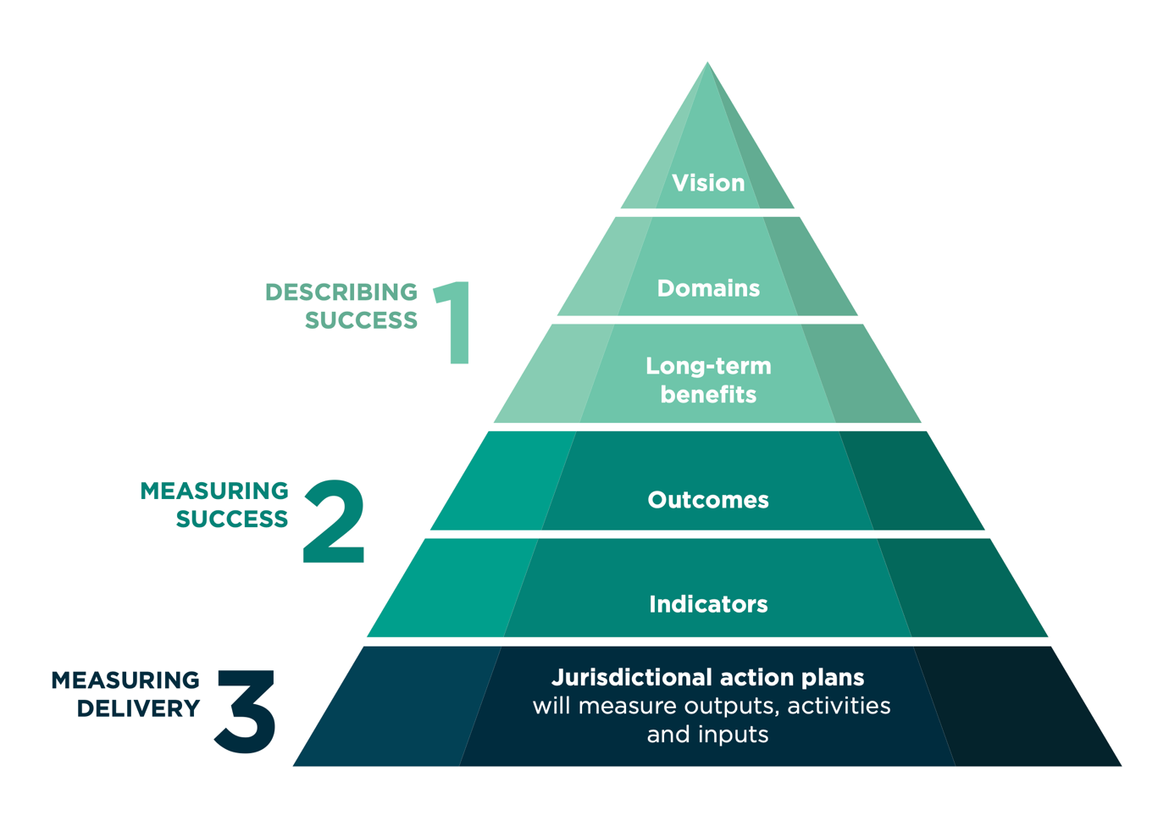

## Vision

An aspirational statement that communicates what the framework should achieve over the long term.

## Domains

The areas the Framework is seeking to improve. They provide a logical structure for grouping related outcomes and a clear link from outcomes and long-term benefits to the vision.

## Long-term benefits

Overarching goals that describe what success looks like within each domain at the population level in the long-term.

## Outcomes

The changes that need to occur to achieve the long-term benefits, and the direction of change required.

Outcomes reflect agreed priorities in achieving the long-term benefits for each Domain, and towards the overall Vision. They are not exhaustive, and will be tested and adapted over time to reflect new priorities.

Both measurable and non-measurable outcomes are included. As new evidence and data is gathered, some outcomes may be able to be measured.

## Indicators

Describes how the change in the outcome will be assessed and how progress will be observed and quantified.

Each outcome may include multiple indicators, and be quantitative and/or qualitative in nature.

## Jurisdictional action plans

The outcomes approach will not specifically measure inputs, activities and outputs, as this will be done through jurisdictional action plans and program reporting mechanisms. It is expected that:

information about implementation and delivery of Foundation Skills programs and activities will feed into the framework, so that outcomes are assessed for ongoing relevance and new priority outcomes are added based on implementation and delivery results

monitoring and reporting on the Outcomes Framework should help to continually prioritise, refine and improve the implementation and delivery of programs and activities.

# Foundation Skills Outcomes Framework

**Shared Vision:** Australian adults can access quality education and training to continuously develop the foundation skills they need to actively and confidently participate in the economy and the community

|  |  |  |  |
| --- | --- | --- | --- |
| **Domains** | **Outcomes** | **Long-term benefits** | **Indicators** |
| **Access & inclusion** | * Information about Foundation Skills Training and support is more accessible for learners. * Training is accessible at times, places and in ways that meet learners’ needs. * Increased education and training pathways * Increased understanding of the benefits of Foundation Skills to reduce stigma * Increased engagement in community/society from those currently disengaged * Increased access to Foundation Skills for cohorts in need | * Increased inclusion in society * Increased civic participation | * Distribution of enrolment data across geographic areas with identified need in Australia * Levels of satisfaction of learners with when, where and how training is delivered * Qualitative reporting of information outlining whole-of-government investment in promotion and outreach for Foundation Skills at a national level |
| **Economic security** | * Increased enrolment in Foundation Skills training * Increased attainment of Foundation Skills * Increased proficiency in Foundation Skills of learners * Increased engagement in further education and/or training * Increased employment outcomes, including gaining, sustaining or improving employment * Increased skills proficiency of the workforce * Increased readiness to seek further training or employment * More employers promote and support Foundation Skills training and programs * Improved labour force participation * Reduced unemployment and impact on social support systems | * More people reach their full potential for rewarding and productive careers * More productive industry and businesses * More equitable sharing in economic prosperity | * Number of enrolments in accredited training * Number of completions of recognised Foundation Skills Units of Competency * Change in proficiency levels of students at the population scale * Self-reported rating of readiness for further training or employment |
| **Sustainable foundation skills sector** | * Strengthened evidence base that contributes to understanding need, demand and outcomes for Foundation Skills * Quality products, tools and resources are available to support training delivery * Support and training for Foundation Skills is embedded in the VET system * Increased awareness of the importance of Foundation Skills in education and training * Increased perception of Foundation Skills as a desirable career choice * Training packages increasingly embed Foundation Skills within them * Increased supply of appropriately skilled Foundation Skills workforce | * The VET system is adaptable to changing needs of workforce, learners, employers and industry * A sustainable foundation skills VET workforce with a pipeline for the future | * Amount of new research and investment into building an evidence base, reported as whole-of-government * Number and investment in products, tools and resources * Foundation Skills Units of Competency mapping across training packages and templates * Satisfaction with how Foundation Skills are embedded in Training Packages * Number of people who have completed the Foundation Skills units of the TAE |

# Monitoring and evaluating the framework

Monitoring and evaluating the Framework is the responsibility of Australian governments Skills Ministers.

It will be important to embed transparent, consistent and regular reporting mechanisms and to agree roles and responsibilities for data collection so that accountability is clear and progress can be clearly communicated with stakeholders and the broader public.

Its success depends upon its ability to iterate and improve over time through monitoring and evaluation, in response to clear indicators of success and underpinned by evidence that supports change.

The framework will support both quantitative and more qualitative, or narrative-based measures that help to share this information in a meaningful and accessible way.

Evaluation of jurisdictional action plans will feed into this reporting, as well as aggregation of data at both national and jurisdictional levels. However, the purpose is not to compare the performance of jurisdictions on each outcome on a like-to-like basis, since priorities, programs and activities vary across Australia.

Instead, the purpose of outcomes measurement at the national level is to collectively understand the progress that is being made by all jurisdictions on outcomes that are being measured and reported against.

The development of the Framework used a ‘top down’ approach, so identification of the outcomes, indicators and measures were intentionally not limited by data availability. The Framework acknowledges the need for more robust and comparable data across jurisdictions to identify LLND needs, demand and outcomes in a consistent manner.

Therefore, the Framework will support work to build greater capacity in:

* developing better data capture, data linkages, analytics
* the development of a robust and evolving evidence base
* work on developing and integrating the National Data Asset
* consideration of the development of national standardised tools to measure outcomes more consistently across Australia.

Australian governments will undertake a review of the Framework every three years to assess and report progress against the outcomes and ensure that the Framework is meeting its objectives and responding to changing demands and priorities at a national and jurisdictional level.

1. Department of the Prime Minister and Cabinet, Heads of Agreement for Skills Reform (2020)
2. Australian Skills Classification Resources, National Skills Commission - March 2021
3. United Nations [Goal 4: Sustainable Development Knowledge Platform (un.org)](https://sustainabledevelopment.un.org/sdg4)
4. OECD – Skills Outlook 2021 – Learning for Life
5. Australia’s Tech Future (2018) Australian Government – industry.gov.au
6. AlphaBeta – Future Skills (2018).
7. Coulombe, S., Tremblay, J. & Marchland, S. (2004) Literacy scores, human capital and growth across fourteen OECD countries, Statistics Canada, Ottawa.
8. Productivity Commission (2014) Literacy and Numeracy Skills and labour Market Outcomes in Australia.
9. OECD – Skills for 2021