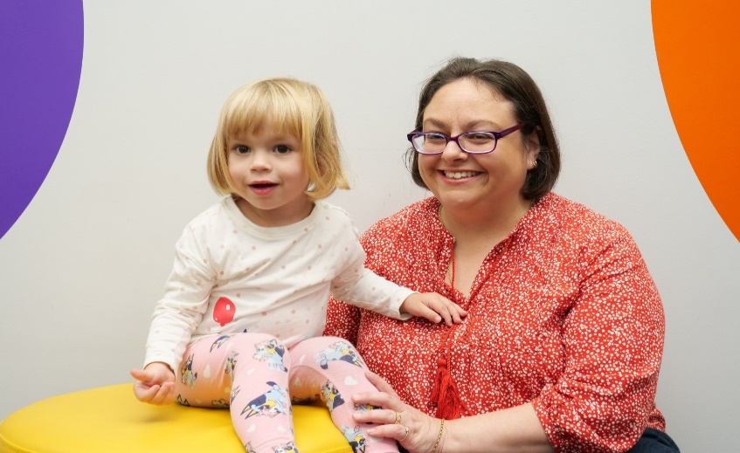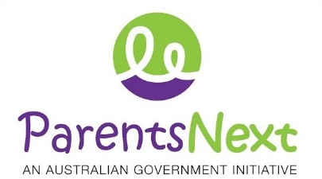JOB SEEKER

SERVICE DELIVERY PLAN

The ParentsNext program is an Australian Government initiative designed to provide tailored career support to assist parents or carers with young children to prepare for employment when their youngest child reaches school age.

**This program is targeted at parents:**

* whose youngest child is at least nine months and under six years of age
* who have not engaged in work in the last six months

Parents are supported by our Career Coaches in a way that compliments their activity requirements, is flexible around family commitments and considers an individual’s cultural, education and employment background.

Services are provided face-to-face with additional phone or virtual support available if required.

## HOW WE CAN HELP YOU

**Our Career Coaches at Designer Life will:**

* meet with you individually and in small groups to explore your current interests, skills and experiences and help you plan for your future career
* assist you to identify and access pathways to achieve your education and employment goals, including work experience and voluntary roles
* provide you with access to online career development and job search tools at our family-friendly office spaces
* invite you to morning teas with employers, training providers and employment service providers to connect you with opportunities and services
* take you on industry tours to help you increase your understanding of employer expectations and the variety of positions available in the local job market.

**Through this process you will be empowered to:**

* identify and action your education and employment goals
* select from our ‘menu’ activities that meet your specific needs
* successfully combine activities with your parenting responsibilities
* access education and employment events and services in the local community.

## OTHER SERVICES AVAILABLE

* We take a proactive approach to connecting you with local supports including - health, childcare and housing.
* We will also refer you to external education and training organisations who deliver courses identified in your participation plan as required.

## OUR LOCATIONS

All our locations are welcoming, safe and family-friendly with activities and healthy snacks available.

ParentsNext is delivered at the following hubs: Caboolture, Deception Bay, Fortitude Valley, Kilcoy, Mitchelton, Nundah, Redcliffe, Strathpine and Toowong.

***FEEDBACK***

*We welcome your feedback. All feedback with be confidential. You can also contact the Department of Education, Skills and Employment National Customer Service Line on 1800 805 260.*

