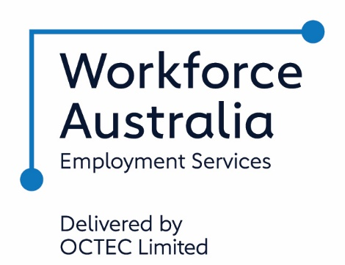

**SERVICE DELIVERY PLAN**

Welcome to OCTEC and Workforce Australia – Transition to Work. OCTEC is committed to providing you with the support you need to gain and retain employment, move into education and/or improve your work readiness.

**About Us**

OCTEC is a successful and high performing community-focused business providing employment, education, training and advocacy services in New South Wales, ACT, Victoria and Queensland.

We are a leader in the important work of empowering members of our communities through education, training and employment services. We also support businesses, large and small, by delivering tailored and high quality recruitment solutions.

We have over 40 years’ history of service provision offering solutions to help people, businesses, and local, state and federal government. Our services are wide ranging and include youth services, employment services, recruitment services and vocational education and training services.

**What You Can Expect**

If you are a Workforce Australia – Transition to Work participant, OCTEC will:

* Connect you with your own consultant, who will partner with you throughout your time with us in Transition to Work.
* Provide you with access to sites which are accessible and inviting to assist you with achieving your education or employment goals.
* Keep you connected, meaning your consultant will contact you through social media, phone, text, email, video and face-to-face meetings.
* Make sure you receive the same standard of service, whether you live in a larger town, or in a more remote location.
* Take the time to listen to your dreams and goals and assess any barriers you might experience in achieving them, this information will be used to develop your Job Plan.
* Give you the chance to work with other Transition to Work participants, from across the Riverina and south-western NSW, to share ideas and provide each other with support.
* Connect you with training providers, including online learning, to obtain the kind of skills and qualifications you need to achieve your goals.
* Connect you with services that will assist to overcome any barriers preventing you from achieving your goals, or to connect you with culture and country.
* Give you the chance to undertake various work experience opportunities, to develop your skills and to build your work history.
* Connect you to employment opportunities across the Riverina and south-western NSW, as well as to jobs in Sydney, other parts of NSW, and interstate.
* Assist you to get your NSW drivers licence, by connecting you to local driving schools, and helping you complete enough supervised driving hours to take your test.
* Provide continued support to both you and your new employer after you commence work.
* Give you the chance to have your say about Transition to Work by participating in our Murray Riverina Youth Advisory Group.

If you are a Transition to Work employer partner, OCTEC will:

* Connect you to our services through a dedicated local Workforce Development Coordinator.
* Engage you in the recruitment, development and placement process, to ensure potential employees have the skills, attributes and qualifications/licences you require.
* Engage with you to place participants in unpaid work experience through government supported programs including Internships and the National Work Experience Program to allow you to assess participant suitability for ongoing employment.
* Provide you with access to OCTEC’s Biz Support packages, using our funds to assist participants to take up new positions, and assist you offset the costs associated with employing a new staff member. Packages can include wage assistance, training, mentoring, and assistance with the purchase of participants clothing and equipment.
* Provide you with access to government Wage Subsidies and relocation assistance for eligible participants.
* Continue to provide assistance to you and your new employee after they commence work, through post-placement support, with contact provided at agreed intervals.

If you are a youth services provider or local secondary school in the Riverina or south-western NSW, OCTEC will:

* Work with your staff to identify participants or students at risk of disengaging from education, family, or community, as potential Transition to Work participants.
* Develop, where appropriate, complementary service strategies and co-servicing initiatives to maximise the benefits each young person receives during their time in Transition to Work.
* Continue to liaise with you on the progress of each participant during their time with OCTEC Transition to Work.

**OCTEC Staff are Committed to Making a Difference**

**in Our Communities**

**OCTEC Sites in Your Local Area include:**

|  |  |  |
| --- | --- | --- |
| **Griffith** | **Leeton** | **Tolland** |
| **\*\*\*\*** | **\*\*\*\*** | **\*\*\*\*** |
|  |  |  |
|  | **Wagga Wagga** |  |
|  | **\*\*\*\*** |  |
|  |  |  |
| **Open Monday – Friday 9:00am to 5:00pm** | | |