PALMIS approved employer portal – getting started guide

**Contents**

1. How to access the approved employer portal 2

2. How to verify your employer details 7

3. How to add more users to your account 11

4. How to find your deed 13

5. How to find your temporary activities sponsor details 15

6. How to find your labour hire licences 16

7. What to do if you need further help 18

Last updated: 07 August 2024

## How to access the approved employer portal

New Pacific Australia Labour Mobility (PALM) scheme employers will receive an invitation email to access the PALMIS approved employer portal (AE portal). The invitation will be sent to the same email address where the PALM scheme deed was sent.

Please see sample invitation email below:

Click the ([portal.palmscheme.gov.au](http://portal.palmscheme.gov.au)) ‘account login’ button to begin.

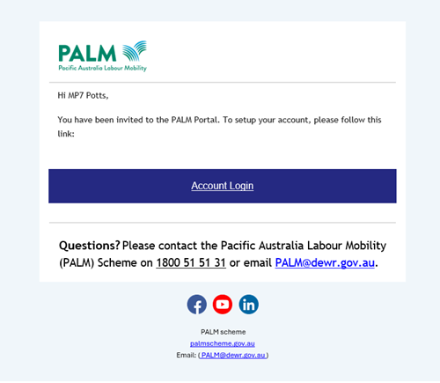

1. In the signup page, click the ‘send verification code’ button.

This will send a verification email to your registered email address with the PALM scheme.

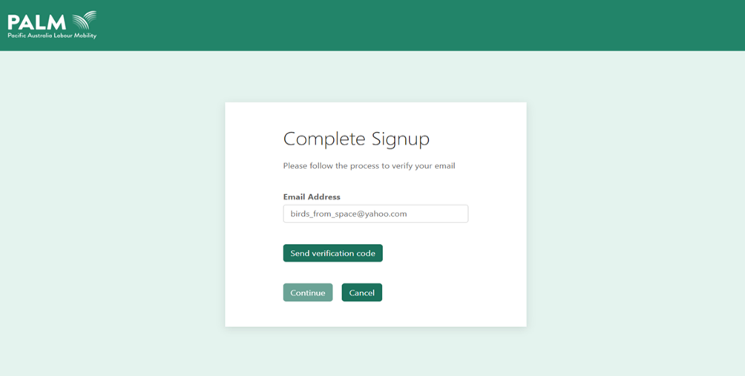

1. Open the verification code email and retrieve your code.

Please see the example below.

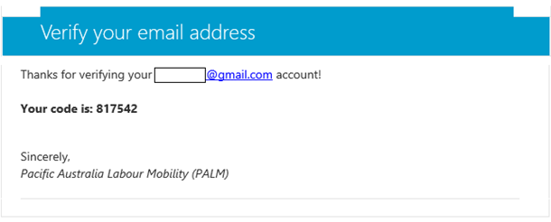

If you have any issues receiving an account verification code, please contact the PALM scheme support service line at ([palm@dewr.gov.au](mailto:palm@dewr.gov.au)) or call (1800 51 51 31).

1. Enter the verification code into the ‘verification code’ field and click the ‘verify code’button. You will only need to complete this process once to verify your email address.

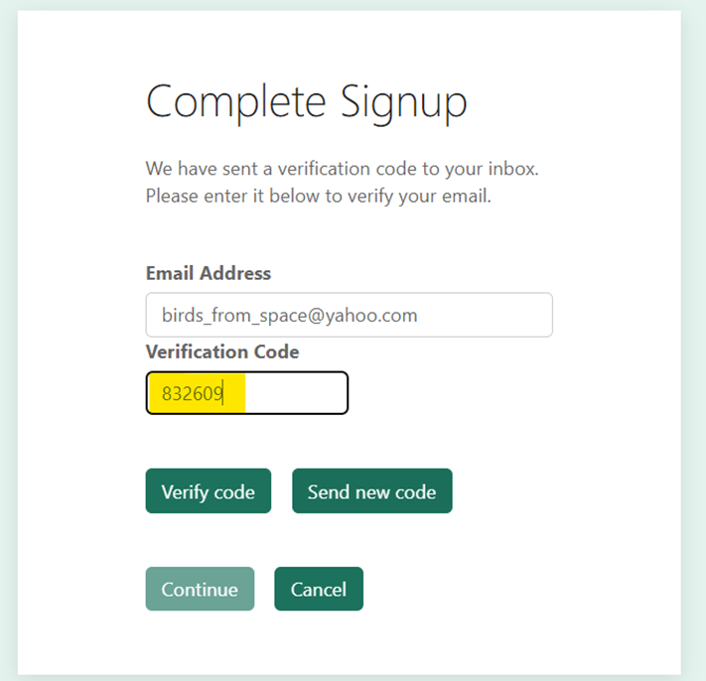

1. Click the ‘continue’ button to proceed. Next, you will need to enter your phone number. This will be used to verify your identity each time you log in to the AE portal.

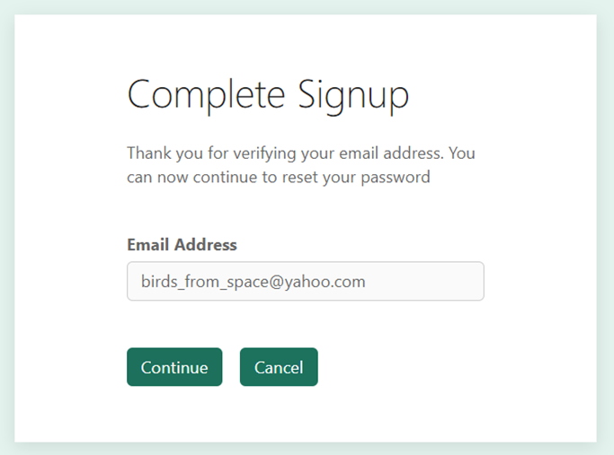

1. Click ‘send code’ to receive an SMS authentication code.

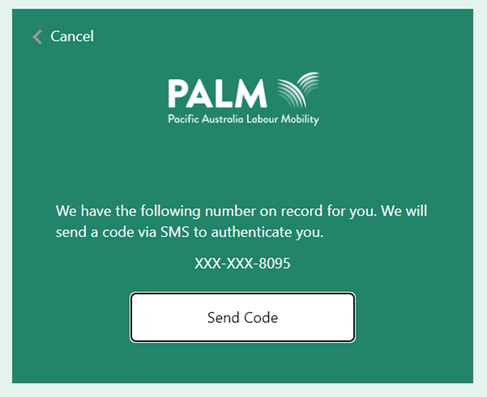

1. Enter the code from the SMS into the provided field and click ‘verify code’.

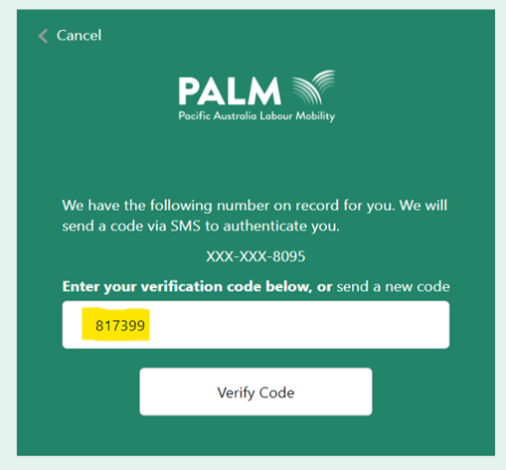

1. You will then need to create a new password for your account. Once you have done this, click the ‘continue’ button to proceed.

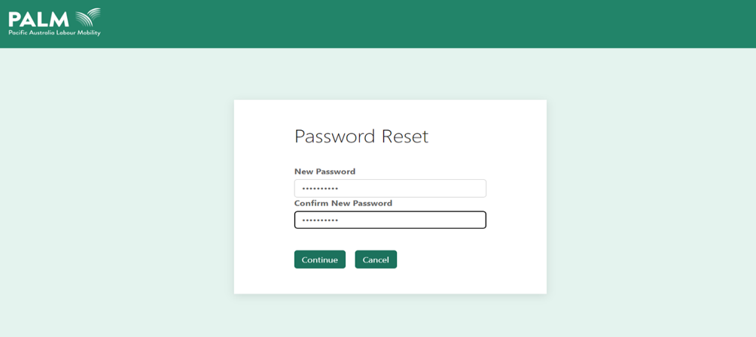

1. You will now be able to login to your account with your email and password.

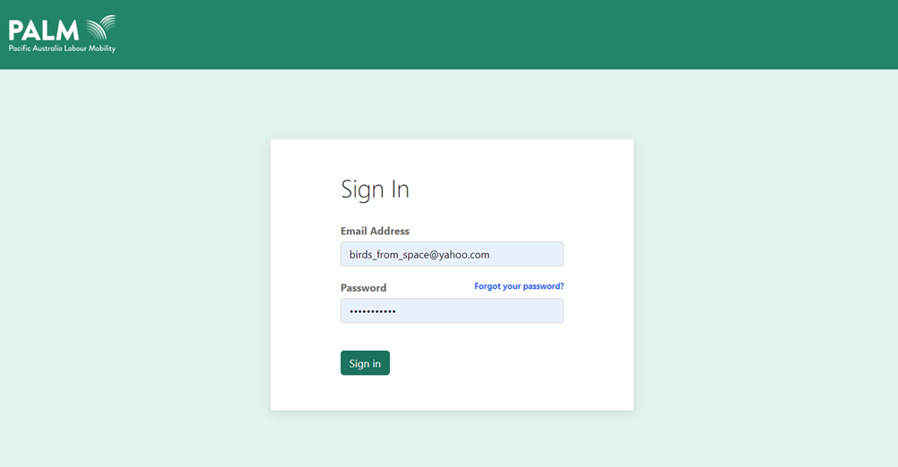

## How to verify your employer details

After logging into your account for the first time, you will need to check your employer details are correct.

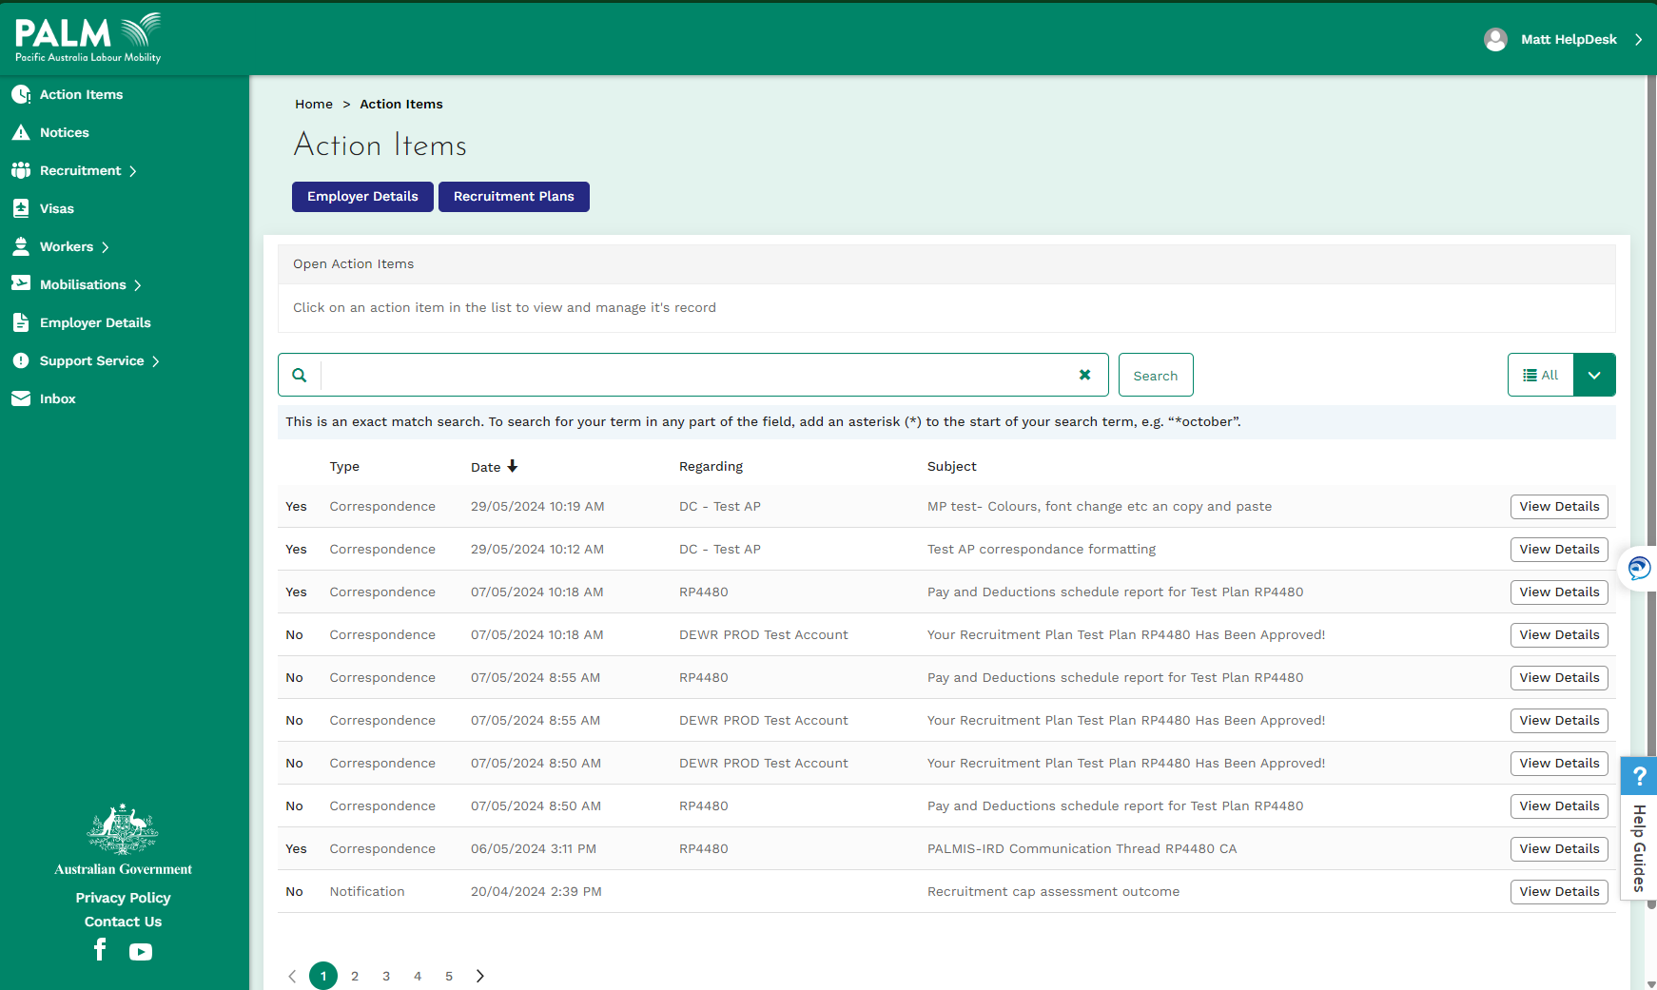

1. Click **‘**employer details’ from the menu on the left or the ‘employer details’ button on the ‘action items’ page.

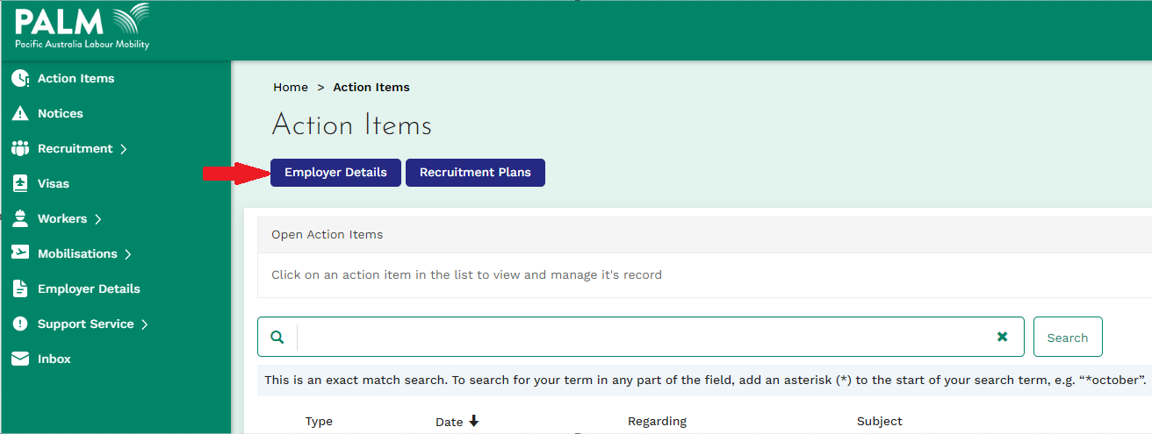

1. On the ‘employer details’ page, review your basic details under the ‘my details’ tab to ensure your employer details are correct.

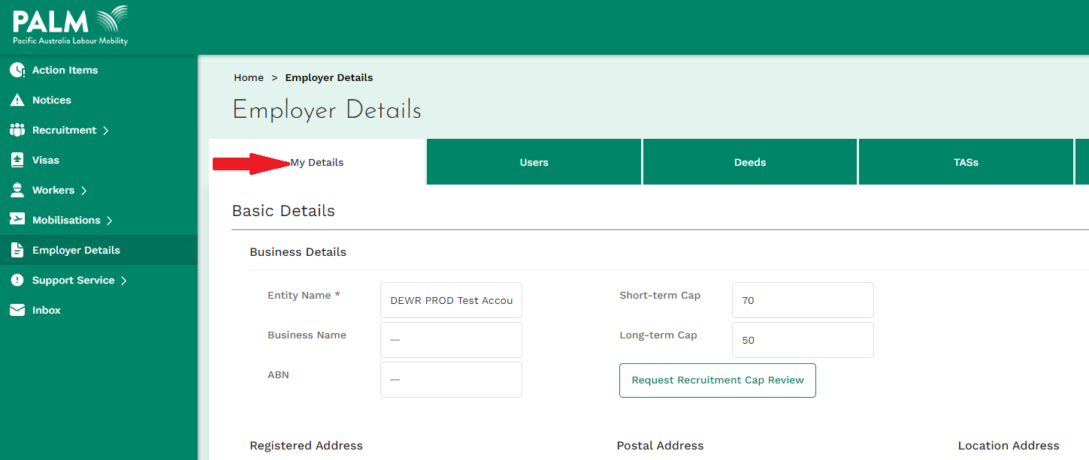

1. Click the ‘edit employer’ button to add a new address or remove any old addresses shown in your account.

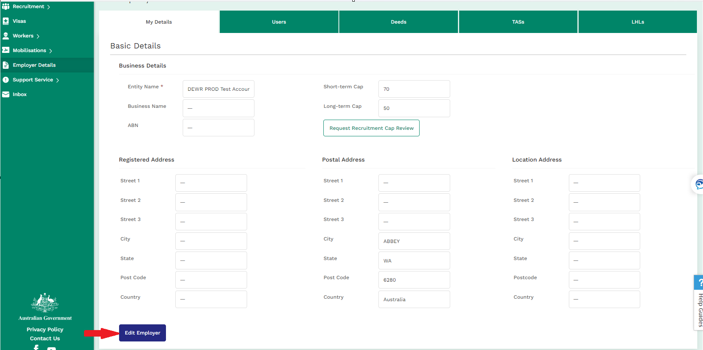

1. Once you have finished editing your employer details, click ‘update’ to update your information.

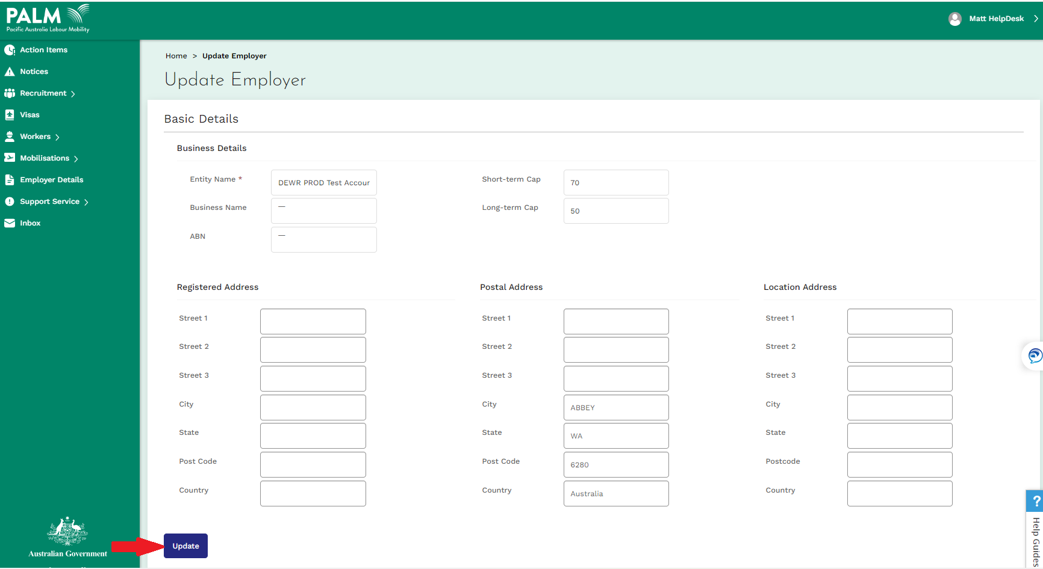

1. Click ‘ok’ to finalise your changes.

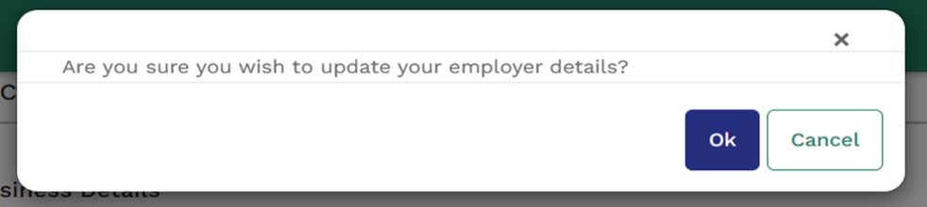

1. The saved changes will now be reflected in the basic details of the ‘my details’ tab.

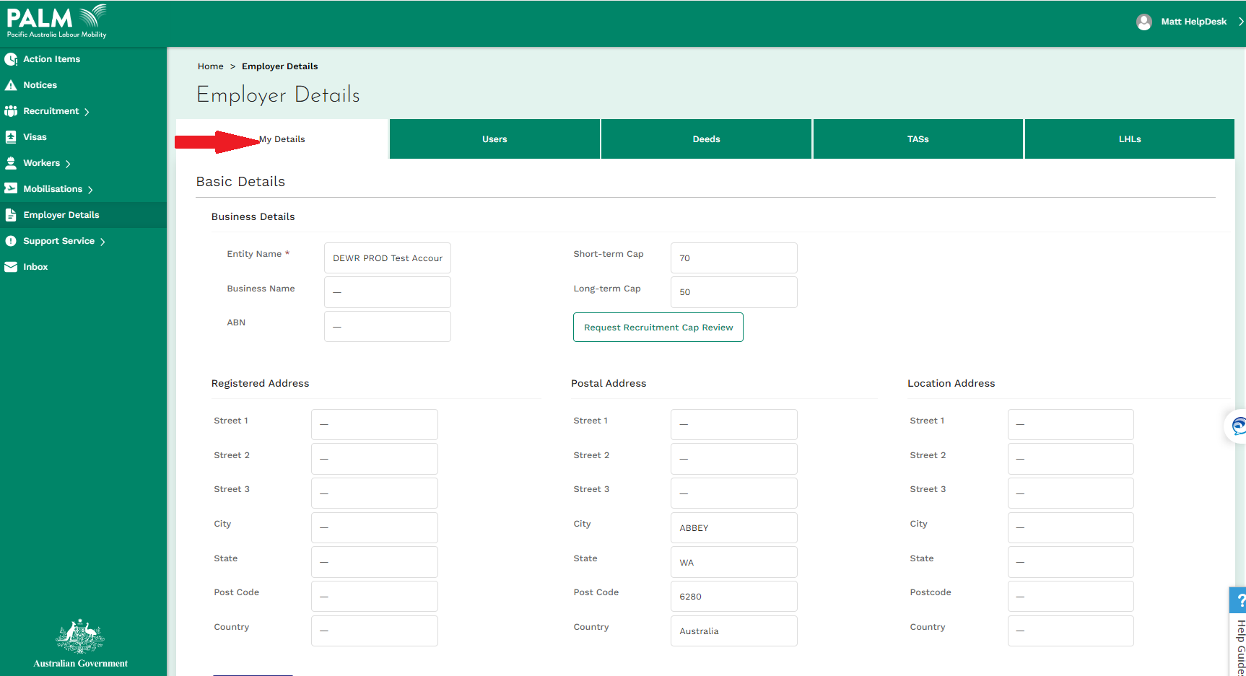

## How to add more users to your account

|  |
| --- |
| Only admin roleshave the appropriate permissions to add other users to your account.   * The contact listed under your deed contact will be assigned the account administrator role. To change administrators, contact your relationship manager or the PALM scheme support service line at ([palm@dewr.gov.au](mailto:palm@dewr.gov.au)) or call (1800 51 51 31). |

1. To access your users, click the ‘users’ tab located within the ‘employer details’ page. The ‘users’ tab lists all the current users with access to your account. Each user can edit and submit recruitment plans, mobilisations, etc.

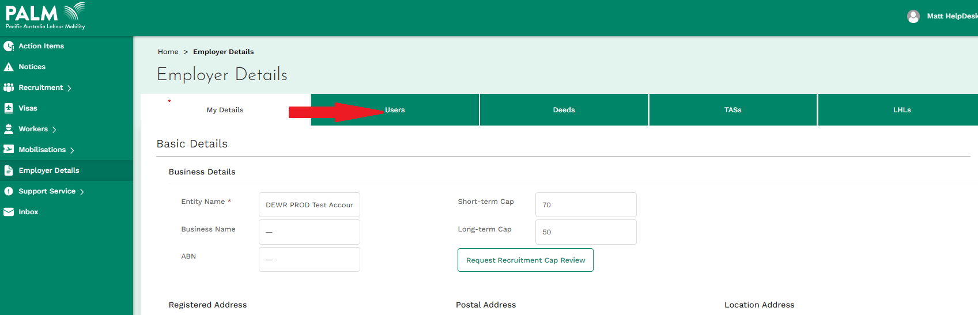

1. Click ‘create user’ to add a new user to your account.

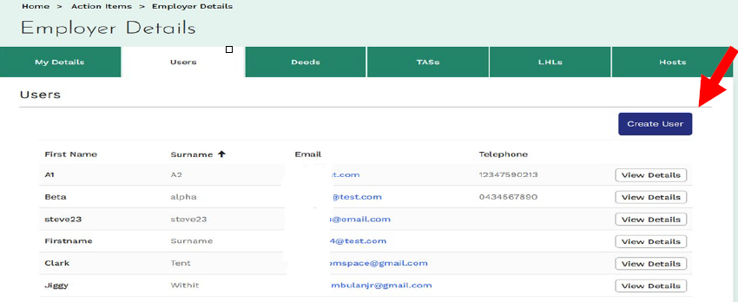

1. Complete the user form and click the ‘create new user’. At a minimum, each account user will need to provide a first name, surname and email contact. It is recommended the account user also provide a phone number. The newly created user will now appear in your list of users.

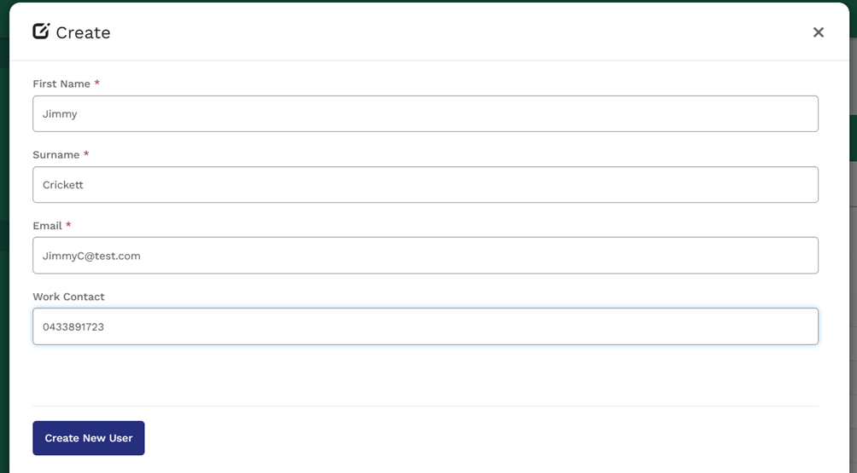

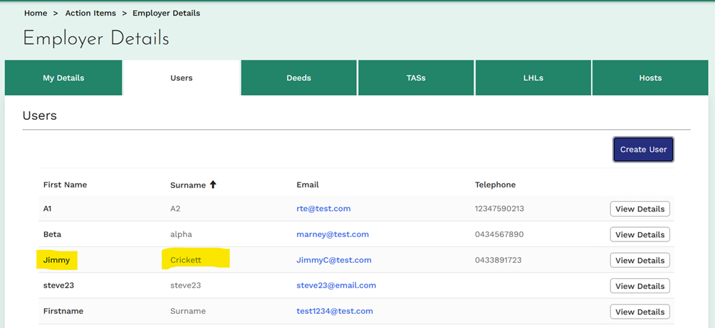

Should a newly created user not appear in your list of users, please contact the PALM scheme support service line at ([palm@dewr.gov.au](mailto:palm@dewr.gov.au)) or call (1800 51 51 31).

## How to find your deed?

Please view and verify that all your information is correct.

1. To access your PALM scheme deed, click the ‘deeds’ tab located within the ‘employer details’ page.

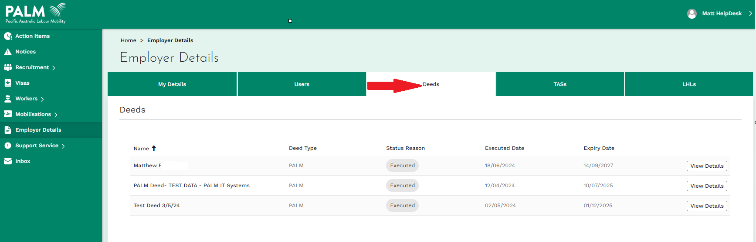

1. Your current PALM scheme deed is listed in the ‘deeds’ tab. Click ‘view details’ to view further details about the deed.

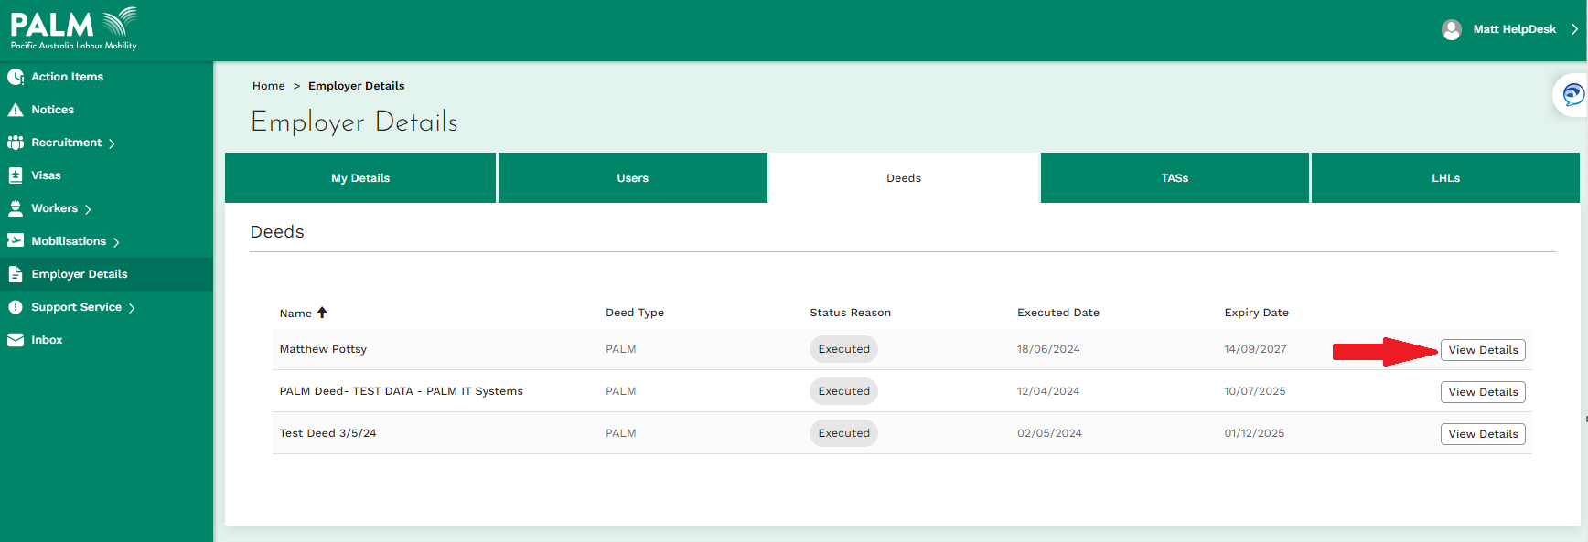

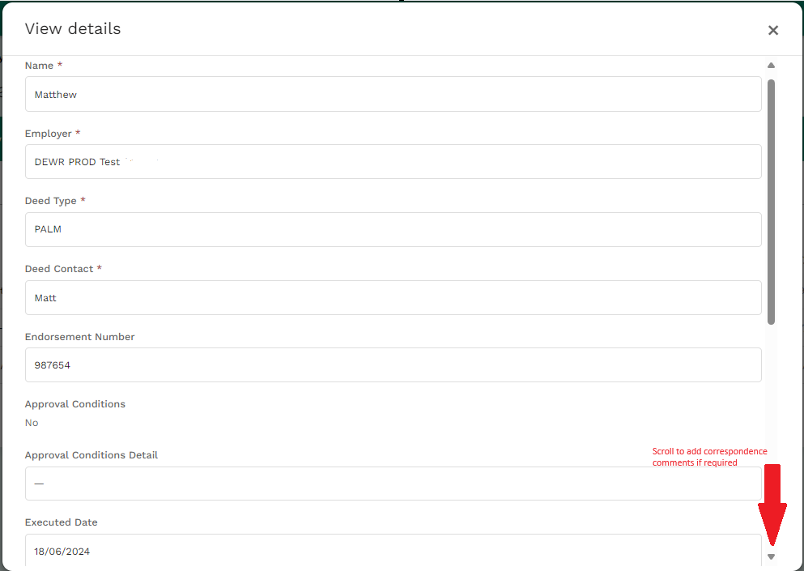

## How to find your temporary activities sponsor details

Your account’s current temporary activities sponsor (TAS) details can be found in the ‘TASs’ tab within the ‘employer details’ page.

1. To access your TAS, click the ‘TASs’ tab located within the ‘employer details’ page.

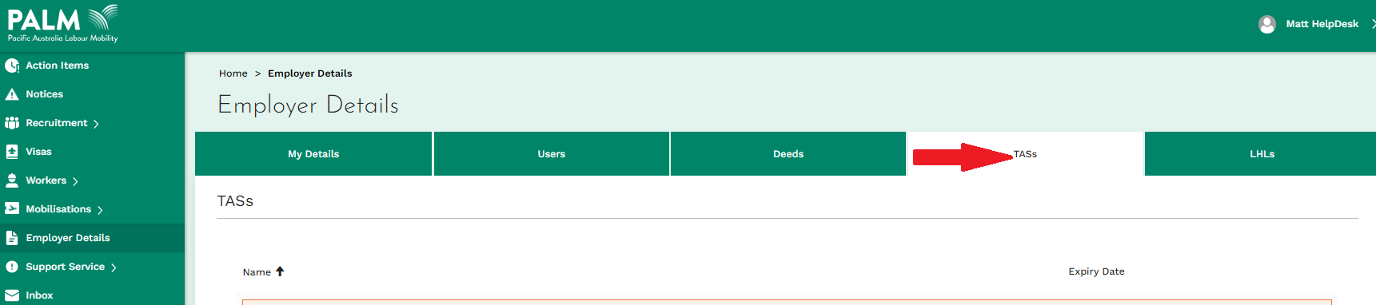

1. Your TAS details will be listed within this page. If your TAS is not visible or requires updating, please contact your relationship manager urgently.

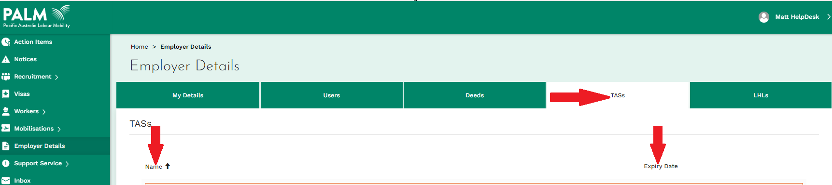

## How to find your labour hire licences

If your organisation operates as a labour hire company, your account’s labour hire licences (LHL) can be found in the ‘LHLs’ tab within the ‘employer details’ page (where applicable).

1. To access your LHLs, click the LHLs tab located within the ‘employer details’ page.

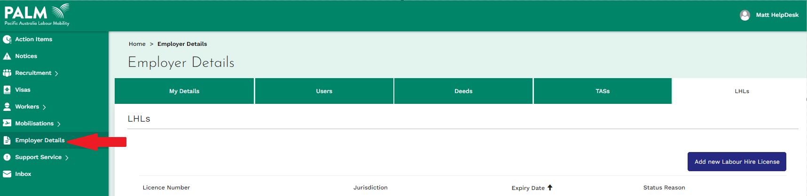

1. Your LHL details will be listed within this page.
2. Click ‘view details’ to view further details about each LHL. You can also edit the details if needed.

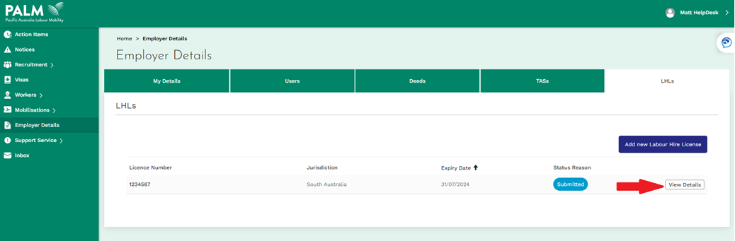

1. Click the ‘submit’ button to submit your changes orclick the **‘x’** button located on the upper right corner to exit without saving.

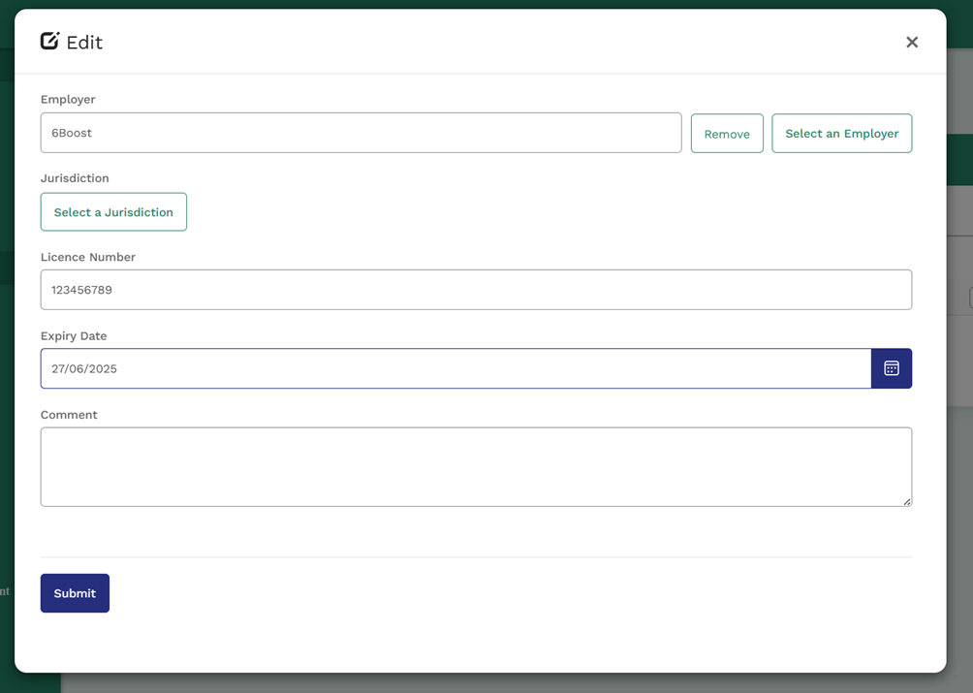

## What to do if you need further help

The PALM scheme has built a help guide within the AE portal to help you when you need assistance.

1. Click the ‘help guides’ tab on the right corner of the screen.

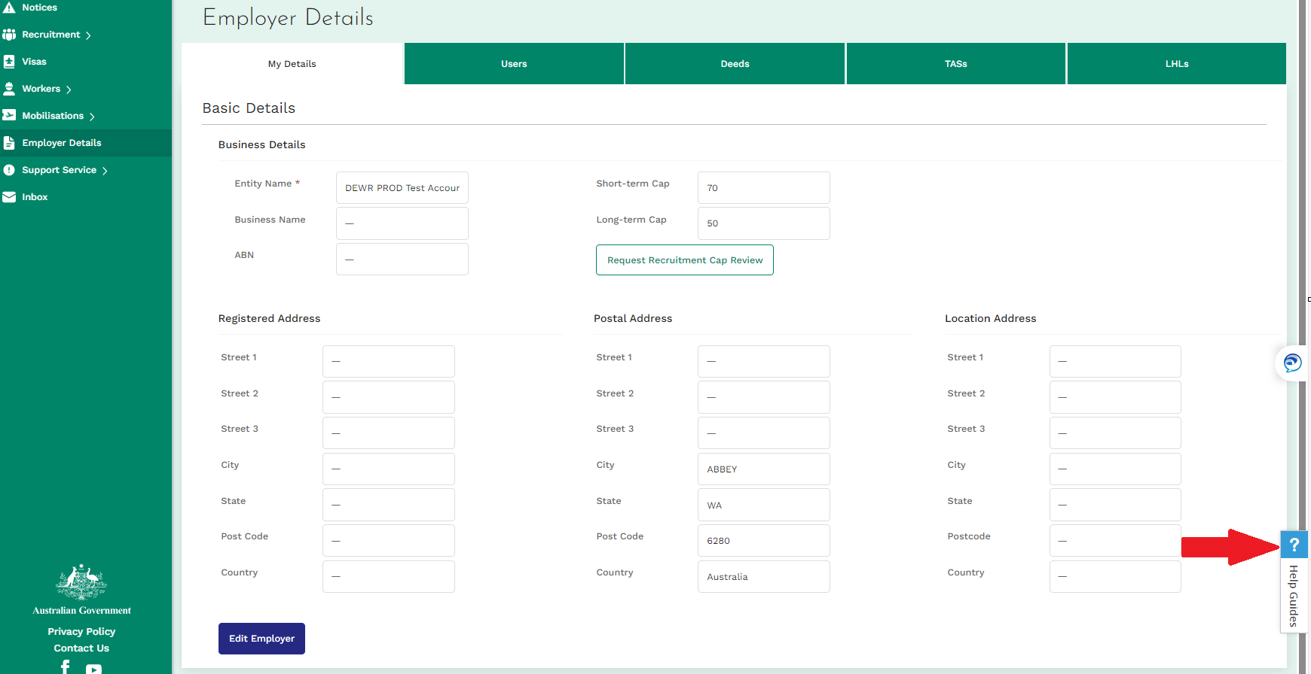

1. Select a category from the ‘help’ tab to view further help guides regarding each topic.

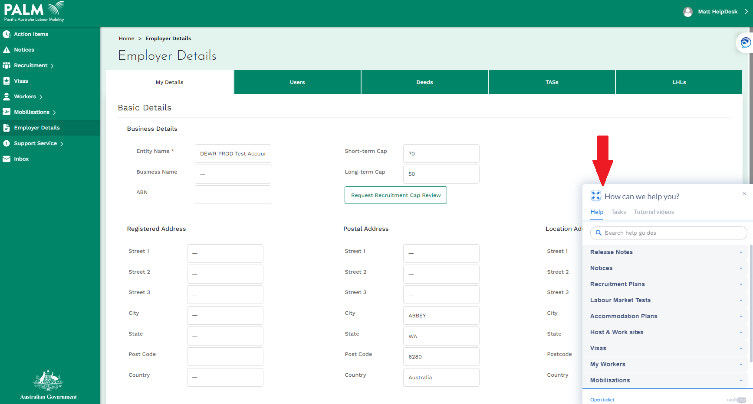

1. Click a topic to be shown a step-by-step guide on how to perform this task. Please ensure to read all the instructions carefully.

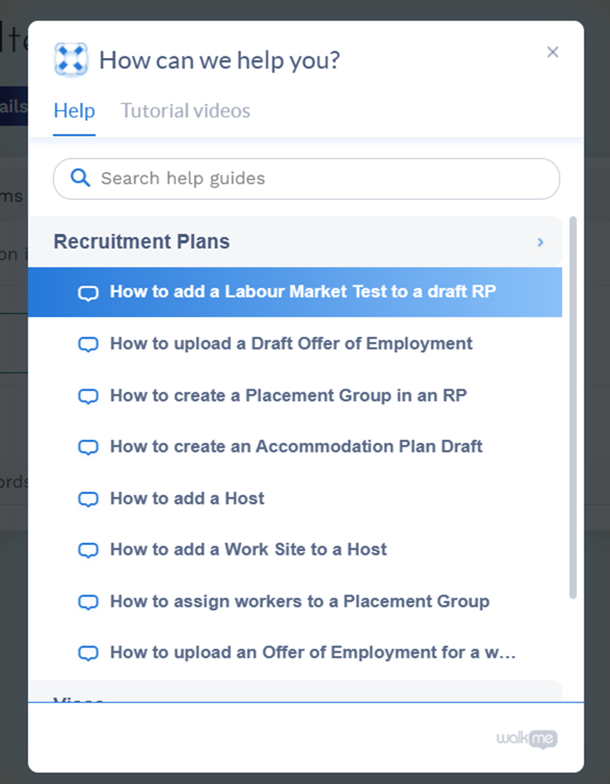

1. Tutorial videos are also provided within the ‘help guide’ menu. Click **‘**tutorial videos’to access these videos.

