

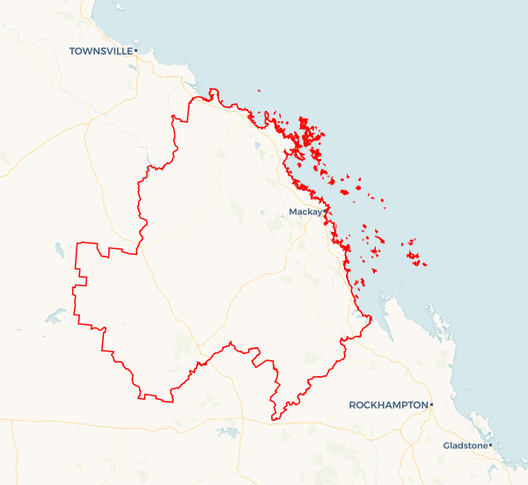Local Jobs Plan

Mackay Employment Region | QLD | ****March 2024****

Workforce Australia Local Jobs (Local Jobs) is a program that supports tailored approaches to accelerate   
reskilling, upskilling, and employment pathways in response to current and emerging local workforce needs.

## Local Jobs elements

### Local Jobs Plan

The Local Jobs Plan sets out the skills and employment challenges and priorities of the region, and associated strategies that will drive the design and implementation of activities to be implemented to address these challenges.

### Employment Facilitators

Employment Facilitators and Support Officers support the delivery of the program by bringing together key stakeholders including businesses, employment services providers, higher education, and training organisations.

### Local Jobs and Skills Taskforce

Each Employment Region has its own Taskforce. Representatives include local stakeholders who have demonstrated experience in upskilling, reskilling, and an ability to represent, connect and collaborate with others in the region to meet labour market needs.

### Local Recovery and National Priority Funds

The Local Recovery Fund supports projects that meet the priorities identified in the Local Jobs Plan. The National Priority Fund provides funding for innovative local solutions to address structural barriers to employment.

Explore labour market insights for the  
[Mackay](https://www.jobsandskills.gov.au/work/employment-region-dashboards-and-profiles/monthly-labour-market-dashboards) Employment Region

Mackay Region (including Isaac & Whitsundays)

## Local labour market challenges in the region

* Labour market disadvantage for traditionally marginalised groups including youth, Indigenous Australians, mature aged, people with a disability and long-term unemployed.
* A need to increase the skills and qualification levels of individuals to align them with current and future industry workforce needs.
* Increased workforce demand for major projects and emerging industries such as the Mackay Hospital Expansion, Mackay Port Access – Bruce Highway and Pioneer-Burdekin Pumped Hydro Projects and the potential risk of a fly in fly out workforce.
* With a large mining and resource sector in the Mackay Employment Region, there is high demand for skilled operators, truck drivers and all trade roles and local businesses including manufacturing, construction, logistics and agriculture are competing to fill vacancies for these in demand roles.
* Health care and social assistance is the largest and fastest growing sectors within the Mackay Employment Region, with skill shortages across nursing, aged, disability and childcare.

## Local jobs and skills priorities and strategies in the region

### Priority 1 – Diversity and inclusion

#### What are our challenges and opportunities?

In the current labour market within the Mackay Employment Region, marginalised cohorts, including Indigenous Australians, youth, mature aged, people with a disability, and the long term unemployed continue to be impacted. Opportunities exist to support greater inclusion of participants within the local labour market and provide more equitable access to skilling and employment pathways. There is a need to address challenges to employment and prepare these cohorts for job vacancies within the region.

#### How are we responding?

* We are fostering relationships between employment services providers and local industry, training, and community stakeholders to ensure Workforce Australia participants have knowledge of, and access to a broad range of opportunities.
* We are working with local Workforce Australia Employment Services Providers to discuss caseload demographics and understand the challenges faced by participants, to enable a collaborative approach to solutions.
* We are championing mentoring support through approved activities and post placement support for successful employment outcomes.
* We are educating employers about the availability of state and federal government wage subsidies and incentives that support businesses hiring marginalised and long-term unemployed cohorts and are building awareness on recruitment strategies and government supports for mature age workers and people with a disability including Career Transition Assistance, Skills Checkpoint for Older Workers, job carving and workplace modifications.
* We are working with stakeholders to increase the participation of youth in existing soft skills, employability, and digital literacy training to support job readiness.
* We are working collaboratively with community, Indigenous organisations, and local industry to identify suitable, sustainable employment opportunities for Indigenous Australians and culturally appropriate supports that assist with overcoming challenges to employment and maintaining employment.
* We are connecting individuals interested in self-employment to programs such as Self-Employment Assistance and Many Rivers program to build capacity and skills for successful transitioning into business.

### Priority 2 – Training focus - place-based training solutions

#### What are our challenges and opportunities?

Industries in the region are struggling to fill positions that require practical training/qualifications and tickets. There is a significant number of individuals not having completed secondary schooling or industry qualifications. This has impacted on literacy and numeracy levels within the region and skills alignment with industry need. Opportunities exist to support access to skilling and employment pathways.

#### How are we responding?

* We are developing place-based strategies that include reskilling and upskilling and employment pathways to meet local employment demand.
* We are working with regional stakeholders and Taskforce members to deliver tailored Local Recovery Fund projects within the region that upskill local people and include in demand nationally recognised qualifications and skill sets, foundation skills and wrap around services.
* We are engaging with industry and sharing entry level career pathways such as apprenticeships and traineeships opportunities available in our region (e.g. BHP Future Fit Academy and Advanced Apprenticeships intakes, Car to Bus Driver Traineeships, Regional Council Apprenticeships and Traineeships).
* We are maximising the use of existing government, industry and community driven employment and skills initiatives and funding to increase reskilling and upskilling in the region to address labour shortages and skills gaps. (e.g. Skilling Queenslanders to Work Projects, Back to Work Pre-employment Programs, Launch into Work projects, Workforce Connect Projects, Skills for Education and Employment Vocational Pathways, etc).
* We are supporting mature age participants to re-enter the workforce by raising awareness of transferable skills across industries and diverse employment opportunities.
* We are collaborating with employment service providers to facilitate a series of Employment Fundamental Workshops within the community to support job seekers with job readiness, linking them with training and upskilling opportunities and connecting them to businesses with current vacancies.

### Priority 3 – Major projects and emerging industries

#### What are our challenges and opportunities?

Maximising the extent to which local individuals and transitioning workers are skilled to meet the needs of major projects in the region, including emerging industries, renewable energy projects, infrastructure, and other large-scale construction projects. There are opportunities to leverage existing programs and initiatives to create pathways into local growth industries.

#### How are we responding?

* We are engaging with employers of upcoming major projects in the region to develop an understanding of their workforce requirements and facilitate engagement with employment services providers and other relevant regional stakeholders.
* We are co-designing with local stakeholders, industry specific pre-employment programs aimed at supporting participant engagement and development of capabilities to uptake employment opportunities in growth areas.
* Informed by the Taskforce and other key stakeholders, we share new regional training opportunities and initiatives such as skillset transitioning to alternative Industries and micro-credentialing to increase access and knowledge to new technology for a future-ready workforce, e.g. Resource Centre of Excellence Virtual Reality labs, Future to Work Regional Development Programs, Greater Whitsunday Alliance Decarbonisation Projects, Ag Tech Digital Skills, and Technology training.
* We are proactively addressing training, licencing upgrades and operator ticketing of participants in collaboration with employment service providers and registered training organisations to ensure suitably skilled pools of candidates are available to meet workforce demand in infrastructure projects.

### Priority 4 – Priority industries including health care and social assistance, manufacturing, transport and logistics, and traditional trades

#### What are our challenges and opportunities?

With a large resource and mining sector in the Mackay Employment Region, there is high demand for skilled operators, truck drivers and all trades and service roles. Local businesses including manufacturing, construction, logistics and agriculture are competing to fill vacancies for these in demand roles.

With an aging population, the health care and social assistance is the largest and fastest growing sector in the Mackay Employment Region, with skill shortages across nursing, aged, disability and childcare. There are opportunities to maximise the benefits of existing government programs and initiatives to create **pathways into priority industries facing skills shortages within the region.**

#### How are we responding?

* We are collaborating with Industry peak bodies across transport and logistics, health care and social assistance, manufacturing, and trade training to identify employment opportunities and recruitment strategies and initiatives for priority industries.
* We are working with the Department of Employment, Small Business and Training, CQ University, TAFE Queensland, and registered training organisations to establish Pre-Apprenticeship Training programs in the region to create pathways into trades and services across all industries.
* We are working with local stakeholders to coordinate the range of pathways directly linked to current labour demand in the region to provide upskilling and reskilling for industries.
* We are coordinating and collaborating on industry specific jobs fairs and career expos to provide training and job opportunities for the local community.

## Want to know more?

* Contact: Cassandra Richardson, Interim Mackay Employment Facilitator: [cassandra.richardson@dewr.gov.au](mailto:cassandra.richardson@dewr.gov.au)
* Visit: [Local Jobs](https://www.dewr.gov.au/local-jobs) or [Workforce Australia](https://www.workforceaustralia.gov.au/businesses/)