

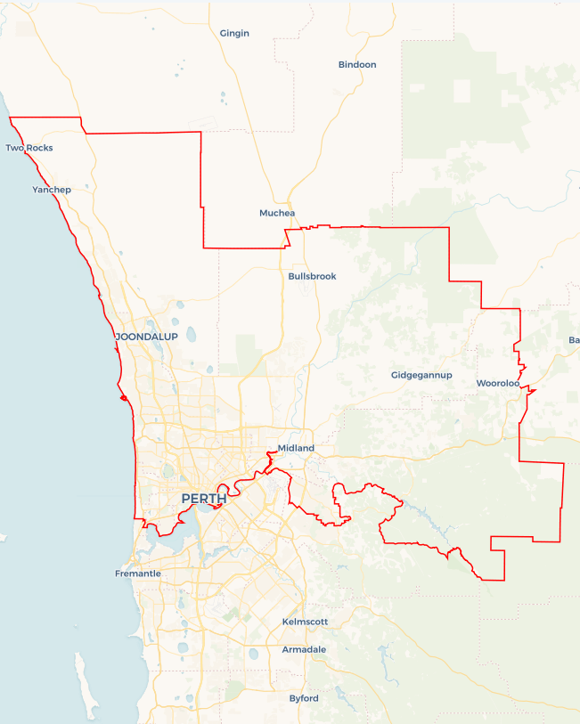Local Jobs Plan

Perth North ****Employment Region**** | WA | ****November 2023****

Workforce Australia Local Jobs (Local Jobs) is a program that supports tailored approaches to accelerate   
reskilling, upskilling and employment pathways in response to current and emerging local workforce needs.

## Local Jobs elements

### Local Jobs Plan

The Local Jobs Plan sets out the skills and employment challenges and priorities of the region, and associated strategies that will drive the design and implementation of activities to be implemented to address these challenges.

### Employment Facilitators

Employment Facilitators and Support Officers support the delivery of the program by bringing together key stakeholders including businesses, employment services providers, higher education and training organisations.

### Local Jobs and Skills Taskforce

Each Employment Region has its own Taskforce. Representatives include local stakeholders who have demonstrated experience in upskilling, reskilling, and an ability to represent, connect and collaborate with others in the region to meet labour market needs.

### Local Recovery and National Priority Funds

The Local Recovery Fund supports projects that meet the priorities identified in the Local Jobs Plan. The National Priority Fund provides funding for innovative local solutions to address structural barriers to employment.

Explore labour market insights for the  
[Perth North](https://www.jobsandskills.gov.au/data/employment-region-dashboards-and-profiles/monthly-labour-market-dashboards) Employment Region

## Local labour market challenges in the region

* An ageing population is driving the demand for staff in the care and support sector. Attracting individuals to the sector is a major challenge.
* Known and predicted skills shortages in multiple sectors. Examples include construction, retail, care and technology.
* Historical low rates of housing availability are impacting the labour market and simultaneously increasing experiences of homelessness.
* There are difficulties attracting individuals to the primary industry sector, which is facing shortages due to a reduction in generational farming. This is a result of young people seeking different career opportunities.

## Local jobs and skills priorities and strategies in the region

### Priority 1 – Remove barriers and disincentives to work

#### What are our challenges and opportunities?

Developing soft skills and teamwork, building resilience and motivation, and providing on the job mentoring support and wrap around services has been identified as crucial to building employment pathways for the most disadvantaged individuals. Obtaining a driver’s license continues to be a key barrier for people gaining employment. Mental health illnesses (depression and anxiety) are representing in higher proportions. Assisting people to develop targeted strategies they can apply when experiencing mental illness to support their return to the workforce. Increased experiences of homelessness are making it difficult for people to commence or maintain employment due to their homelessness experiences such as couch surfing.

#### How are we responding?

* We are working with state government departments and specialist organisations to connect into existing programs and develop initiatives that support individuals to break down barriers that lead into employment opportunities.
* We are working with specialist organisations and programs to understand the issues and experiences surrounding mental health to develop support mechanisms for individuals.
* We are working with local businesses to create employment opportunities aligned with the labour needs through a focus on reducing barriers to employment.

### Priority 2 – Boost apprenticeship and traineeship commencements to match areas of industry need

#### What are our challenges and opportunities?

Improving the collaboration with businesses and industry to address the skills requirement through training, upskilling, reskilling, apprenticeships, and traineeships in line with local employment needs and future infrastructure construction.

#### How are we responding?

* We are promoting emerging employment opportunities for clean energy careers.
* We are targeting engagement with businesses to explore vacancies and skill gaps.
* We are identifying and exploring employment opportunities for short, medium, and long-term growth in civil and residential construction.
* We are working to attract and retain staff with the required skills within the local hospitality and accommodation service industry.

### Priority 3 – Activate industry

#### What are our challenges and opportunities?

* We want to activate industry to design and drive change by taking a strong role in workforce development, this includes identifying and promoting career pathways. By taking a people first approach to workforce development we aim to support the upskilling of individuals, the recognition and identification of transferable skills and knowledge as building blocks for future employees. This includes working with mature age individuals who are predominantly female in the Perth North employment region, to support their re-entry to the workforce.

#### How are we responding?

* We are working with industries to co-design employment pathways and job opportunities to attract people into careers.
* We are establishing relationships with businesses to support delivery of their employment engagement plans such as Reconciliation Action Plans, disability and other diversity and inclusion strategies.
* We will hold industry forums to gain real time insights into labour markets, employment barriers and develop responses to support industry needs.
* We are working with businesses to develop their knowledge to better understand an individual’s potential and eliminate stereotypes and unconscious bias around cohorts. This includes the promotion and recognition of transferable skills and industry knowledge of mature aged and Culturally and Linguistically Diverse (CaLD) individuals.
* We are strengthening relationships with First Nations businesses to foster employment opportunities with culturally sensitive organisations for First Nations peoples.

**Priority 4 – Clean energy careers**

#### What are our challenges and opportunities?

As new job pathways are developed, we aim to work with industries to co-design employment pathways and job opportunities to support the transition and creation of roles in the response to clean energy in the net zero industries.

#### How are we responding?

* We will work with new governing bodies to design roles and careers for those that are experiencing barriers to employment to assist individuals with their entry or return to the workforce.
* We will undertake a market scan to identify businesses with emerging clean energy employment opportunities and infrastructure projects that will have a green energy focus.
* We will identify ways to support and promote entrepreneurship with a focus on clean energy in the region.

### Priority 5 – Healthcare and social assistance

#### What are our challenges and opportunities?

An ageing population is driving the demand for in the care and support sector along with changes in service delivery to include more in-home care as residential care is not growing at the same rate. This is the highest employing sector in the Perth North and the region is home to several major hospitals. The sector provides variety of employment in the disability, aged care, community and health sectors.

#### How are we responding?

* We are exploring how to recruit, support and engage staff in roles in healthcare, aged care and disability care.
* We are promoting employment opportunities in the Healthcare and Social Assistance sector.
* We have created a Taskforce working group to engage with industry to identify and create workforce attraction strategies and reduce barriers for individuals returning to the workforce.
* We are working with state government departments to connect into existing programs and develop initiatives that support individuals into employment opportunities.
* We will work with industries and businesses to create workforce attraction and retention strategies for the sector. This includes supporting entrepreneurship with a focus on new and emerging opportunities in the region.

## Want to know more?

* Contact: Jodie Dutton, Perth North WA Employment Facilitator: [pn@employmentfacilitatorwa.com.au](mailto:pn@employmentfacilitatorwa.com.au)
* Visit: [Local Jobs](https://www.dewr.gov.au/local-jobs) or [Workforce Australia](https://www.workforceaustralia.gov.au/)