

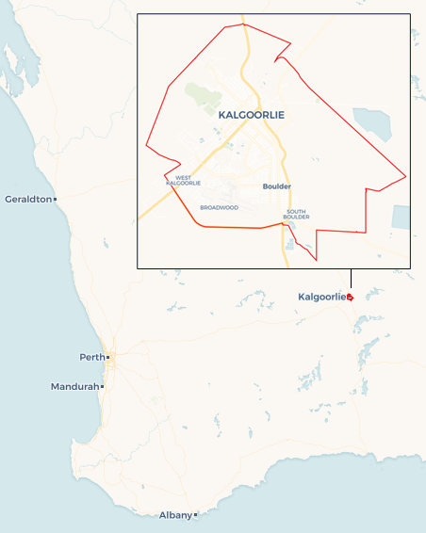Local Jobs Plan

Kalgoorlie ****Employment Region**** | WA | ****January 2023****

Workforce Australia Local Jobs (Local Jobs) is a program that supports tailored approaches to accelerate   
reskilling, upskilling and employment pathways in response to current and emerging local workforce needs.

## Local Jobs elements

### Local Jobs Plan

The Local Jobs Plan sets out the skills and employment challenges and priorities of the region, and associated strategies that will drive the design and implementation of activities to be implemented to address these challenges.

### Employment Facilitators

Employment Facilitators and Support Officers support the delivery of the program by bringing together key stakeholders including businesses, employment services providers, higher education and training organisations.

### Local Jobs and Skills Taskforce

Each Employment Region has its own Taskforce. Representatives include local stakeholders who have demonstrated experience in upskilling, reskilling, and an ability to represent, connect and collaborate with others in the region to meet labour market needs.

### Local Recovery and National Priority Funds

The Local Recovery Fund supports projects that meet the priorities identified in the Local Jobs Plan. The National Priority Fund provides funding for innovative local solutions to address structural barriers to employment.

Explore labour market insights for the   
[Kalgoorlie](https://www.jobsandskills.gov.au/work/employment-region-dashboards-and-profiles/monthly-labour-market-dashboards) Employment Region

## Local labour market challenges in the region

* The absorption of the available workforce into the mining and resource sector has made it challenging to attract and retain staff in hospitality and accommodation services, childcare, health, and aged care and disability support services.
* Lack of affordable long and short-term accommodation can make it difficult for people to move to the region. Homelessness is also a contributing factor to individuals ability to secure employment.
* Difficulty in recruiting trainers impacts on registered training organisations ability to deliver courses which may assist in preparing people to work in industries experiencing skills and labour shortages.
* Low literacy and numeracy levels also has a significant impact on individuals ability to successfully complete accredited training.
* The availability of childcare is a serious constraint on labour market participation, especially for women, and their ability to return to the workforce or work the hours required by businesses.

## Local jobs and skills priorities and strategies in the region

### Priority 1 – Engage with businesses and industry

#### What are our challenges and opportunities?

A high staff turnover and a transient workforce population impacts the ability to remain connected and informed about labour market trends, programs, incentives and opportunities.

#### How are we responding?

* Conducting analysis to identify local industry needs and skills gaps. The Taskforce and Employment Facilitator are developing strategies to maximise employment opportunities to meet business demands.
* The Employment Facilitator is a member of local business and industry networks and committees.
* We are connecting local employment service providers with key industry representatives to develop and promote career paths and develop networks.

### Priority 2 – Employment opportunities and job readiness

#### What are our challenges and opportunities?

A number of factors impact on job readiness, such as lack of transport, low literacy and numeracy levels, homelessness, limited or no work experience, lack of soft skills, justice issues, generational unemployment and drug and alcohol addiction.

#### How are we responding?

* We have identified challenges facing the local workforce and are looking for ways to optimise engagement with long term unemployed individuals.
* We are brokering solutions using available supports and other programs, to develop projects that will address specific barriers and train and prepare individuals to meet labour requirements of local businesses and industries.
* We are training and preparing individuals to meet labour market requirements, utilising existing programs where possible.

### Priority 3 – Pathways into local industries with significant labour shortages

#### What are our challenges and opportunities?

A high proportion of individuals have been unemployed for more than 24 months and have significant barriers that prevent them from being employed in the aged care sector, disability sector, childcare sector and gold mining industry, with limited short-term solutions available. There is a need to leverage programs to create opportunities in these industries, with a focus on youth and Indigenous Australians.

#### How are we responding?

* The Employment Facilitator and local employment service providers are connecting with key representatives of the mining, resources, hospitality, health care and social assistance industries to develop and promote specific career paths and build aspiration to work within these industries.
* We are identifying transferable skills across industries to open alternate pathways.
* We are developing connections with youth and Indigenous Australians support services to develop solutions appropriate and specific to these cohorts.
* Our Taskforce and Employment Facilitator are developing a resource that identifies the programs and initiatives currently available to support individuals to address barriers that limit their employment and training opportunities.

### Priority 4 – Optimise communication and engagement with long term unemployed individuals on education, training and other entry pathways

#### What are our challenges?

A considerable number of individuals have not completed secondary school which has significantly impacted on their literacy and numeracy levels.

#### How are we responding?

* We are leveraging existing promotional opportunities at events and encouraging participation at expos and business-run industry days.
* We are developing strategies to encourage individuals to participate in the Skills for Education and Employment program and other programs to improve work readiness.
* The Employment Facilitator is discussing assessment instruments with vocational education and training providers.
* We are promoting regular workshops and information sessions to individuals on current opportunities and support services available.

## Want to know more?

* Contact: Karen Thomas, Kalgoorlie Employment Region Employment Facilitator: [kalgoorlie@employmentfacilitatorwa.com.au](mailto:kalgoorlie@employmentfacilitatorwa.com.au)
* Visit: [Local Jobs](https://www.dewr.gov.au/local-jobs) or [Workforce Australia](https://www.workforceaustralia.gov.au/)