

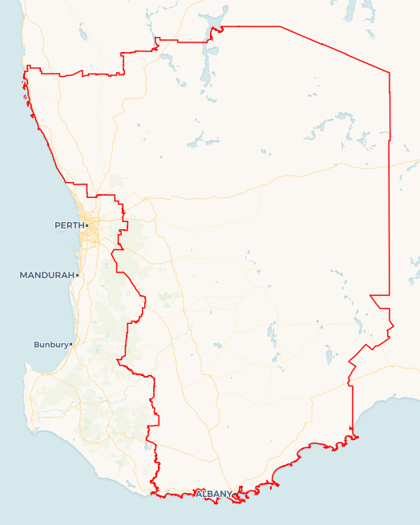Local Jobs Plan

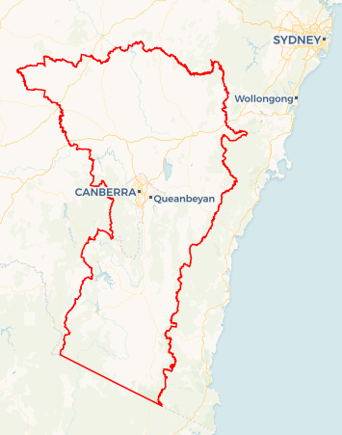

**SAMPLE MAP ONLY**

A map of your Employment Region and hyperlink will be added before publishing.

Great Southern Wheatbelt ****Employment Region**** | WA | ****August 2023****

Workforce Australia Local Jobs (Local Jobs) is a program that supports tailored approaches to accelerate   
reskilling, upskilling and employment pathways in response to current and emerging local workforce needs.

## Local Jobs elements

### Local Jobs Plan

The Local Jobs Plan sets out the skills and employment challenges and priorities of the region, and associated strategies that will drive the design and implementation of activities to be implemented to address these challenges.

### Employment Facilitators

Employment Facilitators and Support Officers support the delivery of the program by bringing together key stakeholders including businesses, employment services providers, higher education and training organisations.

### Local Jobs and Skills Taskforce

Each Employment Region has its own Taskforce. Representatives include local stakeholders who have demonstrated experience in upskilling, reskilling, and an ability to represent, connect and collaborate with others in the region to meet labour market needs.

### Local Recovery and National Priority Funds

The Local Recovery Fund supports projects that meet the priorities identified in the Local Jobs Plan. The National Priority Fund provides funding for innovative local solutions to address structural barriers to employment.

Explore labour market insights for   
[Great Southern Wheatbelt](https://www.jobsandskills.gov.au/work/employment-region-dashboards-and-profiles/monthly-labour-market-dashboards) Employment Region

## Local labour market challenges in the region

* Multiple industry sectors in the Great Southern Wheatbelt region are experiencing ongoing staffing challenges, which affects their productivity and our region’s economic output. Affected sectors include hospitality, agriculture and primary production, manufacturing, construction, health care and support services.
* A significant portion of Workforce Australia participants are experiencing periods of long-term unemployment, due to seasonal and casual work and there are those who also experience inter-generational unemployment. Participants need tailored support to build work-ready skills over a period of time and are not usually ready for “short, sharp” training programs which are favoured by some training providers and other stakeholders. First Nations participants face additional barriers to entering the workforce and need customised support and mentoring.
* Many Workforce Australia participants are enrolled with multiple government services. Participants spend significant time managing the compliance obligations for various supports, and the risk of losing these supports poses a disincentive to entering work at entry level wages and conditions.
* Employers in multiple sectors are interested in targeting young people to enter their industry sector. However, there are some persistent barriers which hinder this recruitment for both employers and youth applicants. These include a mismatch between employer and candidate expectations for entry level roles, insufficient places available in pre-apprenticeship training and programs and lack of support and means to gain a driver’s license. This leaves a portion of the youth cohort disengaged from work and study.
* Small business owners, who form the majority of our region’s employers, lack the time and resources to develop customised recruitment and onboarding programs to connect individuals with support needs and/or those who have been unemployed longer term. As a result, they are not well engaged with government funded employment support services and can overlook available candidates who may require work role adjustment or onboarding support.
* Our region is well positioned for opportunities in the sustainability sector, including renewable energy and other environmental and land restoration projects. Educators and training organisations are keen to promote this career sector. However, the related local job pathways are unclear and there is a risk of jobs being centralised to the capital (Perth) rather than established in the region where energy projects are located.
* Our large geographical area and dispersed population make connecting training and government programs problematic. This is exacerbated by participants being split between differing government services which offer varying services and funding arrangements. Local training and employment support programs have the most success in the region when local service providers are consulted and included in program planning and promotion.

## Local jobs and skills priorities and strategies in the region

### Priority 1 – Improve support to individuals experiencing long term and/or inter-generational unemployment

#### What are our challenges and opportunities?

#### A significant portion of Workforce Australia participants are experiencing periods of long-term unemployment, due to seasonal and casual work and those who also experience inter-generational unemployment. They need tailored support to build work-ready skills over a period of time and are not usually ready for ‘short, sharp’ training programs which are favoured by some training providers and other stakeholders. Additionally, First Nations participants face additional barriers to entering the workforce and need customised support and mentoring.

#### How are we responding?

* With our Taskforce, we will map the programs and services that individuals are reliant on and identify financial and other disincentives to entering work. We will share this feedback with the department and other government stakeholders and use this to inform local job coaching services and programs.
* We will support employment services providers and training organisations to build their skills and awareness of the broader picture of their clients, to inform a holistic approach to their service.
* We will collaborate with local provider networks (including Workforce Australia, other government funded services and disengaged youth program supporters) to identify and support short and long-term programs to support job readiness and job pathway education. Where individuals are experiencing inter-generational unemployment, we will encourage program providers to consider how to involve or communicate with the participant’s family through the program.
* We will promote and support existing and proposed programs and solutions which address structural barriers to employment, such as access to transport, access to training and digital inclusion.
* We will identify and connect with Indigenous owned/ other culturally safe employers in the region and will collaborate with qualified stakeholders to develop and support customised mentoring and job readiness programs for First Nations peoples.

### Priority 2 – Improve connection and hiring success between local employers and candidates

#### What are our challenges and opportunities?

#### Small business owners, who form the majority of our region’s employers, lack the time and resources to develop customised recruitment and onboarding programs to connect to individuals with support needs and/or those who have been unemployed longer term. As a result, they are not well engaged with government funded employment support services and can overlook available candidates who may require work role adjustments or onboarding support.

#### How are we responding?

* We will connect and educate employers (both small business and larger corporate employers) to widen their candidate pool and adjust their recruitment and onboarding process to meet the available labour market.
* We will connect and educate employers on opportunities to upskill staff to meet new market challenges such as automation and sustainability.
* We will connect to relevant and streamlined resources, including to external mentoring supports to support candidates and employers after their job placement.
* We will advocate to connect and support more pre-apprenticeship training opportunities into the region, particularly in trades-based environments such as mechanical and construction services, and in areas of emerging industries such as new energy, manufacturing automation and cyber security.
* We will identify and support initiatives to educate individuals on employer expectations and promote the long-term value of activities which demonstrate work ethic and work readiness such as casual work, community volunteering and involvement in community and sporting activities.

### Priority 3 – Map and connect clean energy job pathways within the region

#### What are our challenges and opportunities?

Our region is well positioned for opportunities in the sustainability sector, including renewable energy and other environmental and land restoration projects. Educators and training organisations are keen to promote this career sector. However, the related local job pathways are unclear and there is a risk of jobs being centralised to the capital (Perth) rather than established in the region where energy projects are located.  
**How are we responding?**

* Together with the Taskforce, we will map existing and emerging regional employment pathways in the sustainability sector, such as clean energy and environmental restoration projects.
* We will communicate these pathways with our employment, training and education networks and advocate to secure relevant training pathways in the region.
* We will work together with key stakeholders to communicate local training and recruitment opportunities with key employers and advocate to bring these jobs into the region to benefit our local communities (rather than hiring from Perth).

### Priority 4 – Support delivery of local programs through collaboration between services

#### What are our challenges and opportunities?

#### Our large geographical area and dispersed population can make connecting training and government programs challenging. This is exacerbated by participants being distributed between differing government services which offer varying services and funding arrangements. Local training and employment support programs have the most success in the region when local service providers are consulted and included in program planning and promotions.

#### How are we responding?

* We will maintain and keep building strong networks within key regional centres, connecting service providers across multiple state and federal government funded services, Registered Training Organisations and Group Training Organisations, education providers, community support agencies and employer networks.
* With our networks, we will map individuals across different government programs to gain a clear picture of local individuals and areas of interest and support required, to inform program development.
* We will work with these sub-regional groups to identify and support relevant employment support and training programs to each location and invite our networks to contribute to program design for potential Local Job Activities, Workforce Specialist programs and other government funded employment supports.
* We will support local job pathway promotion opportunities within the region to a wide variety of candidates including youth, employment services participants and the ‘inactive’ potential workforce in our communities.

## Want to know more?

* Contact: Emma Everett, Great Southern Wheatbelt Employment Facilitator: [emma.everett@gswlocaljobs.com.au](mailto:emma.everett@gswlocaljobs.com.au)
* Visit: [Local Jobs](https://www.dewr.gov.au/local-jobs) or [Workforce Australia](https://www.workforceaustralia.gov.au/)