

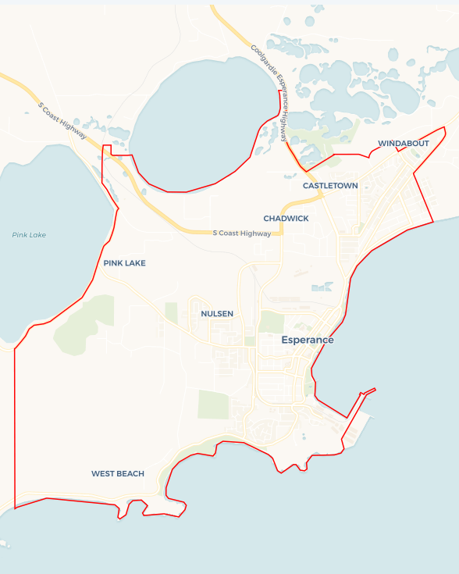Local Jobs Plan

Esperance Employment Region | WA | ****December 2023****

Workforce Australia Local Jobs (Local Jobs) is a program that supports tailored approaches to accelerate   
reskilling, upskilling and employment pathways in response to current and emerging local workforce needs.

## Local Jobs elements

### Local Jobs Plan

The Local Jobs Plan sets out the skills and employment challenges and priorities of the region, and associated strategies that will drive the design and implementation of activities to be implemented to address these challenges.

### Employment Facilitators

Employment Facilitators and Support Officers support the delivery of the program by bringing together key stakeholders including businesses, employment services providers, higher education and training organisations.

### Local Jobs and Skills Taskforce

Each Employment Region has its own Taskforce. Representatives include local stakeholders who have demonstrated experience in upskilling, reskilling, and an ability to represent, connect and collaborate with others in the region to meet labour market needs.

### Local Recovery and National Priority Funds

The Local Recovery Fund supports projects that meet the priorities identified in the Local Jobs Plan. The National Priority Fund provides funding for innovative local solutions to address structural barriers to employment.

Explore labour market insights for the   
[Esperance](https://www.jobsandskills.gov.au/work/employment-region-dashboards-and-profiles/monthly-labour-market-dashboards) Employment Region

## Local labour market challenges in the region

* Lack of rental accommodation.
* Lack of adequate public transport
* Lack of childcare placements.
* Access to Driver Training.
* Skills shortages.
* High levels of underemployment and casualisation in some sectors.
* The locally available workforce is relatively small.

## Local jobs and skills priorities and strategies in the region

### Priority 1 – Engagement and consultation

#### What are our challenges and opportunities?

The Esperance region has a lack of available skilled workforce in the region and limitations on importing skills from interstate and offshore. This is an optimal environment in which to prepare local people to take up vacancies within the Esperance workforce.

#### How are we responding?

* We are developing local strategies to maximise individuals’ employment potential, including identifying opportunities and factors impacting on job readiness.
* We are promoting utilisation of funding and programs to address specific challenges to employment for individuals.
* We are training and preparing individuals to meet labour requirements of local businesses and industries.

### Priority 2 – Employment opportunities and jobs readiness for local people

#### What are our challenges and opportunities?

The Esperance region challenges include skills gaps, limited resource, talent attraction and retention. We need to ensure local people are adequately skilled, prepared and supported for current and upcoming employment opportunities.

#### How are we responding?

* We are developing local strategies to maximise individuals’ employment potential, including identifying opportunities and factors impacting on job readiness.
* We are promoting utilisation of funding and programs to address specific challenges to employment for individuals.
* We are training and preparing individuals to meet labour requirements of local businesses and industries.

### Priority 3 – Leveraging programs for creative pathways into employment

#### What are our challenges and opportunities?

The Esperance region is experiencing increased demand for workers in the agriculture, hospitality, transport, tourism, retail and health care and social assistance industries. There is a need to leverage programs to create pathways into these industries. While the locally available workforce is relatively small, there is an opportunity to focus on supporting mature-aged individuals and Aboriginal and First Nations people.

#### How are we responding?

* We are connecting local employment service providers with key representatives of the agriculture, hospitality, health care, social assistance, and other industries to develop and promote specific career paths and build aspiration to work within these industries.
* We are identifying transferable skills across industries and alternative employment pathways.
* We are identifying and engaging with mature aged and Aboriginal and First Nations support services in workforce development appropriate and specific to these cohorts.

### Priority 4 – Optimising engagement with long term unemployed individuals

#### What are our challenges and opportunities?

While most job ready individuals can secure employment with relative ease, the long-term unemployed caseload continues to increase steadily. Those looking for work experience vocational and/or non-vocational challenges to employment, most notably relating to lack of skills and work experience, drug and alcohol, homelessness, access to transport and justice issues.

#### How are we responding?

* We are leveraging existing promotional opportunities at events such as jobs fairs, employment expos, and employer-run industry days.
* We are delivering regular workshops and information sessions to long-term unemployed people on current opportunities and support services available.
* We are hosting and attending activities and events that optimise communication and engagement with long-term unemployed people on education, training and in collaboration with community support services to create other entry pathways into local industries.

## Want to know more?

* Contact: Andrea Wynne, Esperance Employment Region Employment Facilitator: [employmentfacilitator@esperancelocaljobs.org.au](mailto:employmentfacilitator@esperancelocaljobs.org.au)
* Visit: [Local Jobs](https://www.dewr.gov.au/local-jobs) or [Workforce Australia](https://www.workforceaustralia.gov.au/)