

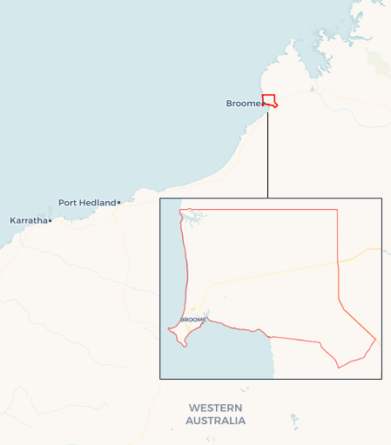Local Jobs Plan

Broome ****Employment Region**** | WA | ****June 2024****

Workforce Australia Local Jobs (Local Jobs) is a program that supports tailored approaches to accelerate   
reskilling, upskilling and employment pathways in response to current and emerging local workforce needs.

## Local Jobs elements

### Local Jobs Plan

The Local Jobs Plan sets out the skills and employment priorities and challenges of the region, and associated strategies that will drive the design and implementation of activities to be implemented to address these challenges.

### Employment Facilitators

Employment Facilitators and Support Officers support the delivery of the program by bringing together key stakeholders including businesses, employment services providers, higher education and training organisations.

### Local Jobs and Skills Taskforce

Each Employment Region has its own Taskforce. Representatives include local stakeholders who have demonstrated experience in upskilling, reskilling, and an ability to represent, connect and collaborate with others in the region to meet labour market needs.

### Local Recovery and National Priority Funds

The Local Recovery Fund supports projects that meet the priorities identified in the Local Jobs Plan. The National Priority Fund provides funding for innovative local solutions to address structural barriers to employment.

Explore labour market insights for the  
[Broome Employment Region](https://www.jobsandskills.gov.au/work/employment-region-dashboards-and-profiles/monthly-labour-market-dashboards)

## Local labour market strengths in the region

* Over half of Broome’s population participate in the labour force.
* The Shire of Broome has made a commitment to improving employment pathways as part of its economic development Growth Plan.
* Broome has many First Nations-owned corporations and businesses promoting economic development and employment opportunities for First Nations people.
* A major tourist destination known for its natural beauty, beaches and cultural heritage, supporting jobs in hospitality, tour operations and related supply chains.
* The town has a thriving pearling industry, offering employment opportunities in pearl farming, processing and sales.
* Rich natural resources which provide employment in various capacities such as mining operations, logistics and support services.
* The Kimberley region supports diverse agricultural activities, including cattle farming and aquaculture.
* Ongoing development and infrastructure projects in Broome and surrounding areas create demand for construction workers and skilled tradespeople. Broome’s construction industry is the largest business sector with a 21% share of Broome’s businesses.
* A variety of retail and service industries providing numerous employment opportunities.
* As the regional hub for healthcare services in the Kimberley, the healthcare and social assistance industry is the largest employer in Broome representing 18% of Broome’s jobs. The town has strong training pathways into the health sector with consistent demand for health professionals.
* Broome is in a unique position to inform Australian Government policies around employment services delivery to First Nations people.
* Employment pathways into industry supported by an approximate spend of $1 billion in Broome and surrounding areas over the next 5 years.
* Broome has a wide range of training opportunities to support pathways to into employment and upskilling.

## Local labour market challenges in the region

* People on the employment services caseloads often face socio-economic challenges and extended periods of unemployment.
* A considerable number of people engaging with employment services identify as being First Nations.
* Significant seasonal fluctuations in labour requirements and a historical reliance on international labour.
* Youth unemployment in the region is higher than the national average, with young people facing challenges completing high school and transitioning from education to employment.
* Common challenges to job-readiness include access to identifying documentation, criminal histories, drug and alcohol dependence and complex mental and physical health conditions.
* Low levels of English literacy and comprehension, numeracy and digital literacy can hinder job readiness, training success and access to employment opportunities.
* Structural challenges include limited access to childcare, transport and affordable housing.
* Broome attracts an ever-fluid, transient population from other communities which challenges consistent employment service provision.

## Local jobs and skills priorities and strategies in the region

**Priority 1 – Closing the Gap on First Nations employment**

**What are our challenges and opportunities?**

With a majority of Broome’s First Nations people in employment, there is an opportunity to provide additional support to those in positions of influence in work and community settings, to enable enhanced mentoring and celebrations of economic independence and self-determination. We need to ensure First Nations individuals and employers are adequately skilled, prepared and supported into and beyond recruitment to promote pathways for continual career growth and progression.

**How are we responding?**

* Enabling self-determination through supporting First Nation led solutions designed in partnership with the community.
* Partnering with local high schools, training bodies and industry to facilitate connections between school leavers and training and employment pathways.
* Connecting First Nations organisations who are offering training, job placement assistance, apprenticeships, traineeships, and job placement support to culturally safe employers who will employee, retain and support career progression for individuals.
* Working with local First Nations people and businesses to develop strategies for stakeholders and corporations to increase engagement in employment and training opportunities.
* Working with First Nations people and communities to build cultural safety across Broome employment opportunities.

### Priority 2 – Engaging business and industry

#### What are our challenges and opportunities?

The seasonal nature of the region impacts a multitude of industry sectors and local available workforce. Many businesses rely seasonally on international, interstate and city-based fly-in fly-out (FIFO) employees to fill labour requirements. We can develop pathways for local businesses to better engage with and build a local workforce.

#### How are we responding?

* Working with businesses and industry to identify current and predicted labour shortages.
* Liaising with registered training providers and peak industry organisations to fast-track training and programs to address gaps in the local labour market.
* Exploring funding and opportunities to support the transition of those looking for work into occupations that are in high demand locally.

## Want to know more?

* Contact: Amy Risinger, Broome Employment Region Australian Government Employment Facilitator: [Amy.Risinger@dewr.gov.au](mailto:Amy.Risinger@dewr.gov.au)
* Visit: [Local Jobs](https://www.dewr.gov.au/local-jobs) or [Workforce Australia](https://www.workforceaustralia.gov.au/)