

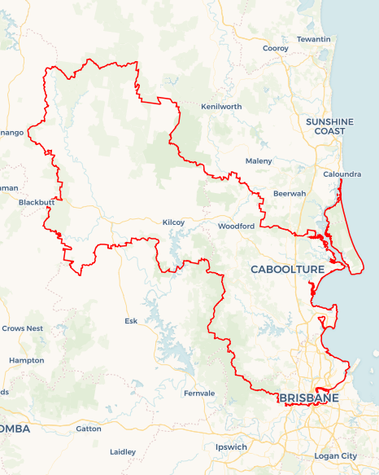Local Jobs Plan

Somerset ****Employment Region**** | ****QLD**** |****January 2023****

Workforce Australia Local Jobs (Local Jobs) is a program that supports tailored approaches to accelerate   
reskilling, upskilling and employment pathways in response to current and emerging local workforce needs.

## Local Jobs elements

### Local Jobs Plan

The Local Jobs Plan sets out the skills and employment challenges and priorities of the region, and associated strategies that will drive the design and implementation of activities to be implemented to address these challenges.

### Employment Facilitators

Employment Facilitators and Support Officers support the delivery of the program by bringing together key stakeholders including businesses, employment services providers, higher education and training organisations.

### Local Jobs and Skills Taskforce

Each Employment Region has its own Taskforce. Representatives include local stakeholders who have demonstrated experience in upskilling, reskilling, and an ability to represent, connect and collaborate with others in the region to meet labour market needs.

### Local Recovery and National Priority Funds

The Local Recovery Fund supports projects that meet the priorities identified in the Local Jobs Plan. The National Priority Fund provides funding for innovative local solutions to address structural barriers to employment.

Explore labour market insights for the  
[Somerset](https://www.jobsandskills.gov.au/work/employment-region-dashboards-and-profiles/monthly-labour-market-dashboards) Employment Region

## Local labour market challenges in the region

* Satisfying demand for skilled labour for construction projects such as The Petrie Mill, North Lakes Eco Resort and growing residential estates.
* Aligning the recruitment and retention of Australian Apprenticeships and Traineeships with projected regional skills and labour shortages and areas of future demand. Target cohorts are youth, Indigenous Australians, women and mature-age participants.
* Meeting demand for workers in the health and community care sector including residential aged care facilities.
* Satisfying demand for entry level workers in regional growth industries including, manufacturing, food services and retail and accommodation.
* Identifying accessible transport options to mobilise workforces in the Deception Bay and Bribie Island areas of Somerset Employment Region.

## Local jobs and skills priorities and strategies in the region

### Priority 1 – Attraction and retention

#### What are our challenges and opportunities?

* To facilitate change in local business and industry and realign workforce recruitment expectations.
* To collaborate with Workforce Australia Employment Services Providers to tailor employment opportunities and support increased participation rates.

#### How are we responding?

* Collaborating with key stakeholders, including business, to design and implement specific industry/business/role attraction models and share with Workforce Australia Employment Services Provider networks and the community.
* Identifying the Workforce Australia Participant caseload skillsets to address skills gaps and meet local business demands.
* Supporting employment services providers to address Participants’ non-vocational barriers.
* Co-ordinating the promotion of pre-employment programs and recruitment opportunities to align with business/industry demand.
* Consulting with industry representatives, businesses and employment services providers to identify the skills, qualities and attributes sought by employers.
* Promoting graduated return to work opportunities for highly disadvantaged participant cohorts, including work experience and phased return to work.
* Working with registered training organisations to help ensure training opportunities are targeted to the local environment and meet business and industry needs.

### Priority 2 – Engage local youth

#### What are our challenges and opportunities?

To increase recruitment and retention of Australian Apprenticeships and Traineeships and align with projected skills and labour shortages for future demand.

We have the opportunity to address engagement and attraction issues resulting from low apprenticeship wages that cause young people to opt for lower skilled roles in return for higher wages rather than acquire skills-based qualifications and trade recognition.

#### How are we responding?

* Developing focus groups to create solutions to engage and mobilise youth in the region.
* Connecting businesses with government employment services that promote the recruitment and retention of trainees and apprentices. For example, using  
  pre-employment and purpose designed programs.
* Contributing at provider and business forums to raise awareness and promote the benefits of apprenticeship and traineeship opportunities.

### Priority 3 – Promote Indigenous opportunities

#### What are our challenges and opportunities?

To identify and address barriers affecting Aboriginal and Torres Strait Islander peoples participation in skilling and employment opportunities and maximise engagement, support and outcomes.

#### How are we responding?

* Engaging with stakeholders including local Indigenous organisations to develop co-designed solutions and address issues in a culturally appropriate manner.
* Hosting business events that promote strategies to recognise the importance of social diversity and inclusion in recruitment.
* Developing a focus group to improve engagement with Aboriginal and Torres Strait Islander participants on the Workforce Australia caseload.
* Connecting with the local Aboriginal and Torres Strait Islander community to help shape and co-design methods of engagement to encourage and create skills development and employment opportunities for target group participants.

### Priority 4 – Mobilise mature-age workforce

#### What are our challenges and opportunities?

To Identify effective strategies to improve workplace participation for mature-age participants.

#### How are we responding?

* Using real time data to highlight to businesses the long-term benefits of employing mature-aged people.
* Promoting to local businesses the benefits of employing mature-aged people and encouraging flexible working arrangements for them (i.e., changing the nature of their engagement in the labour force).
* Developing a focus group to identify skills development opportunities for mature-age participants and maximising training and employment opportunities that align with local demand.
* Investigating transport accessibility in the Deception Bay and Bribie Island areas to increase mature-age participation in the workforce.
* Addressing skills gaps and non-vocational barriers to align with local business opportunities.

## Engaging with stakeholders Want to know more?

* Contact: Kim Dawson, Somerset Employment Facilitator: [employmentfacilitator@somersetlocaljobs.com.au](mailto:employmentfacilitator@somersetlocaljobs.com.au)
* Visit: [Local Jobs](https://www.dewr.gov.au/local-jobs) or [Workforce Australia](https://www.workforceaustralia.gov.au/)