

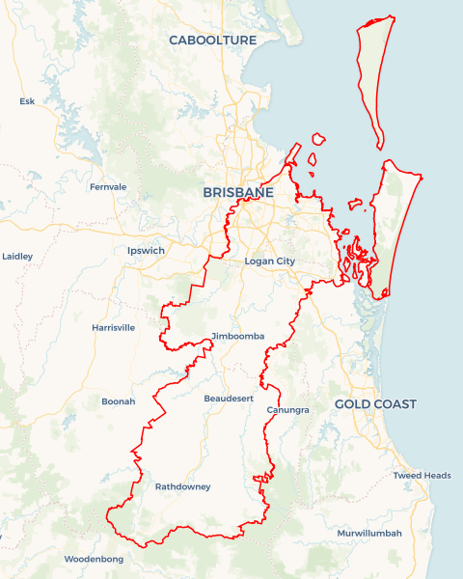Local Jobs Plan

Brisbane South East ****Employment Region**** | QLD | ****January 2024****

Workforce Australia Local Jobs (Local Jobs) is a program that supports tailored approaches to accelerate   
reskilling, upskilling and employment pathways in response to current and emerging local workforce needs.

## Local Jobs elements

### Local Jobs Plan

The Local Jobs Plan sets out the skills and employment challenges and priorities of the region, and associated strategies that will drive the design and implementation of activities to be implemented to address these challenges.

### Employment Facilitators

Employment Facilitators and Support Officers support the delivery of the program by bringing together key stakeholders including businesses, employment services providers, higher education and training organisations.

### Local Jobs and Skills Taskforce

Each Employment Region has its own Taskforce. Representatives include local stakeholders who have demonstrated experience in upskilling, reskilling, and an ability to represent, connect and collaborate with others in the region to meet labour market needs.

### Local Recovery and National Priority Funds

The Local Recovery Fund supports projects that meet the priorities identified in the Local Jobs Plan. The National Priority Fund provides funding for innovative local solutions to address structural barriers to employment.

Explore labour market insights for the  
[Brisbane South East](https://www.jobsandskills.gov.au/work/employment-region-dashboards-and-profiles/monthly-labour-market-dashboards) Employment Region

## Local labour market challenges in the region

* Projected shortfalls of skilled labour in existing, growth and emerging sectors, including health and community care services, manufacturing, construction, retail, hospitality and tourism.
* Diversity of multiple small labour markets with varying industry bases and workforce needs and cohorts including First Nations people, people with disabilities, people from culturally and linguistically diverse backgrounds, mature ageworkers, and youth, who require specific tailored employment solutions.
* Housing, transport and costs of living pressures faced by participants located in the Brisbane South East Employment Region impact on industries ability to attract, engage and retain workers.
* Meeting future demand for workforce for major projects, including the 2032 Brisbane Olympics with some venues located in the Brisbane South East Employment Region. This includes demand for First Nations employees as part of major project workforce commitments.

## Local jobs and skills priorities and strategies in the region

### Priority 1 – Local workforce mobilisation

#### What are our challenges and opportunities?

* To work with key stakeholders to identify short and medium-term employment opportunities in the Brisbane South East Employment Region.
* To identify the required skills and pathways to skill, re-skill and up-skill participants to meet demand for existing, emerging and future industry.
* To develop place-based strategies to meet local employment demand. This includes identifying wrap around servicing opportunities focusing on key groups including First Nations people, people with disabilities, people from culturally and linguistically diverse backgrounds, mature age workers, and youth.

#### How are we responding?

* We are developing strategies to identify suitable individuals in the Brisbane South EastEmployment Region to work in these industries.
* We are developing programs in partnership with key stakeholders to provide tailored support for the identified target groups and sectors.
* We are creating, promoting, and enhancing training and development pathways for suitable individuals to gain employment in the sectors.
* We are consulting with industry representatives, businesses and associations to develop and refine strategies and deliver workshops to industry and Employment Service Providers, to assist in recruitment, retention and capacity building for their sector, including facilitating knowledge of government support, to ensure sustained employment and a reduction in staff turnover.
* We have established a First Nations Employment Action Group and a Multicultural Employment Action Group with key stakeholder membership to focus on impacting, addressing and overcoming barriers and challenges that exist within the diverse population residing in Brisbane South East.
* We have created the Brisbane South East Local Jobs Program Bulletin Board to actively promote employment pathways to stakeholders who assist those looking for work, including Employment Service Providers, schools and community organisations.

### Priority 2 – Promotion of Australian apprenticeships to align with projected skills shortages

#### What are our challenges and opportunities?

* The Brisbane South East Employment Region is experiencing a shortage of qualified tradespeople to meet current and projected future demand.
* To increase employer awareness and take up of apprenticeships and traineeships to meet industry demand, in construction, manufacturing, health care and social assistance, and hospitality sectors.

#### How are we responding?

* We are promoting the benefits of hiring apprentices and trainees through various forums and direct engagement with businesses.
* We are promoting awareness and effective use of school-based apprenticeships and traineeships. We will develop a ‘train and retain’ strategy for apprentices and trainees to ensure greater retention of young people within apprenticeships and traineeships.
* We are engaging with the Australian Apprenticeship Support Network to leverage existing approaches and programs to increase apprenticeship and traineeship opportunities, including using Trade Apprentices (a job matching service for unemployed Queensland apprentices).
* We are developing and hosting a ‘Try a Trade’ Jobs Expo, designed to introduce individuals to interactive, hands-on trade displays with the goal of facilitating employment opportunities across a range of trades.

### Priority 3 – Bridging the gap between individual’s skills and business requirements

#### What are our challenges and opportunities?

* To understand employer and industry requirements and expectations in relation to their existing, emerging and future workforce needs.
* To understand the gaps in skills and attributes of the available workforce.
* To develop and co-design pre-employment preparation programs to support participants to better meet the needs of businesses.

#### How are we responding?

* We engage with local businesses and industry to identify their requirements and specifications for job opportunities.
* We encourage local business to consider what skillsets are absolutely necessary for a productive worker where there is a shortage of skilled labour and tradespeople.
* We are engaging with employment service providers to appropriately match individuals against the job requirements.
* We are assisting to develop and co-design pre-employment programs with input from businesses and industry.
* We are identifying and negotiating with Registered Training Organisations who have pre-approval for funding to deliver these programs. We work closely with proponents for the Local Recovery Fund as a source of either full or partial funding.
* We are engaging with businesses in the selection of participants and delivery of programs.
* We evaluate the effectiveness of programs through participant engagement, completion and consequent employment.
* We are promoting programs and supports that will assist businesses in expanding working hours and provide opportunities for local unemployed people.
* We are identifying the local ‘hidden’ workforce and encourage businesses to use the vacancy filling services of the Employment Service Provider network.
* We are identifying future major projects and will engage with contractors and sub-contractors to source local job opportunities and understand the social impact commitments of major projects.
* We will develop and deliver retention and capacity workshops to businesses and Employment Service Providers to ensure quality job matching, leading to sustained employment and reduced turnover for businesses.

### Priority 4 – Major projects and emerging industries

#### What are our challenges and opportunities?

* To identify new opportunities in the Brisbane South East Employment Region, including those in the advanced manufacturing, hydrogen/clean energy, and technical sectors.
* To collaborate with employment service providers, schools, and other stakeholders to develop employment pathways that align with these emerging industries and job markets.

#### How are we responding?

* We are fostering a collaborative working group of all employment service providers in the Brisbane South East Employment Region and meet regularly.
* We identify future major projects in the region and are engaging with government agencies and contractors to identify social impact commitments and skillsets needed to meet the labour requirements of these projects.
* We are identifying local employment and skill needs associated with preparation for the 2032 Olympic Games and emerging industries in Brisbane South East Employment Region.
* We are sharing job vacancy opportunities in these sectors to ensure matching against businesses’ specifications.
* Where skill gaps are identified with the potential workforce we will develop and co-design pre-employment programs to meet identified employment needs.
* Sourcing funding for pre-employment programs from all levels of government and business / industry.
* Engaging employment service providers in monitoring and evaluating the success of pre-employment programs.
* Engaging businesses in presentations and virtual presentations on their job vacancies to the employment service provider group.
* Engaging with employment service providers to analyse their caseloads by occupation and sub-region to assist in identifying any mismatch between business requirements and available unemployed individuals.

## Want to know more?

* Contact: Simon Nicholls, Brisbane South East Employment Facilitator: [simon.nicholls@employmentfacilitator.com.au](mailto:simon.nicholls@employmentfacilitator.com.au)
* Visit: [Local Jobs](https://www.dewr.gov.au/local-jobs) or [Workforce Australia](https://www.workforceaustralia.gov.au/)