

# Department of Education and Training Gender Equality Action Plan 2017-2019

Valuing Difference – Respecting Our People

## Gender Equality at Education and Training

*“Balancing the Future: Australian Public Service Gender Equality Strategy 2016-19* (APS Gender Equality Strategy) *sets out actions for driving high performance and boosting productivity in the Australian Public Service. It is a strategy for harnessing the best talent, changing cultures, and challenging assumptions that hold us back.”[1]*

The Department of Education and Training is committed to supporting the APS Gender Equality Strategy and will hold itself accountable through the targets and actions identified in this action plan. This plan is designed to support the five actions as outlined in the APS Gender Equality Strategy:

1. Driving a supportive and enabling workplace culture
2. Achieving gender equality in APS leadership
3. Working innovatively to embed gender equality in employment practices
4. Increasing take-up of flexible work arrangements by both men and women
5. Measuring and evaluating actions.

Actions driven through the department’s response to the APS Gender Equality Strategy will ensure the department values all genders as capable, credible leaders, provides all genders with the same opportunities for career progression and flexible work, and addresses all forms of gender discrimination in the workplace. All employees will be responsible for ensuring the success of the Action Plan.

This Action Plan will also support the Department of Education and Training Diversity and Inclusion Strategy and provides clear linkages to other diversity groups’ action plans.

Targets and actions will be monitored and progress will be reported on a quarterly basis to the Department of Education and Training Executive Board.

The Action Plan will be reviewed and updated over time to reflect emerging priorities and intelligence, reflect completed actions and to allow for the addition of new actions and targets.

## Current State

### Number of employees

* As at 31 December 2016 the Department of Education and Training had a total of 1,905 employees: 1,294 female (68 per cent) and 611 male (32 per cent).
* The Department does not currently collect data on sexual orientation and no employee has yet to formally identify as gender non-specified. Through the anonymity of the APS employee census 22 employees identified as Gender X (Indeterminate/Intersex/Unspecified).
* The gender profile across classification levels varies (figure 1.1). At the APS level the percentage of female employees is much greater, with 73 per cent of APS 5 and 74 per cent of APS 6 employees female.
* At the EL1 level the percentage of female employees falls below the departmental split of 68 per cent female to 64 per cent. This trend continues through to EL2 and SES with only 61 per cent of SES Band 1 and SES Band 2 employees being female.
* The highest proportion of male employees is at the EL1 level with 34 per cent (210 employees).
* The highest proportion of female employees is at the APS 6 level with 29 per cent (378 employees).

Figure 1.1 Headcount by gender and classification (actual) as at 31 December 2016*

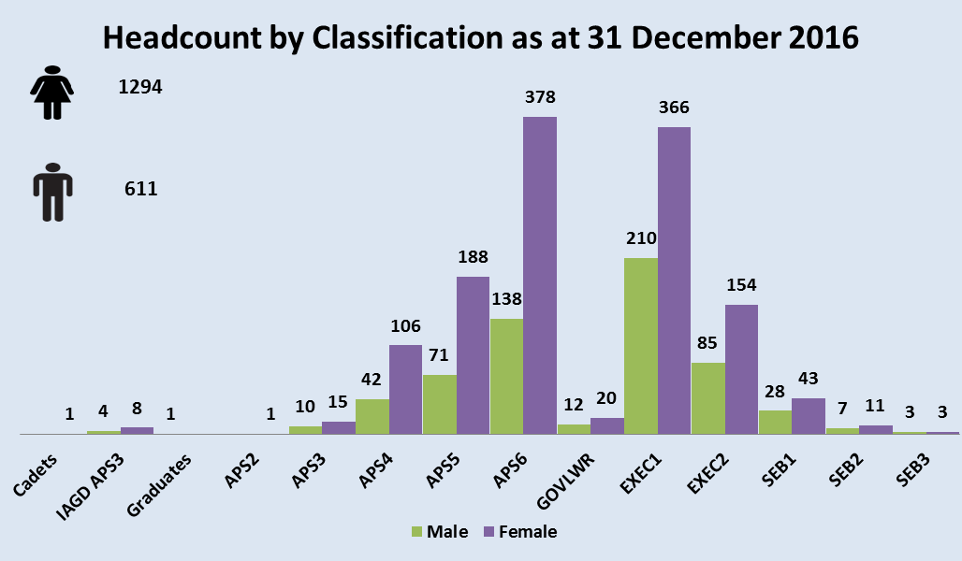

\****Note****: Point in time data and includes short and long term acting arrangements.*

### Part time employees

* 17 per cent of the department are part time employees (figure 1.2).
* 91 per cent of part time employees are female – 23 per cent of female employees are part time.
* 9 per cent of part time employees are male – 5 per cent of male employees are part time.
* There is currently no data available on the number of employees with ‘informal’ flexible work arrangements, for example, working from home or flexible start / finish times.

Figure 1.2 Headcount by Employment Status as at 31 December 2016

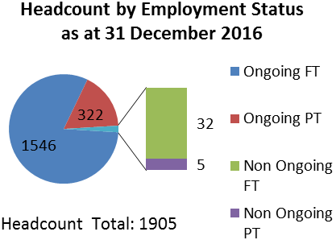

### Board representation

* At 30 June 2016, the Education and Training Portfolio had 15 boards with 89 positions. Females represented 41.6 per cent of the overall gender balance by occupying 37 of the 89 positions.
* This is below the APS Gender Equality Strategy 2016-19 target of women holding 50 per cent of Australian Government board positions.

### Workforce Gender Equality Agency (WGEA) gender equality diagnostic tool Assessment

* The department has completed the WGEA gender equality self-diagnostic tool. As at   
  1 January 2017 the department is assessed as 1 (Compliant).

### Remuneration by gender

* The difference between male and female average salary is $5,835 (figure 1.3).
* The difference between male and female median salary is $21,166 (figure 1.3).

Figure 1.3 Average and Median Remuneration by Gender as at 31 December 2016

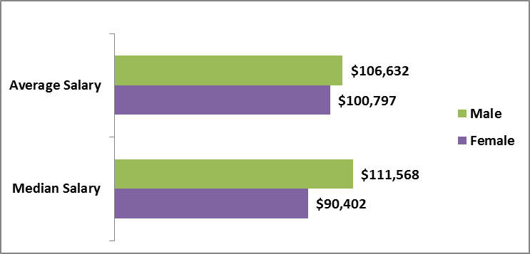

Data set extracted 16 January 2017. Data includes all employees except for Secretary (includes employees on long term leave and maternity leave). Average salary was calculated as total number of employees by total salaryfor each gender. Median salary was the 50th percentile for each gender.

### 2016 employee census results

* Overall, female employees were less likely to agree that SES in the department support opportunities for women in leadership roles.
* Male employees were less likely to agree that the department’s SES support the use of flexible work by men and women and were less satisfied with work-life balance and their ability to access and use flexible working arrangements.
* When we break this information down further by classification the discrepancies become clearer (figure 1.4). For example:
* 91 per cent of SES males believe SES in the agency actively support opportunities for women in leadership roles as compared to 64 per cent of EL1 women.
* 82 per cent of APS males are satisfied with their ability to access and use flexible working arrangements as compared to only 65 per cent of SES males.
* 70 per cent of SES males are satisfied with their work-life balance in their current job as compared to only 52 per cent of SES females.

Figure 1.4 Selected 2016 census results by classification and gender

| Question | APS Male | APS Female | EL1 Male | EL1 Female | EL2 Male | EL2 Female | SES Male | SES Female |
| --- | --- | --- | --- | --- | --- | --- | --- | --- |
|  | Base: 225 | Base: 600 | Base: 177 | Base: 273 | Base: 67 | Base: 90 | Base: 23 | Base: 33 |
| In my agency, SES actively support opportunities for women in leadership roles | 59% | 60% | 70% | 64% | 80% | 68% | 91% | 81% |
| In my agency, SES actively support the use of flexible work arrangements by men and women | 56% | 60% | 55% | 65% | 67% | 58% | 83% | 77% |
| Considering your work and life priorities, how satisfied are you with the work-life balance in your current job? | 80% | 82% | 69% | 76% | 72% | 66% | 70% | 52% |
| Overall, how satisfied are you with your ability to access and use flexible working arrangements? | 82% | 79% | 63% | 73% | 71% | 72% | 65% | 68% |

The number indicates the percentage of employees who selected either ‘strongly agree’ or ‘agree’ in response to each question.

## Departmental Targets

The WGEA diagnostic tool analysis, in conjunction with the department’s HR demographic data and 2016 census results have been used to identify key areas of focus and to inform the setting of customised, measurable targets. By completing the action items and achieving the targets the department will move from the diagnostic tool rating of 1 (Compliant) to 2 (Programmatic) with the view to extending our actions and targets to reach 3 (Strategic) by the end of 2019.

To achieve this goal the Department of Education and Training has identified six targets (Figure 1.5). The six targets will be supported by a suite of actions (Attachment A) designed to ensure that all genders have the same access to flexible work arrangements, are provided with the same opportunity to progress their careers and ensuring we have a balanced workforce with a gender and diversity profile at all classification levels to match that of the overall department. In completing these actions we would also expect to improve the remuneration outcomes for female employees.

The Action Plan has been divided into three focus areas:

* Focus Area 1: Flexible work arrangements
* Focus Area 2: Career advancement parity
* Focus Area 3: Gender composition.

Flexible work arrangements can include options about when, where, and how work is performed, with a focus on outcomes rather than hours in the office. Examples include hours of work (e.g. changes to start and finish times, fewer hours), patterns of work (e.g. job sharing, compressed hours), and location of work (e.g. working from home for part of the work week).

Figure 1.5 Department of Education and Training Targets

| Target | Description | Link to Focus Area: |
| --- | --- | --- |
| **A** | **Thirty-five** per cent of employees (all genders) regularly access flexible work arrangements by 31 December 2019. | 1. Flexible work arrangements |
| **B** | **Ten per cent** increase in the 2018 APS employee census (and each subsequent year thereafter for the life of the plan) from all respondents, in response to the question: *SES actively support flexible work arrangements by men and women*. | 1. Flexible work arrangements |
| **C** | **Ten per cent** increase in the 2018 APS employee census (and each subsequent year thereafter for the life of the plan) from all respondents, in response to the question*: SES actively support opportunities for women in leadership roles*. | 1. Career advancement parity |
| **D** | **Five per cent** reduction in the pay gap between the male and female median salary by 31 December 2017. | 1. Career advancement parity |
| **E** | **50 per cent** representation of women on the Education and Training Portfolio’s boards (from 41.6 per cent) each year. | 1. Gender composition |
| **F** | **All** internal governance committees have a gender balance of 40 per cent female, 40 per cent male and 20 per cent either female, male or Gender X. | 1. Gender composition |

The issue of unconscious bias has a significant impact on all aspects of gender equality. Addressing unconscious bias will underpin all initiatives outlined in the Action Plan.

## Attachment A

### Focus Area 1: Flexible Work Arrangements: Support all genders at all levels to work flexibly

| Initiative / Action | Type | Measurement | Estimated timing | Lead responsibility | WGEA diagnostic tool focus area | Target |
| --- | --- | --- | --- | --- | --- | --- |
| 1.1 Investigate the lower take up of flexible work arrangements by male employees. | Data | Investigation complete and results communicated, including any recommendations. | Completed by  30 June 2017 | Branch Manager, People, Culture and Capability | * Leader and Manager Capability * Gender Inclusive Culture * Flexibility | A  B |
| 1.2 Develop guidance / training to assist managers in job design to balance individual and workplace requirements. | Training | Material and communication plan developed and information disseminated to managers. | Completed by 30 September 2017 | Branch Manager, People, Culture and Capability and all managers involved in recruiting | * Leader and Manager Capability * Gender Inclusive Culture * Flexibility | A  B |
| 1.3 Flexible work arrangements are considered for every position: “All Roles Flex”. | Recruitment | All new vacancies state that the department supports the use of flexible work arrangements. | Implemented by  31 March 2017 | Branch Manager, People, Culture and Capability and all managers involved in recruiting | * Leader and Manager Capability * Gender Inclusive Culture * Flexibility | A  B |
| 1.4 Review remuneration methodology for part time SES employees. | Policy | Employment Value Proposition for part time SES employees is attractive and competitive with other agencies based on feedback from SES employees. | Completed by 30 September 2017 | Branch Manager, People, Culture and Capability | * Gender Inclusive Culture * Flexibility * Policies and processes | A  B |
| 1.5 Investigate strategies to record applications (both successful and unsuccessful) for all types of flexible work arrangements. | System enhancement  APS employee census | Investigate strategies to enhance HR system capability to record applications for all types of flexible work arrangements. Investigation complete and results communicated, including any recommendations.  As an interim measure and to allow for additional analysis - Include a question each year in the APS employee census (agency specific questions) to track all types of flexible work arrangements at all levels, for all genders. | Completed by  31 December 2017  Census results received end July 2017 | Branch Manager, People, Culture and Capability in conjunction with HR Connect Support, Department of Finance | * Leader and Manager Capability * Gender Inclusive Culture * Flexibility | A  B |
| 1.6 SES to share their experience of flexible working arrangements. | Promotion / Communication | Examples of SES (all genders) utilising flexible working arrangements are communicated to Education and Training employees. | Program in place by 31 May 2017 | Branch Manager, Communication Branch, in consultation with all SES | * Leader and Manager Capability * Gender Inclusive Culture * Flexibility * Leadership Accountability | A  B |
| 1.7 Develop a toolkit to support employees returning from maternity / paternity leave. | Promotion / Communication | Employees returning from maternity / paternity leave feel supported and their transition back into the department is improved. | Toolkit developed by 30 June 2017 | Branch Manager, People, Culture and Capability with Women’s Network | * Leader and Manager Capability * Gender Inclusive Culture * Flexibility | A  B |
| 1.8 Appoint an SES advocate to help drive gender equality outcomes. | Promotion / Communication | SES advocate appointed and vision communicated to Education and Training employees. | Completed by  30 April 2017 | Deputy Secretary, Corporate | * Leader and Manager Capability * Gender Inclusive Culture * Flexibility * Leadership Accountability | A  B |

### Focus Area 2: Career advancement parity: Ensure all genders have the same opportunity for career progression

| Initiative / Action | Type | Measurement | Estimated timing | Lead responsibility | WGEA diagnostic tool focus area | Target |
| --- | --- | --- | --- | --- | --- | --- |
| 2.1 Regular review of gender balance, by diversity, at each classification level, including pay differential. This is to identify any systemic barriers to achieving balance. | Data | Classification profile is reflective of our workforce gender and diversity profile. Reporting down to branch level to engage management in consideration of their diversity within an overall workforce planning process. | 30 June 2017 (and six monthly thereafter) | All EL and SES managers, CAUs and supported by Branch Manager, People, Culture and Capability | * Leader and Manager Capability * Gender Inclusive Culture * Measurement and Reporting * Gender Composition Gender Pay Equity | C  D |
| 2.2 Ensure departmental recruitment panels are gender diverse. | Recruitment | The composition of every departmental recruitment panel is gender diverse and all recruitment panels / managers are provided with information on unconscious bias. | Implemented by 31 March 2017 | All EL and SES managers, CAUs and supported by Branch Manager, People, Culture and Capability | * Leader and Manager Capability * Gender Inclusive Culture | C  D |
| 2.3 Implement a talent program to help women advance to higher levels. | Talent Management | Investigate talent programs of other agencies and design / adapt a talent program for the department. | Implemented by 31 March 2018 | Women’s Network and Branch Manager, People, Culture and Capability | * Leader and Manager Capability * Gender Inclusive Culture * Talent Pipeline | C  D |
| 2.4 Ensure employees with flexible work arrangements are afforded the same learning and development opportunities as employees who work 8.30 – 5 Mon-Fri. | Training | Learning and development strategies and programs include opportunities for employees with flexible work arrangements. | Implemented 31 April 2017 | All EL and SES managers, CAUs and supported by Branch Manager, People, Culture and Capability | * Leader and Manager Capability * Gender Inclusive Culture | C  D |
| 2.5 Investigate and report career progression of part time employees. | Data | Part time employees have the same opportunity for career progression as full time employees | 30 June 2017 | Branch Manager, People, Culture and Capability | * Gender Inclusive Culture * Measurement and Reporting | C  D |

### Focus area 3: Gender composition: Support a balanced and inclusive workforce

| Initiative / Action | Type | Measurement | Estimated timing | Lead responsibility | WGEA diagnostic tool focus area | Target |
| --- | --- | --- | --- | --- | --- | --- |
| 3.1 Examine gender profile of the department at the branch level to identify areas/skills groupings where gender imbalances are high with a particular focus on STEM functions. | Data | Aligned with action 2.1 - Gender profile complete and SES advised of results. Advice provided to help inform what action is to be taken to achieve gender balance. | 30 June 2017 | Branch Manager, People, Culture and Capability in consultation with SES | * Measurement and Reporting * Gender Composition | E  F |
| 3.2 Review recruitment advertising to ensure wording to attract all genders and diversity groups is current and all inclusive. | Recruitment | Wording reviewed. External vacancies attract applications from all genders and diversity groups. | Implemented by 30 June 2017 | Branch Manager, People, Culture and Capability and all managers involved in recruiting | * Leader and Manager Capability * Gender Inclusive Culture | E  F |
| 3.3 Build the resources for BoardLinks by establishing processes to identify and endorse women as future members on Boards. | Talent Management | Increased representation of women on the Education and Training portfolio’s boards. | Process established 30 June 2017 | Branch Manager, Parliamentary and Corporate Reform | * Leader and Manager Capability * Gender Inclusive Culture | E  F |
| 3.4 Ensure equal representation of nominees to the Minister for consideration of board appointments. | Talent Management | Increased representation of women on the Education and Training portfolio’s boards. | Implemented by 31 March 2017 | Branch Manager, Parliamentary and Corporate Reform | * Leader and Manager Capability * Gender Inclusive Culture | E  F |

1. *Balancing the Future: The Australian Public Service Gender Equality Strategy 2016-19*.