

Fact Sheet: Overview of Apprentice Claim Applications in ADMS

This fact sheet introduces the components and process for Australian Apprentices completing claim applications in ADMS. Use this fact sheet along with the other ADMS help and support resources to submit claim applications.

# ADMS Home Screen

Once you have received a notification that you can lodge an Apprentice claim application, you will need to [log into ADMS](https://adms.australianapprenticeships.gov.au/adms/how-to-access).

After you have logged into ADMS, you will see the ADMS home screen. To access your Apprentice claim application list, click the ‘Apprentice claim applications’ button in top navigation menu.



# Apprentice claim applications list

The Apprentice claim applications list displays all available claims. This page has three main components:

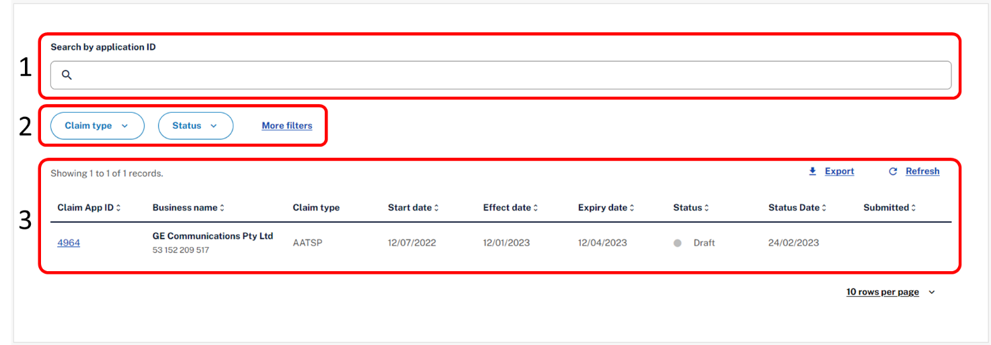

|  |  |  |
| --- | --- | --- |
| Number | Name | Description |
| 1 | Search Bar | The search bar allows you to search for a specific Apprentice claim application using the application ID |
| 2 | Filter | The filter allows you to limit the Apprentice claim applications that appear in the list below based on the:   * Claim Type * Status   The More filters button displays additional filters:   * Start date * Status date * Expiry date * Effect date * Submitted date   For example, you can filter the list so that only Australian Apprentice Training Support Payment (AATSP) claim applications in ‘Draft’ status are displayed. |
| 3 | Claim List | The claim list shows claim applications available for you to process and all claim applications previously submitted. To help you find claim applications quickly and easily, you can sort the claim list in ascending or descending order by any of the columns displayed:   * Claim Application ID * Business name * Claim type * Start date * Effect date * Expiry date * Status * Status date * Submitted   To sort, just click the up and down arrows next to the column heading. To reverse the sort order, click them again. |

# Apprentice claim application

Clicking on an entry in the claim list will open the Apprentice claim application. When completing your Apprentice claim application, you will need to add information and evidence to support your claim before submitting. You can edit an application when its status is “Ready”, “Draft”, “Returned”, or “Expired”. You can only view applications with a status of “Submitted”, “Assessment”, “Verified”, “Approved”, “Rejected”, “Withdrawn” or “Ineligible”.

For further information about fields or statuses, please visit the [Australian Apprenticeships](https://www.australianapprenticeships.gov.au/apprentices) website.

The Apprentice claim application contains the following sections:

## Apprentice details

The Apprentice details section displays your name and any other names recorded in ADMS.

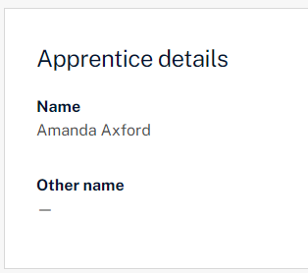

## Qualification details

The Qualification details section displays the key information about the qualification you are working towards.

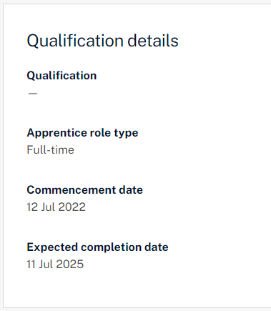

## Bank account

The Bank account section allows you to select which bank account you would like your payment to be paid into.

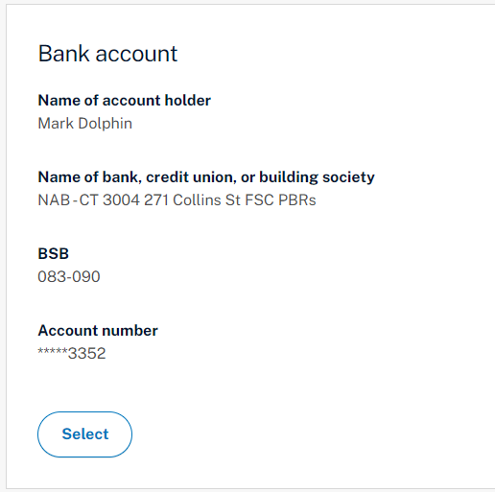

## Employer details

## The Employer details section shows key information about your employer.

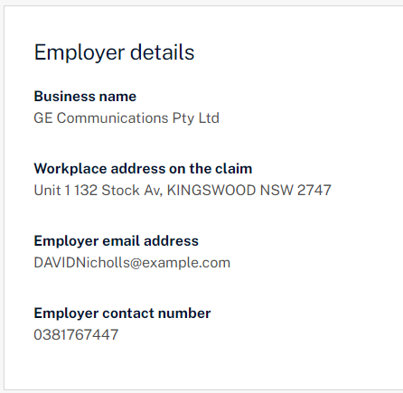

## Provider details

The Provider details section displays key information about your Australian Apprenticeship Support Network provider.

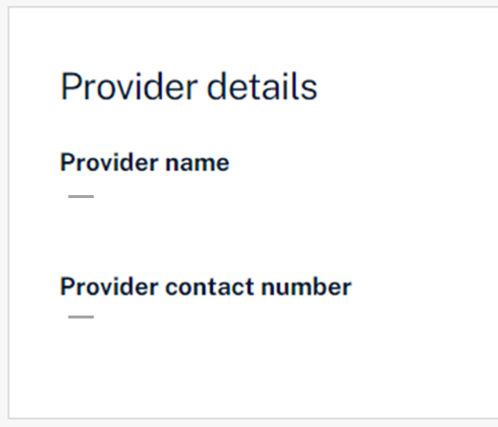

## Claim details

The Claim details section is where you enter key information about the claim, including whether your taxation rate is standard, or subject to an agreed individual taxation withholding rate with the Australian Tax Office.

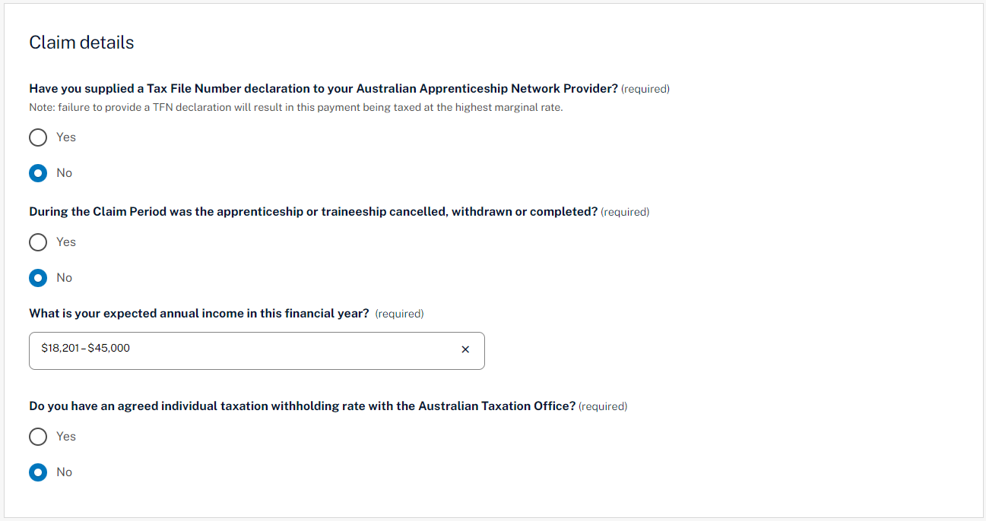

## Evidence of Training plan

The Evidence of Training plan section is where you upload your Training plan or select whether your Australian Apprenticeship Support Network (AASN) provider has this evidence already. This section will only be shown when required.

Documents can be uploaded with the following format: ".jpeg", ".jpg", ".bmp", ".png", ".tiff", ".xls", ".xlsx", ".pdf", ".doc", ".docx", ".ppt", ".pptx".

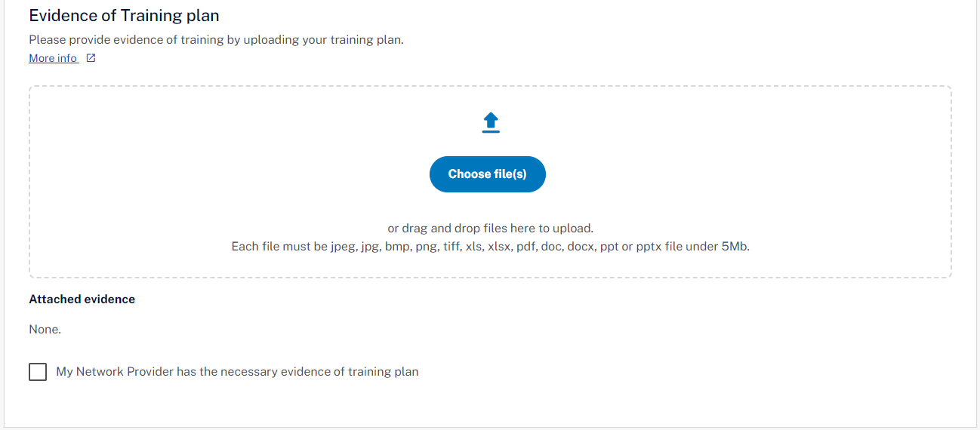

## Wage evidence

The Wage evidence section is where you provide evidence of your employment for the claim period.

Documents can be uploaded with the following format: ".jpeg", ".jpg", ".bmp", ".png", ".tiff", ".xls", ".xlsx", ".pdf", ".doc", ".docx", ".ppt", ".pptx".

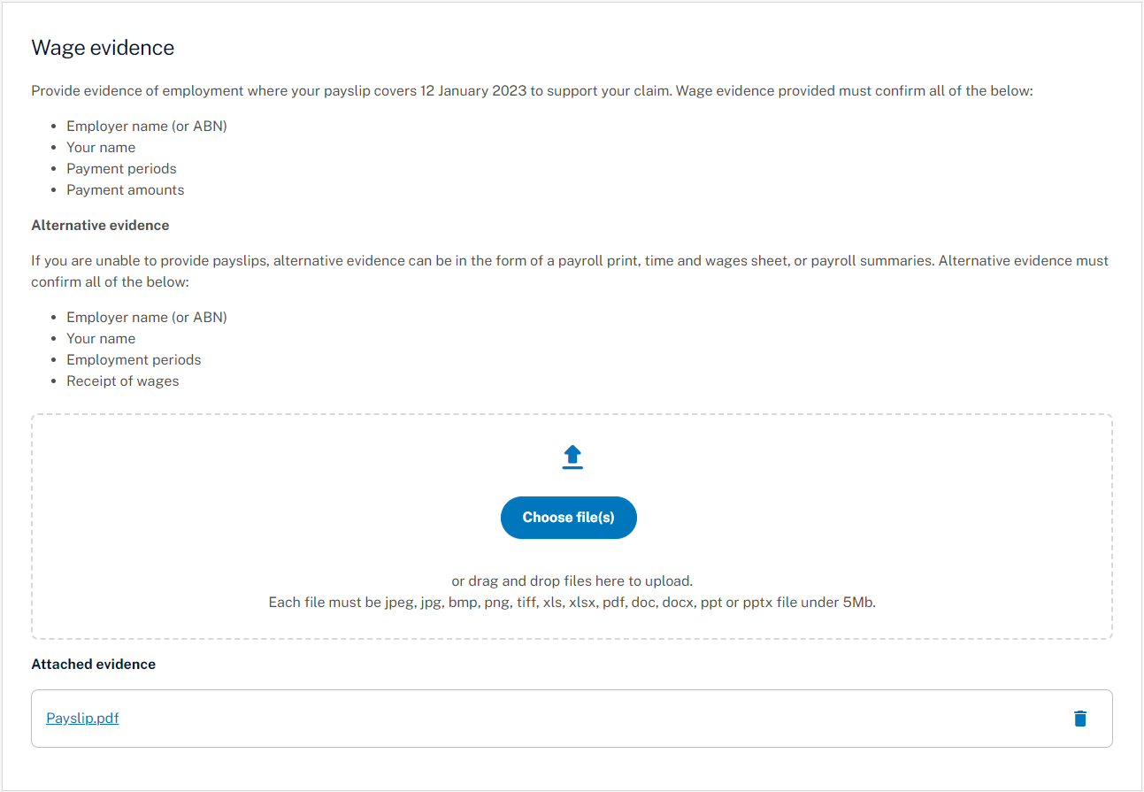

## Gross claim amount

The Gross claim amount section displays the claim amount before tax, based on the information and evidence provided.

## Apprentice declaration

The Apprentice declaration section is where you will need to declare that you checked all information on the application is accurate and that you understand providing false information is a serious offence.

## Submitting your claim

Once you have completed all sections of the Apprentice claim application, you are ready to submit for processing.

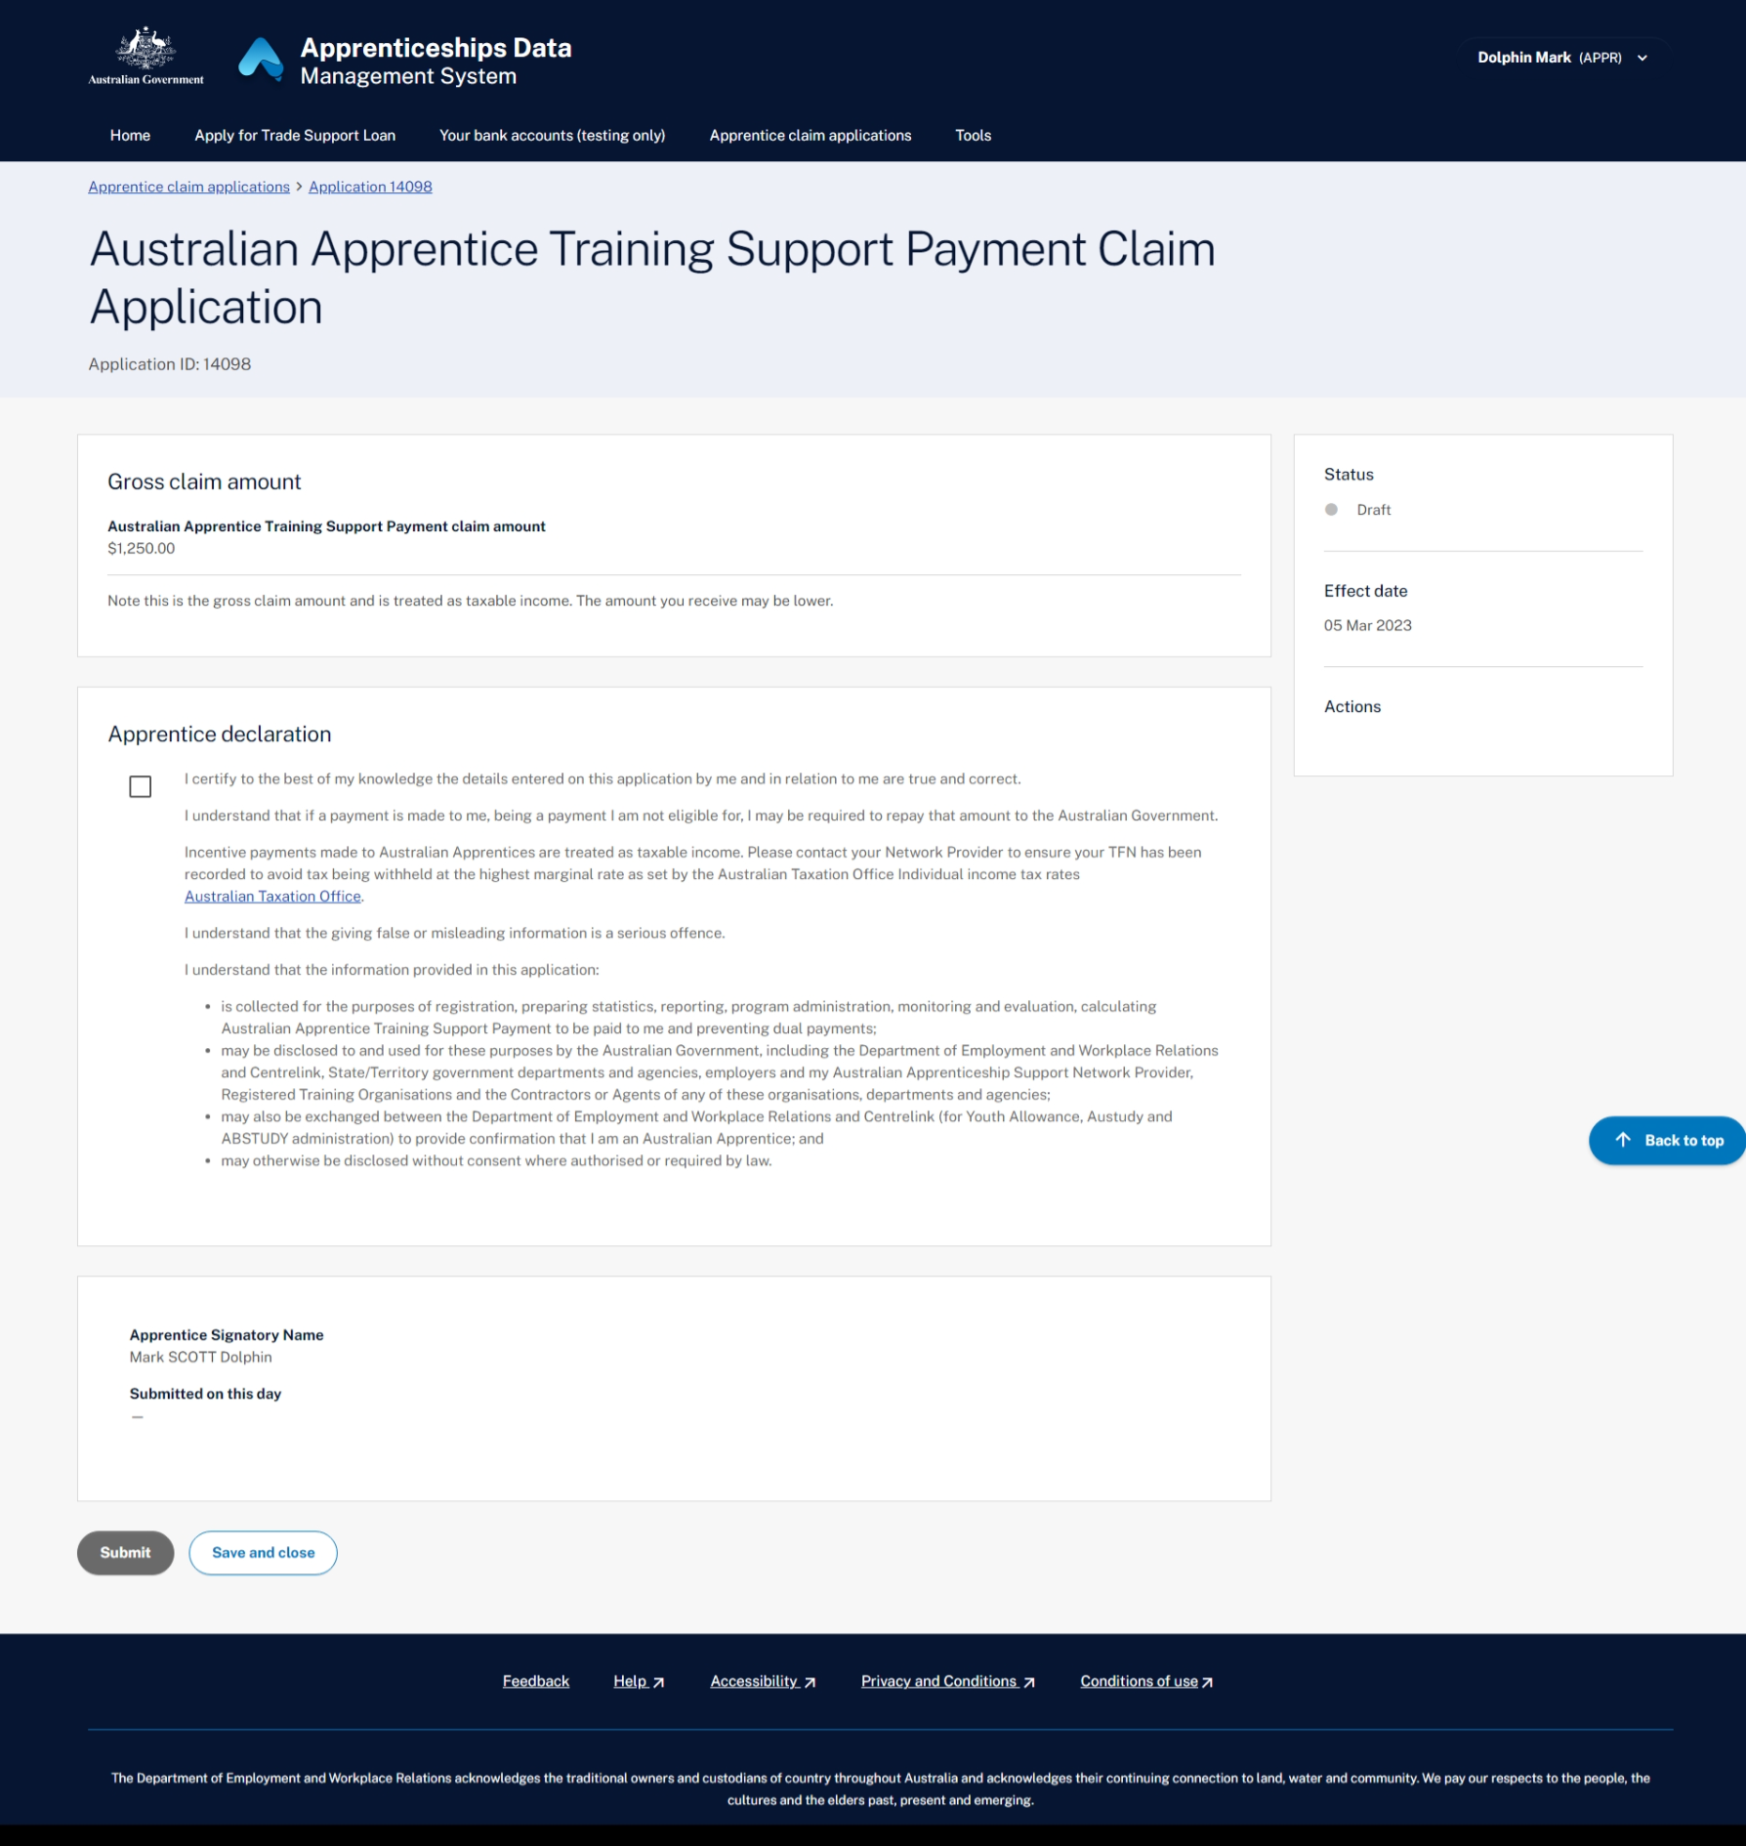

# Support

For assistance with ADMS, contact your Australian Apprenticeship Support Network (AASN) provider.