

Fact Sheet: Checking the Status of a Claim Application

This fact sheet will show you how you can check the status of your claim application. It will also explain what each status means.

# Checking statuses in ADMS

To check on the status of your claim application, you will first need to log into ADMS. For help with logging into ADMS, visit the [Australian Apprenticeships](https://www.australianapprenticeships.gov.au/) website.

After you have logged into ADMS, you will see the ADMS homepage. To access your claim application list, click the ‘View claim applications’ or ‘View apprentice claim applications’ button in the Actions section of the homepage.

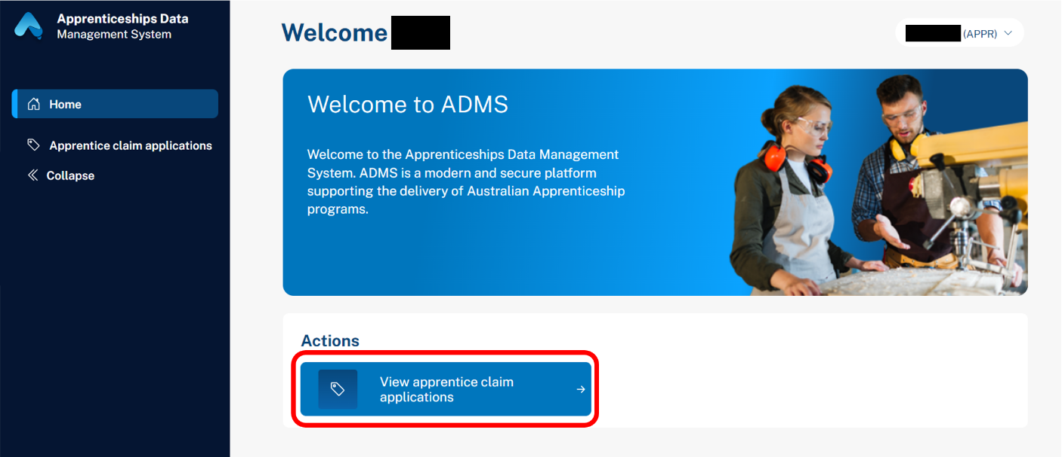

# Claim application list

The claim application list displays all available claims for you or your business (if you’re an Employer). For each claim you can check the status column to see how the claim is progressing.

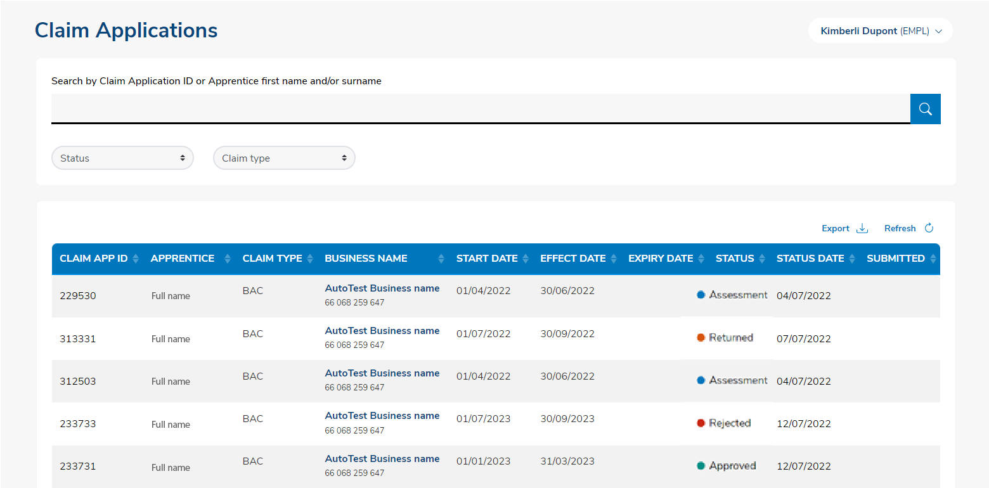

The status of your claim may show as one of the following:

| Status | Description |
| --- | --- |
| Ready | A claim application is available for you to begin. The claim will remain in Ready status until you save the information you have entered. |
| Draft | A claim application will change to Draft status when you have saved the information you have entered but haven’t submitted the claim. |
| Submitted | Once you have entered all required information and attached your evidence you will be able to submit the claim. The status will then change to Submitted. |
| Assessment | If ADMS cannot automatically verify your claim, it will move to a manual assessment process. Once assessment is complete the claim will move to Approved, Rejected, or Returned status. |
| Verified | Your application has been assessed as valid and is awaiting final approval. |
| Approved | Your application has been approved. |
| Rejected | Your application has been rejected. |
| Returned | Your application has been returned to you as it requires further information. |
| Withdrawn | Your application was withdrawn by yourself or the department. A withdrawn application can be reinstated as required. |
| Ineligible | Your application has been determined to be ineligible as it was raised in error or no longer meets eligibility criteria. |
| Expired | Your claim application is no longer valid as the timeframe to claim has lapsed. You will receive notifications when your claim application will soon expire. |

# Support

For assistance with ADMS, contact your Australian Apprenticeship Network Provider.