

Quick Reference Guide: How to apply for an Australian Apprenticeship Support Loan

Australian Apprentices who are eligible to claim an Australian Apprenticeship Support Loan can use this guide to help complete each section of the application.

1. Navigate to [ADMS](https://adms.australianapprenticeships.gov.au/adms/sign-in) and log in using the Apprentice login button.

*NOTE: If you are logging into ADMS for the first time, you will need to set up your ADMS access. Visit the* [*Claiming Apprentice Incentives page*](https://www.australianapprenticeships.gov.au/claiming-apprentice-incentives-adms) *on the Australian Apprenticeships website for further information.*

1. Click ‘Apply for Australian Apprenticeship Support Loan’ from the Actions menu.

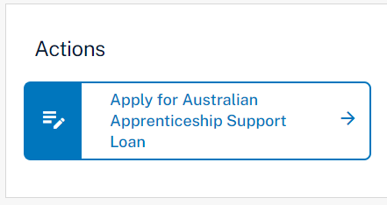

**RESULT:** The Australian Apprenticeship Support Loan information page is displayed.

1. Carefully read the information provided.
2. Click the ‘Next’ button.

**RESULT:** The Australian Apprenticeship Support Loan application is displayed.

1. Confirm the pre-populated information on the application is correct.

*NOTE: The pre-populated information is taken from information recorded in ADMS. Contact your Australian Apprenticeship Support Network provider if you need to update any details.*

1. Add your Tax File Number (if it is not already recorded).

*NOTE: ADMS will attempt to verify your TFN with the Australian Tax Office (ATO). If it can’t be verified, check that you entered the correct TFN and that your details are up to date with the ATO. You can still submit your application, but it cannot be approved until your TFN is verified. Your Australian Apprenticeship Support Network (AASN) provider will contact you where this is the case.*

1. Click the ‘Select’ button in the Bank details section.

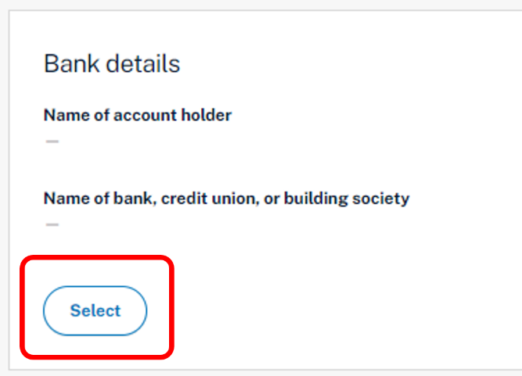

*NOTE: To add a new or update an existing bank account, contact your Australian Apprenticeship Support Network provider.*

1. Choose a bank account from the ‘Select a bank account’ pop-up.
2. Click the ‘Select’ button.

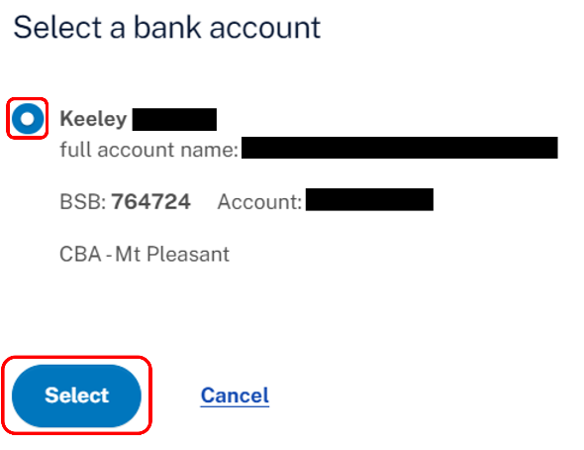

**RESULT:** The selected bank account will now show on your Australian Apprenticeship Support Loan application.

1. Read through the ‘Document evidence required’ section.
2. Click the ‘Choose file(s)’ button.
3. Locate your documents and click ‘Open’.

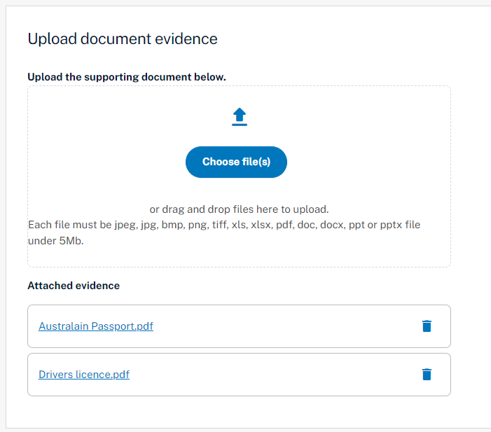

*NOTE: You can also drag and drop from your computer to upload your documents.*

**RESULT:** Your selected documents will be uploaded.

1. Click the ‘Next’ button at the bottom of the screen.
2. Select the check box after you have read and agreed to the information in the Apprentice declaration.
3. Click the ‘Submit’ button to finalise your application.

**RESULT:** Your Australian Apprenticeship Support Loan application will be submitted for assessment.

*NOTE****:*** *You can click the ‘Apply for Australian Apprenticeship Support Loan’ button from the ADMS home page to open your submitted application.*

# Support

For assistance with ADMS, contact your Australian Apprenticeship Support Network (AASN) provider. If you aren’t sure who your AASN provider is, please call 1800 020 108.