

Quick Reference Guide: How to complete a Living Away From Home Allowance claim application

Australian Apprentices who are eligible to claim Living Away From Home Allowance (LAFHA) can use this guide to help complete each section of the application. If you instead need to apply for LAFHA eligibility, visit the [Australian Apprenticeships](https://www.australianapprenticeships.gov.au/claiming-apprentice-incentives-adms) website and read through the Quick reference guide on How to complete a Living Away from Home Allowance eligibility application.

1. Navigate to [ADMS](https://adms.australianapprenticeships.gov.au/adms/sign-in) and log in using the Apprentice login button.

*NOTE: If you are logging into ADMS for the first time, you will need to set up your ADMS access. Visit the* [*Claiming Apprentice Incentives page*](https://www.australianapprenticeships.gov.au/claiming-apprentice-incentives-adms) *on the Australian Apprenticeships website for further information.*

1. Navigate to the ‘Apprentice claim applications’ module by clicking the ‘Apprentice claim applications’ tab in the top navigation bar.

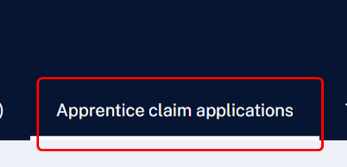

**RESULT:** The Apprentice claim applications list is displayed.

1. Carefully read the Purpose of this application section.
2. Confirm the pre-populated information on the application is correct.

*NOTE: The pre-populated information is taken from information recorded in ADMS. Contact your Australian Apprenticeship Network provider if you need to update any details.*

1. Click the ‘Select’ button in the Bank account section.

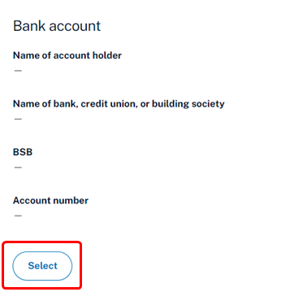

1. Choose a bank account from the ‘Select a bank account’ pop-up.
2. Click the ‘Select’ button.

*NOTE: To add a new or update an existing bank account, contact your Australian Apprenticeship Support Network provider.*

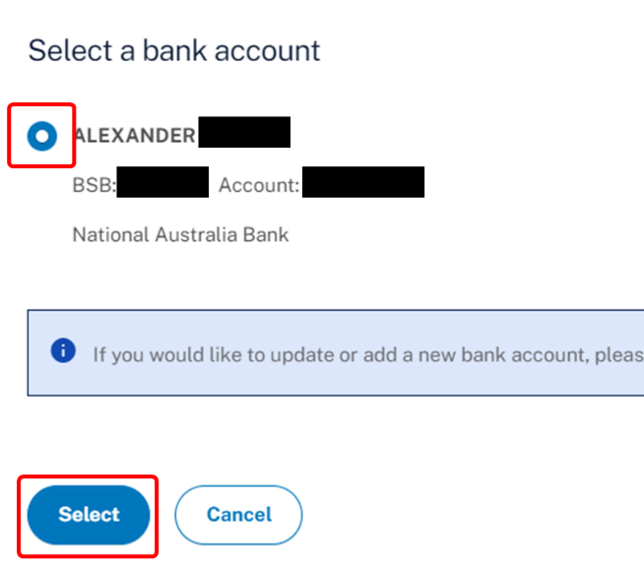

**RESULT:** A bank account will be added to your LAFHA claim application for the claim to be paid into.

1. Complete the Claim details section.
2. Click the ‘Next’ button at the bottom of the screen.
3. Review your claim amount payable for the claim period.

*NOTE: If you believe your Claim amount payable is incorrect, contact your Australian Apprenticeships Support Network provider.*

1. Select the checkbox after you have read and agreed to the information in the Australian apprentice declaration.
2. Click the ‘Submit’ button at the bottom of the screen.

**RESULT:** Your LAFHA claim application will be submitted for assessment.

*NOTE: You can click the ‘View apprentice claim applications’ button from the ADMS home page to open your submitted application.*

*NOTE: If you are claiming Centrelink payments, contact your Australian Apprenticeship Support Network provider to cancel your LAFHA eligibility.*

# Support

For assistance with ADMS, contact your Australian Apprenticeship Support Network (AASN) provider. If you aren’t sure who your AASN provider is, please call 1800 020 108.