



Stakeholder Kit

**New Energy Apprenticeships Program**

**Last Updated: 8 August 2024**

# Introduction

The [New Energy Apprenticeships Program](https://www.apprenticeships.gov.au/support-and-resources/financial-support-apprentices-priority-occupations) provides financial incentive payments of up to $10,000 and tailored energy mentoring support to new apprentices taking up an apprenticeship to work in the clean energy sector. It assists more apprentices and trainees to skill-up in sectors with exposure to clean energy and will increase the skilled workforce required to deliver Australia’s clean energy infrastructure now and into the future.

# Spread the word!

You have received this stakeholder kit to share information about the [New Energy Apprenticeships Program](https://www.apprenticeships.gov.au/support-and-resources/financial-support-apprentices-priority-occupations) with apprentices and employers who may benefit from this support. In this kit you will find a range of promotional resources and information, including social media assets, posters, postcards, and website promotion to help you promote the New Energy Apprenticeships Program supports available.

# Promoting on social media

Social media is a great promotional tool to use as it has the potential to reach and engage a large audience. This includes the ability for your audience to like and share posts with a wider range of people. We encourage you to share the social media assets included in this kit on your own social media networks to help spread the word about the [New Energy Apprenticeships Program](https://www.apprenticeships.gov.au/support-and-resources/financial-support-apprentices-priority-occupations). Don’t forget to tag us in your social media posts and use these hashtags:

|  |  |
| --- | --- |
| Facebook logo | [@DepartmentofEmploymentandWorkplaceRelations](https://www.facebook.com/AusGovDEWR) |
| Facebook logo | [@YourCareer](https://www.facebook.com/YourCareer.Aus) |
| LinkedIn logo | [@DepartmentofEmploymentandWorkplaceRelations](https://www.linkedin.com/company/department-of-employment-and-workplace-relations/posts?lipi=urn%3Ali%3Apage%3Ad_flagship3_detail_base%3ByO6BPhrvQJyAQlniJ%2Bt5wA%3D%3D) |
| LinkedIn logo | [@YourCareer](https://www.linkedin.com/showcase/yourcareergov/) |

# Key messages

The New Energy Apprenticeships Program is designed to encourage apprentices to choose clean energy careers, improve retention rates and deliver more successful completions. The Australian Apprentice must be provided with **meaningful exposure, experience and work** in the clean energy sector, appropriate to skill level and/or off-the-job training. New Energy Apprentices may be eligible to receive up to $10,000 during their Australian Apprenticeship and receive tailored support services to help them through their apprenticeship.

Employers may also be eligible for the Priority Hiring Incentive as clean energy occupations are a subset of the [Priority List.](https://www.dewr.gov.au/australian-apprenticeships/apprenticeship-support#toc-australian-apprenticeship-priority-list)

# Promotional Products

The following promotional products are available to promote online or through social media channels. Simply copy and paste the text content to the relevant platform, noting you can tailor the text according to your audience.

***\*The graphics below are visual examples of each promotional product. Please use the high-resolution files saved in the zipped folders attached to this kit for application.***

## Digital poster

Digital posters can be used online by displaying on relevant websites or attaching to an email for self-download and printing. Printable versions are also supplied to print at your local printing business.

There are 2 versions of the poster available in the zip file:

* Digital copy for online publishing: New Energy_Digital.pdf
* High resolution copy for printing: New Energy_Print.pdf

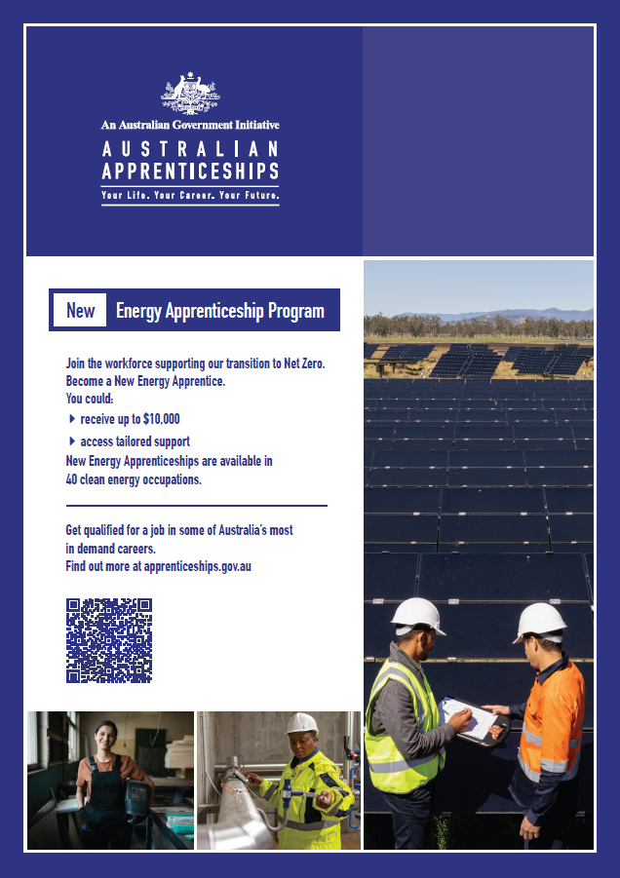

## Digital postcards

Digital postcards can also be used online by displaying on relevant websites or attaching to an email for self-download and printing. Printable versions are also supplied to print at your local printing business.

 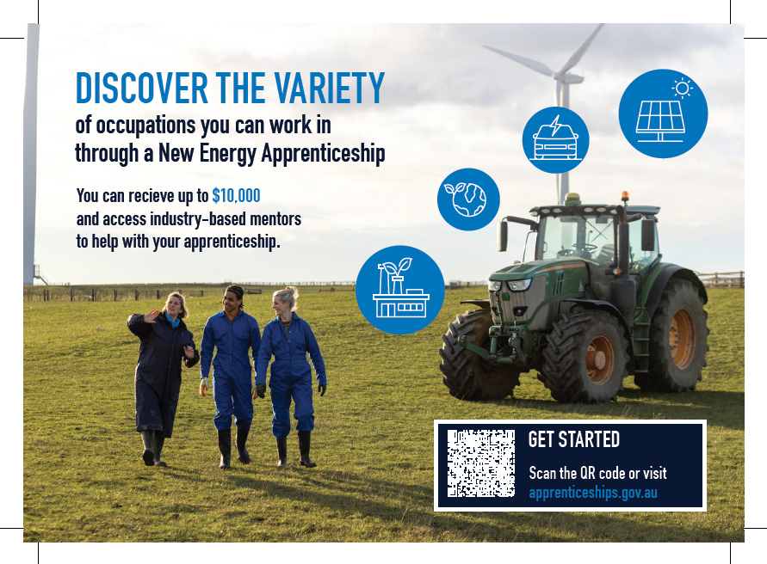

## Social media

### Targeting apprentices

| Content promotion | Image asset |
| --- | --- |
| **Apprentice promotional tile 1:**  Are you looking for a fresh start in a career in demand? Why not explore the clean energy sector and work with cutting edge technologies?  The New Energy Apprenticeships Program is available for Australian Apprentices in the clean energy industry. You will receive up to $10,000 on top of your wage and have access to tailored support.  To find out more about the New Energy Apprenticeship, speak to your local Australian Apprenticeship Support Network or visit <https://www.apprenticeships.gov.au/who-to-contact/search-for-an-australian-apprenticeship-support-network-provider> | New Energy Apprenticeships social media tile 1 |
| **Apprentice promotional tile 2:**  You can access up to $10,000 of the New Energy Apprenticeship Payment on top of your apprentice wage to help support you while you study and work.  The New Energy Apprenticeship Program is available to apprentices working in the clean energy sector.  There are 40 different occupations that you could work in to receive the payments from the Australian Government.  Find out more at <https://www.apprenticeships.gov.au/support-and-resources/financial-support-apprentices-priority-occupations> | New Energy Apprenticeships social media tile 2 |
| **Apprentice promotional tile 3:**  The New Energy Apprenticeships Program provides incentives and mentoring support to apprentices working in the clean energy sector.  Be part of the workforce helping Australia transition to a Net Zero economy, start a New Energy Australian Apprenticeship today!  Get qualified in one of Australia’s most in-demand sectors.  Contact your local Apprentice Connect Australia Provider today.  https://www.apprenticeships.gov.au/who-to-contact/search-for-an-australian-apprenticeship-support-network-provider | New Energy Apprenticeships tile 3 |

### Targeting employers

| Content promotion | Image asset |
| --- | --- |
| **Employer promotional tile 1:**  Does your business work on clean energy projects?  If you bring on an Australian Apprentice, you may be eligible for support with their salary over the first 3 years - and your apprentice may receive bonus payments from the government too!  Speak to your local Australian Apprenticeship Support Network to get involved.  <https://www.apprenticeships.gov.au/who-to-contact/search-for-an-australian-apprenticeship-support-network-provider> | New Energy Apprenticeships tile 4 |
| **Employer promotional tile 2:**  Support is available for employers training the talented workers needed to deliver Australia’s clean energy infrastructure.  Businesses who employ an Australian Apprentice in the clean energy sector may be eligible for the Priority Hiring Incentive.  Find out what support is available for your business when you take on an Australian Apprentice.  <https://www.apprenticeships.gov.au/support-and-resources/financial-support-employers> | New Energy Apprenticeships social media tile 4 |

## Website articles/Newsletter content



**Heading: $10,000 to help start a career in clean energy**

* **Long description:** Up to $10,000 may be available to apprentices working in a clean energy occupation that is on the [Australian Apprenticeship Priority List](https://www.dewr.gov.au/skills-support-individuals/resources/appendix-australian-apprenticeship-priority-list).
* **Short description:** Find out about the New Energy Apprenticeships Program.

Australia’s commitment to achieving Net Zero will cause profound changes in the economy and the transition has been identified as one of the most significant challenges facing the Australian labour market.

To support our clean energy ambitions, the Australian Government has introduced the New Energy Apprenticeships Program that supports apprentices in the clean energy sector.

As a New Energy Apprentice, you will be part of this significant change!

**What’s on offer?**

As a New Energy Apprentice, you may be eligible to receive:

* up to $10,000 in payments on top of your wage (it’s not a loan)
* access to tailored support services to help you through your apprenticeship.

**Who can be part of the New Energy Apprenticeship Program?**

There are up to 40 occupations eligible for New Energy Apprenticeship Program. Each of these is classified as a clean energy occupation on the [Australian Apprenticeship Priority List](https://www.dese.gov.au/australian-apprenticeships/resources/about-australian-apprenticeship-priority-list).

This means you’ll be training towards a career in some of Australia’s most in-demand jobs.

**Support for employers**

Employers of New Energy Apprentices may be eligible for the Priority Hiring Incentive.

You may be eligible to receive up to $5,000 paid in two instalments of:

* $2,000 at 6 months and $3,000 at 12 months (full- time)
* $1,000 at 6 months and $1,500 at 12 months (part-time)

**How do you get involved?**

If you are interested in becoming a New Energy Apprentice, contact your local [Apprentice Connect Australia Provider](https://www.apprenticeships.gov.au/who-to-contact/search-for-an-australian-apprenticeship-support-network-provider).

# Frequently Asked Questions

## What if my audience live in different states and territories across Australia?

The information provided in this pack is applicable across Australia.

## Can I modify the suggested posts and example articles contained in the toolkit?

Yes. The content of these materials can be amended to suit the tone and style of your channels however we ask that you utilise co-branding concepts in line with the Australian Apprenticeship Service Delivery Style Guide.

# Contact

For more information, or additional content you might like to use on your communication channels, please email [communication@dewr.gov.au](mailto:communication@dewr.gov.au).