Australian Government
Department of Employment and Workplace Relations

Fair Entitlements Guarantee Logo


FEG IP Online

Discrepancy Notification and Resolution Process Help Guide

Table of Contents

1 Introduction 3

1.1 Discrepancy task types 3

Case Discrepancy Report task 3

Claimant Discrepancy Report task 3

Confirmation Report task 3

1.2 Support 3

2 Case Discrepancy Report Task 4

2.1 Case Discrepancy Report task description 4

2.2 Respond to Case Discrepancy Report task 4

3 Claimant Discrepancy Report Task 6

3.1 Claimant Discrepancy Report task description 6

3.2 Respond to Claimant Discrepancy Report task 6

Source Data 6

Entitlement Amounts 7

Governing Instruments 8

General Comments 9

Claim Attachments 9

4 Further Information 10

4.1 IP decisions 10

4.2 Comments 10

4.3 Progressing claims 10

4.4 Reports 10

1. Introduction

This document has been prepared to assist insolvency practitioners transition to the new discrepancy notification and resolution process (‘discrepancy process’). It supplements the [FEG IP Online Help Guide](https://www.dewr.gov.au/fair-entitlements-guarantee/resources/feg-ip-online-help-guide).

The discrepancy process has been integrated into [FEG IP Online](https://extranet.employment.gov.au/FEGIPONLINE/) to make it easier for insolvency practitioners to complete this important work. The integration of the new discrepancy process provides insolvency practitioners with the facility to check and confirm discrepancy data directly into FEG IP Online rather than into a Word document. This will provide efficiencies for insolvency practitioners and assist FEG provide accurate and timely payments to FEG claimants.

This guide describes the new discrepancy task types, outlines the key steps involved in actioning those tasks, and contains additional tips to help users respond to discrepancies efficiently.

Within FEG IP Online, insolvency practitioners can:

* see which claimants have a discrepancy raised
* view the discrepancy per claimant
* write a response to the discrepancy
* see which claimants and discrepancies they have addressed
* save work performed prior to sending or exiting the system
* agree or disagree to one or more discrepancies for a claimant or one or more claimants (ie update records in bulk)
* generate a printable Claimant Discrepancy Report – showing the comments from FEG and any comments insolvency practitioners have entered.

The system has been designed to allow insolvency practitioners to respond to all discrepancies related to a case at the one time, or to respond in tranches. In both scenarios, the relevant discrepancy task will need to be submitted once all discrepancies for a claimant have been responded to. **Note:** the system requires IPs to either agree or disagree to each FEG recommendation.

* 1. Discrepancy task types

Case Discrepancy Report task

The Case Discrepancy Report task is used, where applicable, to clarify key information at the case level. Clearing up a single issue for multiple claimants at the case level will reduce the need for insolvency practitioners to respond to the same type of discrepancy for each applicable claimant.

Claimant Discrepancy Report task

The Claimant Discrepancy Task is used to seek a response from insolvency practitioners in relation to discrepancies for each applicable claimant’s entitlement(s).

This is a similar approach to the previous Discrepancy Report task but shifts the information from outside FEG IP Online to inside FEG IP Online.

Confirmation Report task

The Confirmation Report task remains unchanged. It is sent as an information task to insolvency practitioners to provide visibility of the position FEG has formed following the discrepancy notification and resolution process, and which forms the basis for the FEG advances.

* 1. Support

If you have any questions about the new process, support is available at:

Email: [FEGIPOnline@dewr.gov.au](mailto:FEGIPOnline@dewr.gov.au) | Phone: (02) 6240 0440, Mon - Fri, 9 am - 5 pm (AEST/ADST)

1. Case Discrepancy Report Task
   1. Case Discrepancy Report task description

The Case Discrepancy Report task provides information on our preliminary assessment of details of a FEG case and discrepancies that need to be resolved to finalise the assessment of claims.

* 1. Respond to Case Discrepancy Report task

To resolve discrepancies, FEG will send IPs the Case Discrepancy Report task.

To action this task, you will need to:

1. Click **Work on Task**
2. Click on **Manage** **Data**.

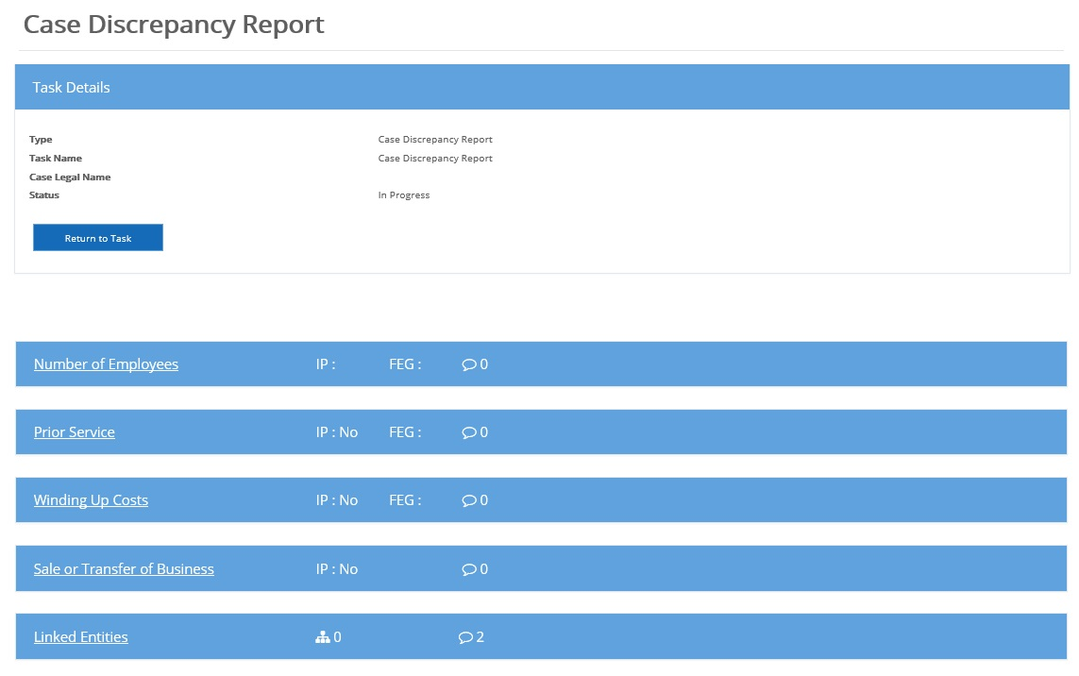

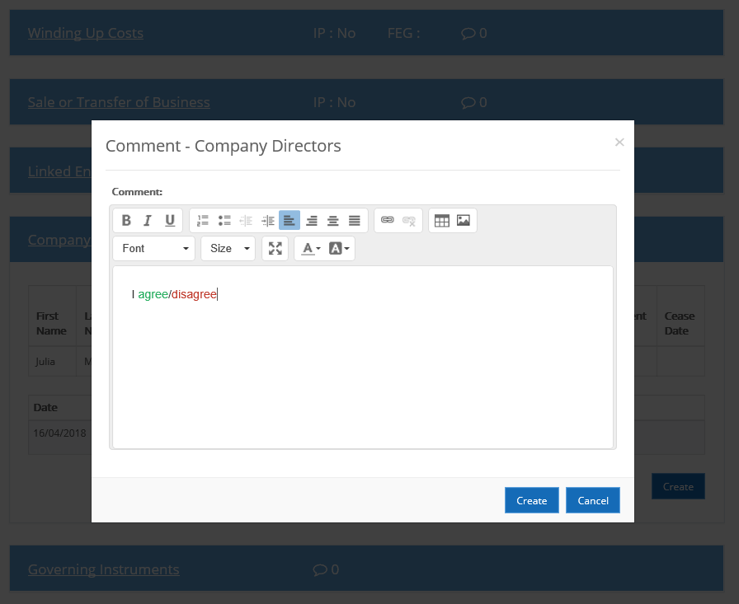

FEG will include a comment under the relevant panel(s) for the insolvency practitioner to respond to. To enter a comment (response) the insolvency practitioner performs the following steps:

1. Click the panel to expand
2. Click on the **Create** button
3. Enter the comment(s)
4. Click on the **Create** button within the comment field popup.

Once all case discrepancies have been responded to, the insolvency practitioner submits the task back to FEG.

1. Claimant Discrepancy Report Task
   1. Claimant Discrepancy Report task description

The Claimant Discrepancy Report task provides more granular information on our preliminary assessment of entitlements payable under FEG and discrepancies that need to be resolved to finalise the assessment of the claim.

* 1. Respond to Claimant Discrepancy Report task

To reconcile the discrepancies associated with the data provided by the claimant and IPs via the verification spreadsheet, FEG will send IPs the Claimant Discrepancy Report task, which includes in most instances our recommendations.

To action this task, you will need to:

1. Click **Work on Task**
2. Click on Manage Data.

This will navigate you to the *Claimant Summary*. Here you will be able to access each record for the claimants attached to the task.

To review the discrepancies for an individual claimant you will need to:

1. Click on their name.

Source Data

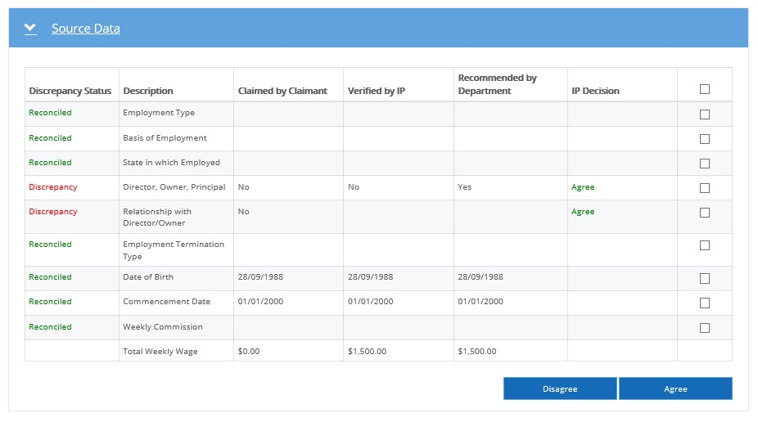

To agree with a discrepancy, you can:

1. Select one or more of the check boxes for data flagged as discrepancy
2. Click on the **Agree** button.

To disagree with a discrepancy, you can:

1. Select one or more of the check boxes for data flagged as discrepancy
2. Click on the **Disagree** button.

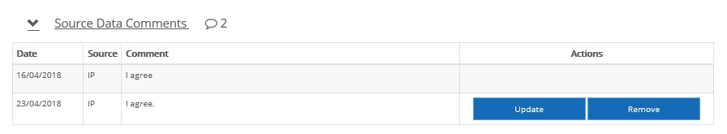

If you disagree with a FEG recommendation or wish to provide additional information, to provide a comment for the FEG claim assessor you:

1. Click on the **Source Data Comments** drop down
2. Click on the **Create** button
3. Enter comment(s)
4. Click on the **Save** button.

**Note:** an IP must either agree or disagree with a FEG recommendation. It is expected a comment will be provided wherever you disagree with a FEG recommendation.

Any comments entered by IPs will only be visible to FEG in the instances where you have submitted the record or task.

Entitlement Amounts

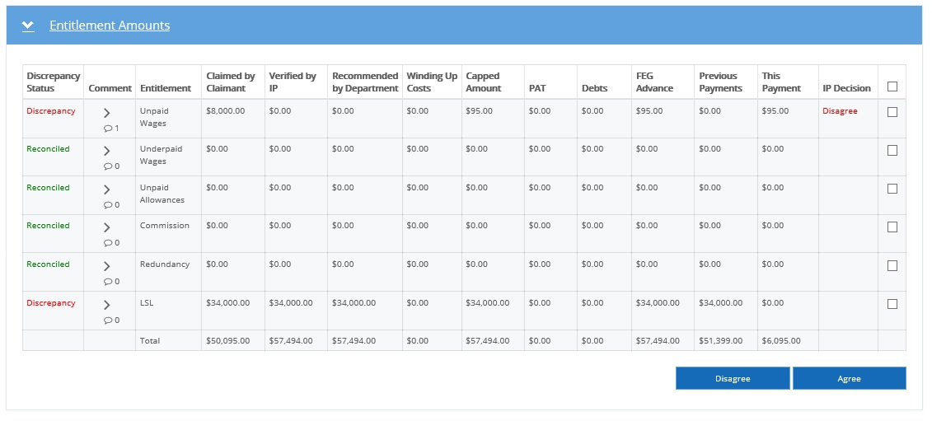

To agree with a discrepancy, you can:

1. Select one or more of the check boxes for data flagged as discrepancy
2. Click on the **Agree** button.

To disagree with a discrepancy, you can:

1. Select one or more of the check boxes for data flagged as discrepancy
2. Click on the **Disagree** button.

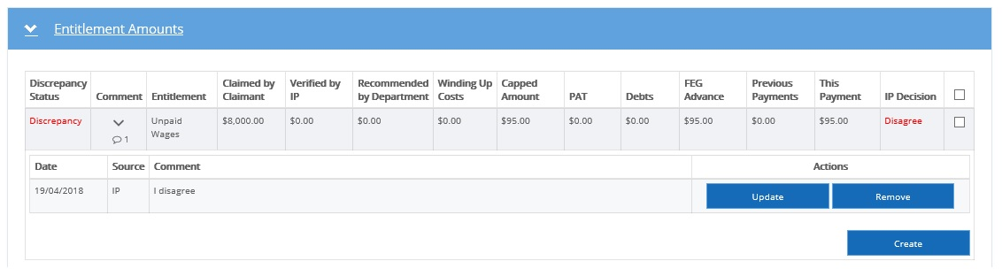

Where applicable you can leave a comment for the FEG claim assessor under each entitlement. To do this you:

1. Click on the **Comments** drop down for each entitlement
2. Click on the **Create** button
3. Enter comment(s)
4. Click on the **Save** button.

**Note:** while the task is in progress, you are able to update and remove each comment you enter against an entitlement. However, once the task or individual record is submitted back to FEG you will be unable to make any further edits or remove the comment.

Governing Instruments

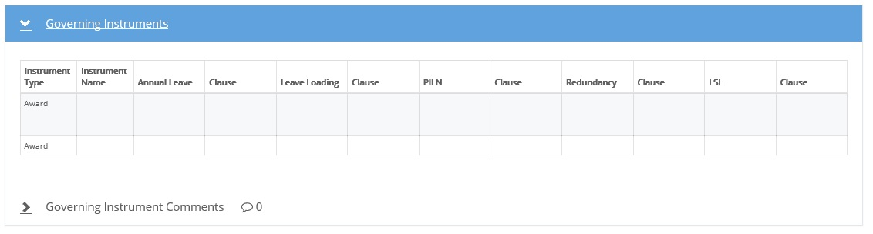

Where applicable you can leave a comment for the FEG claim assessor regarding the Governing Instruments by performing the following steps:

1. Click on the **Comments** drop down
2. Click on the **Create** button
3. Enter comment(s)
4. Click on the **Save** button.

General Comments

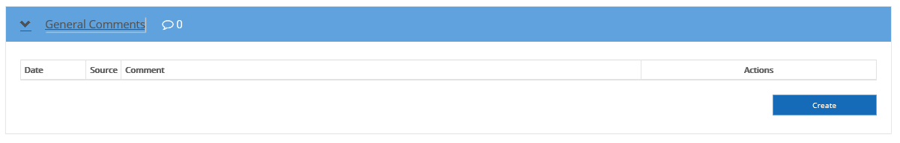

Where applicable you can leave a general comment for the FEG by performing the following steps:

1. Click on the **Comments** drop down
2. Click on the **Create** button
3. Enter comment(s)
4. Click on the **Save** button.

**Note:** while the task is in progress you are able to update and remove each comment you enter against an entitlement. However, once the task or individual record is submitted you will be unable to make any further edits or remove the comment.

Claim Attachments

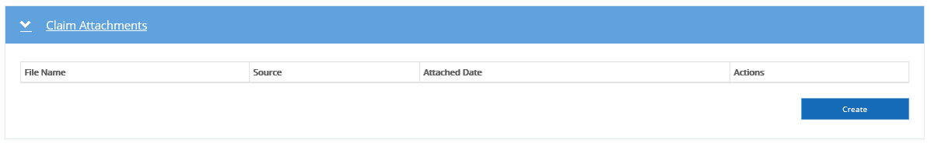

In the instances where you wish to provide documents that assist in the discrepancy resolution process you can add them as an attachment to the task:

1. Expand the **Claim Attachments** drop down
2. Click on the **Create** button
3. Drag and drop the file onto the popup window **OR**  
   Click on the popup window to select the file manually
4. Click on the **Upload File** button
5. Click **Close** on the popup window once all relevant documents have been attached.
6. Further Information
   1. IP decisions

An insolvency practitioner is required to either agree or disagree to each FEG recommendation before submitting an individual record or the Claimant Discrepancy Report task.

* 1. Comments

While the system does not make it mandatory to include a comment each time an insolvency practitioner disagrees with a discrepancy raised by FEG, a comment is essential information for the FEG officer to determine the next step. Where a comment is not provided up front, it is almost certain the FEG officer will need to contact the insolvency practitioner for this information.

* 1. Progressing claims

Where insolvency practitioners choose to respond to discrepancies in tranches, they will need to ensure any internal approval requirements are met prior to submitting individual records, as FEG will progress claims upon receipt of an ‘agree’ response from insolvency practitioners.

* 1. Reports

Insolvency practitioners can generate a PDF version of the Claimant Discrepancy Report. This replaces the Entitlement Discrepancy Report (EDR) that used to be sent with the Discrepancy task. The report contains case and claimant information, including where discrepancies have been raised.

The Report icon can be used by IPs to access a number of other reports which can be used to supplement the Claimant Discrepancy Report to assist IPs respond to discrepancies raised. Further instruction on how to access Exportable Reports is available in the [FEG IP Online Help Guide](https://www.dewr.gov.au/fair-entitlements-guarantee/resources/feg-ip-online-help-guide).