Australian Government
Department of Employment and Workplace Relations

Fair Entitlements Guarantee Logo


How do I verify my FEG Online Services account?

The **Identity and Residency Document Verification Service** (DVS) available in [FEG Online Services](https://fegonlineservices.dewr.gov.au/) is the easiest way to verify your account and provide evidence of your identity and Australian citizenship or residency status when making a claim for assistance under the Fair Entitlements Guarantee (FEG).

The DVS is a secure online platform which allows claimants to self-verify documents relating to proof of identity and evidence of residency status, issued by a range of Australian government agencies. The DVS system checks if the biographic information entered in the document matches the original record from the issuer agency.

Once an Identity and a residency document is matched the status of your account will change to Verified. The DVS record and its attachments will also be provided to FEG on the submission of your claim or will otherwise be added to all submitted but unprocessed claims.

This fact sheet provides a step-by-step guide to using DVS in [FEG Online Services](https://fegonlineservices.dewr.gov.au/).

Identity and residency Document types

The DVS functionality can verify your identity and Australian citizenship or residency status from a list of ten documents:

1. Birth Certificate
2. Change of Name Certificate
3. Citizenship
4. Drivers Licence
5. ImmiCard
6. Marriage Certificate
7. Medicare
8. Passport
9. Registration By Descent
10. Visa.

Verify your FEG Online Services account

1. To sign in, go to [FEG Online Services](https://fegonlineservices.dewr.gov.au/) and click **Sign In**.

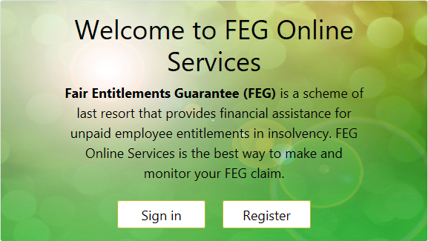

If you do not have an account, you can register for FEG Online Services.The [How do I access FEG Online Services](https://www.dewr.gov.au/fair-entitlements-guarantee/resources/how-do-i-access-feg-online-services-fact-sheet) fact sheet provides a step-by-step guide on how to register and log into FEG Online Services.

1. After successful login, you will be prompted to verify your account if the status of your account is Unverified and you have not completed the Identity and Residency Document Verification process.

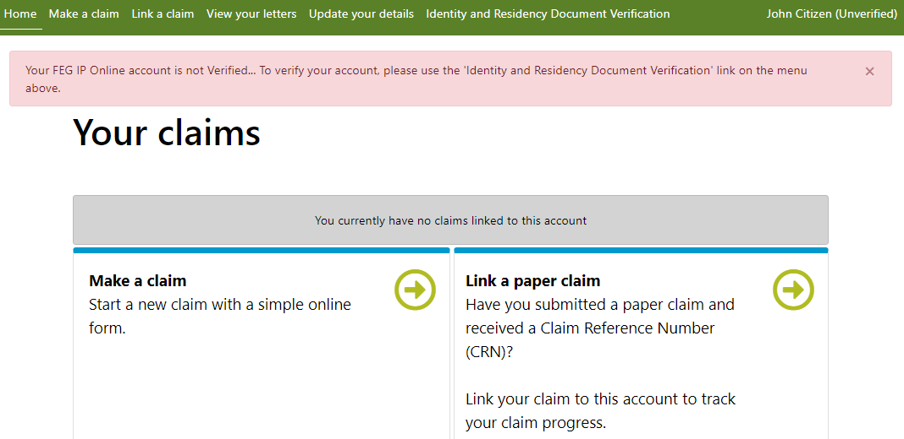

**Note:** There is no requirement to verify your account or use the Identity and Residency Document process to provide evidence of your Identity or residency status to support your claim. Documentary evidence to support your Australian citizenship or residency status can be provided as an attachment to your unsubmitted claim form or added to a claim in the status of ‘In Assessment’ by selecting Actions and Manage Attachments.

1. Select **Identity and Residency Document Verification** on the navigation bar.

Navigation bar

1. Once you have selected Identity and Residency Document Verificationyou will be directed to the manage Identity and Residency Documents screen. Select **Add New Verification**.

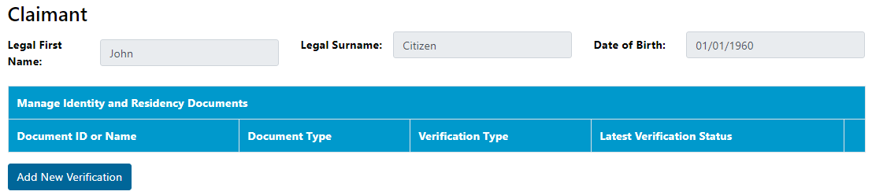

1. Read the Verify Identity or Residency Document Consent information and select the **Agree** check box to confirm you are authorised to provide the personal details and you consent to the information being checked by the issuer or official record holder. Then select **Continue**.

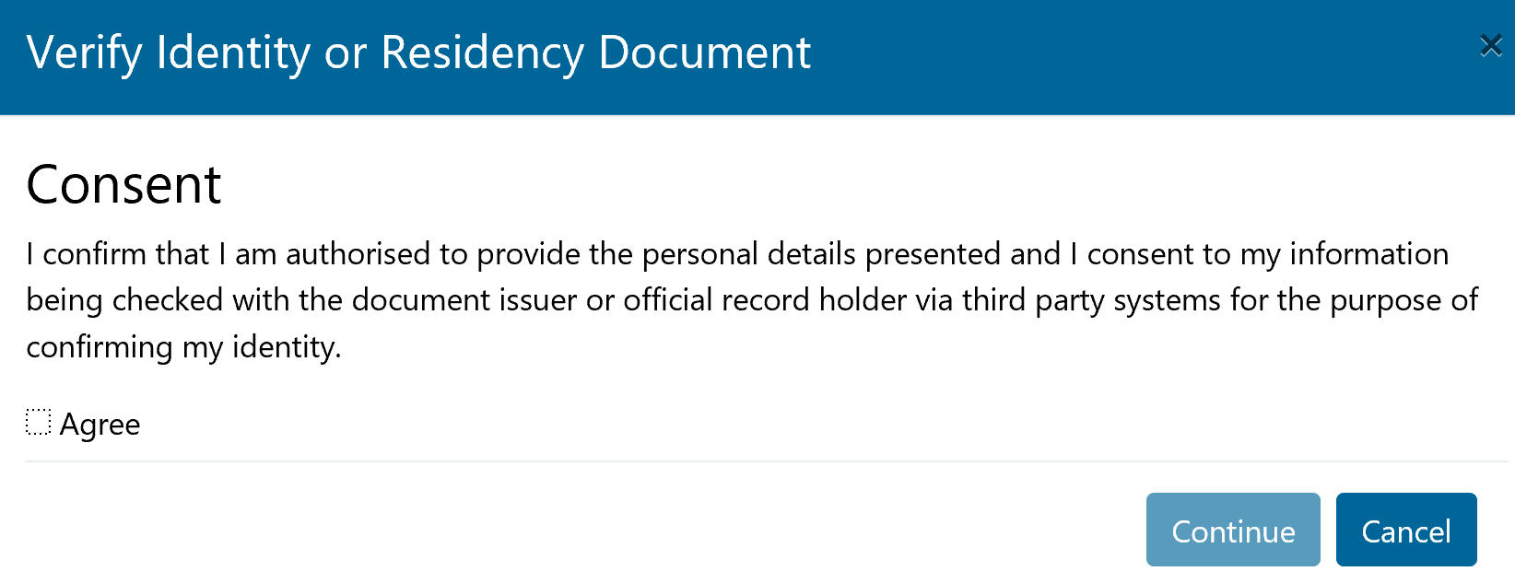

1. You will be prompted to select one of the documents types. Select a document from the list and click **Continue**.

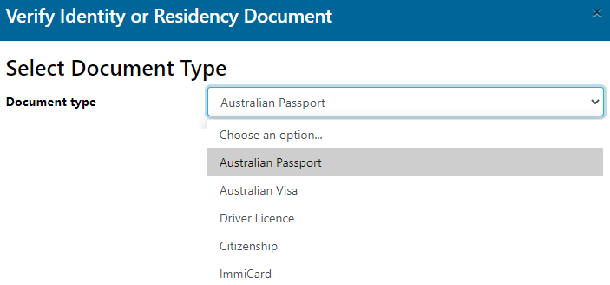

1. Accurately complete all fields and then click **Save.**

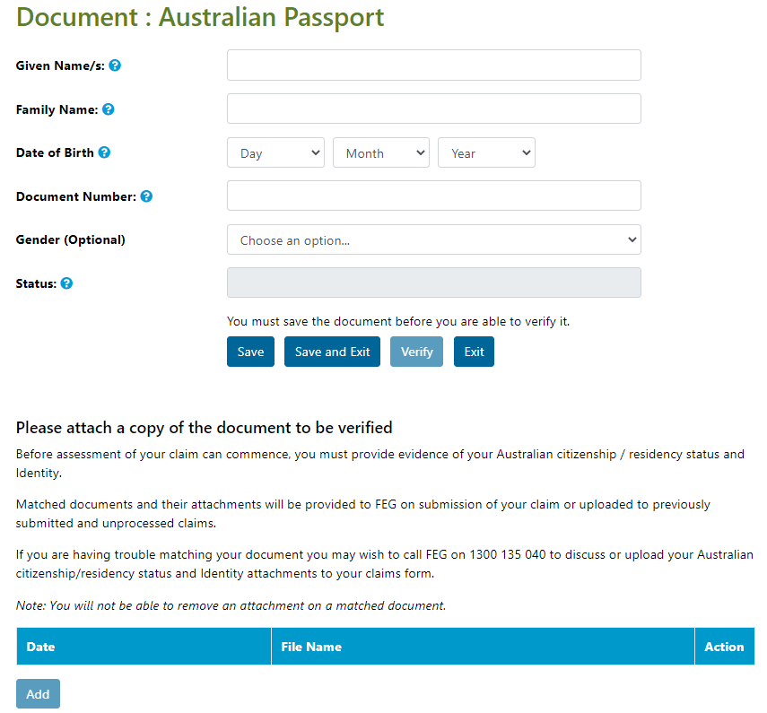

1. Once your document successfully saves you will be able to add attachments. To add an attachment select the **Add** button underneath the attachment table.

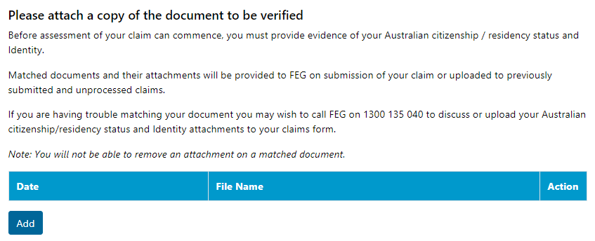

In the pop window, drag and drop the appropriate file or click the grey panel to manually choose a file or files from your desktop and local drives.

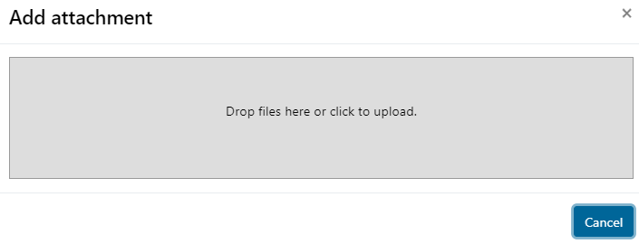

**Note:** It is important you provide the Fair Entitlements Guarantee with documentary evidence of your Australian citizenship or residency status to make an effective claim. The [Eligibility for FEG assistance](https://www.dewr.gov.au/fair-entitlements-guarantee/resources/eligibility-feg-assistance-fact-sheet) fact sheet provides information about the eligibility requirements for the Fair Entitlements Guarantee.

1. You are now ready to verify your document. Check to ensure the details you have entered are correct and select **Verify**. The DVS will check to ensure all the mandatory fields are complete and send your request to the Issuer agency.

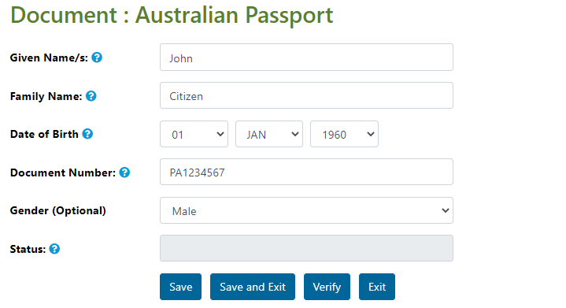

1. The status of your document will change to one of four verification responses from the issuer agency:
2. *Matched*—No further action is required for this document. Once the document is in a matched status you cannot make any changes to the document or remove attachments. You can add additional attachments and they will be included on the submission of your claim or be added to any submitted and unprocessed claims.
3. *Not Matched*—some or all details do not match the issuer record. You will need to check information entered in the document to ensure it matches the original record. Update detail in the records to match the original document and select **Verify** to return a result from the issuer agency.
4. *Document is invalid or not electronically captured*—the document cannot be matched as it is not electronically captured by the associated agency. You can select another document to verify or provide evidence of your Australian citizenship or residency status with your claim form so that it can be manually verified by the department.
5. *System Error*—Potential internet or server issue. Select **Verify** to resend the request to the issuer agency.
6. To add an additional document, select **Exit** and you will return to the Identity and Residency Documents screen.
7. To view all draft, submitted and processed claims, select **Home** on the navigation bar.

Trouble shooting tips

1. I verified a document and it returned a Matched result. My FEG Online Services account status did not change to Verified.

Tip: When attempting to verify your FEG Online Services account, you must provide evidence to support your identity and residency. Your account will remain in the status of unverified until you have verified your identity and residency status. Documents such as your passport would meet the requirements of proving your identity and residency status, while your driver licence can only be used to verify your identity.

1. I attempted to verify a document and it returned a status of Unmatched. Can I use the same document again or should I create a new document record using the same document type?

Tip: You can reuse the same document. Check the details and make changes to ensure it matches the details of the original record. You will have to save the document before you are able to verify it.

1. I verified a document and it returned a matched result. Is it to late to add attachments to my document?

Tip: No, you can provide attachments after the document is verified. The document/s in question will also be made available to FEG staff if you have added your identity and proof of residency document before the submission of your claim or prior to the finalisation of your claim.

Important!

To be eligible for assistance under FEG you must be an Australian citizen or the holder of a permanent visa   
(ie your current visa allows you to live in Australia indefinitely) or special category visa (ie your current visa allows you to stay and work in Australia as long as you remain a New Zealand citizen) at the time your employment ended*.*

Before assessment of your claim can commence, you must provide documentary evidence to support your claim that you were an Australian citizen or the holder of a permanent visa at the time your employment ended. If you do not provide this evidence your claim will not be effective and you will not be eligible for assistance under FEG.

Acceptable evidence of your citizenship or residency status includes a copy of at least one of the following categories of documents:

* Australian passport issued **no later** than the date of the end of your employment
* Full Australian Birth Certificate. Extracts of birth certificates are insufficient
* Australian Citizenship Certificate issued prior to the end of your employment. **This should include both sides if there is anything on the reverse side**
* ImmiCard that is linked to an official online record of your permanent Australian visa, and which confirms that the visa was issued prior to the end of your employment
* Registration by Descent document
* Where appropriate, for the purpose of proving you hold a permanent visa, a copy of a passport that is linked to an official online record of your permanent Australian visa, and which confirms that the visa was issued prior to the end of your employment; or a copy of the visa label from your passport (**passport details must be visible**), or a copy of the Visa Grant Notice that includes the details of your passport you used to apply for that visa
* Where appropriate, for the purpose of proving you held a Special Category visa at the end of your employment, a current New Zealand passport that is linked to an official online record of your Special Category Visa, and which confirms that the visa was issued prior to the end of your employment, or a New Zealand passport that was current at the end of your employment or, if your passport had expired, the most recent expired New Zealand passport that you held at the time you entered Australia prior to working for the employer
* Confirmation of Identity and Citizenship for Aboriginal and Torres Strait Islander people where other documentation is not available. You should use the [Confirmation of Identity and Citizenship form](https://www.dewr.gov.au/fair-entitlements-guarantee/resources/feg-confirmation-identity-and-citizenship) which is available on the department’s website.
* In circumstances where you are not able to provide any of the above categories of documents before the end of the legislated 12-month period for lodging your claim, a completed statutory declaration from you, verifying that you do not have and are unable to obtain such documents, and detailing the steps you propose to take to obtain a copy of the required document(s). You should use the [Commonwealth statutory declaration form](https://www.ag.gov.au/legal-system/publications/commonwealth-statutory-declaration-form) which is available on the website of the Attorney-General’s department.

**Please note:** Your driver’s licence is not acceptable evidence of your citizenship or residency status.

Where the name on the document does not match the name that you are claiming under you will also need to provide proof of the change of name by providing one of either:

* Change of name certificate, or
* Marriage certificate.

**Important:** The department verifies the authenticity of the mandatory documents that you provided by requesting confirmation of the document from the agency or organisation that issued the document.

Want more information?

You can contact the FEG Hotline if you want further information about using [FEG Online Services](https://fegonlineservices.dewr.gov.au/):

* Phone 1300 135 040  
  Mon - Fri, 9 am - 5 pm (AEST/ADST)
* Email [FEG@dewr.gov.au](mailto:FEG@dewr.gov.au)

If you speak a language other than English, call the Translating and Interpreting Service (TIS) on 13 14 50 for free help anytime. If you speak an Indigenous language, call the Aboriginal Interpreter Services on **1800 334 944**.

Further information about FEG is also available on the [FEG website](https://www.dewr.gov.au/fair-entitlements-guarantee).

The information contained in this fact sheet is of a general nature and explains, in summary form, the intended operation of the *Fair Entitlements Guarantee Act 2012* - it is not legal advice. Where necessary, you should seek your own independent legal advice relevant to your particular circumstances. The Commonwealth does not make any representation or warranty about the accuracy, reliability, currency or completeness of the information contained in this fact sheet and is not liable for any loss resulting from any action taken or reliance made by you on the information contained in this factsheet.