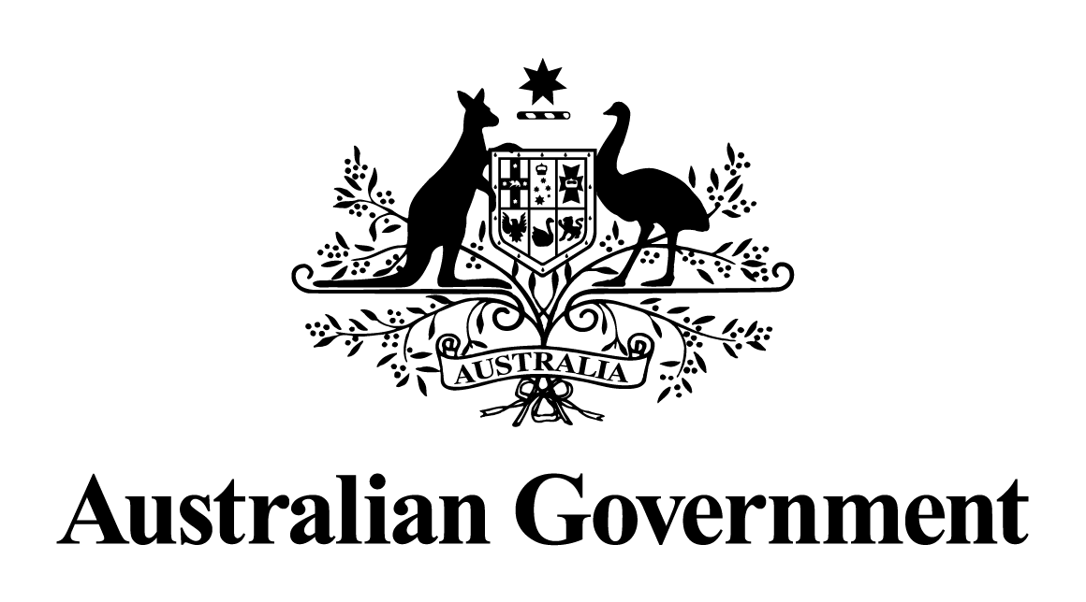

# Australian Government response to the Senate Education and Employment Legislation Committee report:

# Social Security Legislation Amendment (Streamlined Participation Requirements and Other Measures) Bill 2021 [Provisions]

On the 27 May 2021, the Senate Education and Employment Legislation Committee (the Committee) commenced an inquiry into the Social Security Legislation Amendment (Streamlined Participation Requirements and Other Measures) Bill 2021 [Provisions].

The Australian Government thanks the Committee members for their work in delivering the report and associated recommendations.

The Government notes all recommendations made by the Committee and in the dissenting reports made by the Australian Labor Party and the Australian Greens Senators.

Given the passage of time, a substantive Government response is no longer appropriate.